YUKON WILDLAND FIRE MANAGEMENT WEATHER FORECAST - 9:00 AM ISSUE

28-May-2026
YESTERDAY'S VALUES
Community | Max  Temp  (°C) | Diff.  from  Normal | Min Temp  (°C) | Diff. from Normal | Pcpn  (mm) | Min RH | Max RH | L110 | L30
Old Crow | 4.7 | -8.1 | -1.4 | -2.6 | 0.0 | 65 | 80 | 4 | 0
Fort Mcpherson Airport | 1.5 |  | -2.8 |  | 0.0M | 83 | 93 | 0 | 0
Rock River Climate | 7.8 |  | -3.4 |  | 0.0 | 67 | 94 | NA | NA
Eagle Plains Fire | 12.3 |  | 0.0 |  | 4.8 | 39 | 98 | 26 | 2
Antimony Creek | 14.1 |  | -0.8 |  | 2.8 | 40 | 98 | 8 | 3
Klondike Fc | 14.0M | -4.0 | 1.3M | -1.9 | 0.0M | 34M | 93M | 4 | 1
Forty Mile | 15.9 |  | 3.8 |  | 0.0 | 16 | 78 | 2 | 0
Henderson | 13.0 |  | 1.9 |  | 0.8 | 28 | 91 | 4 | 0
Barlow | 12.9 |  | 0.8 |  | 0.0 | 40 | 95 | 4 | 0
Mayo A | 11.7 | -5.7 | 3.2 | -0.8 | 0.2 | 46 | 92 | 0 | 0
Stewart Crossing | 12.9 |  | 3.0 |  | 1.6 | 39 | 97 | 2 | 0
Willow Creek | 8.8 |  | -0.1 |  | 1.8 | 58 | 96 | 0 | 0
Pelly Farm | M |  | M |  | M | M | M | 0 | 0
Carmacks | 15.6 |  | -0.2 |  | 0.0 | 26 | 77 | 0 | 0
Drury Creek | 13.4 |  | 2.2 |  | 0.0 | 25 | 72 | 0 | 0
Faro | 12.0 | -4.0 | 2.6 | -0.7 | 0.0 | 50 | 95M | 0 | 0
Ross River | 12.5 |  | 1.4 |  | 0.0 | 23 | 74 | 0 | 0
Macmillan Pass | 3.6M |  | -3.0M |  | 1.2 | 53M | 100M | 1 | 0
Beaver Creek A | 13.2 | -2.1 | 4.1 | 2.4 | 0.0 | 19 | 56 | 0 | 0
Beaver Creek Town | 14.2 |  | 5.0 |  | 0.0 | 16 | 59 | 0 | 0
Burwash A | 10.7 | -3.6 | 2.2 | 1.7 | 0.0M | 27 | 60 | 0 | 0
Haines Junction | 14.6 | -0.9 | 2.0 | 2.5 | 0.0 | 20 | 67 | 0 | 0
Rainbow | 12.5 |  | 0.8 |  | 0.0 | 27 | 80 | 0 | 0
Champagne | 12.3 |  | -1.2 |  | 0.0 | 26 | 80 | 0 | 0
Braeburn | 14.7 |  | -0.3 |  | 0.0 | 20 | 76 | 0 | 0
Nursery | 12.1 |  | -1.0 |  | 0.0 | 21 | 75 | 0 | 0
Whitehorse Auto | 12.3 | -3.1 | 1.3 | -1.0 | 0.0 | 21 | 69 | 0 | 0
Mount Sima | 7.7 |  | -1.9 |  | 0.0 | 29 | 78 | 0 | 0
Carcross | 12.7 |  | -2.6 |  | 0.0 | 29 | 90 | 0 | 0
Atlin | 7.8 |  | 1.4 |  | 0.0 | 44 | 68 | 0 | 0
Jakes Corner | 10.9 |  | -0.3 |  | 0.0 | 29 | 70 | 0 | 0
Teslin | 8.7 |  | -2.2 |  | 0.6 | 37 | 84 | 0 | 0
Quiet Lake | 13.3 |  | -1.0 |  | 0.0 | 24 | 82 | 0 | 0
Swift River | 10.3 |  | -4.5 |  | 0.0 | 22 | 85 | 0 | 0
Tuchitua | 13.5 |  | -6.2 |  | 0.0 | 20 | 94 | 0 | 0
Hasselburg | 11.0 |  | -3.7 |  | 0.0 | 29 | 93 | 0 | 0
Tom Creek | 12.1 |  | -2.2 |  | 0.0 | 24 | 79 | 0 | 0
Watson Lake | 11.5 | -4.5 | -1.9 | -5.1 | 0.0 | 33 | 96 | 0 | 0
Iron Creek | 15.5 |  | -4.7 |  | 0.0 | 20 | 93 | 0 | 0
Max Temp is the actual maximum temperature in °C from yesterday afternoon or evening.
Min Temp is the actual overnight minimum temperature in °C up until 6:00 AM this morning.
Diff. from Normal is the difference from the 30 year average max or min temperature.
Pcpn is the precipitation in mm since 13:00 yesterday.
Min RH is the minimum observed RH in % from yesterday afternoon or evening.
Max RH is the maximum observed overnight RH in % up until 6:00 AM this morning.
L110 is the actual number of lightning strikes within 110 km and in the Yukon for 24 hours ending at 06:00 AM this morning.
L30 is the actual number of lightning strikes within 30 km and in the Yukon for 24 hours ending at 06:00 AM this morning.
M is missing data. * denotes precipitation at stations that failed to report for at least part of the evening and overnight period.

SYNOPSIS:
Today: A deep upper trough located over the Gulf of Alaska will overspread the Territory today, keeping conditions unsettled across most regions. Isolated to scattered convective showers and thundershowers are forecast to develop through nearly all regions today by afternoon as a slightly unstable air mass will be paired with the upper-level troughing. However, a developing surface low in northern BC will advance northward late in the day today into overnight tonight, bringing steadier light rains to parts of Tintina (particularly near and east of Watson Lake). Old Crow will be cool under a moderate northeasterly flow, with a slight risk of patchy light snow particularly this evening/tonight. Also a chance of precipitation changing over to light snow through eastern Tatchun areas overnight into Friday morning as temperatures cool to near the freezing mark. Highs today in the Territory generally in the low to mid-teens, with min RHs in the 20-35% range. Cooler with damper conditions in Old Crow.

Friday: An upper-level low will remain anchored over the Gulf of Alaska, with broad troughing in place across the Yukon. A surface low is forecast to develop in the southern Klondike during the day. Scattered convection is forecast to develop around the surface low with pop-up showers and thundershowers forecast to develop in the southern Klondike, southern Northern Tutchone, Tatchun, and parts of Kluane (particularly Beaver Creek district). Drier through Southern Lakes and Tintina under a light to moderate southwesterly flow. Old Crow remains cool under a northeasterly flow and slight risk of a rain shower or mixed precipitation. Steadier precipitation possible in Kluane Friday night on the backside of the developing low. Precipitation amounts of 5-15 mm possible, particularly in the Beaver Creek district, with localized heavier amounts.

Saturday: Troughing loosens its grip in the Territory, though scattered showers and thundershowers are still expected through the central Territory, with light synoptic precipitation persisting in parts of Kluane (Beaver Creek/Burwash). Elsewhere, scattered to broken cloud cover is generally forecast. Temperatures remain cool. Somewhat of a drier air mass in place through Southern Lakes and Tintina under a south-southwesterly flow, dropping RHs into the 20-25% range.

Sunday: The trough continues to weaken in the region, with weak ridging beginning to develop in southeast Yukon. Slight risk of convective showers in southern Klondike and Beaver Creek district, otherwise quiet weather in the Territory combined with a warming trend. Temperatures climb into the mid to upper teens across the Yukon.

Monday: Broad ridging expands into the Yukon, leading to a continued gradual warming and drying trend in the Territory. Highs generally in the upper teens to low twenties through central and southern Yukon. Low teens in the northern Territory.

Forecast for | Thursday | (Peak burning period and overnight)
Community | Clouds | Pcpn | POP | POL | Max Temp | Min RH | Min Temp | Max  RH | Wind Dir | Wind Speed
Old Crow | BKN | SN-/RW- | 60 | NIL | 6 | 60 | -2 | 85 | 20 | 20G30
Klondike Fc | BKN | RW-/TRW- | 40 | ISO | 16 | 35 | 5 | 73 | 70 | 5-10
Mayo A | BKN | RW-/TRW- | 40 | ISO | 14 | 35 | 6 | 88 | 140 | 10-15
Carmacks | BKN | RW-/TRW- | 40 | RISK | 16 | 20 | 3 | 67 | 140 | 10G20
Faro | BKN | RW-/TRW- | 60 | RISK | 12 | 30 | 1 | 77 | 160 | 10G20
Ross River | BKN | RW-/TRW- | 60 | RISK | 14 | 30 | 0 | 82 | 160 | 10G20
Beaver Creek Town | BKN | RW-/TRW- | 40 | ISO | 11 | 45 | -1 | 91 | 270 | 10
Burwash A | BKN | RW-/SW- | 40 | NIL | 10 | 30 | 0 | 74 | 160 | 10-15
Haines Junction | SCT | RW- | 20 | NIL | 13 | 25 | -1 | 88 | 200 | 10G25
Whitehorse Auto | BKN | RW-/TRW- | 30 | RISK | 12 | 20 | 3 | 79 | 220 | 15G30
Teslin | BKN | R-/RW- | 60 | NIL | 10 | 30 | 2 | 83 | 140 | 10G20
Watson Lake | BKN | R-/RW- | 70 | NIL | 12 | 35 | 5 | 94 | 140 | 10G20
POP is probability of precipitation in %.
POL is probability of lightning in %.

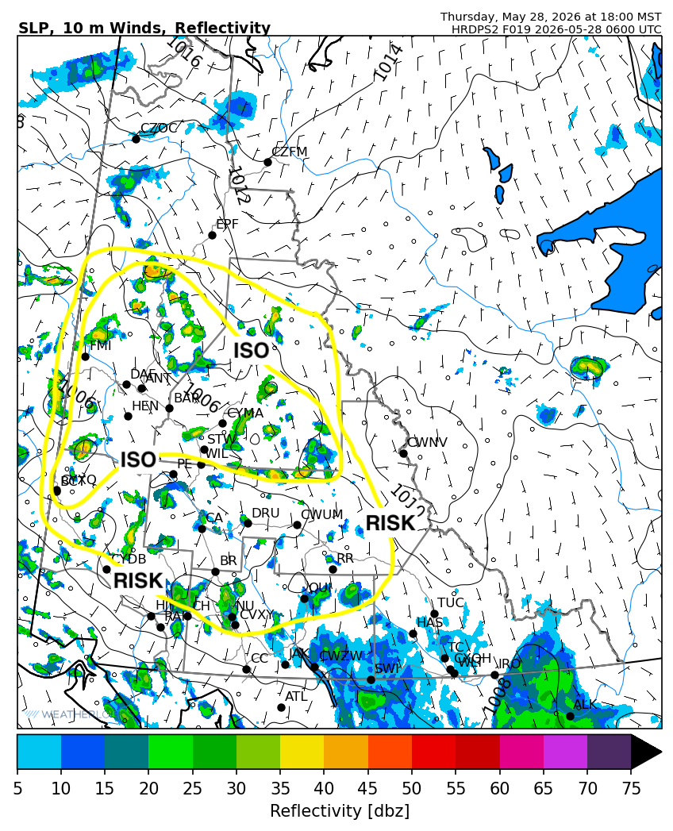
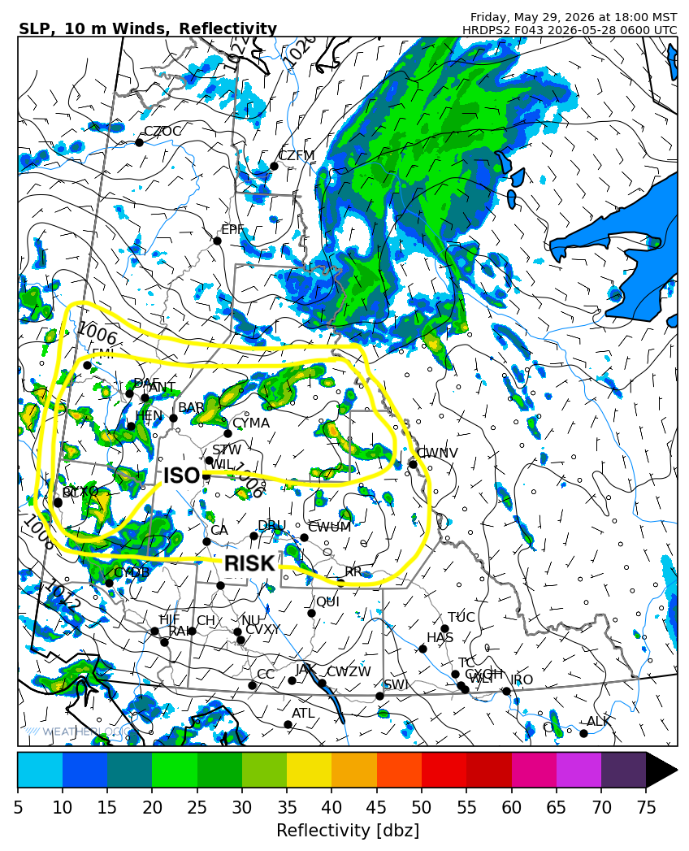

Forecast for | Friday | (Peak burning period and overnight)
Community | Clouds | Pcpn | POP | POL | Max Temp | Min RH | Min Temp | Max  RH | Wind Dir | Wind Speed
Old Crow | BKN | RW-/SW- | 30 | NIL | 4 | 65 | -4 | 80 | 20 | 30G50
Klondike Fc | BKN | RW-/TRW- | 40 | ISO | 15 | 40 | 3 | 74 | 40 | 10-15
Mayo A | BKN | RW-/TRW- | 60 | ISO | 14 | 40 | 5 | 85 | 20 | 10
Carmacks | BKN | RW-/TRW- | 60 | RISK | 14 | 30 | 2 | 67 | 180 | 10G25
Faro | BKN | RW-/TRW- | 60 | RISK | 10 | 45 | -1 | 77 | 220 | 10G20
Ross River | SCT | RW-/TRW- | 40 | RISK | 12 | 35 | -3 | 79 | 220 | 10G20
Beaver Creek Town | BKN | RW-/TRW- | 60 | ISO | 14 | 40 | 1 | 84 | 290 | 10-15
Burwash A | BKN | RW-/SN- | 60 | NIL | 9 | 50 | 0 | 83 | 160 | 10-15
Haines Junction | SCT | RW- | 20 | NIL | 11 | 30 | 0 | 81 | 200 | 20G40
Whitehorse Auto | SCT |  | 10 | NIL | 11 | 20 | 0 | 74 | 220 | 15G30
Teslin | FEW |  | 10 | NIL | 10 | 25 | 0 | 73 | 220 | 10G30
Watson Lake | SCT |  | 0 | NIL | 12 | 30 | 3 | 61 | 270 | 10G20

Forecast for |  |  | Saturday |  | (Peak burning period and overnight)
Community |  |  | Clouds |  | Pcpn |  | POP |  | POL |  | Max Temp |  | Min RH | Min Temp | Max  RH | Wind Dir | Wind Speed
Old Crow |  |  | SCT |  |  |  | 0 |  | NIL |  | 6 |  | 50 | -2 | 84 | 40 | 15
Klondike Fc |  |  | BKN |  | RW-/TRW- |  | 40 |  | RISK |  | 15 |  | 40 | 5 | 85 | 110 | 5
Mayo A |  |  | BKN |  | RW-/TRW- |  | 30 |  | RISK |  | 13 |  | 45 | 6 | 79 | 180 | 5-10
Carmacks |  |  | BKN |  | RW-/TRW- |  | 20 |  | RISK |  | 15 |  | 30 | 2 | 63 | 180 | 10G25
Faro |  |  | BKN |  |  |  | 10 |  | NIL |  | 12 |  | 35 | 0 | 73 | 220 | 10G20
Ross River |  |  | SCT |  |  |  | 10 |  | NIL |  | 14 |  | 30 | -2 | 67 | 200 | 10G25
Beaver Creek Town |  |  | BKN |  | R-/RW- |  | 60 |  | NIL |  | 12 |  | 60 | 1 | 86 | 290 | 10G20
Burwash A |  |  | BKN |  | R-/SN- |  | 60 |  | NIL |  | 9 |  | 55 | 0 | 84 | 160 | 10-15
Haines Junction |  |  | BKN |  | RW-/SW- |  | 30 |  | NIL |  | 11 |  | 35 | 0 | 82 | 180 | 20G40
Whitehorse Auto |  |  | SCT |  |  |  | 0 |  | NIL |  | 12 |  | 20 | 1 | 79 | 180 | 15G30
Teslin |  |  | FEW |  |  |  | 0 |  | NIL |  | 11 |  | 25 | 0 | 77 | 200 | 10G30
Watson Lake |  |  | SCT |  |  |  | 0 |  | NIL |  | 13 |  | 25 | 3 | 67 | 250 | 10G20
3-Day Forecast Precipitation Totals from 13:00 Yesterday
OC | 2.5 |  | FA | 2.4 |  | JAK | 0.3
EPF | 5.9 |  | RR | 3.7 |  | TE | 2.3
ANT | 6.1 |  | BC | 14.7 |  | QUI | 4.9
DA | 5.2 |  | BCT | 14.7 |  | SWI | 2.5
FMI | 1.6 |  | BU | 7.3 |  | FL | 7.6
HEN | 9.4 |  | HJF | 0.7 |  | TUC | 6.5
BAR | 5.3 |  | RAI | 0.4 |  | HAS | 3.2
MA | 7.1 |  | CH | 1.0 |  | TC | 2.9
STW | 7.0 |  | BR | 0.7 |  | WL | 2.7
WIL | 7.7 |  | NU | 0.8 |  | PE | 6.4
XY | 0.7 |  | IRO | 3.1 |  | CA | 3.1
CC | 0.0 |  | ELK | 3.2 |  | DRU | 1.0
ATL | 0.5 |  | NA | NA |  | NA | NA
Matt Desorcy Meteorologist

Disclaimer : The information in these forecasts is collected and prepared for internal use by the Government of Yukon. The forecasts are specifically designed to meet the needs of the Wildland Fire Management and may not cover the requirements of other parties. Weather warnings or advisories are not included as part of the forecasts. Wildland Fire Management makes no representation and provides no warranty as to the accuracy of its weather forecasts. Any use the recipient chooses to make of the forecasts will be at its sole risk.

