YUKON WILDLAND FIRE MANAGEMENT WEATHER FORECAST - 9:00 AM ISSUE

30-May-2026
YESTERDAY'S VALUES
Community | Max  Temp  (°C) | Diff.  from  Normal | Min Temp  (°C) | Diff. from Normal | Pcpn  (mm) | Min RH | Max RH | L110 | L30
Old Crow | -0.3 | -13.8 | -4.0 | -5.9 | 0.4 | 71 | 84 | 0 | 0
Fort Mcpherson Airport | 2.6 |  | -2.5 |  | 0.0M | 65 | 85 | 0 | 0
Rock River Climate | 1.3 |  | -3.9 |  | 0.0 | 72 | 92 | NA | NA
Eagle Plains Fire | 6.3 |  | -3.6 |  | 0.0 | 58 | 86 | 0 | 0
Antimony Creek | 14.8 |  | -0.4 |  | 0.6 | 34 | 96 | 33 | 7
Klondike Fc | 17.7M | -0.7 | 1.2M | -2.3 | 4.1M | 33M | 98M | 27 | 6
Forty Mile | 16.4 |  | 2.7 |  | 0.0 | 29 | 80 | 22 | 1
Henderson | 11.3 |  | 1.4 |  | 3.1 | 42 | 96 | 38 | 0
Barlow | 14.4 |  | 2.6 |  | 3.7 | 39 | 96 | 23 | 1
Mayo A | 15.8 | -2.0 | 3.5 | -0.9 | 2.7 | 28 | 94 | 0 | 0
Stewart Crossing | 17.0 |  | 4.8 |  | 1.4 | 22 | 94 | 17 | 0
Willow Creek | 15.5 |  | 3.0 |  | 0.3 | 22 | 96 | 14 | 0
Pelly Farm | M |  | M |  | M | M | M | 15 | 2
Carmacks | 9.1 |  | -0.4 |  | 0.0 | 57 | 75 | 4 | 0
Drury Creek | 8.8 |  | -2.6 |  | 2.9 | 51 | 97 | 1 | 0
Faro | 9.6 | -6.9 | -2.8 | -6.5 | 4.6 | 65M | 99M | 0 | 0
Ross River | 10.0 |  | -5.0 |  | 0.8 | 52 | 94 | 1 | 0
Macmillan Pass | 8.0 |  | -1.5 |  | 2.2 | 63 | 100 | 2 | 0
Beaver Creek A | 12.2 | -3.5 | 2.9 | 0.8 | 7.9 | 45 | 94 | 14 | 1
Beaver Creek Town | 13.2 |  | 2.9 |  | 4.2 | 37 | 94 | 14 | 1
Burwash A | 3.6 | -11.1 | 0.1 | -0.8 | 3.5M | 87 | 99 | 11 | 0
Haines Junction | 10.8 | -5.3 | 2.0 | 2.3 | 0.3 | 28 | 90 | 0 | 0
Rainbow | 12.4 |  | 1.6 |  | 0.0 | 24 | 71 | 0 | 0
Champagne | 13.1 |  | 2.0 |  | 0.0 | 18 | 56 | 0 | 0
Braeburn | 12.8 |  | -4.6 |  | 0.0 | 28 | 82 | 1 | 0
Nursery | 13.1 |  | -7.2 |  | 0.0 | 26 | 88 | 0 | 0
Whitehorse Auto | 11.8 | -4.0 | 0.4 | -2.2 | 0.0 | 23 | 68 | 0 | 0
Mount Sima | 9.1 |  | -1.8 |  | 0.0 | 19 | 60 | 0 | 0
Carcross | 12.8 |  | 0.4 |  | 0.0 | 26 | 78 | 0 | 0
Atlin | 11.6 |  | -1.9 |  | 0.0 | 26 | 69 | 0 | 0
Jakes Corner | 13.3 |  | -3.1 |  | 0.0 | 20 | 70 | 0 | 0
Teslin | 10.9 |  | -3.2 |  | 0.2 | 23 | 81 | 0 | 0
Quiet Lake | 13.1 |  | -3.6 |  | 0.0 | 26 | 87 | 0 | 0
Swift River | 11.0 |  | -5.0 |  | 0.0 | 25 | 90 | 0 | 0
Tuchitua | 16.2 |  | -6.9 |  | 0.0 | 17 | 93 | 0 | 0
Hasselburg | 12.5 |  | -2.8 |  | 0.0 | 24 | 90 | 0 | 0
Tom Creek | 14.5 |  | -1.1 |  | 0.0 | 20 | 69 | 0 | 0
Watson Lake | 13.7 | -2.7 | -1.9 | -5.5 | 0.0 | 25 | 88 | 0 | 0
Iron Creek | 16.0 |  | -2.8 |  | 0.0 | 22 | 89 | 0 | 0
Max Temp is the actual maximum temperature in °C from yesterday afternoon or evening.
Min Temp is the actual overnight minimum temperature in °C up until 6:00 AM this morning.
Diff. from Normal is the difference from the 30 year average max or min temperature.
Pcpn is the precipitation in mm since 13:00 yesterday.
Min RH is the minimum observed RH in % from yesterday afternoon or evening.
Max RH is the maximum observed overnight RH in % up until 6:00 AM this morning.
L110 is the actual number of lightning strikes within 110 km and in the Yukon for 24 hours ending at 06:00 AM this morning.
L30 is the actual number of lightning strikes within 30 km and in the Yukon for 24 hours ending at 06:00 AM this morning.
M is missing data. * denotes precipitation at stations that failed to report for at least part of the evening and overnight period.

SYNOPSIS:
Today: A dry but chilly airmass will bring spotty showers, and a marginal fire weather threat today. The fire weather threat will be driven by low relative humidity and moderate winds. Showers with the risk of lightning will develop over the western half of the Yukon Plateau. Over southern Klondike region, daytime highs will be around 10 degrees and minimum RH values around 45%. East of the showers, daytime highs will be around 10 degrees, RH between 20-30%, and a moderate southwesterly wind will blow at 15 km/h over Tatchun, Southern Lakes, and Tintina Region. The driest conditions will be located over Tintina region where minimum relative humidity values will sit around 20%. Over northern Yukon, daytime highs will be in the mid-single digits, and relative humidity will be above 45%.

Sunday: A dry airmass overspread southern and northern Yukon with a marginal fire weather threat while unsettled weather lingers over central Yukon. Over Old Crow region, minimum relative humidity values will be 30-40%, daytime highs will be around 10 degrees, and westerly winds will prevail at 10-15 km/h. Further south over the Yukon Plateau, the driest conditions will sit over Tatchun, Southern Lakes, and Tintina regions where RH values of 25-30% will be common, temperatures will sit around 10 degrees and winds will be out of the southwest at 15 km/h. Isolated showers with the risk of lightning are possible over Tintina, but scattered showers and thundershowers are expected over northern Kluane, Northern Tutchone, and southern Klondike region where conditions remain damp and cool.

Monday: A dry airmass remains in place over the territory and daytime highs rise underneath quiet skies. A marginal fire weather threat will be driven by low relative humidity and isolated crossovers are possible. Over the southern and central Yukon, daytime highs will be around 15 degrees, minimum RH values of 20-25% will be common, and winds will be light and variable. Relative humidity values in the low 20s, locally 15-20%, will be common over Tintina and Tatchun region. The airmass over northern Yukon will see minimum relative humidity values rise to 35% with daytime highs around 15 degrees and a 15 km/h wind out of the southwest. Isolated showers will develop in the afternoon over the Northern Yukon.

Tuesday: A dry airmass remains in place over much of the territory, but afternoon rain may cap the fire weather threat over the northern Yukon. Crossovers are expected over southern and central Yukon because daytime highs will crest into the low 20s accompanied by relative humidity values of 20-25%, locally 15%. The driest air will be located over Tatchun and southern Lakes along the Hwy 2 corridor where minimum relative humidity will fall close to 15%. Higher moisture will lead to RH values of 30% over Kluane and southern Klondike region. Over northern Yukon, minimum RH values should briefly hit 30-40% before the rain arrives.

Wednesday: A dry and warm airmass accompanied by light winds remains in place over the Yukon. Daytime highs will be shy of 20 degrees in northern Yukon and minimum relative humidity values will be 25-30%. Over southern and central Yukon, daytime highs will be in the low 20s and minimum relative humidity values will generally be within 20-25%, however values may locally approach 10-15% over Tatchun and Southern Lakes region.

Forecast for | Saturday | (Peak burning period and overnight)
Community | Clouds | Pcpn | POP | POL | Max Temp | Min RH | Min Temp | Max  RH | Wind Dir | Wind Speed
Old Crow | BKN |  | 0 | NIL | 3 | 45 | -3 | 80 | 40 | 10
Klondike Fc | BKN | RW- | 60 | NIL | 10 | 35 | 5 | 90 | 40 | 5
Mayo A | BKN | RW- TRW- | 80 | RISK | 10 | 50 | 7 | 85 | 140 | 5
Carmacks | BKN | RW- TRW- | 80 | RISK | 8 | 50 | 2 | 80 | 180 | 10
Faro | SCT | RW- | 20 | NIL | 12 | 30 | 1 | 70 | 220 | 15
Ross River | SCT |  | 15 | NIL | 13 | 25 | -1 | 65 | 200 | 15
Beaver Creek Town | BKN | RW- TRW- | 80 | RISK | 10 | 60 | 2 | 90 | 290 | 5
Burwash A | BKN | R- SN | 90 | NIL | 4 | 75 | 1 | 95 | 160 | 10
Haines Junction | BKN | R- SN- | 60 | NIL | 10 | 25 | 2 | 80 | 230 | 10
Whitehorse Auto | BKN | 15 | 0 | NIL | 12 | 25 | 3 | 70 | 200 | 15
Teslin | SCT | 15 | 0 | NIL | 10 | 30 | 1 | 75 | 200 | 15
Watson Lake | SCT |  | 0 | NIL | 13 | 20 | 4 | 70 | 220 | 15
POP is probability of precipitation in %.
POL is probability of lightning in %.

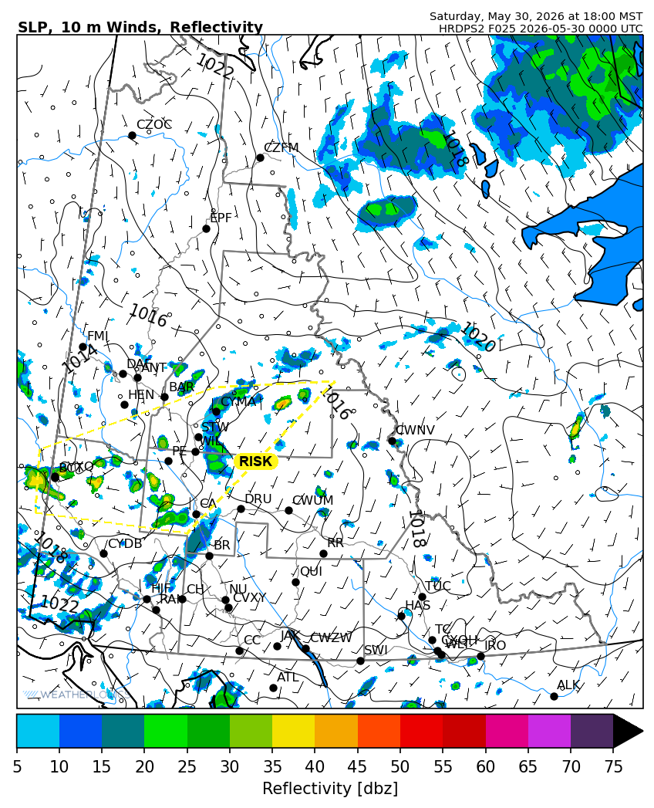
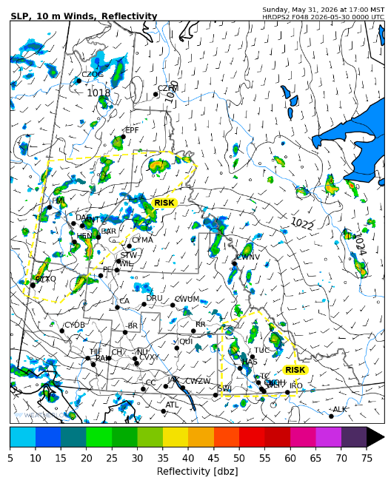

Forecast for | Sunday | (Peak burning period and overnight)
Community | Clouds | Pcpn | POP | POL | Max Temp | Min RH | Min Temp | Max  RH | Wind Dir | Wind Speed
Old Crow | BKN | RW- | 20 | NIL | 10 | 35 | 2 | 80 | 220 | 15
Klondike Fc | SCT | RW- TRW- | 80 | RISK | 10 | 50 | 5 | 85 | 180 | 5
Mayo A | BKN | RW- SW- | 60 | NIL | 10 | 55 | 8 | 90 | 200 | 10
Carmacks | SCT | RW- SW- | 60 | NIL | 12 | 40 | 2 | 80 | 200 | 15
Faro | SCT |  | 0 | NIL | 12 | 25 | 0 | 70 | 220 | 15
Ross River | SCT |  | 15 | NIL | 12 | 25 | -2 | 65 | 220 | 15
Beaver Creek Town | SCT | RW- TRW- | 60 | RISK | 10 | 50 | -1 | 80 | 270 | 5
Burwash A | SCT | SN- | 30 | NIL | 9 | 45 | -3 | 80 | 160 | 15
Haines Junction | SCT |  | 0 | NIL | 13 | 30 | -2 | 90 | 200 | 15
Whitehorse Auto | SCT |  | 15 | NIL | 12 | 25 | 1 | 75 | 220 | 15
Teslin | FEW |  | 15 | NIL | 12 | 30 | 1 | 70 | 220 | 15
Watson Lake | FEW | TRW- | 20 | RISK | 14 | 25 | 3 | 60 | 250 | 15

Forecast for |  |  | Monday |  |  | (Peak burning period and overnight)
Community |  |  | Clouds |  |  | Pcpn | POP |  | POL |  | Max Temp |  | Min RH | Min Temp | Max  RH | Wind Dir | Wind Speed
Old Crow |  |  | BKN |  |  |  | 15 |  | NIL |  | 15 |  | 35 | 5 | 90 | 220 | 15
Klondike Fc |  |  | SCT |  |  |  | 15 |  | NIL |  | 16 |  | 35 | 7 | 70 | 200 | 5
Mayo A |  |  | FEW |  |  |  | 15 |  | NIL |  | 16 |  | 20 | 8 | 70 | 220 | 5
Carmacks |  |  | CLR |  |  |  | 0 |  | NIL |  | 18 |  | 25 | 5 | 60 | 160 | 10
Faro |  |  | CLR |  |  |  | 0 |  | NIL |  | 15 |  | 25 | 4 | 60 | 250 | 10
Ross River |  |  | CLR |  |  |  | 0 |  | NIL |  | 18 |  | 20 | 1 | 60 | 240 | 10
Beaver Creek Town |  |  | CLR |  |  |  | 0 |  | NIL |  | 17 |  | 20 | 1 | 70 | 110 | 10
Burwash A |  |  | CLR |  |  |  | 0 |  | NIL |  | 10 |  | 35 | 1 | 75 | 140 | 10
Haines Junction |  |  | CLR |  |  |  | 0 |  | NIL |  | 14 |  | 20 | 3 | 70 | 200 | 10
Whitehorse Auto |  |  | CLR |  |  |  | 0 |  | NIL |  | 17 |  | 20 | 6 | 50 | 170 | 10
Teslin |  |  | CLR |  |  |  | 0 |  | NIL |  | 16 |  | 20 | 5 | 60 | 140 | 5
Watson Lake |  |  | CLR |  |  |  | 0 |  | NIL |  | 18 |  | 20 | 6 | 50 | 270 | 5
3-Day Forecast Precipitation Totals from 13:00 Yesterday
OC | 1.0 |  | FA | 4.6 |  | JAK | 0.0
EPF | 0.3 |  | RR | 0.8 |  | TE | 0.2
ANT | 8.4 |  | BC | 14.5 |  | QUI | 0.0
DA | 10.4 |  | BCT | 10.8 |  | SWI | 0.3
FMI | 0.9 |  | BU | 9.4 |  | FL | 0.4
HEN | 9.6 |  | HJF | 0.8 |  | TUC | 0.0
BAR | 12.6 |  | RAI | 0.0 |  | HAS | 0.0
MA | 7.0 |  | CH | 0.0 |  | TC | 0.0
STW | 9.6 |  | BR | 0.0 |  | WL | 0.1
WIL | 7.3 |  | NU | 0.0 |  | PE | 9.9
XY | 0.0 |  | IRO | 0.0 |  | CA | 2.6
CC | 0.0 |  | ELK | 0.0 |  | DRU | 2.9
ATL | 0.0 |  | NA | NA |  | NA | NA
Dylan Kikuta Meteorologist

Disclaimer : The information in these forecasts is collected and prepared for internal use by the Government of Yukon. The forecasts are specifically designed to meet the needs of the Wildland Fire Management and may not cover the requirements of other parties. Weather warnings or advisories are not included as part of the forecasts. Wildland Fire Management makes no representation and provides no warranty as to the accuracy of its weather forecasts. Any use the recipient chooses to make of the forecasts will be at its sole risk.

