YUKON WILDLAND FIRE MANAGEMENT WEATHER FORECAST - 9:00 AM ISSUE

31-May-2026
YESTERDAY'S VALUES
Community | Max  Temp  (°C) | Diff.  from  Normal | Min Temp  (°C) | Diff. from Normal | Pcpn  (mm) | Min RH | Max RH | L110 | L30
Old Crow | 4.6 | -9.3 | -2.2 | -4.5 | 0.0 | 54 | 90 | 0 | 0
Fort Mcpherson Airport | 1.2 |  | -0.1 |  | 0.0 | 56 | 78 | 0 | 0
Rock River Climate | 2.5M |  | -2.5M |  | 0.0M | 64M | 92M | NA | NA
Eagle Plains Fire | 6.8 |  | -0.7 |  | 0.0 | 46 | 76 | 0 | 0
Antimony Creek | 14.8 |  | 2.5 |  | 0.3 | 36 | 96 | 0 | 0
Klondike Fc | 15.8M | -2.8 | 5.7M | 2.0 | 1.6M | 29M | 96M | 0 | 0
Forty Mile | 15.7 |  | 4.8 |  | 0.5 | 24 | 93 | 0 | 0
Henderson | 10.0 |  | 2.6 |  | 0.0 | 49 | 94 | 1 | 0
Barlow | 9.2 |  | 3.1 |  | 2.4 | 72 | 96 | 0 | 0
Mayo A | 11.5 | -6.5 | 3.7 | -0.9 | 0.7 | 61 | 94 | 0 | 0
Stewart Crossing | 13.8 |  | 4.5 |  | 1.8 | 34 | 94 | 0 | 0
Willow Creek | 11.3 |  | 2.5 |  | 0.0 | 41 | 84 | 0 | 0
Pelly Farm | M |  | M |  | M | M | M | 0 | 0
Carmacks | 14.0 |  | 3.3 |  | 0.0 | 37 | 79 | 0 | 0
Drury Creek | 12.7 |  | 3.0 |  | 0.3 | 27 | 92 | 0 | 0
Faro | 11.5 | -5.2 | 3.0 | -0.9 | 0.0 | 50M | 95M | 0 | 0
Ross River | 14.9 |  | -2.9 |  | 0.0 | 17 | 79 | 0 | 0
Macmillan Pass | 6.5M |  | 0.5M |  | 0.0M | 36M | 68M | 0 | 0
Beaver Creek A | 11.7 | -4.3 | 2.6 | 0.3 | 2.7 | 55 | 95 | 34 | 21
Beaver Creek Town | 12.6 |  | 2.3 |  | 2.5 | 47 | 96 | 34 | 20
Burwash A | 7.7 | -7.2 | 1.2 | 0.2 | 2.2M | 64 | 97 | 0 | 0
Haines Junction | 9.2 | -6.9 | -2.5 | -2.7 | 0.8 | 39 | 92 | 0 | 0
Rainbow | 10.2 |  | 2.7 |  | 0.0 | 28 | 57 | 0 | 0
Champagne | 11.9 |  | 2.8 |  | 0.0 | 20 | 61 | 0 | 0
Braeburn | 12.6 |  | 0.1 |  | 0.0 | 27 | 74 | 0 | 0
Nursery | 13.9 |  | 2.9 |  | 0.0 | 21 | 65 | 0 | 0
Whitehorse Auto | 12.5 | -3.5 | 1.8 | -1.0 | 0.0 | 20 | 68 | 0 | 0
Mount Sima | 8.2M |  | -1.3M |  | 0.0M | 25M | 78M | 0 | 0
Carcross | 12.6 |  | -0.7 |  | 0.0 | 27 | 89 | 0 | 0
Atlin | 11.3 |  | 0.1 |  | 0.0 | 29 | 68 | 0 | 0
Jakes Corner | 11.1 |  | -1.1 |  | 0.0 | 27 | 71 | 0 | 0
Teslin | 11.4 |  | -2.7 |  | 0.0 | 28 | 85 | 0 | 0
Quiet Lake | 12.1 |  | 0.2 |  | 0.0 | 27 | 81 | 0 | 0
Swift River | 11.9 |  | -3.5 |  | 0.0 | 24 | 94 | 0 | 0
Tuchitua | 15.0 |  | -5.9 |  | 0.0 | 18 | 94 | 0 | 0
Hasselburg | 11.9 |  | -1.6 |  | 0.0 | 23 | 94 | 0 | 0
Tom Creek | 14.4 |  | -0.8 |  | 0.0 | 17 | 86 | 0 | 0
Watson Lake | 12.9 | -3.6 | 0.9 | -2.9 | 0.0 | 25 | 92 | 0 | 0
Iron Creek | 16.0 |  | -3.0 |  | 0.0 | 13 | 96 | 0 | 0
Max Temp is the actual maximum temperature in °C from yesterday afternoon or evening.
Min Temp is the actual overnight minimum temperature in °C up until 6:00 AM this morning.
Diff. from Normal is the difference from the 30 year average max or min temperature.
Pcpn is the precipitation in mm since 13:00 yesterday.
Min RH is the minimum observed RH in % from yesterday afternoon or evening.
Max RH is the maximum observed overnight RH in % up until 6:00 AM this morning.
L110 is the actual number of lightning strikes within 110 km and in the Yukon for 24 hours ending at 06:00 AM this morning.
L30 is the actual number of lightning strikes within 30 km and in the Yukon for 24 hours ending at 06:00 AM this morning.
M is missing data. * denotes precipitation at stations that failed to report for at least part of the evening and overnight period.

SYNOPSIS:
Today: A dry airmass dominates southern and northern Yukon with a marginal fire weather threat driven by low RH and a slight breeze, while damp and unsettled weather lingers over central Yukon. A slight southwesterly breeze at 15 km/h will prevail over much of the Territory along with temperatures around 10 degrees. The driest air will be over southern Yukon (Tatchun, Southern Lakes, and Tintina), where RH will be 25-30%. North of the Ogilvie Mountains, minimum RHs around 35% are expected. Isolated showers with the risk of lightning are possible over Tintina, but scattered showers and thundershowers are expected over northern Kluane, Northern Tutchone, and the Klondike region.

Monday: A generally dry airmass locks in over the territory and daytime highs rise into the mid-teens underneath quiet skies. A marginal fire weather threat will be driven by low relative humidity and isolated crossovers. Throughout the territory, daytime highs will climb close to 15 degrees with generally light winds. The driest air will be over the southern and central Yukon where minimum RHs of 20-25% will be common, especially Tintina and eastern Tatchun where low 20s, locally 15-20%, will be common. Northern Yukon will see minimum RHs around 35% and moderate winds. Isolated showers and thundershowers will develop in the afternoon over the Klondike region.

Tuesday: Dry and warm conditions are expected over southern and central Yukon, but a cold front with scattered showers will roll through northern Yukon. Crossovers are expected over southern and central Yukon because daytime highs will crest into the low 20s accompanied by relative humidity values of 20-25% and light southerly winds. The driest air will be located over Tatchun and Southern Lakes along the Hwy 2/ Hwy 1 corridor where minimum relative humidity will fall to 15%. North of the Ogilvie Mountains, showers along the cold front should keep RH above 35%, but if showers are more isolated then RH will fall to 30%. Winds will shift from the south at 10-15 km/h to westerly at 10-15 km/h after frontal passage.

Wednesday: A dry and warm airmass accompanied by light winds and no precipitation encompasses all of the Yukon. Over southern and central Yukon, daytime highs will be around 20 degrees and RHs of 20-30%. The driest conditions will be over Southern Lakes and Tintina where RHs of 15-25% are expected. Over northern Yukon, daytime highs will be shy of 20 degrees and minimum RHs of 25-30% are expected. An aggressive cold front will roll off the Richardson Mountains into Old Crow late evening/overnight and will drop temperatures by 15 degrees in one hour and shift the winds from westerly at 15 km/h to northerly at 25 km/h gusting 60 km/h.

Thursday: A cold front will stall near the Ogilvie Mountains and divide the weather between the north and south. In northern Yukon, damp and cool conditions are expected underneath light northerly flow. Daytime highs are expected to peak around 10 degrees and RHs remain above 50%. South of the Ogilvie Mountains, a warm and dry airmass resides with daytime highs around 20 degrees and RHs of 20-30%. Isolated showers are possible and the potential for strong gusty winds to accompany convective showers bears watching.

Forecast for | Sunday | (Peak burning period and overnight)
Community | Clouds | Pcpn | POP | POL | Max Temp | Min RH | Min Temp | Max  RH | Wind Dir | Wind Speed
Old Crow | BKN | RW- TRW- | 30 | RISK | 9 | 40 | 5 | 90 | 220 | 10
Klondike Fc | SCT | RW- TRW- | 80 | RISK | 12 | 45 | 5 | 80 | 180 | 5
Mayo A | BKN | RW- TRW- | 70 | RISK | 10 | 55 | 7 | 95 | 200 | 5
Carmacks | SCT | R- | 60 | NIL | 14 | 35 | 2 | 70 | 200 | 15
Faro | SCT |  | 15 | NIL | 12 | 30 | 0 | 70 | 220 | 15
Ross River | SCT |  | 0 | NIL | 14 | 25 | -2 | 65 | 220 | 15
Beaver Creek Town | FEW | RW- TRW- | 60 | RISK | 12 | 40 | -2 | 75 | 250 | 5
Burwash A | FEW | SW- | 60 | NIL | 5 | 40 | -2 | 80 | 160 | 15
Haines Junction | FEW |  | 15 | NIL | 10 | 30 | -2 | 90 | 220 | 15
Whitehorse Auto | SCT |  | 15 | NIL | 13 | 30 | 1 | 75 | 220 | 15
Teslin | FEW |  | 15 | NIL | 10 | 30 | 2 | 75 | 220 | 15
Watson Lake | FEW | RW- | 20 | NIL | 14 | 25 | 3 | 60 | 250 | 15
POP is probability of precipitation in %.
POL is probability of lightning in %.

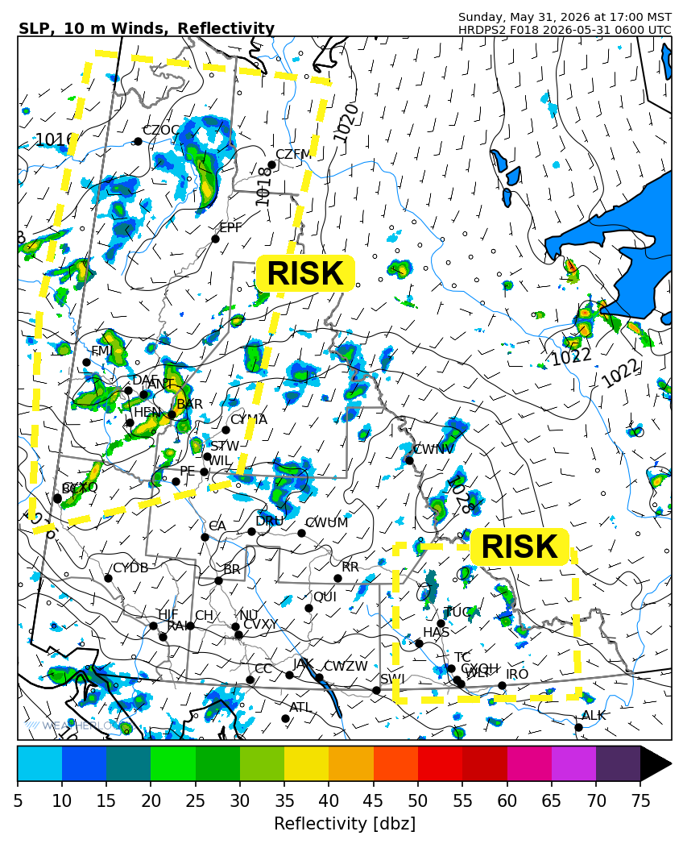
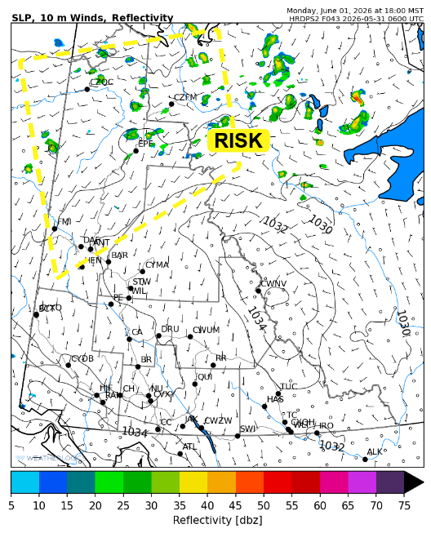

Forecast for | Monday | (Peak burning period and overnight)
Community | Clouds | Pcpn | POP | POL | Max Temp | Min RH | Min Temp | Max  RH | Wind Dir | Wind Speed
Old Crow | SCT | RW- TRW- | 20 | RISK | 16 | 30 | 5 | 80 | 220 | 20
Klondike Fc | SCT | RW- TRW- | 20 | RISK | 16 | 30 | 7 | 65 | 180 | 10
Mayo A | FEW | RW- | 20 | NIL | 18 | 25 | 8 | 70 | 200 | 5
Carmacks | FEW |  | 0 | NIL | 18 | 25 | 6 | 55 | 160 | 5
Faro | FEW |  | 0 | NIL | 15 | 25 | 4 | 60 | 130 | 10
Ross River | FEW |  | 0 | NIL | 16 | 20 | 2 | 60 | 160 | 5
Beaver Creek Town | FEW |  | 0 | NIL | 16 | 20 | 3 | 70 | 170 | 10
Burwash A | FEW |  | 0 | NIL | 10 | 40 | 2 | 75 | 140 | 10
Haines Junction | FEW |  | 0 | NIL | 15 | 30 | 3 | 80 | 200 | 10
Whitehorse Auto | FEW |  | 0 | NIL | 18 | 20 | 7 | 55 | 170 | 10
Teslin | CLR |  | 0 | NIL | 15 | 25 | 6 | 60 | 140 | 5
Watson Lake | CLR |  | 0 | NIL | 18 | 20 | 7 | 50 | 270 | 5

Forecast for |  |  | Tuesday |  |  | (Peak burning period and overnight)
Community |  |  | Clouds |  |  | Pcpn | POP |  | POL |  | Max Temp |  | Min RH | Min Temp | Max  RH | Wind Dir | Wind Speed
Old Crow |  |  | SCT |  |  | RW- | 20 |  | NIL |  | 18 |  | 35 | 8 | 70 | 300 | 15
Klondike Fc |  |  | FEW |  |  |  | 15 |  | NIL |  | 20 |  | 30 | 8 | 70 | 320 | 5
Mayo A |  |  | FEW |  |  |  | 0 |  | NIL |  | 22 |  | 20 | 10 | 70 | 270 | 5
Carmacks |  |  | FEW |  |  |  | 0 |  | NIL |  | 23 |  | 15 | 9 | 60 | 140 | 5
Faro |  |  | FEW |  |  |  | 0 |  | NIL |  | 20 |  | 15 | 7 | 60 | 300 | 10
Ross River |  |  | FEW |  |  |  | 0 |  | NIL |  | 22 |  | 15 | 5 | 60 | 200 | 10
Beaver Creek Town |  |  | FEW |  |  |  | 0 |  | NIL |  | 20 |  | 25 | 5 | 65 | 0 | 5
Burwash A |  |  | FEW |  |  |  | 0 |  | NIL |  | 15 |  | 25 | 6 | 70 | 100 | 5
Haines Junction |  |  | FEW |  |  |  | 0 |  | NIL |  | 20 |  | 15 | 7 | 70 | 250 | 5
Whitehorse Auto |  |  | CLR |  |  |  | 0 |  | NIL |  | 23 |  | 15 | 10 | 50 | 160 | 10
Teslin |  |  | CLR |  |  |  | 0 |  | NIL |  | 22 |  | 20 | 9 | 60 | 170 | 10
Watson Lake |  |  | CLR |  |  |  | 0 |  | NIL |  | 23 |  | 20 | 10 | 55 | 140 | 10
3-Day Forecast Precipitation Totals from 13:00 Yesterday
OC | 0.5 |  | FA | 0.0 |  | JAK | 0.0
EPF | 0.3 |  | RR | 0.0 |  | TE | 0.0
ANT | 4.5 |  | BC | 3.2 |  | QUI | 0.0
DA | 5.0 |  | BCT | 3.0 |  | SWI | 0.0
FMI | 2.7 |  | BU | 2.6 |  | FL | 1.2
HEN | 3.0 |  | HJF | 0.8 |  | TUC | 0.0
BAR | 9.1 |  | RAI | 0.0 |  | HAS | 0.0
MA | 3.1 |  | CH | 0.0 |  | TC | 0.0
STW | 6.3 |  | BR | 0.0 |  | WL | 0.0
WIL | 4.9 |  | NU | 0.0 |  | NA | NA
PE | 5.3 |  | XY | 0.0 |  | IRO | 0.0
CA | 1.2 |  | CC | 0.0 |  | NA | NA
DRU | 0.3 |  | ATL | 0.0 |  | NA | NA
Dylan Kikuta Meteorologist

Disclaimer : The information in these forecasts is collected and prepared for internal use by the Government of Yukon. The forecasts are specifically designed to meet the needs of the Wildland Fire Management and may not cover the requirements of other parties. Weather warnings or advisories are not included as part of the forecasts. Wildland Fire Management makes no representation and provides no warranty as to the accuracy of its weather forecasts. Any use the recipient chooses to make of the forecasts will be at its sole risk.

