YUKON WILDLAND FIRE MANAGEMENT WEATHER FORECAST - 9:00 AM ISSUE

1-Jun-2026
YESTERDAY'S VALUES
Community | Max  Temp  (°C) | Diff.  from  Normal | Min Temp  (°C) | Diff. from Normal | Pcpn  (mm) | Min RH | Max RH | L110 | L30
Old Crow | 12.7 | -1.6 | 2.4 | -0.2 | 0.4 | 53 | 99 | 0 | 0
Fort Mcpherson Airport | 15.9 |  | 7.1 |  | 0.0 | 30 | 81 | 0 | 0
Rock River Climate | 10.9 |  | 4.2 |  | 0.0 | 38 | 87 | NA | NA
Eagle Plains Fire | 13.1 |  | 6.1 |  | 0.0 | 29 | 86 | 0 | 0
Antimony Creek | 12.8 |  | 1.0 |  | 0.5 | 52 | 97 | 0 | 0
Klondike Fc | 16.0M | -2.8 | 4.0M | 0.1 | 2.0M | 39M | 95M | 0 | 0
Forty Mile | 16.7 |  | 5.8 |  | 0.3 | 25 | 91 | 0 | 0
Henderson | 12.6 |  | 3.4 |  | 0.5 | 33 | 89 | 1 | 0
Barlow | 13.0 |  | 3.5 |  | 5.5 | 49 | 95 | 0 | 0
Mayo A | 11.4 | -6.8 | 2.2 | -2.6 | 0.7 | 54 | 95 | 0 | 0
Stewart Crossing | 11.9 |  | 4.3 |  | 0.8 | 54 | 90 | 0 | 0
Willow Creek | 12.3 |  | -1.2 |  | 1.3 | 48 | 96 | 0 | 0
Pelly Farm | M |  | M |  | M | M | M | 0 | 0
Carmacks | 17.2 |  | -1.0 |  | 1.3 | 30 | 93 | 0 | 0
Drury Creek | 13.6 |  | -1.5 |  | 0.0 | 25 | 81 | 0 | 0
Faro | 12.5 | -4.4 | -2.1 | -6.2 | 0.0 | 47M | 97M | 0 | 0
Ross River | 15.5 |  | -5.3 |  | 0.0 | 18 | 84 | 0 | 0
Macmillan Pass | 4.8 |  | 1.0 |  | 0.6 | 54 | 75 | 0 | 0
Beaver Creek A | 13.3 | -2.9 | -2.4 | -4.8 | 0.6 | 36 | 92 | 34 | 21
Beaver Creek Town | 13.6 |  | -1.8 |  | 2.9 | 32 | 95 | 34 | 20
Burwash A | 11.9 | -3.2 | 1.7 | 0.5 | 0.0M | 32 | 59 | 0 | 0
Haines Junction | 15.0 | -1.0 | -4.0 | -4.7 | 0.0 | 23 | 85 | 0 | 0
Rainbow | 14.5 |  | 1.2 |  | 0.0 | 26 | 71 | 0 | 0
Champagne | 13.3 |  | -4.5 |  | 0.0 | 22 | 79 | 0 | 0
Braeburn | 16.4 |  | -3.8 |  | 0.0 | 20 | 78 | 0 | 0
Nursery | 14.7 |  | -5.7 |  | 0.0 | 21 | 81 | 0 | 0
Whitehorse Auto | 12.6 | -3.6 | 1.3 | -1.7 | 0.0 | 24 | 64 | 0 | 0
Mount Sima | 8.8 |  | -1.0 |  | 0.0 | 30 | 63 | 0 | 0
Carcross | 13.8 |  | -3.5 |  | 0.0 | 28 | 87 | 0 | 0
Atlin | 11.3M |  | -0.9M |  | 0.0M | 33M | 68M | 0 | 0
Jakes Corner | 13.1 |  | -3.2 |  | 0.0 | 22 | 76 | 0 | 0
Teslin | 12.2 |  | -3.5 |  | 0.0 | 26 | 82 | 0 | 0
Quiet Lake | 15.2 |  | -3.2 |  | 0.0 | 24 | 81 | 0 | 0
Swift River | 12.2 |  | -6.1 |  | 0.0 | 26 | 89 | 0 | 0
Tuchitua | 16.6 |  | -7.5 |  | 0.0 | 17 | 91 | 0 | 0
Hasselburg | 12.7 |  | -2.3 |  | 0.0 | 21 | 88 | 0 | 0
Tom Creek | 14.0 |  | -0.1 |  | 0.0 | 20 | 60 | 0 | 0
Watson Lake | 13.1 | -3.6 | -2.0 | -5.9 | 0.0 | 28 | 90 | 0 | 0
Iron Creek | 16.8 |  | -5.8 |  | 0.0 | 18 | 92 | 0 | 0
Max Temp is the actual maximum temperature in °C from yesterday afternoon or evening.
Min Temp is the actual overnight minimum temperature in °C up until 6:00 AM this morning.
Diff. from Normal is the difference from the 30 year average max or min temperature.
Pcpn is the precipitation in mm since 13:00 yesterday.
Min RH is the minimum observed RH in % from yesterday afternoon or evening.
Max RH is the maximum observed overnight RH in % up until 6:00 AM this morning.
L110 is the actual number of lightning strikes within 110 km and in the Yukon for 24 hours ending at 06:00 AM this morning.
L30 is the actual number of lightning strikes within 30 km and in the Yukon for 24 hours ending at 06:00 AM this morning.
M is missing data. * denotes precipitation at stations that failed to report for at least part of the evening and overnight period.

SYNOPSIS:
Today: A dry airmass looms over the territory and daytime highs rise into the mid-teens underneath quiet skies. A marginal fire weather threat will be driven by low relative humidity and isolated crossovers. Throughout the territory, daytime highs will climb close to 15 degrees with generally light winds. The driest air will be over the southern and central Yukon where minimum RHs of 20-30% will be common, especially Tintina, Tatchun, and Southern Lakes where low 20s, locally 15%, will be common. Northern Yukon will see minimum RHs around 35% and moderate winds at 15-20 km/h. Isolated showers and thundershowers will develop in the afternoon over the Klondike region and Northern Tutchone. The main hazards are rain and wind gusts up to 40km/h.

Tuesday: Dry and warm conditions are expected over southern and central Yukon, but a cold front and showers will roll through northern Yukon. A marginal fire weather threat with crossovers will emerge over southern and central Yukon driven by daytime highs in the low 20s accompanied by relative humidity values of 15-25%. The driest air will center over Tatchun/Southern Lakes between Carmacks and Whitehorse, and another pocket in Tintina, where minimum relative humidity will fall to 15%. North of the Ogilvie Mountains, the development of showers and thundershowers along the cold front should keep RH above 35%, but locations that avoid the shower activity will see RH fall to 30%. Winds will shift from southerly at 10-15 km/h to westerly at 10-15 km/h after frontal passage.

Wednesday: A dry and warm airmass accompanied by light winds and no precipitation encompasses the entire Yukon during peak burning period. Over southern and central Yukon, daytime highs will be in the low 20s and RHs of 20-30%. Winds will remain below 10 km/h. The driest conditions will be over Southern Lakes, Tintina, and Tatchun where RHs of 15-20% are expected. Over northern Yukon, daytime highs will be shy of 20 degrees and minimum RHs of 25-30% are expected. The driest conditions are expected along the Porcupine River basin where westerly winds blow at 15 km/h. An aggressive cold front will roll off the Richardson Mountains into Old Crow late evening/overnight and drop temperatures by 10-15 degrees in one hour, spike moisture, and shift the winds from westerly at 15 km/h to northerly at 25 km/h gusting 60 km/h.

Thursday: A cold front will stall near the Ogilvie Mountains and divide the weather between the north and south. Over northern Yukon, damp and cool conditions are expected with a light north/northeasterly flow. Daytime highs will remain below 10 degrees and RHs remain above 50%. South of the Ogilvie Mountains, a warm and dry airmass resides with daytime highs around 20 degrees and RHs of 20-30%. Moisture accompanied by showers may build from the south and may limit the fire weather threat over Tintina, Southern Lakes, and Kluane region. If convective showers develop, the potential for gusty winds bears watching.

Friday: Generally, rain free skies are expected over central and northern Yukon, however Pacific moisture accompanied by showers may linger over the southern Yukon. The airmass will be dry and warm over central Yukon with RHs around 30% and temperatures in the mid to upper teens. The fire weather threat will be limited over northern and far southern Yukon where relative humidity values are expected to remain above 50%.

Forecast for | Monday | (Peak burning period and overnight)
Community | Clouds | Pcpn | POP | POL | Max Temp | Min RH | Min Temp | Max  RH | Wind Dir | Wind Speed
Old Crow | FEW | RW- TRW- | 20 | RISK | 15 | 35 | 6 | 75 | 250 | 15
Klondike Fc | SCT | RW- TRW- | 20 | RISK | 16 | 30 | 8 | 60 | 170 | 5
Mayo A | FEW |  | 15 | NIL | 16 | 20 | 9 | 60 | 180 | 5
Carmacks | FEW |  | 0 | NIL | 18 | 20 | 7 | 50 | 170 | 10
Faro | FEW |  | 0 | NIL | 18 | 20 | 4 | 60 | 150 | 5
Ross River | CLR |  | 0 | NIL | 17 | 15 | 2 | 60 | 200 | 5
Beaver Creek Town | SCT |  | 0 | NIL | 16 | 25 | 4 | 60 | 160 | 10
Burwash A | FEW |  | 0 | NIL | 10 | 35 | 3 | 75 | 140 | 10
Haines Junction | FEW |  | 0 | NIL | 15 | 30 | 4 | 75 | 210 | 5
Whitehorse Auto | FEW |  | 0 | NIL | 18 | 15 | 7 | 50 | 180 | 10
Teslin | CLR |  | 0 | NIL | 16 | 20 | 6 | 60 | 180 | 5
Watson Lake | CLR |  | 0 | NIL | 18 | 20 | 6 | 45 | 40 | 5
POP is probability of precipitation in %.
POL is probability of lightning in %.

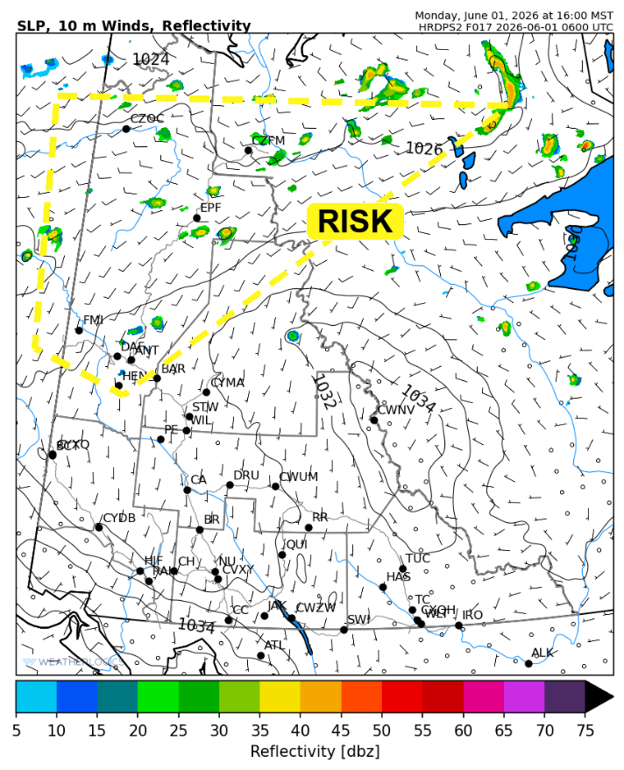
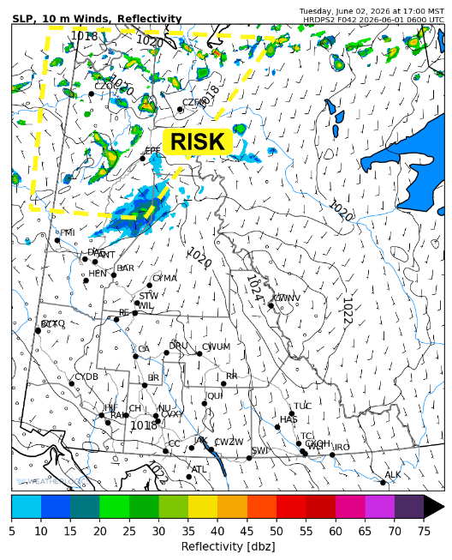

Forecast for | Tuesday | (Peak burning period and overnight)
Community | Clouds | Pcpn | POP | POL | Max Temp | Min RH | Min Temp | Max  RH | Wind Dir | Wind Speed
Old Crow | SCT | RW- TRW- | 20 | RISK | 18 | 35 | 7 | 75 | 220 | 10
Klondike Fc | SCT |  | 0 | NIL | 18 | 30 | 8 | 75 | 340 | 10
Mayo A | FEW |  | 0 | NIL | 22 | 25 | 11 | 70 | 0 | 5
Carmacks | FEW |  | 0 | NIL | 24 | 15 | 10 | 55 | 180 | 5
Faro | FEW |  | 0 | NIL | 23 | 20 | 8 | 60 | 110 | 10
Ross River | FEW |  | 0 | NIL | 22 | 15 | 5 | 65 | 160 | 5
Beaver Creek Town | FEW |  | 0 | NIL | 20 | 25 | 6 | 65 | 270 | 5
Burwash A | FEW |  | 0 | NIL | 15 | 30 | 6 | 75 | 90 | 5
Haines Junction | FEW |  | 0 | NIL | 22 | 20 | 6 | 70 | 230 | 5
Whitehorse Auto | FEW |  | 0 | NIL | 24 | 15 | 10 | 50 | 180 | 10
Teslin | FEW |  | 0 | NIL | 18 | 20 | 9 | 60 | 180 | 10
Watson Lake | CLR |  | 0 | NIL | 22 | 20 | 10 | 50 | 180 | 10

Forecast for |  |  | Wednesday |  |  | (Peak burning period and overnight)
Community |  |  | Clouds |  |  | Pcpn | POP |  | POL |  | Max Temp |  | Min RH | Min Temp | Max  RH | Wind Dir | Wind Speed
Old Crow |  |  | SCT |  |  | RW- | 20 |  | NIL |  | 20 |  | 25 | 3 | 80 | 250 | 15
Klondike Fc |  |  | FEW |  |  |  | 0 |  | NIL |  | 20 |  | 30 | 10 | 70 | 320 | 5
Mayo A |  |  | FEW |  |  |  | 0 |  | NIL |  | 20 |  | 25 | 12 | 70 | 320 | 5
Carmacks |  |  | FEW |  |  |  | 0 |  | NIL |  | 25 |  | 15 | 13 | 50 | 20 | 5
Faro |  |  | SCT |  |  |  | 0 |  | NIL |  | 21 |  | 15 | 10 | 60 | 0 | 5
Ross River |  |  | FEW |  |  |  | 0 |  | NIL |  | 23 |  | 15 | 8 | 60 | 110 | 5
Beaver Creek Town |  |  | FEW |  |  |  | 0 |  | NIL |  | 20 |  | 30 | 8 | 60 | 290 | 5
Burwash A |  |  | SCT |  |  | RW- | 20 |  | NIL |  | 29 |  | 30 | 9 | 75 | 60 | 5
Haines Junction |  |  | SCT |  |  |  | 0 |  | NIL |  | 22 |  | 15 | 9 | 70 | 200 | 10
Whitehorse Auto |  |  | SCT |  |  |  | 0 |  | NIL |  | 25 |  | 15 | 12 | 60 | 170 | 10
Teslin |  |  | SCT |  |  |  | 0 |  | NIL |  | 22 |  | 15 | 11 | 60 | 160 | 5
Watson Lake |  |  | BKN |  |  |  | 0 |  | NIL |  | 24 |  | 15 | 13 | 60 | 160 | 5
3-Day Forecast Precipitation Totals from 13:00 Yesterday
OC | 0.9 |  | FA | 0.0 |  | JAK | 0.0
EPF | 1.0 |  | RR | 0.0 |  | TE | 0.0
ANT | 1.0 |  | BC | 0.6 |  | QUI | 0.0
DA | 2.2 |  | BCT | 2.9 |  | SWI | 0.0
FMI | 0.3 |  | BU | 0.0 |  | FL | 0.0
HEN | 0.9 |  | HJF | 0.0 |  | TUC | 0.0
BAR | 5.7 |  | RAI | 0.0 |  | HAS | 0.0
MA | 0.7 |  | CH | 0.0 |  | TC | 0.0
STW | 0.8 |  | BR | 0.0 |  | WL | 0.0
WIL | 1.3 |  | NU | 0.0 |  | NA | NA
PE | 0.0 |  | XY | 0.0 |  | IRO | 0.0
CA | 1.3 |  | CC | 0.0 |  | NA | NA
DRU | 0.0 |  | ATL | 0.0 |  | NA | NA
Dylan Kikuta Meteorologist

Disclaimer : The information in these forecasts is collected and prepared for internal use by the Government of Yukon. The forecasts are specifically designed to meet the needs of the Wildland Fire Management and may not cover the requirements of other parties. Weather warnings or advisories are not included as part of the forecasts. Wildland Fire Management makes no representation and provides no warranty as to the accuracy of its weather forecasts. Any use the recipient chooses to make of the forecasts will be at its sole risk.

