YUKON WILDLAND FIRE MANAGEMENT WEATHER FORECAST - 9:00 AM ISSUE

6-Jun-2026
YESTERDAY'S VALUES
Community | Max  Temp  (°C) | Diff.  from  Normal | Min Temp  (°C) | Diff. from Normal | Pcpn  (mm) | Min RH | Max RH | L110 | L30
Old Crow | 5.2 | -10.8 | 1.1 | -2.9 | 0.0 | 57 | 72 | 0 | 0
Fort Mcpherson Airport | 3.8 |  | 0.5 |  | 0.0 | 60 | 84 | 0 | 0
Rock River Climate | -0.7 |  | -2.8 |  | 0.0 | 74 | 87 | NA | NA
Eagle Plains Fire | 6.7 |  | -3.2 |  | 0.0 | 53 | 91 | 0 | 0
Antimony Creek | 22.2 |  | 6.4 |  | 0.0 | 22 | 86 | 1 | 0
Klondike Fc | 21.9M | 2.1 | 9.4M | 4.7 | 0.0M | 25M | 83M | 1 | 0
Forty Mile | 19.9 |  | 4.5 |  | 0.0 | 30 | 84 | 0 | 0
Henderson | 17.9 |  | 6.8 |  | 0.0 | 27 | 74 | 1 | 0
Barlow | 20.7 |  | 8.9 |  | 0.0 | 21 | 72 | 1 | 0
Mayo A | 19.2 | 0.0 | 7.6 | 2.0 | 1.0 | 27 | 80 | 1 | 0
Stewart Crossing | 21.8 |  | 10.0 |  | 0.0 | 21 | 68 | 1 | 0
Willow Creek | 21.8 |  | 6.9 |  | 0.0 | 20 | 82 | 1 | 0
Pelly Farm | 24.0 | 4.5 | 8.3 | 4.0 | 0.0 | 21 | 83 | 0 | 0
Carmacks | 25.7 |  | 8.3 |  | 0.0 | 16 | 75 | 0 | 0
Drury Creek | 23.2 |  | 7.5 |  | 0.6 | 14 | 96 | 0 | 0
Faro | 20.6 | 2.7 | 9.2 | 4.2 | 0.0 | 33 | 86 | 0 | 0
Ross River | 23.4 |  | 2.6 |  | 0.0 | 15 | 80 | 0 | 0
Macmillan Pass | 12.8 |  | 2.1 |  | 0.0 | 33 | 86 | 0 | 0
Beaver Creek A | 20.7 | 3.5 | 3.2 | -0.2 | 0.0 | 22 | 77 | 0 | 0
Beaver Creek Town | 21.2 |  | 4.1 |  | 0.0 | 19 | 81 | 0 | 0
Burwash A | 20.3 | 4.3 | 2.3 | 0.2 | 1.5M | 27 | 98 | 0 | 0
Haines Junction | 24.4 | 6.8 | 2.4 | 1.3 | 0.0 | 19 | 90 | 0 | 0
Rainbow | 23.2 |  | 6.2 |  | 0.0 | 20 | 78 | 0 | 0
Champagne | 22.7 |  | 6.7 |  | 1.3 | 18 | 85 | 0 | 0
Braeburn | 24.7 |  | 8.7 |  | 0.0 | 15 | 83 | 0 | 0
Nursery | 25.9 |  | 5.6 |  | 0.0 | 14 | 78 | 0 | 0
Whitehorse Auto | 21.9 | 4.8 | 6.3 | 2.6 | 0.0 | 17 | 71 | 0 | 0
Mount Sima | 18.9 |  | 6.0 |  | 0.0 | 20 | 62 | 0 | 0
Carcross | 24.5 |  | 2.7 |  | 0.0 | 14 | 87 | 0 | 0
Atlin | 19.4 |  | 5.9 |  | 0.0 | 34 | 75 | 0 | 0
Jakes Corner | 22.8 |  | 6.3 |  | 0.0 | 14 | 68 | 0 | 0
Teslin | 19.0 |  | 4.6 |  | 0.0 | 34 | 86 | 3 | 0
Quiet Lake | 21.3 |  | 6.7 |  | 0.0 | 17 | 81 | 3 | 0
Swift River | 16.8 |  | 2.4 |  | 0.0 | 45 | 89 | 6 | 0
Tuchitua | 13.6 |  | 3.0 |  | 0.0 | 64 | 99 | 3 | 0
Hasselburg | 11.2 |  | 5.7 |  | 0.0 | 68 | 93 | 6 | 0
Tom Creek | 9.2 |  | 3.5 |  | 1.0 | 82 | 96 | 0 | 0
Watson Lake | 10.1 | -7.6 | 7.0 | 2.2 | 0.0 | 74 | 88 | 0 | 0
Iron Creek | 12.6 |  | 5.3 |  | 1.8 | 69 | 99 | 0 | 0

Max Temp is the actual maximum temperature in °C from yesterday afternoon or evening.
Min Temp is the actual overnight minimum temperature in °C up until 6:00 AM this morning.
Diff. from Normal is the difference from the 30 year average max or min temperature.
Pcpn is the precipitation in mm since 13:00 yesterday.
Min RH is the minimum observed RH in % from yesterday afternoon or evening.
Max RH is the maximum observed overnight RH in % up until 6:00 AM this morning.
L110 is the actual number of lightning strikes within 110 km and in the Yukon for 24 hours ending at 06:00 AM this morning.
L30 is the actual number of lightning strikes within 30 km and in the Yukon for 24 hours ending at 06:00 AM this morning.
M is missing data. * denotes precipitation at stations that failed to report for at least part of the evening and overnight period.

SYNOPSIS:
Today: A surface trough extending from a surface low pressure in Alaska through central Yukon, will bring showers and a scattered thundershower risk along its path, particularly across the southern Klondike, Kluane, Tatchun, and northern Tutchone regions. Southwesterly winds of 15-20 km/h, gusting to 40 km/h, are expected across the Kluane and Southern Lakes regions. Maximum temperature value of low to mid-teens for the territory with pockets of lower RH values are forecast along the Burwash-to-Whitehorse corridor and north of Dawson City toward the Old Crow corridor.
Sunday: The surface low-pressure system is expected to continue influencing the area tomorrow as it deepens west of the border near Old Crow, bringing showers and a risk of thundershowers primarily across the northern regions, particularly the Klondike, eastern Tatchun and Old Crow regions. Farther south, drier air is expected to spread into the Yukon Plateau, resulting in minimum RH values of 20-25% alongside temperatures in the mid to high teens. Winds will generally be southwesterly, with the strongest conditions expected across northern regions and localized areas where sustained winds may reach 25 km/h with gusts up to 50 km/h. Elsewhere, winds are expected to range from 10-20 km/h, gusting to 35 km/h.
Monday: The low-pressure system will remain near Old Crow, supporting another day of stronger winds across northern Yukon, with sustained speeds around 20 km/h and gusts up to 40 km/h. Showers and convective thundershowers are expected across northern and eastern Yukon, with the greatest impacts near Eagle Plains and the Dawson-Mayo corridor. Across southern Yukon, temperatures are expected to remain near seasonal values, while minimum RH values fall to 20-25% during the afternoon. Synoptic winds are generally expected to remain light.
Tuesday: The departing trough is expected to continue producing light showers, with a risk of thunderstorms across portions of the Yukon Plateau. Temperatures are forecast to reach the mid-teens to low 20s across southern Yukon. Drier air moving into the southern and northeastern regions will allow minimum RH values to fall into the 20-30% range during the afternoon.
Wednesday: The Pacific upper-level ridge is now expected to rebuild more slowly than previously anticipated, with ridging gradually returning to the region by Friday. There remains considerable uncertainty regarding the strength and extent of the ridge throughout the forecast period. In the meantime, a low-pressure system tracking through the southern half of the Yukon will bring showers and scattered thundershower activity. As a result, the region is not expected to be significantly influenced by the rebuilding ridge until later in the week.

Forecast for | Saturday | (Peak burning period and overnight)
Community | Clouds | Pcpn | POP | POL | Max Temp | Min RH | Min Temp | Max  RH | Wind Dir | Wind Speed
Old Crow | SCT |  | 20 | NIL | 14 | 40 | 5 | 80 | 40 | 10
Klondike Fc | BKN | RW-/TRW- | 70 | RISK | 20 | 30 | 9 | 85 | 260 | 5
Mayo A | BKN | RW-/TRW- | 70 | ISO | 21 | 30 | 12 | 90 | 200 | 15
Carmacks | BKN | RW-/TRW- | 70 | RISK | 20 | 35 | 9 | 85 | 180 | 10
Faro | BKN | R-/TRW- | 70 | ISO | 18 | 40 | 7 | 80 | 250 | 15G30
Ross River | BKN | R-/TRW- | 80 | ISO | 18 | 50 | 5 | 80 | 220 | 15-20
Beaver Creek Town | SCT | RW-/TRW- | 60 | RISK | 19 | 40 | 4 | 75 | 220 | 10-15
Burwash A | SCT | RW- | 40 | NIL | 18 | 30 | 5 | 75 | 140 | 15G30
Haines Junction | FEW |  | 0 | NIL | 16 | 40 | 4 | 90 | 180 | 20G40
Whitehorse Auto | SCT |  | 0 | NIL | 18 | 30 | 6 | 75 | 200 | 20G40
Teslin | SCT |  | 0 | NIL | 15 | 40 | 6 | 75 | 220 | 20G35
Watson Lake | SCT | RW- | 30 | NIL | 18 | 35 | 7 | 65 | 250 | 15G30
POP is probability of precipitation in %.
POL is probability of lightning in %.
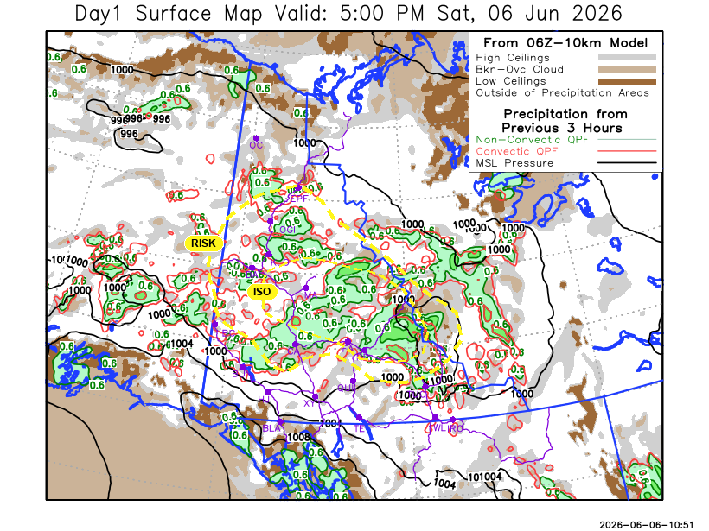
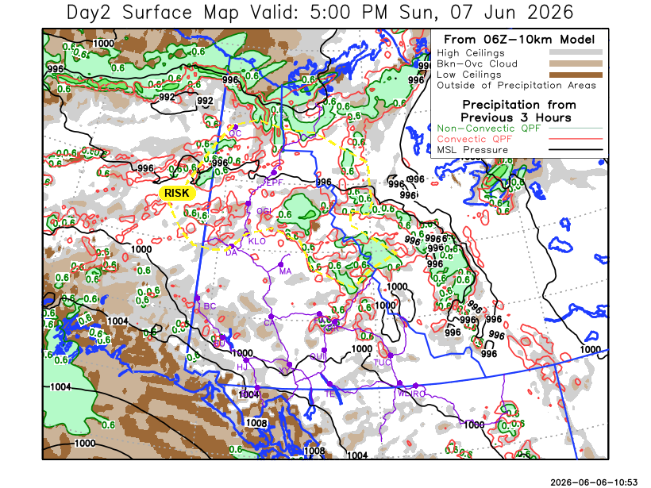

Forecast for | Sunday | (Peak burning period and overnight)
Community | Clouds | Pcpn | POP | POL | Max Temp | Min RH | Min Temp | Max  RH | Wind Dir | Wind Speed
Old Crow | BKN | R-/TRW- | 40 | RISK | 16 | 30 | 7 | 80 | 250 | 30G50
Klondike Fc | SCT | RW-/TRW- | 30 | RISK | 20 | 30 | 10 | 65 | 280 | 10-15
Mayo A | SCT | RW- | 30 | NIL | 21 | 25 | 12 | 70 | 250 | 15G30
Carmacks | SCT |  | 20 | NIL | 22 | 25 | 10 | 65 | 160 | 10
Faro | FEW |  | 0 | NIL | 19 | 25 | 7 | 70 | 270 | 15
Ross River | SCT |  | 20 | NIL | 20 | 30 | 6 | 70 | 250 | 10
Beaver Creek Town | SCT |  | 20 | NIL | 20 | 35 | 8 | 70 | 290 | 10-15
Burwash A | SCT |  | 10 | NIL | 18 | 30 | 7 | 70 | 140 | 20G35
Haines Junction | FEW |  | 0 | NIL | 19 | 35 | 4 | 90 | 200 | 15G35
Whitehorse Auto | SCT |  | 0 | NIL | 19 | 30 | 7 | 75 | 180 | 15G30
Teslin | FEW |  | 0 | NIL | 16 | 35 | 7 | 70 | 250 | 15
Watson Lake | SCT |  | 0 | NIL | 19 | 30 | 10 | 60 | 270 | 15

Forecast for |  |  | Monday |  |  | (Peak burning period and overnight)
Community |  |  | Clouds |  |  | Pcpn |  |  | POP |  | POL |  | Max Temp |  | Min RH | Min Temp |  | Max  RH | Wind Dir |  | Wind Speed
Old Crow |  |  | BKN |  |  | RW-/TRW- |  |  | 50 |  | RISK |  | 14 |  | 50 | 4 |  | 90 | 250 |  | 25G45
Klondike Fc |  |  | SCT |  |  | RW-/TRW- |  |  | 30 |  | RISK |  | 21 |  | 30 | 10 |  | 80 | 200 |  | 5-10
Mayo A |  |  | SCT |  |  | RW-/TRW- |  |  | 30 |  | RISK |  | 20 |  | 30 | 12 |  | 75 | 220 |  | 5
Carmacks |  |  | SCT |  |  |  |  |  | 0 |  | NIL |  | 24 |  | 25 | 9 |  | 60 | 160 |  | 10-15
Faro |  |  | SCT |  |  | RW- |  |  | 30 |  | NIL |  | 20 |  | 35 | 8 |  | 70 | 250 |  | 10
Ross River |  |  | SCT |  |  | RW- |  |  | 30 |  | NIL |  | 22 |  | 30 | 6 |  | 70 | 250 |  | 5-10
Beaver Creek Town |  |  | BKN |  |  | RW-/TRW |  |  | 40 |  | RISK |  | 20 |  | 40 | 6 |  | 80 | 270 |  | 10
Burwash A |  |  | BKN |  |  |  |  |  | 10 |  | NIL |  | 18 |  | 30 | 6 |  | 80 | 140 |  | 10-15
Haines Junction |  |  | FEW |  |  |  |  |  | 0 |  | NIL |  | 19 |  | 30 | 4 |  | 90 | 200 |  | 15G35
Whitehorse Auto |  |  | FEW |  |  |  |  |  | 0 |  | NIL |  | 21 |  | 25 | 8 |  | 70 | 160 |  | 15G30
Teslin |  |  | FEW |  |  |  |  |  | 0 |  | NIL |  | 18 |  | 30 | 7 |  | 70 | 220 |  | 10
Watson Lake |  |  | SCT |  |  |  |  |  | 0 |  | NIL |  | 21 |  | 30 | 11 |  | 60 | 220 |  | 5-10
3-Day Forecast Precipitation Totals from 13:00 Yesterday
OC | 1.3 |  |  | FA | 2.5 |  |  | JAK |  | 0.0
EPF | 0.9 |  |  | RR | 2.3 |  |  | TE |  | 0.0
ANT | 2.5 |  |  | BC | 2.5 |  |  | QUI |  | 0.0
DA | 2.5 |  |  | BCT | 2.5 |  |  | SWI |  | 0.0
FMI | 2.8 |  |  | BU | 3.4 |  |  | FL |  | 1.5
HEN | 1.8 |  |  | HJF | 0.0 |  |  | TUC |  | 1.2
BAR | 3.4 |  |  | RAI | 0.0 |  |  | HAS |  | 0.7
MA | 4.1 |  |  | CH | 1.3 |  |  | TC |  | 1.4
STW | 3.6 |  |  | BR | 0.0 |  |  | WL |  | 0.4
WIL | 4.6 |  |  | NU | 0.0
PE | 3.0 |  |  | XY | 0.0 |  |  | IRO |  | 1.8
CA | 3.0 |  |  | CC | 0.0
DRU | 2.0 |  |  | ATL | 0.0
Pallawi Paudel Meteorologist

Disclaimer : The information in these forecasts is collected and prepared for internal use by the Government of Yukon. The forecasts are specifically designed to meet the needs of the Wildland Fire Management and may not cover the requirements of other parties. Weather warnings or advisories are not included as part of the forecasts. Wildland Fire Management makes no representation and provides no warranty as to the accuracy of its weather forecasts. Any use the recipient chooses to make of the forecasts will be at its sole risk.

