YUKON WILDLAND FIRE MANAGEMENT WEATHER FORECAST - 9:00 AM ISSUE

7-Jun-2026
YESTERDAY'S VALUES
Community | Max  Temp  (°C) | Diff.  from  Normal | Min Temp  (°C) | Diff. from Normal | Pcpn  (mm) | Min RH | Max RH | L110 | L30
Old Crow | 12.9 | -3.5 | 3.0 | -1.3 | 0.0 | 44 | 87 | 0 | 0
Fort Mcpherson Airport | 12.8 |  | 1.9 |  | 0.0M | 47 | 87 | 0 | 0
Rock River Climate | 10.5 |  | 3.9 |  | 0.0 | 48 | 78 | NA | NA
Eagle Plains Fire | 15.3 |  | 7.2 |  | 0.3 | 34 | 76 | 11 | 1
Antimony Creek | 20.2 |  | 2.3 |  | 1.0 | 27 | 98 | 20 | 0
Klondike Fc | 22.6M | 2.6 | 2.5M | -2.3 | 1.8M | 28M | 100M | 22 | 0
Forty Mile | 19.3 |  | 3.9 |  | 0.0 | 29 | 94 | 11 | 0
Henderson | 16.4 |  | 6.8 |  | 3.9 | 36 | 85 | 27 | 4
Barlow | 18.8 |  | 6.6 |  | 0.8 | 29 | 91 | 20 | 0
Mayo A | 19.5 | 0.1 | 5.0 | -0.8 | 0.4 | 34 | 87 | 19 | 1
Stewart Crossing | 19.9 |  | 7.1 |  | 0.3 | 30 | 87 | 33 | 0
Willow Creek | 19.5 |  | 1.9 |  | 3.8 | 32 | 98 | 48 | 2
Pelly Farm | 22.3 | 2.6 | 3.6 | -0.9 | 2.7 | 30 | 98 | 53 | 4
Carmacks | 23.6 |  | 6.4 |  | 1.8 | 25 | 94 | 77 | 13
Drury Creek | 21.2 |  | 1.5 |  | 2.5 | 29 | 98 | 90 | 1
Faro | 20.1 | 2.1 | 4.7 | -0.5 | 13.0 | 49M | - | 121 | 1
Ross River | 21.7 |  | 5.2 |  | 3.7 | 27 | 98 | 80 | 0
Macmillan Pass | 12.0 |  | 1.3 |  | 4.8 | 51 | 100 | 65 | 8
Beaver Creek A | 18.1 | 0.7 | 0.3 | -3.3 | 0.4 | 34 | 95 | 13 | 7
Beaver Creek Town | 19.6 |  | 0.9 |  | 3.1 | 28 | 96 | 12 | 7
Burwash A | 18.7 | 2.5 | 6.6 | 4.3 | 0.0M | 32 | 69 | 26 | 0
Haines Junction | 17.8 | -0.8 | 1.0 | -0.8 | 0.0 | 33 | 91 | 5 | 0
Rainbow | 17.1 |  | 5.1 |  | 0.0 | 33 | 77 | 4 | 0
Champagne | 18.0 |  | 3.7 |  | 0.0 | 30 | 78 | 7 | 0
Braeburn | 23.0 |  | 2.4 |  | 0.0 | 24 | 91 | 40 | 3
Nursery | 23.1 |  | -0.3 |  | 0.0 | 24 | 92 | 7 | 0
Whitehorse Auto | 19.3 | 2.0 | 3.4 | -0.5 | 0.0 | 27 | 78 | 7 | 0
Mount Sima | 14.8 |  | 3.2 |  | 0.0 | 33 | 69 | 5 | 0
Carcross | 16.1 |  | -0.9 |  | 0.0 | 37 | 94 | 0 | 0
Atlin | 16.5 |  | 7.3 |  | 0.0 | 33 | 62 | 0 | 0
Jakes Corner | 19.2 |  | 0.4 |  | 0.0 | 27 | 81 | 0 | 0
Teslin | 18.9 |  | 0.9 |  | 0.0 | 28 | 92 | 0 | 0
Quiet Lake | 19.0 |  | 3.4 |  | 0.0 | 28 | 80 | 0 | 0
Swift River | 17.4 |  | 2.7 |  | 0.0 | 33 | 78 | 0 | 0
Tuchitua | 21.1 |  | 0.0 |  | 5.1 | 34 | 98 | 45 | 4
Hasselburg | 19.7 |  | 5.3 |  | 0.0 | 29 | 77 | 26 | 0
Tom Creek | 19.5 |  | 2.7 |  | 0.5 | 32 | 88 | 28 | 0
Watson Lake | 18.7 | 0.8 | 4.1 | -0.9 | 0.0 | 38 | 90 | 32 | 0
Iron Creek | 22.3 |  | -0.7 |  | 0.0 | 33 | 98 | 48 | 1

Max Temp is the actual maximum temperature in °C from yesterday afternoon or evening.
Min Temp is the actual overnight minimum temperature in °C up until 6:00 AM this morning.
Diff. from Normal is the difference from the 30 year average max or min temperature.
Pcpn is the precipitation in mm since 13:00 yesterday.
Min RH is the minimum observed RH in % from yesterday afternoon or evening.
Max RH is the maximum observed overnight RH in % up until 6:00 AM this morning.
L110 is the actual number of lightning strikes within 110 km and in the Yukon for 24 hours ending at 06:00 AM this morning.
L30 is the actual number of lightning strikes within 30 km and in the Yukon for 24 hours ending at 06:00 AM this morning.
M is missing data. * denotes precipitation at stations that failed to report for at least part of the evening and overnight period.

SYNOPSIS:
Today: A surface low-pressure system centred west of the northern Klondike will bring showers and a risk of thundershowers primarily across the northern half of the Yukon. Activity is expected through the Klondike and parts of Northern Tutchone, though the Dawson-Mayo corridor is less likely to see convective cells develop compared to locations further north. Farther south, drier air is expected to spread into the Yukon Plateau, resulting in minimum RH values of 20-25% and temperatures in the high teens reaching mid-20s. Winds will generally be southwesterly, with the strongest conditions across northern regions where sustained winds may reach 25 km/h with gusts up to 50 km/h. Elsewhere, winds are expected to range from 10-20 km/h, gusting to 35 km/h.
Monday: The low-pressure system will remain near Old Crow, supporting another day of stronger winds across northern Yukon, with sustained speeds around 20 km/h and gusts up to 40 km/h. Convective showers and thundershowers will see highest coverage near Eagle Plains, in the Mayo district, into the Beaver Creek district, and across Tatchun. In southern Yukon, temperatures are expected to remain near seasonal values, while minimum RH values fall to 20-25% during the afternoon. Elsewhere, synoptic winds are generally expected to remain light.
Tuesday: A weakening upper-level trough is expected to continue producing light showers, along with a risk of thundershowers from the Northern Tutchone and southern Klondike regions, south/eastward toward the Tintina area. Temperatures are forecast to reach the high teens to mid-20s across southern Yukon. Drier pockets of air expected into southern and northeastern Yukon allowing minimum RH values to fall into the 20-30% range during the afternoon.
Wednesday: A low-pressure system tracking through the southern half of Yukon will bring showers and scattered thundershower activity, while the northern half of the Territory sees quieter/drier conditions. Temperatures are expected to reach the high teens to mid-20s, with minimum RH values of 20-30% outside of precipitation and convective areas. Winds will generally be light to moderate outside of stronger gusts near thundershowers.
Thursday: Shower activity is expected to continue across southeastern portions of the territory, with embedded thundershowers possible. Unsettled conditions are expected to persist through much of Thursday as upper-level ridging remains weak and displaced to the west.

Forecast for | Sunday | (Peak burning period and overnight)
Community | Clouds | Pcpn | POP | POL | Max Temp | Min RH | Min Temp | Max  RH | Wind Dir | Wind Speed
Old Crow | SCT | RW-/TRW- | 30 | RISK | 18 | 35 | 9 | 70 | 250 | 25G45
Klondike Fc | SCT | RW-/TRW- | 30 | RISK | 21 | 30 | 10 | 65 | 270 | 15
Mayo A | SCT | RW- | 50 | NIL | 22 | 25 | 13 | 65 | 220 | 15G30
Carmacks | SCT |  | 20 | NIL | 24 | 25 | 9 | 65 | 140 | 15
Faro | SCT | RW- | 30 | NIL | 20 | 25 | 7 | 70 | 250 | 10
Ross River | SCT | RW- | 70 | NIL | 21 | 30 | 6 | 70 | 220 | 5-10
Beaver Creek Town | BKN |  | 10 | NIL | 21 | 25 | 7 | 80 | 250 | 15G25
Burwash A | SCT |  | 20 | NIL | 19 | 25 | 5 | 80 | 140 | 20G40
Haines Junction | FEW |  | 0 | NIL | 20 | 30 | 4 | 90 | 180 | 15G35
Whitehorse Auto | FEW |  | 0 | NIL | 20 | 25 | 7 | 75 | 180 | 20G30
Teslin | SCT |  | 0 | NIL | 17 | 35 | 7 | 70 | 250 | 15
Watson Lake | SCT |  | 0 | NIL | 19 | 25 | 9 | 60 | 250 | 15G30
POP is probability of precipitation in %.
POL is probability of lightning in %.
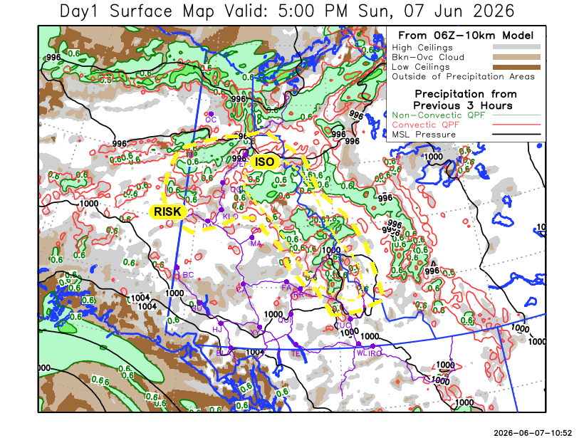
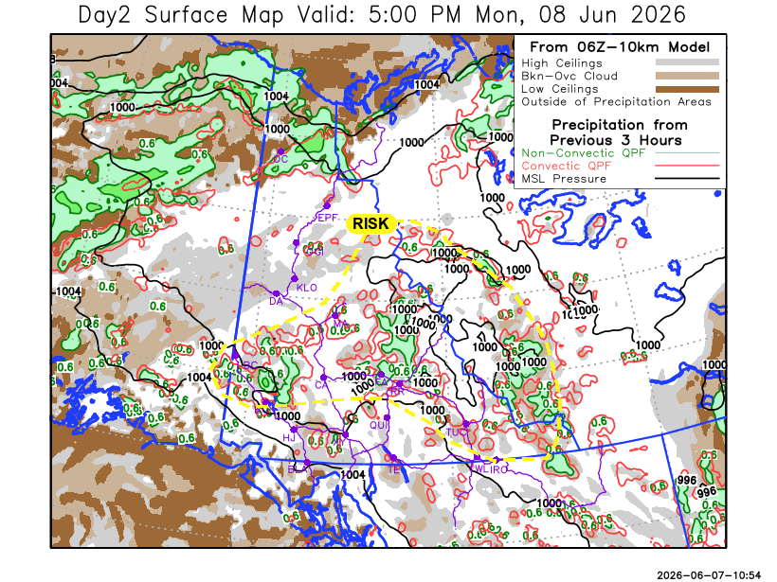

Forecast for | Monday | (Peak burning period and overnight)
Community | Clouds | Pcpn | POP | POL | Max Temp | Min RH | Min Temp | Max  RH | Wind Dir | Wind Speed
Old Crow | BKN | RW- | 60 | NIL | 15 | 45 | 2 | 85 | 330 | 20G35
Klondike Fc | BKN | RW-/TRW- | 30 | RISK | 22 | 25 | 11 | 80 | 290 | 5
Mayo A | SCT | RW-/TRW- | 40 | RISK | 23 | 25 | 14 | 65 | 200 | 5
Carmacks | FEW |  | 20 | NIL | 24 | 20 | 10 | 60 | 160 | 10-15
Faro | SCT | RW-/TRW- | 50 | RISK | 21 | 25 | 8 | 75 | 270 | 5
Ross River | SCT | RW-/TRW- | 50 | RISK | 23 | 30 | 7 | 75 | 240 | 5-10
Beaver Creek Town | BKN | RW-/TRW- | 70 | RISK | 20 | 30 | 7 | 80 | 270 | 10-15
Burwash A | SCT | RW-/TRW- | 30 | RISK | 18 | 25 | 6 | 75 | 140 | 15G30
Haines Junction | FEW |  | 0 | NIL | 20 | 30 | 4 | 90 | 200 | 15G35
Whitehorse Auto | FEW |  | 0 | NIL | 20 | 25 | 8 | 70 | 160 | 15G30
Teslin | SCT |  | 0 | NIL | 19 | 30 | 8 | 65 | 250 | 15
Watson Lake | SCT |  | 0 | NIL | 21 | 25 | 10 | 60 | 270 | 5

Forecast for |  |  | Tuesday |  | (Peak burning period and overnight)
Community |  |  | Clouds |  | Pcpn |  |  | POP |  | POL |  | Max Temp |  | Min RH | Min Temp | Max  RH | Wind Dir | Wind Speed
Old Crow |  |  | SCT |  | RW-/SW- |  |  | 30 |  | NIL |  | 12 |  | 40 | 2 | 80 | 20 | 15
Klondike Fc |  |  | SCT |  | RW- |  |  | 40 |  | NIL |  | 18 |  | 30 | 8 | 85 | 340 | 15G35
Mayo A |  |  | SCT |  | RW-/TRW- |  |  | 40 |  | RISK |  | 20 |  | 30 | 11 | 85 | 340 | 10
Carmacks |  |  | SCT |  | RW-/TRW- |  |  | 50 |  | RISK |  | 24 |  | 25 | 10 | 80 | 310 | 15
Faro |  |  | BKN |  | RW-/TRW- |  |  | 30 |  | RISK |  | 21 |  | 25 | 9 | 75 | 270 | 5-10
Ross River |  |  | BKN |  | RW-/TRW- |  |  | 30 |  | RISK |  | 24 |  | 30 | 7 | 70 | 270 | 5-10
Beaver Creek Town |  |  | OVC |  | RW- |  |  | 60 |  | NIL |  | 16 |  | 40 | 5 | 85 | 290 | 15-20
Burwash A |  |  | BKN |  | RW- |  |  | 40 |  | NIL |  | 16 |  | 30 | 7 | 90 | 320 | 15-20
Haines Junction |  |  | FEW |  |  |  |  | 0 |  | NIL |  | 21 |  | 25 | 5 | 90 | 200 | 15G35
Whitehorse Auto |  |  | BKN |  |  |  |  | 0 |  | NIL |  | 20 |  | 25 | 9 | 70 | 250 | 15
Teslin |  |  | BKN |  |  |  |  | 0 |  | NIL |  | 21 |  | 30 | 8 | 70 | 250 | 10-15
Watson Lake |  |  | BKN |  | RW-/TRW- |  |  | 30 |  | RISK |  | 22 |  | 25 | 11 | 65 | 270 | 5
3-Day Forecast Precipitation Totals from 13:00 Yesterday
OC | 4.7 |  | FA | 4.9 |  |  | JAK | 0.0
EPF | 6.2 |  | RR | 4.9 |  |  | TE | 0.0
ANT | 3.9 |  | BC | 7.1 |  |  | QUI | 0.0
DA | 4.8 |  | BCT | 9.8 |  |  | SWI | 0.0
FMI | 2.9 |  | BU | 0.8 |  |  | FL | 0.7
HEN | 7.1 |  | HJF | 0.0 |  |  | TUC | 5.7
BAR | 3.6 |  | RAI | 0.0 |  |  | HAS | 0.0
MA | 1.8 |  | CH | 0.0 |  |  | TC | 0.5
STW | 1.4 |  | BR | 0.0 |  |  | WL | 0.0
WIL | 5.0 |  | NU | 0.0
PE | 4.5 |  | XY | 0.0 |  |  | IRO | 0.0
CA | 1.8 |  | CC | 0.0
DRU | 2.8 |  | ATL | 0.0
Pallawi Paudel Meteorologist

Disclaimer : The information in these forecasts is collected and prepared for internal use by the Government of Yukon. The forecasts are specifically designed to meet the needs of the Wildland Fire Management and may not cover the requirements of other parties. Weather warnings or advisories are not included as part of the forecasts. Wildland Fire Management makes no representation and provides no warranty as to the accuracy of its weather forecasts. Any use the recipient chooses to make of the forecasts will be at its sole risk.

