YUKON WILDLAND FIRE MANAGEMENT WEATHER FORECAST - 9:00 AM ISSUE

8-Jun-2026
YESTERDAY'S VALUES
Community | Max  Temp  (°C) | Diff.  from  Normal | Min Temp  (°C) | Diff. from Normal | Pcpn  (mm) | Min RH | Max RH | L110 | L30
Old Crow | 17.3 | 0.6 | 1.8 | -2.8 | 0.4 | 27 | 82 | 6 | 0
Fort Mcpherson Airport | 22.7 |  | 3.1 |  | 0.0 | 24 | 91 | 6 | 0
Rock River Climate | 16.7 |  | 5.6 |  | 0.4 | 30 | 75 | NA | NA
Eagle Plains Fire | 17.1 |  | 9.7 |  | 1.4 | 29 | 62 | 6 | 2
Antimony Creek | 22.3 |  | 3.5 |  | 0.0 | 26 | 90 | 19 | 1
Klondike Fc | 21.7M | 1.6 | 4.6M | -0.4 | 0.0M | 33M | 93M | 20 | 6
Forty Mile | 21.7 |  | 4.1 |  | 0.0 | 23 | 94 | 19 | 0
Henderson | 18.5M |  | 9.0M |  | 0.0 | 26M | 64M | 11 | 0
Barlow | 20.9 |  | 8.9 |  | 0.3 | 28 | 72 | 9 | 0
Mayo A | 20.5 | 0.9 | 9.7 | 3.8 | 0.0 | 28 | 77 | 6 | 0
Stewart Crossing | 21.2 |  | 7.1 |  | 1.8 | 29 | 92 | 0 | 0
Willow Creek | 22.9 |  | 8.3 |  | 0.3 | 20 | 90 | 1 | 0
Pelly Farm | 23.2 | 3.3 | 9.7 | 5.1 | 0.0 | 26 | 90 | 0 | 0
Carmacks | 23.8 |  | 7.3 |  | 0.0 | 24 | 66 | 0 | 0
Drury Creek | 21.6 |  | 3.2 |  | 0.0 | 24 | 88 | 0 | 0
Faro | 20.7 | 2.5 | 3.8 | -1.6 | 0.0 | 40M | 93M | 1 | 0
Ross River | 21.2 |  | 2.3 |  | 0.0 | 29 | 96 | 1 | 0
Macmillan Pass | 11.1 |  | 0.8 |  | 0.0 | 51 | 91 | 2 | 0
Beaver Creek A | 19.9 | 2.4 | 5.8 | 2.0 | 0.0 | 31 | 77 | 0 | 0
Beaver Creek Town | 21.8 |  | 5.7 |  | 0.0 | 24 | 82 | 0 | 0
Burwash A | 19.1 | 2.7 | 4.4 | 1.9 | 0.0M | 29 | 76 | 0 | 0
Haines Junction | 19.2 | 1.7 | 0.3 | -1.4 | 0.0 | 30 | 89 | 0 | 0
Rainbow | 18.6 |  | 4.5 |  | 0.0 | 31 | 81 | 0 | 0
Champagne | 19.1 |  | -1.2 |  | 0.0 | 26 | 87 | 0 | 0
Braeburn | 23.4 |  | 2.1 |  | 0.0 | 20 | 80 | 0 | 0
Nursery | 21.4 |  | -0.6 |  | 0.0 | 24 | 90 | 0 | 0
Whitehorse Auto | 19.2 | 1.8 | 3.7 | -0.3 | 0.0 | 27 | 73 | 0 | 0
Mount Sima | 15.9 |  | 3.3 |  | 0.0 | 33 | 72 | 0 | 0
Carcross | 16.2 |  | 0.4 |  | 0.0 | 38 | 92 | 0 | 0
Atlin | 16.5 |  | 2.7 |  | 0.0 | 33 | 78 | 0 | 0
Jakes Corner | 18.9 |  | 0.7 |  | 0.0 | 29 | 84 | 0 | 0
Teslin | 16.8 |  | 1.5 |  | 0.0 | 33 | 90 | 0 | 0
Quiet Lake | 22.2 |  | 1.2 |  | 0.0 | 27 | 87 | 0 | 0
Swift River | 16.0 |  | -1.8 |  | 0.0 | 33 | 92 | 0 | 0
Tuchitua | 23.3 |  | 0.2 |  | 0.0 | 22 | 98 | 0 | 0
Hasselburg | 19.1 |  | 2.4 |  | 0.0 | 27 | 87 | 0 | 0
Tom Creek | 20.1 |  | 4.8 |  | 0.0 | 24 | 74 | 0 | 0
Watson Lake | 18.8 | 0.8 | 3.7 | -1.4 | 0.0 | 28 | 82 | 0 | 0
Iron Creek | 21.1 |  | -1.2 |  | 0.0 | 24 | 98 | 0 | 0

Max Temp is the actual maximum temperature in °C from yesterday afternoon or evening.
Min Temp is the actual overnight minimum temperature in °C up until 6:00 AM this morning.
Diff. from Normal is the difference from the 30 year average max or min temperature.
Pcpn is the precipitation in mm since 13:00 yesterday.
Min RH is the minimum observed RH in % from yesterday afternoon or evening.
Max RH is the maximum observed overnight RH in % up until 6:00 AM this morning.
L110 is the actual number of lightning strikes within 110 km and in the Yukon for 24 hours ending at 06:00 AM this morning.
L30 is the actual number of lightning strikes within 30 km and in the Yukon for 24 hours ending at 06:00 AM this morning.
M is missing data. * denotes precipitation at stations that failed to report for at least part of the evening and overnight period.

SYNOPSIS:
Today: A broad upper-level trough and associated low-pressure system will remain over Yukon, supporting another day of stronger winds across northern Yukon, with sustained speeds near 20 km/h and gusts up to 40 km/h. Moderate winds also possible in parts of southern Yukon, including the Haines Junction/Whitehorse areas. Convective showers and thundershowers are expected to develop across central and eastern Yukon, with the greatest confidence from Kluane into Klondike, Northern Tutchone, and Tatchun regions. Across southern Yukon and areas outside shower/thundershower activity, temperatures are expected to reach the high teens to mid-20s (warmest in the Carmacks district), with minimum RH values falling to 20-25% during the afternoon. Risk of crossover in the Carmacks district as a result.
Tuesday: The departing surface low is expected to continue producing light showers, along with a risk of thundershowers across a broad area of the southern half of the Yukon. Temperatures are forecast to reach the mid-teens to low-20s across southern Yukon. Drier pockets of air are expected across southern and northeastern Yukon, allowing minimum RH values to fall into the 25-30% range during the afternoon. Moderate north/west winds are forecast across much of Yukon, though winds may be variable in direction near any convective cells.
Wednesday: A weak trough of low pressure extending through the southern half of Yukon will bring showers and scattered thundershower activity. Temperatures are expected to reach the mid to high teens, with minimum RH values of 25-30% outside of precipitation and convective areas. Winds will generally be light to moderate outside of thunderstorms.
Thursday: Scattered shower activity is expected to redevelop across southern half of the territory, with thundershowers possible by afternoon/evening. Unsettled conditions are expected to persist through much of Thursday as upper-level ridging remains weak and generally displaced to the east.
Friday: A Pacific ridge will slowly rebuild to the west, while a weak disturbance moving in from Alaska is likely to bring isolated showers and thundershower activity across the territory. Temperatures in the upper teens to low twenties. A slight risk of crossover conditions exists across the northern half of Yukon.

Forecast for | Monday | (Peak burning period and overnight)
Community | Clouds | Pcpn | POP | POL | Max Temp | Min RH | Min Temp | Max  RH | Wind Dir | Wind Speed
Old Crow | BKN | RW- SN- | 70 | NIL | 15 | 50 | -3 | 85 | 240 | 25G45
Klondike Fc | BKN | RW-/TRW- | 50 | RISK | 23 | 25 | 11 | 80 | 290 | 10
Mayo A | BKN | RW-/TRW- | 60 | ISO | 23 | 25 | 14 | 70 | 220 | 10-15
Carmacks | SCT | RW-/TRW- | 20 | RISK | 25 | 20 | 10 | 60 | 160 | 15
Faro | BKN | RW-/TRW- | 60 | ISO | 21 | 30 | 8 | 75 | 270 | 10
Ross River | BKN | RW-/TRW- | 60 | ISO | 23 | 25 | 6 | 80 | 240 | 5-10
Beaver Creek Town | BKN | RW-/TRW- | 70 | ISO | 20 | 30 | 7 | 80 | 270 | 10-15
Burwash A | BKN | RW-/TRW- | 50 | RISK | 18 | 40 | 6 | 80 | 330 | 15G20
Haines Junction | SCT |  | 0 | NIL | 20 | 25 | 4 | 95 | 200 | 15G35
Whitehorse Auto | SCT |  | 0 | NIL | 20 | 25 | 8 | 75 | 180 | 15G30
Teslin | SCT |  | 0 | NIL | 18 | 30 | 8 | 70 | 240 | 15
Watson Lake | SCT | RW-/TRW- | 30 | RISK | 20 | 25 | 10 | 65 | 180 | 15G30
POP is probability of precipitation in %.
POL is probability of lightning in %.

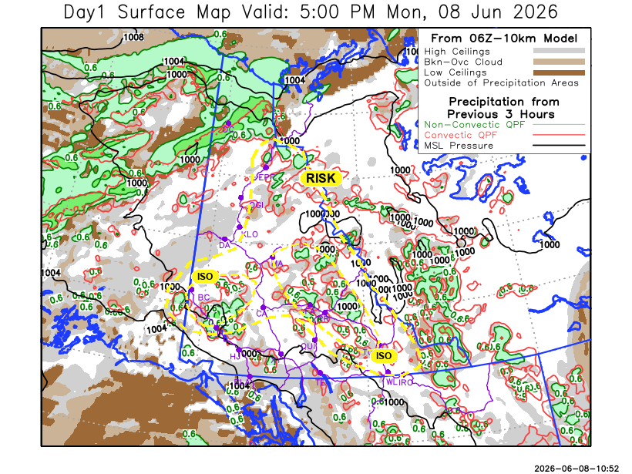
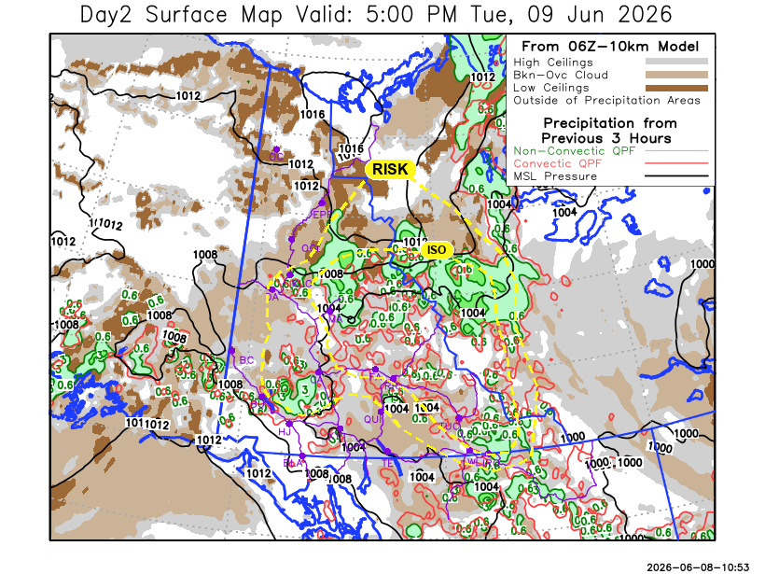
Forecast for | Tuesday | (Peak burning period and overnight)
Community | Clouds | Pcpn | POP | POL | Max Temp | Min RH | Min Temp | Max  RH | Wind Dir | Wind Speed
Old Crow | SCT | RW-/SW- | 20 | NIL | 10 | 50 | 1 | 80 | 40 | 15G25
Klondike Fc | BKN | RW-/TRW- | 50 | RISK | 18 | 40 | 8 | 75 | 340 | 15G30
Mayo A | BKN | RW-/TRW- | 70 | ISO | 20 | 35 | 11 | 75 | 0 | 15G25
Carmacks | BKN | RW-/TRW- | 60 | RISK | 23 | 30 | 9 | 80 | 320 | 15G20
Faro | BKN | RW-/TRW- | 80 | ISO | 21 | 30 | 9 | 85 | 290 | 10-15
Ross River | BKN | RW-/TRW- | 60 | ISO | 24 | 25 | 8 | 75 | 290 | 15
Beaver Creek Town | BKN | RW- | 70 | NIL | 17 | 35 | 6 | 80 | 290 | 15G30
Burwash A | SCT |  | 20 | NIL | 16 | 45 | 7 | 90 | 320 | 15G30
Haines Junction | SCT |  | 0 | NIL | 22 | 30 | 5 | 90 | 200 | 15G30
Whitehorse Auto | SCT | RW-/TRW- | 30 | RISK | 21 | 25 | 10 | 70 | 270 | 15
Teslin | SCT |  | 0 | NIL | 21 | 25 | 9 | 70 | 220 | 15
Watson Lake | BKN | RW-/TRW- | 40 | ISO | 21 | 30 | 12 | 75 | 270 | 10

Forecast for |  |  | Wednesday |  | (Peak burning period and overnight)
Community |  |  | Clouds |  | Pcpn |  |  | POP |  | POL |  | Max Temp |  | Min RH | Min Temp | Max  RH | Wind Dir | Wind Speed
Old Crow |  |  | SCT |  |  |  |  | 0 |  | NIL |  | 17 |  | 30 | 6 | 70 | 30 | 15
Klondike Fc |  |  | BKN |  | RW-/TRW- |  |  | 30 |  | RISK |  | 20 |  | 30 | 9 | 75 | 320 | 10-15
Mayo A |  |  | BKN |  | RW-/TRW- |  |  | 50 |  | RISK |  | 19 |  | 35 | 11 | 80 | 0 | 5-10
Carmacks |  |  | BKN |  | RW-/TRW- |  |  | 60 |  | RISK |  | 23 |  | 40 | 10 | 90 | 320 | 5-10
Faro |  |  | BKN |  | RW-/TRW- |  |  | 60 |  | RISK |  | 19 |  | 50 | 8 | 90 | 290 | 15
Ross River |  |  | BKN |  | RW-/TRW- |  |  | 60 |  | RISK |  | 20 |  | 55 | 6 | 90 | 290 | 15
Beaver Creek Town |  |  | BKN |  | RW- |  |  | 40 |  | NIL |  | 18 |  | 50 | 5 | 80 | 320 | 15G25
Burwash A |  |  | BKN |  | RW-/TRW- |  |  | 80 |  | RISK |  | 17 |  | 55 | 7 | 90 | 320 | 15G30
Haines Junction |  |  | FEW |  |  |  |  | 20 |  | NIL |  | 20 |  | 35 | 6 | 90 | 200 | 15G30
Whitehorse Auto |  |  | BKN |  | RW-/TRW- |  |  | 30 |  | RISK |  | 21 |  | 30 | 9 | 80 | 250 | 15G30
Teslin |  |  | SCT |  |  |  |  | 20 |  | NIL |  | 20 |  | 30 | 8 | 80 | 250 | 15
Watson Lake |  |  | BKN |  | RW-/TRW- |  |  | 50 |  | RISK |  | 21 |  | 30 | 11 | 80 | 270 | 10-15
3-Day Forecast Precipitation Totals from 13:00 Yesterday
OC | 4.1 |  | FA | 8.5 |  |  | JAK | 0.0
EPF | 8.4 |  | RR | 4.2 |  |  | TE | 0.0
ANT | 2.9 |  | BC | 6.3 |  |  | QUI | 3.2
DA | 2.8 |  | BCT | 6.3 |  |  | SWI | 2.4
FMI | 0.7 |  | BU | 4.3 |  |  | FL | 3.7
HEN | 4.0 |  | HJF | 0.0 |  |  | TUC | 3.4
BAR | 3.9 |  | RAI | 0.0 |  |  | HAS | 0.8
MA | 3.8 |  | CH | 0.0 |  |  | TC | 0.6
STW | 6.2 |  | BR | 2.1 |  |  | WL | 0.3
WIL | 4.0 |  | NU | 0.2
PE | 6.7 |  | XY | 0.5 |  |  | IRO | 2.8
CA | 2.3 |  | CC | 0.2
DRU | 3.2 |  | ATL | 0.0

Pallawi Paudel Meteorologist

Disclaimer : The information in these forecasts is collected and prepared for internal use by the Government of Yukon. The forecasts are specifically designed to meet the needs of the Wildland Fire Management and may not cover the requirements of other parties. Weather warnings or advisories are not included as part of the forecasts. Wildland Fire Management makes no representation and provides no warranty as to the accuracy of its weather forecasts. Any use the recipient chooses to make of the forecasts will be at its sole risk.

