YUKON WILDLAND FIRE MANAGEMENT WEATHER FORECAST - 9:00 AM ISSUE

13-Jun-2026
YESTERDAY'S VALUES
Community | Max  Temp  (°C) | Diff.  from  Normal | Min Temp  (°C) | Diff. from Normal | Pcpn  (mm) | Min RH | Max RH | L110 | L30
Old Crow | 21.7 | 3.6 | 7.6 | 1.8 | 0.0 | 26 | 83 | 17 | 0
Fort Mcpherson Airport | 25.4 |  | 7.8 |  | 0.0M | 23 | 93 | 50 | 0
Rock River Climate | 19.3 |  | 8.3 |  | 0.8 | 27 | 74 | NA | NA
Eagle Plains Fire | 21.8 |  | 11.7 |  | 0.0 | 20 | 50 | 3 | 0
Antimony Creek | 22.7 |  | 5.2 |  | 2.5 | 25 | 87 | 40 | 3
Klondike Fc | 25.5M | 4.6 | 5.9M | 0.2 | 0.0M | 18M | 84M | 34 | 0
Forty Mile | 23.6 |  | 5.1 |  | 0.5 | 20 | 93 | 2 | 0
Henderson | 19.1 |  | 9.4 |  | 0.0 | 27 | 64 | 58 | 0
Barlow | 22.2 |  | 9.1 |  | 0.0 | 31 | 67 | 77 | 19
Mayo A | 19.2 | -1.3 | 5.8 | -0.9 | 0.2 | 39 | 93 | 99 | 0
Stewart Crossing | 20.8 |  | 8.1 |  | 0.0 | 33 | 87 | 101 | 4
Willow Creek | 21.9 |  | 2.6 |  | 0.3 | 29 | 96 | 109 | 2
Pelly Farm | 23.1 | 2.5 | 3.6 | -1.9 | 1.9 | 31 | 97 | 96 | 16
Carmacks | 23.6 |  | 5.2 |  | 0.3 | 23 | 88 | 39 | 0
Drury Creek | 18.9 |  | 2.1 |  | 0.8 | 40 | 94 | 21 | 0
Faro | 19.3 | 0.3 | 4.0 | -2.2 | 2.2 | 50M | 99M | 13 | 0
Ross River | 19.2 |  | 1.8 |  | 1.1 | 38 | 97 | 12 | 2
Macmillan Pass | 13.6 |  | 2.9 |  | 0.0 | 48 | 94 | 3 | 0
Beaver Creek A | 19.3 | 0.9 | 1.1 | -3.5 | 0.0M | 31 | 85 | 10 | 0
Beaver Creek Town | 22.5 |  | 1.7 |  | 0.0 | 25 | 86 | 11 | 0
Burwash A | 16.7 | -0.4 | 0.4 | -2.9 | 0.0M | 44 | 98 | 16 | 2
Haines Junction | 21.1 | 2.7 | 2.7 | 0.0 | 0.0 | 32 | 89 | 0 | 0
Rainbow | 20.2 |  | 7.2 |  | 0.0 | 29 | 71 | 0 | 0
Champagne | 20.8 |  | 1.8 |  | 0.0 | 24 | 83 | 0 | 0
Braeburn | 23.0 |  | 0.2 |  | 0.0 | 20 | 94 | 3 | 0
Nursery | 21.2 |  | 2.8 |  | 0.3 | 26 | 94 | 3 | 0
Whitehorse Auto | 19.4 | 1.2 | 7.1 | 2.4 | 0.0 | 26 | 67 | 3 | 0
Mount Sima | 17.3 |  | 5.9 |  | 0.0 | 29 | 59 | 0 | 0
Carcross | 20.5 |  | 1.9 |  | 0.0 | 26 | 91 | 0 | 0
Atlin | 19.7 |  | 3.4 |  | 0.0 | 21 | 64 | 0 | 0
Jakes Corner | 21.5 |  | 2.6 |  | 0.0 | 20 | 73 | 0 | 0
Teslin | 19.6 |  | 2.5 |  | 0.0 | 31 | 75 | 4 | 0
Quiet Lake | 20.4 |  | 3.4 |  | 0.0 | 36 | 93 | 13 | 0
Swift River | 20.4 |  | -0.1 |  | 0.0 | 29 | 93 | 8 | 0
Tuchitua | 17.6 |  | 0.7 |  | 1.7 | 56 | 99 | 24 | 0
Hasselburg | 17.4 |  | 4.1 |  | 2.3 | 48 | 97 | 14 | 1
Tom Creek | 16.4 |  | 5.8 |  | 0.0 | 48 | 96 | 18 | 0
Watson Lake | 17.8 | -1.0 | 5.6 | -0.3 | 0.4 | 48 | 100 | 14 | 0
Iron Creek | 20.2 |  | 2.1 |  | 0.0 | 39 | 99 | 70 | 0
Max Temp is the actual maximum temperature in °C from yesterday afternoon or evening.
Min Temp is the actual overnight minimum temperature in °C up until 6:00 AM this morning.
Diff. from Normal is the difference from the 30 year average max or min temperature.
Pcpn is the precipitation in mm since 13:00 yesterday.
Min RH is the minimum observed RH in % from yesterday afternoon or evening.
Max RH is the maximum observed overnight RH in % up until 6:00 AM this morning.
L110 is the actual number of lightning strikes within 110 km and in the Yukon for 24 hours ending at 06:00 AM this morning.
L30 is the actual number of lightning strikes within 30 km and in the Yukon for 24 hours ending at 06:00 AM this morning.
M is missing data. * denotes precipitation at stations that failed to report for at least part of the evening and overnight period.

SYNOPSIS:
Today: A warm and somewhat dry airmass will encompass much of territory. An upper-level cloud deck will build over the south while convective clouds will bubble over central and northern Yukon. Generally, daytime highs will be in the high teens to low 20s, and relative humidity will be within 25-30% on the Yukon Plateau and on the Porcupine River basin. Relative humidity could hit 20% and trigger crossovers within valleys, especially over northern Klondike region. Local rainfall amounts up to 10 mm are the main hazard with the showers and thundershowers that develop along the perimeters of the Mackenzie and Richardson mountains in the afternoon.

Sunday: An advancing pacific low will transport moisture over southern and central Yukon while hot and dry air dams between the Ogilvie and Richardson Mountains. Gusty southerly winds accompanied by a low-level jet will overspread the Territory, RHs generally above 40% will keep the fire weather threat low over the south but dry air over the northern Yukon will generate an elevated threat. Between the Ogilvie and Richardson Mountains, crossovers (~ 25C / 20-25%) will coincide with 20-25 km/h southeasterly winds gusting to 50 km/h. Spotty showers will occur over southern and central Yukon through the afternoon and spread north of the Ogilvie Mountains by late evening. Lightning is possible in far southeastern and far northern regions.

Monday: Winds diminish and low-level moisture continues to build across the territory as the precipitation deck advances. Minimum relative humidity over much of the territory will generally sit above 35% and daytime highs will be in the mid-teens. The driest air is expected over southern Klondike, Kluane, and Tatchun where RH has a better shot at approaching 30%. The fire weather threat will remain low because winds will be below 10 km/h. Breezy 15-20 km/h winds will persist over northern Yukon, but damp conditions will regulate the fire weather threat. Scattered showers will mill over much of the territory, and the coverage will be highest over the southeast and the north.

Tuesday: A system over the Mackenzies will bring widespread rain to southern and central Yukon throughout the day. Areas caught by the rain will see daytime highs around 10C and minimum RH values above 75%. Dry air is expected to hold its ground over the Klondike region where daytime highs should crest in the high teens and minimum relative humidity will bottom around 30%. Strong winds are not expected to accompany this system.

Wednesday: Unsettled conditions should linger over much of the territory and limit the fire weather threat. Areas caught by the rain showers will see daytime highs around 10C and high moisture, but areas in the clear will see daytime highs in the high teens and minimum relative humidity around 35%.

Forecast for | Saturday | (Peak burning period and overnight)
Community | Clouds | Pcpn | POP | POL | Max Temp | Min RH | Min Temp | Max  RH | Wind Dir | Wind Speed
Old Crow | FEW | RW- TRW- | 20 | RISK | 22 | 25 | 10 | 70 | 70 | 10
Klondike Fc | BKN | RW- TRW- | 20 | RISK | 23 | 30 | 13 | 55 | 110 | 10
Mayo A | BKN | RW- TRW- | 20 | RISK | 21 | 25 | 14 | 65 | 160 | 5
Carmacks | BKN |  | 0 | NIL | 19 | 25 | 12 | 65 | 170 | 10
Faro | BKN | RW- TRW- | 30 | RISK | 18 | 30 | 9 | 70 | 200 | 5
Ross River | BKN | RW- TRW- | 20 | RISK | 20 | 25 | 7 | 60 | 210 | 10
Beaver Creek Town | BKN |  | 0 | NIL | 19 | 25 | 8 | 65 | 160 | 10
Burwash A | BKN |  | 0 | NIL | 14 | 45 | 8 | 80 | 140 | 20
Haines Junction | BKN |  | 0 | NIL | 17 | 40 | 9 | 90 | 180 | 10
Whitehorse Auto | BKN |  | 0 | NIL | 19 | 30 | 11 | 80 | 170 | 10
Teslin | BKN |  | 0 | NIL | 17 | 30 | 11 | 75 | 200 | 10
Watson Lake | BKN |  | 0 | NIL | 21 | 25 | 12 | 60 | 250 | 10
POP is probability of precipitation in %.
POL is probability of lightning in %.

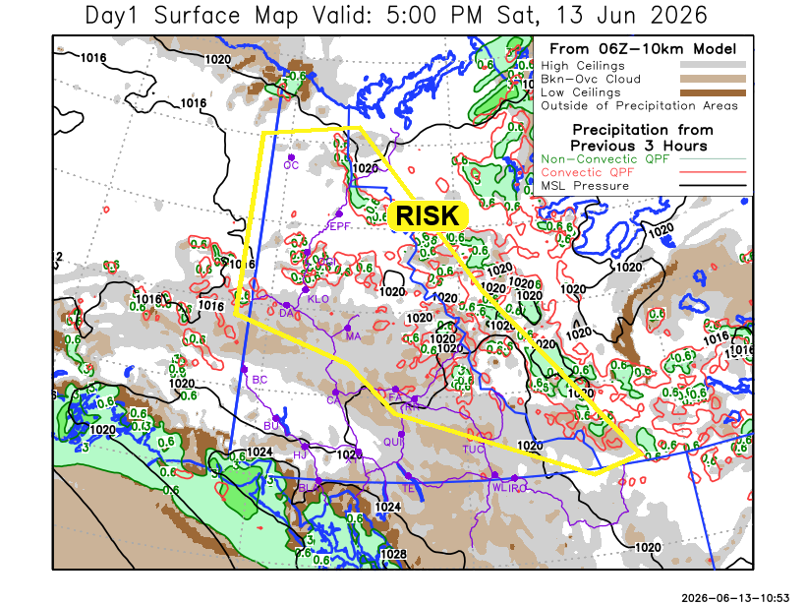
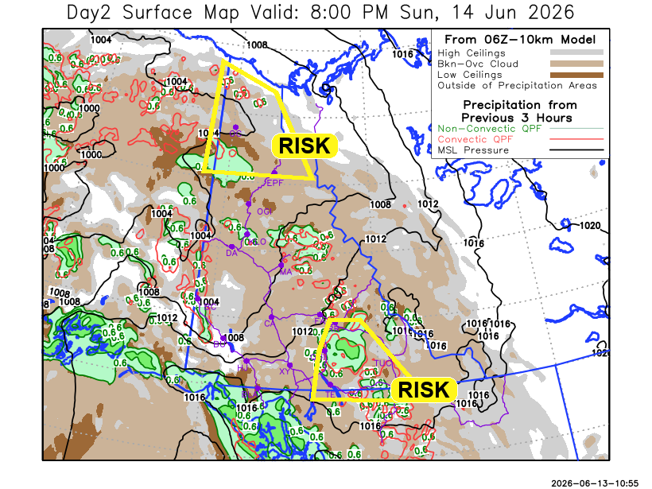

Forecast for | Sunday | (Peak burning period and overnight)
Community | Clouds | Pcpn | POP | POL | Max Temp | Min RH | Min Temp | Max  RH | Wind Dir | Wind Speed
Old Crow | BKN | RW- TRW- | 30 | RISK | 26 | 20 | 12 | 85 | 140 | 20G40
Klondike Fc | OVC | R- | 40 | NIL | 20 | 40 | 11 | 85 | 140 | 25G50
Mayo A | BKN | R- | 40 | NIL | 18 | 45 | 13 | 70 | 170 | 15
Carmacks | BKN | R- | 20 | NIL | 20 | 40 | 9 | 75 | 180 | 20G60
Faro | BKN | R- | 60 | NIL | 19 | 55 | 9 | 80 | 150 | 15
Ross River | BKN | RW- TRW- | 70 | RISK | 18 | 55 | 8 | 80 | 140 | 10
Beaver Creek Town | BKN | R- | 60 | NIL | 22 | 35 | 5 | 70 | 180 | 10
Burwash A | BKN | R- | 50 | NIL | 12 | 45 | 5 | 80 | 160 | 35G60
Haines Junction | BKN | R- | 60 | NIL | 14 | 55 | 6 | 90 | 180 | 15
Whitehorse Auto | BKN | R- | 40 | NIL | 16 | 45 | 9 | 80 | 180 | 20G50
Teslin | BKN | RW- TRW- | 60 | RISK | 18 | 50 | 10 | 85 | 200 | 15
Watson Lake | OVC | RW- TRW- | 70 | RISK | 18 | 50 | 12 | 90 | 140 | 15

Forecast for |  |  | Monday |  |  | (Peak burning period and overnight)
Community |  |  | Clouds |  |  | Pcpn | POP |  | POL |  | Max Temp |  | Min RH | Min Temp | Max  RH | Wind Dir | Wind Speed
Old Crow |  |  | SCT |  |  | R- | 30 |  | NIL |  | 15 |  | 45 | 8 | 80 | 250 | 20G40
Klondike Fc |  |  | BKN |  |  | R- | 40 |  | NIL |  | 16 |  | 45 | 9 | 75 | 250 | 10
Mayo A |  |  | BKN |  |  | RW- | 40 |  | NIL |  | 14 |  | 50 | 8 | 80 | 270 | 10
Carmacks |  |  | BKN |  |  |  | 15 |  | NIL |  | 18 |  | 35 | 9 | 80 | 180 | 5
Faro |  |  | BKN |  |  | RW- | 40 |  | NIL |  | 16 |  | 40 | 8 | 80 | 250 | 5
Ross River |  |  | BKN |  |  | RW- | 40 |  | NIL |  | 18 |  | 35 | 6 | 80 | 270 | 5
Beaver Creek Town |  |  | BKN |  |  | R- | 60 |  | NIL |  | 17 |  | 35 | 5 | 70 | 270 | 5
Burwash A |  |  | BKN |  |  | R- | 60 |  | NIL |  | 12 |  | 45 | 6 | 90 | 40 | 5
Haines Junction |  |  | SCT |  |  |  | 15 |  | NIL |  | 16 |  | 35 | 6 | 85 | 200 | 10
Whitehorse Auto |  |  | BKN |  |  | R- | 20 |  | NIL |  | 16 |  | 35 | 9 | 75 | 180 | 5
Teslin |  |  | BKN |  |  | R- | 60 |  | NIL |  | 15 |  | 45 | 7 | 85 | 240 | 5
Watson Lake |  |  | BKN |  |  | RW- | 70 |  | NIL |  | 17 |  | 50 | 10 | 85 | 250 | 5
3-Day Forecast Precipitation Totals from 13:00 Yesterday
OC | 2.3 |  | FA | 5.8 |  | JAK | 2.9
EPF | 0.2 |  | RR | 3.7 |  | TE | 5.4
ANT | 5.1 |  | BC | 2.5 |  | QUI | 6.3
DA | 2.3 |  | BCT | 2.5 |  | SWI | 7.8
FMI | 3.3 |  | BU | 2.0 |  | FL | 10.1
HEN | 3.1 |  | HJF | 1.5 |  | TUC | 11.5
BAR | 1.7 |  | RAI | 1.8 |  | HAS | 10.9
MA | 1.3 |  | CH | 1.2 |  | TC | 7.2
STW | 0.0 |  | BR | 0.5 |  | WL | 7.5
WIL | 0.8 |  | NU | 1.7 |  | NA | NA
PE | 2.6 |  | XY | 1.5 |  | IRO | 5.0
CA | 0.6 |  | CC | 2.2 |  | NA | NA
DRU | 2.9 |  | ATL | 4.2 |  | NA | NA
Dylan Kikuta Meteorologist

Disclaimer : The information in these forecasts is collected and prepared for internal use by the Government of Yukon. The forecasts are specifically designed to meet the needs of the Wildland Fire Management and may not cover the requirements of other parties. Weather warnings or advisories are not included as part of the forecasts. Wildland Fire Management makes no representation and provides no warranty as to the accuracy of its weather forecasts. Any use the recipient chooses to make of the forecasts will be at its sole risk.

