YUKON WILDLAND FIRE MANAGEMENT WEATHER FORECAST - 9:00 AM ISSUE

15-Jun-2026
YESTERDAY'S VALUES
Community | Max  Temp  (°C) | Diff.  from  Normal | Min Temp  (°C) | Diff. from Normal | Pcpn  (mm) | Min RH | Max RH | L110 | L30
Old Crow | 27.7 | 9.2 | 11.7 | 5.5 | 0.0 | 18 | 88 | 0 | 0
Fort Mcpherson Airport | 29.0 |  | 16.4 |  | 0.0 | 20 | 67 | 0 | 0
Rock River Climate | 23.6 |  | 12.7 |  | 0.0 | 27 | 67 | - | -
Eagle Plains Fire | 25.7 |  | 13.8 |  | 0.0 | 21 | 62 | 0 | 0
Antimony Creek | 19.6 |  | 10.1 |  | 0.8 | 36 | 98 | 0 | 0
Klondike Fc | 21.1M | -0.1 | 12.8M | 6.9 | 1.3M | 34M | 97M | 0 | 0
Forty Mile | 19.2 |  | 9.6 |  | 7.2 | 38 | 98 | 0 | 0
Henderson | 16.2 |  | 7.6 |  | 0.0 | 47 | 97 | 0 | 0
Barlow | 18.4 |  | 9.2 |  | 0.3 | 39 | 91 | 0 | 0
Mayo A | 20.9 | 0.1 | 10.1 | 3.1 | 0.1 | 37 | 66 | 0 | 0
Stewart Crossing | 20.9 |  | 11.4 |  | 0.0 | 37 | 65 | 0 | 0
Willow Creek | 20.3 |  | 8.6 |  | 0.0 | 38 | 77 | 0 | 0
Pelly Farm | 21.0 | 0.1 | 10.6 | 4.8 | 0.0 | 33 | 71 | 0 | 0
Carmacks | 20.8 |  | 8.6 |  | 0.0 | 39 | 71 | 0 | 0
Drury Creek | 20.1 |  | 8.4 |  | 0.3 | 41 | 89 | 0 | 0
Faro | 18.7 | -0.6 | 10.7 | 4.2 | 0.0 | 68 | 100M | 0 | 0
Ross River | 19.5 |  | 8.7 |  | 1.0 | 39 | 97 | 0 | 0
Macmillan Pass | 18.9 |  | 6.2 |  | 1.0 | 32 | 99 | 0 | 0
Beaver Creek A | 18.9 | 0.3 | 6.2 | 1.3 | 0.0 | 39 | 93 | 0 | 0
Beaver Creek Town | 19.5 |  | 7.4 |  | 0.0 | 35 | 95 | 0 | 0
Burwash A | 16.3 | -1.1 | 6.2 | 2.6 | 0.0M | 45 | 81 | 0 | 0
Haines Junction | 19.3 | 0.8 | 8.5 | 6.0 | 0.0 | 43 | 76 | 0 | 0
Rainbow | 17.5 |  | 7.3 |  | 0.0 | 46 | 80 | 0 | 0
Champagne | 18.3 |  | 8.8 |  | 0.0 | 37 | 74 | 0 | 0
Braeburn | 19.5 |  | 1.1 |  | 0.0 | 42 | 96 | 0 | 0
Nursery | 17.6 |  | 6.9 |  | 0.0 | 47 | 83 | 0 | 0
Whitehorse Auto | 17.0 | -1.5 | 7.5 | 2.5 | 0.0 | 48 | 78 | 0 | 0
Mount Sima | 12.5 |  | 3.9 |  | 0.0 | 62 | 87 | 0 | 0
Carcross | 17.1 |  | 4.7 |  | 0.0 | 53 | 93 | 0 | 0
Atlin | 15.5 |  | 6.9 |  | 1.0 | 59 | 88 | 0 | 0
Jakes Corner | 19.0 |  | 6.8 |  | 0.0 | 46 | 81 | 0 | 0
Teslin | 18.9 |  | 6.4 |  | 3.8 | 51 | 99 | 0 | 0
Quiet Lake | 17.6 |  | 5.7 |  | 3.3 | 56 | 99 | 0 | 0
Swift River | 18.8 |  | 9.0 |  | 7.5 | 47 | 99 | 0 | 0
Tuchitua | 23.0 |  | 9.6 |  | 1.1 | 32 | 99 | 0 | 0
Hasselburg | 19.6 |  | 10.0 |  | 2.5 | 41 | 99 | 0 | 0
Tom Creek | 20.2 |  | 9.7 |  | 4.0 | 38 | 98 | 0 | 0
Watson Lake | 21.7 | 2.6 | 11.8 | 5.6 | 2.6 | 38 | 96 | 0 | 0
Iron Creek | 25.4 |  | 11.4 |  | 0.0 | 31 | 94 | 0 | 0
Max Temp is the actual maximum temperature in °C from yesterday afternoon or evening.
Min Temp is the actual overnight minimum temperature in °C up until 6:00 AM this morning.
Diff. from Normal is the difference from the 30 year average max or min temperature.
Pcpn is the precipitation in mm since 13:00 yesterday.
Min RH is the minimum observed RH in % from yesterday afternoon or evening.
Max RH is the maximum observed overnight RH in % up until 6:00 AM this morning.
L110 is the actual number of lightning strikes within 110 km and in the Yukon for 24 hours ending at 06:00 AM this morning.
L30 is the actual number of lightning strikes within 30 km and in the Yukon for 24 hours ending at 06:00 AM this morning.
M is missing data. * denotes precipitation at stations that failed to report for at least part of the evening and overnight period.

SYNOPSIS:
Today: Upper level troughing advances into the Yukon. Winds diminish (except remaining moderate in Old Crow), and low-level moisture remains elevated across the Territory. Minimum RHs over much of the Territory will sit near or above 35% and daytime highs will be in the mid-teens to low 20s. The driest air is expected over southern Klondike, Northern Tutchone, and western Tatchun, where RH will hit 30% in a few locales. Despite these drier regions, the fire weather threat remains low as winds remain near or below 10 km/h over southern and central Yukon. Scattered convective showers with slight risk of thundershowers will mill over much of the Territory, with steadier rains likely developing in Tintina tied to a surface low developing in NWT. Rainfall amounts in Tintina 5-10 mm possible.

Tuesday: A system developing over the Mackenzies will bring steady rain to eastern regions of the Yukon during the day, while scattered convective showers and thundershowers develop through the remainder of southern and central Yukon. Northern Yukon is expected to remain drier under variable cloudiness. Temperatures generally remain in the mid-teens to low twenties, with minimum RHs 35% or higher through most locations. Westerly/northwesterly winds become moderate in intensity across the Territory, with gusts of 25-30 km/h possible through most regions (except Kluane).

Wednesday: Unsettled conditions brought on by an upper-level low situated in the Gulf of Alaska, and high surface moisture, will limit the fire weather threat over much of the Territory. Highest risk of scattered showers and risk of thundershowers through southern and central Yukon, while the northern Yukon is expected to remain dry again. Temperatures remain in the teens to low twenties, with minimum RHs generally around or above 35%. Winds light to moderate west/northwesterly.

Thursday: Unsettled conditions should linger over much of the southern and central Territory, and limit the fire weather threat, as scattered convective showers and thundershowers develop. A weak upper-level ridge begins to develop in northern Yukon, which will lead to a slight warming trend in the region (highs in the low to mid-twenties) and decreasing minimum RHs in the 25-35% range.

Friday: The upper-level ridge that is expected to develop on Thursday in northern Yukon is expected to continue to expand southward, into central Yukon by Friday. In response to the ridge building into the Territory, highs climb into the mid-twenties through the Klondike and Northern Tutchone combined with overall drying conditions. Temperatures in the low twenties through southern Yukon with decreasing cloud.

Forecast for | Monday | (Peak burning period and overnight)
Community | Clouds | Pcpn | POP | POL | Max Temp | Min RH | Min Temp | Max  RH | Wind Dir | Wind Speed
Old Crow | SCT | RW-/TRW- | 40 | RISK | 19 | 45 | 11 | 73 | 250 | 20G35
Klondike Fc | BKN | RW-/TRW- | 30 | RISK | 20 | 35 | 11 | 80 | 290 | 10
Mayo A | BKN | RW-/TRW- | 30 | RISK | 20 | 40 | 14 | 84 | 250 | 10
Carmacks | BKN | RW-/TRW- | 60 | RISK | 22 | 35 | 10 | 74 | 290 | 10
Faro | BKN | RW-/TRW- | 60 | RISK | 18 | 50 | 9 | 88 | 270 | 10
Ross River | OVC | RW-/TRW- | 60 | RISK | 19 | 40 | 7 | 89 | 220 | 10
Beaver Creek Town | BKN | RW-/TRW- | 40 | RISK | 17 | 50 | 6 | 81 | 270 | 10
Burwash A | BKN | RW-/TRW- | 60 | RISK | 16 | 45 | 6 | 86 | 320 | 10
Haines Junction | BKN | RW-/TRW- | 40 | RISK | 19 | 35 | 7 | 87 | 200 | 10G20
Whitehorse Auto | BKN | RW-/TRW- | 60 | RISK | 18 | 35 | 9 | 83 | 220 | 15
Teslin | BKN | RW-/TRW- | 70 | RISK | 16 | 45 | 8 | 87 | 220 | 10
Watson Lake | BKN | R-/TRW- | 80 | RISK | 15 | 65 | 10 | 92 | 270 | 10
POP is probability of precipitation in %.
POL is probability of lightning in %.

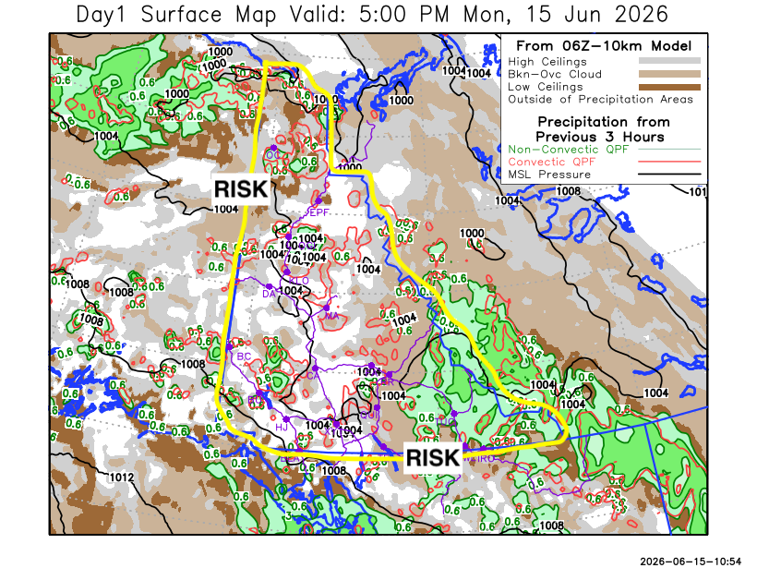
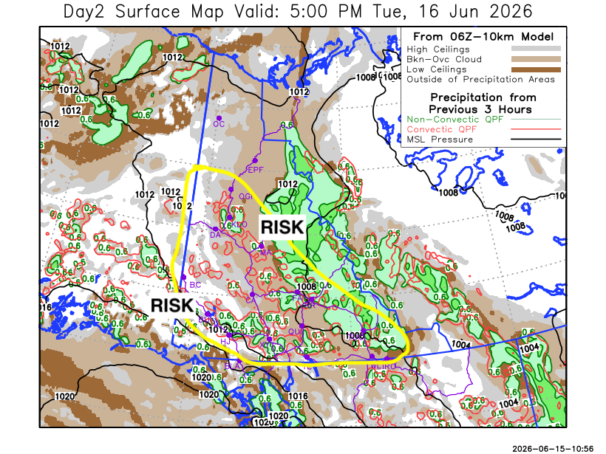

Forecast for | Tuesday | (Peak burning period and overnight)
Community | Clouds | Pcpn | POP | POL | Max Temp | Min RH | Min Temp | Max  RH | Wind Dir | Wind Speed
Old Crow | BKN |  | 10 | NIL | 19 | 40 | 9 | 74 | 250 | 15G30
Klondike Fc | BKN | RW-/TRW- | 30 | RISK | 21 | 40 | 11 | 83 | 320 | 10G20
Mayo A | OVC | RW-/TRW- | 40 | RISK | 17 | 55 | 12 | 90 | 340 | 10G20
Carmacks | BKN | RW-/TRW- | 40 | RISK | 20 | 35 | 10 | 87 | 320 | 15G30
Faro | OVC | R-/TRW- | 80 | RISK | 17 | 55 | 8 | 94 | 270 | 15G30
Ross River | OVC | R-/TRW- | 60 | RISK | 18 | 50 | 7 | 90 | 290 | 15G30
Beaver Creek Town | BKN | RW-/TRW- | 40 | RISK | 20 | 35 | 7 | 83 | 290 | 10G25
Burwash A | BKN | RW-/TRW- | 70 | RISK | 16 | 45 | 8 | 91 | 320 | 10
Haines Junction | BKN | RW-/TRW- | 40 | RISK | 18 | 40 | 6 | 87 | 200 | 10
Whitehorse Auto | BKN | RW-/TRW- | 70 | RISK | 18 | 40 | 8 | 87 | 270 | 10G25
Teslin | BKN | RW-/TRW- | 60 | RISK | 15 | 50 | 7 | 83 | 250 | 15G30
Watson Lake | OVC | R-/TRW- | 40 | RISK | 15 | 60 | 9 | 78 | 270 | 15G30

Forecast for |  |  | Wednesday |  |  | (Peak burning period and overnight)
Community |  |  | Clouds |  |  | Pcpn |  | POP |  | POL |  | Max Temp |  | Min RH | Min Temp | Max  RH | Wind Dir | Wind Speed
Old Crow |  |  | BKN |  |  |  |  | 0 |  | NIL |  | 21 |  | 40 | 12 | 69 | 270 | 10
Klondike Fc |  |  | OVC |  |  | R-/TRW- |  | 30 |  | RISK |  | 19 |  | 50 | 10 | 88 | 340 | 10G20
Mayo A |  |  | BKN |  |  | R-/TRW- |  | 30 |  | RISK |  | 18 |  | 55 | 13 | 88 | 20 | 5
Carmacks |  |  | BKN |  |  | RW-/TRW- |  | 60 |  | RISK |  | 21 |  | 40 | 10 | 84 | 160 | 10G20
Faro |  |  | BKN |  |  | RW-/TRW- |  | 40 |  | RISK |  | 18 |  | 55 | 8 | 92 | 270 | 10
Ross River |  |  | BKN |  |  | RW-/TRW- |  | 40 |  | RISK |  | 20 |  | 45 | 6 | 90 | 270 | 10
Beaver Creek Town |  |  | BKN |  |  | RW-/TRW- |  | 60 |  | RISK |  | 18 |  | 50 | 6 | 92 | 290 | 15G30
Burwash A |  |  | OVC |  |  | R-/TRW- |  | 80 |  | RISK |  | 14 |  | 60 | 7 | 94 | 220 | 10
Haines Junction |  |  | BKN |  |  | RW-/TRW- |  | 40 |  | RISK |  | 15 |  | 55 | 5 | 91 | 200 | 10G20
Whitehorse Auto |  |  | BKN |  |  | RW-/TRW- |  | 40 |  | RISK |  | 16 |  | 45 | 8 | 83 | 270 | 10
Teslin |  |  | BKN |  |  | RW-/TRW- |  | 30 |  | RISK |  | 16 |  | 45 | 7 | 81 | 250 | 10G25
Watson Lake |  |  | BKN |  |  | RW-/TRW- |  | 40 |  | RISK |  | 17 |  | 50 | 8 | 86 | 290 | 10G20
3-Day Forecast Precipitation Totals from 13:00 Yesterday
OC | 1.5 |  | FA | 14.7 |  |  | JAK | 9.6
EPF | 4.9 |  | RR | 12.7 |  |  | TE | 12.4
ANT | 6.8 |  | BC | 5.4 |  |  | QUI | 17.0
DA | 5.9 |  | BCT | 5.4 |  |  | SWI | 19.3
FMI | 8.2 |  | BU | 11.4 |  |  | FL | 19.9
HEN | 5.2 |  | HJF | 4.7 |  |  | TUC | 17.3
BAR | 10.6 |  | RAI | 5.3 |  |  | HAS | 11.7
MA | 12.5 |  | CH | 7.1 |  |  | TC | 14.8
STW | 11.8 |  | BR | 11.8 |  |  | WL | 11.3
WIL | 8.6 |  | NU | 8.9 |  |  | NA | NA
PE | 6.8 |  | XY | 8.4 |  |  | IRO | 11.5
CA | 8.9 |  | CC | 3.7 |  |  | NA | NA
DRU | 16.2 |  | ATL | 6.4 |  |  | NA | NA
Matt Desorcy Meteorologist

Disclaimer : The information in these forecasts is collected and prepared for internal use by the Government of Yukon. The forecasts are specifically designed to meet the needs of the Wildland Fire Management and may not cover the requirements of other parties. Weather warnings or advisories are not included as part of the forecasts. Wildland Fire Management makes no representation and provides no warranty as to the accuracy of its weather forecasts. Any use the recipient chooses to make of the forecasts will be at its sole risk.

