YUKON WILDLAND FIRE MANAGEMENT WEATHER FORECAST - 9:00 AM ISSUE

20-Jun-2026
YESTERDAY'S VALUES
Community | Max  Temp  (°C) | Diff.  from  Normal | Min Temp  (°C) | Diff. from Normal | Pcpn  (mm) | Min RH | Max RH | L110 | L30
Old Crow | 26.0 | 6.5 | 11.4 | 4.3 | 0.0 | 27 | 82 | 1 | 0
Fort McPherson Airport | 25.5 |  | 13.5 |  | 0.0M | 35 | 86 | 0 | 0
Rock River Climate | 19.9 |  | 12.8 |  | 0.2 | 36 | 65 | NA | NA
Eagle Plains Fire | 21.5 |  | 12.9 |  | 0.8 | 38 | 64 | 2 | 0
Antimony Creek | 25.7 |  | 7.7 |  | 0.0 | 27 | 89 | 17 | 0
Klondike Fc | 27.5M | 5.6 | 8.3M | 1.7 | 0.0M | 22M | 89M | 23 | 4
Forty Mile | 25.5 |  | 8.9 |  | 0.0 | 27 | 91 | 21 | 0
Henderson | 22.1 |  | 11.7 |  | 0.3 | 31 | 71 | 33 | 1
Barlow | 22.0 |  | 10.8 |  | 0.3 | 34 | 78 | 14 | 1
Mayo A | 22.8 | 1.4 | 9.9 | 2.3 | 0.0 | 34 | 88 | 11 | 0
Stewart Crossing | 23.7 |  | 11.2 |  | 1.3 | 29 | 91 | 12 | 0
Willow Creek | 22.6 |  | 6.3 |  | 5.9 | 39 | 98 | 18 | 2
Pelly Farm | 24.3 | 2.8 | 7.0 | 0.5 | 0.0 | 32 | 97 | 50 | 1
Carmacks | 25.6 |  | 8.5 |  | 0.0 | 33 | 94 | 53 | 1
Drury Creek | 22.7 |  | 5.0 |  | 0.5 | 32 | 95 | 47 | 0
Faro | 20.6 | 0.7 | 6.2 | -1.0 | 3.6 | 54M | 99M | 35 | 0
Ross River | 22.5 |  | 3.3 |  | 2.3 | 32 | 97 | 24 | 3
Macmillan Pass | 16.5 |  | 5.4 |  | 0.4 | 35 | 78 | 1 | 0
Beaver Creek A | 20.7 | 1.4 | 3.5 | -2.1 | 0.3M | 39 | 96 | 45 | 1
Beaver Creek Town | 22.1 |  | 3.6 |  | 0.5 | 35 | 95 | 46 | 1
Burwash A | 18.5 | 0.5 | 1.8 | -2.5 | 0.0M | 46 | 98 | 88 | 9
Haines Junction | 21.9 | 3.0 | 5.1 | 1.5 | 1.3 | 39 | 98 | 57 | 3
Rainbow | 22.0 |  | 5.6 |  | 0.0 | 37 | 98 | 57 | 0
Champagne | 22.2 |  | 1.0 |  | 1.9 | 31 | 98 | 66 | 3
Braeburn | 25.0 |  | 5.9 |  | 2.3 | 29 | 98 | 71 | 4
Nursery | 23.3 |  | 4.4 |  | 0.0 | 36 | 98 | 75 | 13
Whitehorse Auto | 21.0 | 1.9 | 7.1 | 1.5 | 0.6 | 38 | 93 | 75 | 6
Mount Sima | 20.2 |  | 8.2 |  | 0.0 | 37 | 83 | 67 | 5
Carcross | 22.8 |  | 5.5 |  | 0.0 | 35 | 94 | 27 | 0
Atlin | 21.9 |  | 7.1 |  | 0.0 | 30 | 80 | 5 | 0
Jakes Corner | 23.5 |  | 5.4 |  | 2.9 | 25 | 96 | 47 | 1
Teslin | 20.1 |  | 5.1 |  | 0.8 | 39 | 97 | 33 | 3
Quiet Lake | 21.3 |  | 3.8 |  | 4.6 | 35 | 99 | 66 | 3
Swift River | 20.1 |  | 1.9 |  | 2.3 | 32 | 97 | 43 | 1
Tuchitua | 21.5 |  | 0.7 |  | 1.8 | 36 | 98 | 95 | 11
Hasselburg | 18.2 |  | 4.3 |  | 3.1 | 46 | 98 | 104 | 1
Tom Creek | 18.4 |  | 4.9 |  | 3.9 | 38 | 99 | 77 | 8
Watson Lake | 17.1 | -2.6 | 4.7 | -2.2 | 1.0 | 49 | 99 | 47 | 5
Iron Creek | 20.4 |  | 4.2 |  | 0.9 | 37 | 99 | 24 | 8
Max Temp is the actual maximum temperature in °C from yesterday afternoon or evening.
Min Temp is the actual overnight minimum temperature in °C up until 6:00 AM this morning.
Diff. from Normal is the difference from the 30 year average max or min temperature.
Pcpn is the precipitation in mm since 13:00 yesterday.
Min RH is the minimum observed RH in % from yesterday afternoon or evening.
Max RH is the maximum observed overnight RH in % up until 6:00 AM this morning.
L110 is the actual number of lightning strikes within 110 km and in the Yukon for 24 hours ending at 06:00 AM this morning.
L30 is the actual number of lightning strikes within 30 km and in the Yukon for 24 hours ending at 06:00 AM this morning.
M is missing data. * denotes precipitation at stations that failed to report for at least part of the evening and overnight period.

SYNOPSIS:
Today: An upper ridge of high pressure is in place over the Yukon. This will lead to normal or warmer than normal temperatures again today. High temperatures will be in the low to mid-twenties across most regions with some locations in the Klondike and western Tatchun regions reaching the upper twenties. The day will start out with few clouds, but daytime heating will prompt convective showers and thunderstorms to form across most of the Territory by afternoon. These showers and storms will be spotty, but many locations will pick up light rain as they move through. Winds will remain light today, generally around 10 km/h in the afternoon, with direction being highly variable. Stronger wind gusts and sudden changes in wind direction are possible as showers/thunderstorms pass by. Crossovers are possible in the Klondike region; elsewhere crossovers are unlikely and good RH recoveries are expected overnight.

Sunday: The weather pattern will change little on Sunday as upper ridging remains in place. This will again result in normal or warmer than normal temperatures, with highs mainly ranging from the low to mid-twenties, with a few locations (mainly Klondike/western Tatchun) potentially reaching the upper twenties. Showers and thunderstorms will again develop by afternoon, affecting most of the Territory. The atmosphere may be a bit more unstable on Sunday, potentially allowing for some stronger storms in the Tatchun, Klondike, and Northern Tutchone regions. Like Saturday, winds will be light and variable in direction, but as showers and thunderstorms move through, winds will briefly gust up and the wind direction will shift. Stronger storms could produce 10 mm or more, but most locations will only see a few millimetres with passing showers/storms. Crossovers are again possible in the Klondike region; elsewhere crossovers are unlikely and good RH recoveries are expected overnight.

Monday: Still no change in the weather pattern for Monday as upper ridging remains in place. Showers and thunderstorms are likely once again, with daytime temperatures remaining normal to above normal. The main fire weather concern remains the risk of lightning. Winds look to remain light.

Tuesday: A low in the Gulf of Alaska is expected to begin approaching the coast by midweek, causing the upper ridge to weaken. It does not appear that this will result in a dramatic weather pattern change. This will most likely send temperatures into a very gradual cooling trend. Winds may also begin to increase – especially in the Kluane and Southern Lakes – as the low approaches. Daytime showers/thunderstorms remain likely.

Wednesday: The low in the Gulf of Alaska remains near the coast. At this point there is still no sign of it bringing any significant changes to the weather in the Yukon. As noted in Tuesday’s forecast, temperatures may trend down slightly back to around normal values. Wind speeds may also be slightly stronger in the southern Yukon. Daytime showers/thunderstorms remain likely.

Forecast for | Saturday | (Peak burning period and overnight)
Community | Clouds | Pcpn | POP | POL | Max Temp | Min RH | Min Temp | Max  RH | Wind Dir | Wind Speed
Old Crow | SCT | RW-/TRW- | 30 | RISK | 27 | 25 | 12 | 80 | 200 | 10
Klondike Fc | SCT | RW-/TRW- | 50 | ISO | 29 | 20 | 12 | 90 | 320 | 10
Mayo A | SCT | RW-/TRW- | 50 | ISO | 25 | 30 | 13 | 90 | 220 | 15
Carmacks | SCT | RW-/TRW- | 60 | ISO | 27 | 30 | 11 | 90 | 220 | 10
Faro | SCT | RW-/TRW- | 40 | ISO | 22 | 40 | 9 | 95 | 220 | 10
Ross River | SCT | RW-/TRW- | 40 | ISO | 24 | 30 | 8 | 95 | 270 | 10
Beaver Creek Town | SCT | RW-/TRW- | 50 | RISK | 24 | 30 | 7 | 95 | 250 | 10
Burwash A | SCT | RW-/TRW- | 40 | RISK | 20 | 45 | 6 | 95 | 110 | 15
Haines Junction | SCT | RW-/TRW- | 30 | RISK | 23 | 35 | 7 | 95 | 300 | 15
Whitehorse Auto | SCT | RW-/TRW- | 30 | ISO | 22 | 35 | 10 | 90 | 200 | 10
Teslin | SCT | RW-/TRW- | 40 | RISK | 22 | 35 | 9 | 95 | 220 | 10
Watson Lake | SCT | RW-/TRW- | 40 | RISK | 21 | 35 | 9 | 95 | 140 | 10
POP is probability of precipitation in %.
POL is probability of lightning in %.

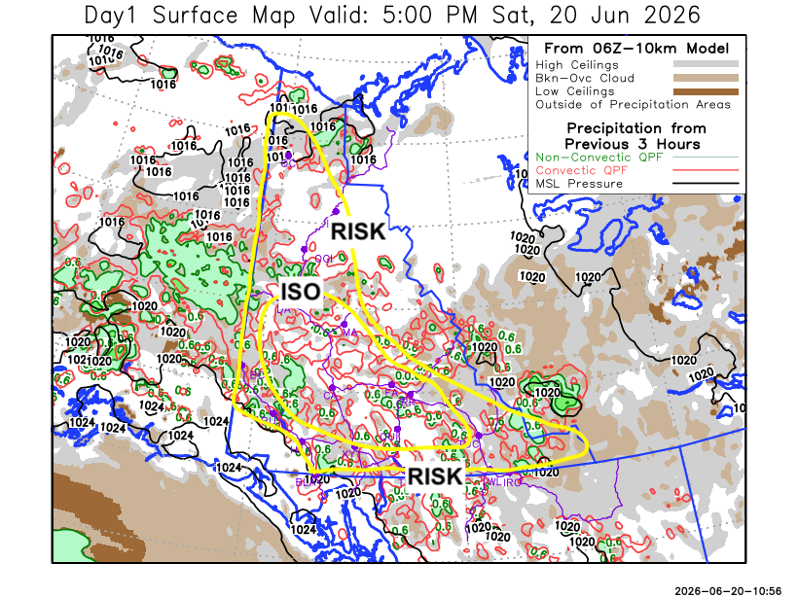
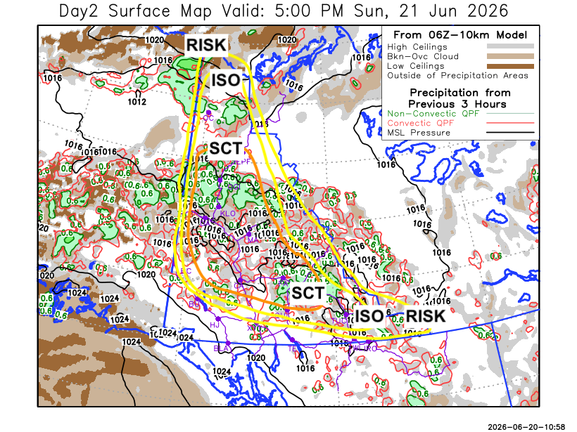

Forecast for | Sunday | (Peak burning period and overnight)
Community | Clouds | Pcpn | POP | POL | Max Temp | Min RH | Min Temp | Max  RH | Wind Dir | Wind Speed
Old Crow | SCT | RW-/TRW- | 70 | ISO | 26 | 30 | 9 | 95 | 0 | 10
Klondike Fc | BKN | RW-/TRW- | 70 | SCT | 27 | 25 | 13 | 95 | 270 | 10
Mayo A | BKN | RW-/TRW- | 60 | SCT | 25 | 25 | 15 | 95 | 220 | 10
Carmacks | SCT | RW-/TRW- | 70 | SCT | 27 | 30 | 12 | 95 | 200 | 10
Faro | SCT | RW-/TRW- | 60 | SCT | 22 | 35 | 10 | 95 | 270 | 10
Ross River | SCT | RW-/TRW- | 60 | SCT | 24 | 30 | 8 | 95 | 250 | 10
Beaver Creek Town | SCT | RW-/TRW- | 60 | ISO | 24 | 30 | 10 | 95 | 270 | 10
Burwash A | SCT | RW-/TRW- | 30 | RISK | 21 | 40 | 9 | 85 | 140 | 15
Haines Junction | FEW | RW- | 30 | NIL | 24 | 30 | 7 | 90 | 270 | 15
Whitehorse Auto | FEW | RW-/TRW- | 40 | RISK | 24 | 25 | 11 | 85 | 220 | 15
Teslin | FEW | RW- | 30 | NIL | 23 | 30 | 11 | 80 | 220 | 10
Watson Lake | SCT | RW-/TRW- | 50 | RISK | 23 | 30 | 12 | 85 | 180 | 10

Forecast for |  |  | Monday |  |  | (Peak burning period and overnight)
Community |  |  | Clouds |  |  | Pcpn |  | POP |  | POL |  | Max Temp |  | Min RH | Min Temp | Max  RH | Wind Dir | Wind Speed
Old Crow |  |  | SCT |  |  | RW-/TRW- |  | 30 |  | RISK |  | 24 |  | 30 | 10 | 95 | 20 | 15
Klondike Fc |  |  | SCT |  |  | RW-/TRW- |  | 50 |  | ISO |  | 25 |  | 30 | 11 | 95 | 200 | 10
Mayo A |  |  | SCT |  |  | RW-/TRW- |  | 50 |  | ISO |  | 25 |  | 30 | 12 | 95 | 220 | 10
Carmacks |  |  | SCT |  |  | RW-/TRW- |  | 50 |  | ISO |  | 28 |  | 25 | 10 | 95 | 180 | 15
Faro |  |  | SCT |  |  | RW-/TRW- |  | 40 |  | RISK |  | 24 |  | 30 | 9 | 85 | 220 | 10
Ross River |  |  | SCT |  |  | RW-/TRW- |  | 40 |  | RISK |  | 26 |  | 25 | 8 | 90 | 250 | 10
Beaver Creek Town |  |  | SCT |  |  | RW-/TRW- |  | 30 |  | RISK |  | 23 |  | 35 | 8 | 95 | 270 | 10
Burwash A |  |  | SCT |  |  | RW-/TRW- |  | 30 |  | RISK |  | 21 |  | 40 | 7 | 85 | 140 | 20G35
Haines Junction |  |  | SCT |  |  | RW- |  | 30 |  | NIL |  | 22 |  | 35 | 7 | 90 | 270 | 20
Whitehorse Auto |  |  | SCT |  |  | RW-/TRW- |  | 30 |  | RISK |  | 23 |  | 30 | 9 | 85 | 170 | 20
Teslin |  |  | SCT |  |  | RW- |  | 30 |  | NIL |  | 23 |  | 30 | 10 | 85 | 220 | 15
Watson Lake |  |  | SCT |  |  | RW-/TRW- |  | 30 |  | RISK |  | 26 |  | 30 | 11 | 85 | 220 | 10
3-Day Forecast Precipitation Totals from 13:00 Yesterday
OC | 2.8 |  | FA | 5.9 |  |  | JAK | 3.6
EPF | 3.8 |  | RR | 3.4 |  |  | TE | 0.9
ANT | 3.0 |  | BC | 4.7 |  |  | QUI | 7.6
DA | 4.1 |  | BCT | 4.9 |  |  | SWI | 3.4
FMI | 4.3 |  | BU | 2.6 |  |  | FL | 0.4
HEN | 5.7 |  | HJF | 1.8 |  |  | TUC | 3.0
BAR | 3.8 |  | RAI | 1.0 |  |  | HAS | 3.7
MA | 2.0 |  | CH | 2.9 |  |  | TC | 3.9
STW | 3.6 |  | BR | 3.7 |  |  | WL | 1.0
WIL | 8.3 |  | NU | 0.9
PE | 1.9 |  | XY | 2.1 |  |  | IRO | 1.4
CA | 1.8 |  | CC | 1.4
DRU | 3.8 |  | ATL | 0.8
Scott Kehler Meteorologist

Disclaimer : The information in these forecasts is collected and prepared for internal use by the Government of Yukon. The forecasts are specifically designed to meet the needs of the Wildland Fire Management and may not cover the requirements of other parties. Weather warnings or advisories are not included as part of the forecasts. Wildland Fire Management makes no representation and provides no warranty as to the accuracy of its weather forecasts. Any use the recipient chooses to make of the forecasts will be at its sole risk.

