YUKON WILDLAND FIRE MANAGEMENT WEATHER FORECAST - 9:00 AM ISSUE

21-Jun-2026
YESTERDAY'S VALUES
Community | Max  Temp  (°C) | Diff.  from  Normal | Min Temp  (°C) | Diff. from Normal | Pcpn  (mm) | Min RH | Max RH | L110 | L30
Old Crow | 27.5 | 7.8 | 13.7 | 6.4 | 0.0 | 19 | 77 | 3 | 0
Fort Mcpherson Airport | 28.2 |  | 12.7 |  | 0.0 | 26 | 75 | 0 | 0
Rock River Climate | 22.4M |  | 17.9M |  | 2.2M | 32M | 43M | NA | NA
Eagle Plains Fire | 26.3 |  | 14.8 |  | 0.0 | 21 | 41 | 0 | 0
Antimony Creek | 26.7 |  | 10.0 |  | 6.6 | 22 | 99 | 43 | 1
Klondike Fc | 27.5M | 5.5 | 12.8M | 6.1 | 0.8M | 24M | 92M | 43 | 1
Forty Mile | 26.3 |  | 9.3 |  | 0.0 | 24 | 90 | 42 | 6
Henderson | 22.5 |  | 11.4 |  | 0.0 | 29 | 80 | 59 | 7
Barlow | 25.6 |  | 10.8 |  | 0.0 | 24 | 81 | 45 | 0
Mayo A | 24.4M | 2.8 | 16.1M | 8.3 | 0.0 | 27M | 52M | 15 | 0
Stewart Crossing | 25.8 |  | 11.0 |  | 0.0 | 22 | 79 | 49 | 4
Willow Creek | 25.8 |  | 7.0 |  | 0.3 | 23 | 94 | 68 | 5
Pelly Farm | 26.6 | 5.0 | 7.5 | 0.9 | 0.5 | 24 | 96 | 91 | 13
Carmacks | 27.9 |  | 10.5 |  | 3.3 | 23 | 95 | 68 | 16
Drury Creek | 24.3 |  | 5.7 |  | 0.0 | 29 | 93 | 22 | 0
Faro | 24.0 | 4.0 | 8.1 | 0.8 | 0.0 | 34M | 88M | 8 | 0
Ross River | 24.9 |  | 4.9 |  | 0.0 | 21 | 96 | 2 | 0
Macmillan Pass | 18.9 |  | 4.0 |  | 0.0 | 26 | 84 | 1 | 0
Beaver Creek A | 21.6 | 2.2 | 10.1 | 4.3 | 5.8 | 36 | 96 | 36 | 5
Beaver Creek Town | 23.2 |  | 10.2 |  | 3.4 | 30 | 97 | 36 | 3
Burwash A | 20.4 | 2.3 | 1.8 | -2.6 | 0.0M | 38 | 97 | 23 | 1
Haines Junction | 25.4M | 6.6 | 7.0M | 3.7 | 0.0M | 29M | 89M | 6 | 0
Rainbow | 24.4 |  | 7.7 |  | 0.0 | 25 | 78 | 1 | 0
Champagne | 22.3 |  | 2.7 |  | 0.0 | 29 | 90 | 4 | 0
Braeburn | 23.5 |  | 8.9 |  | 0.0 | 33 | 95 | 36 | 2
Nursery | 23.2 |  | 5.0 |  | 4.6 | 32 | 98 | 6 | 0
Whitehorse Auto | 21.6 | 2.4 | 8.0 | 2.3 | 0.0 | 31 | 84 | 6 | 0
Mount Sima | 18.7M |  | 12.2M |  | 0.3M | 38M | 61M | 6 | 0
Carcross | 22.3 |  | 5.4 |  | 0.0 | 30 | 91 | 2 | 0
Atlin | 23.0M |  | 11.8M |  | 0.0M | 27M | 58M | 2 | 0
Jakes Corner | 23.1 |  | 6.5 |  | 1.8 | 32 | 93 | 2 | 2
Teslin | 22.3 |  | 5.5 |  | 0.0 | 22 | 95 | 2 | 0
Quiet Lake | 25.2 |  | 4.4 |  | 0.0 | 19 | 93 | 5 | 0
Swift River | 24.1 |  | 3.1 |  | 0.0 | 17 | 92 | 0 | 0
Tuchitua | 23.4 |  | 2.4 |  | 0.0 | 27 | 98 | 7 | 0
Hasselburg | 21.2 |  | 8.4 |  | 0.3 | 27 | 87 | 7 | 0
Tom Creek | 21.0 |  | 9.5 |  | 0.0 | 27 | 78 | 12 | 0
Watson Lake | 20.3M | 0.5 | 11.6M | 4.6 | 0.0M | 28M | 82M | 11 | 0
Iron Creek | 22.3 |  | 5.7 |  | 0.0 | 33 | 99 | 11 | 4
Max Temp is the actual maximum temperature in °C from yesterday afternoon or evening.
Min Temp is the actual overnight minimum temperature in °C up until 6:00 AM this morning.
Diff. from Normal is the difference from the 30 year average max or min temperature.
Pcpn is the precipitation in mm since 13:00 yesterday.
Min RH is the minimum observed RH in % from yesterday afternoon or evening.
Max RH is the maximum observed overnight RH in % up until 6:00 AM this morning.
L110 is the actual number of lightning strikes within 110 km and in the Yukon for 24 hours ending at 06:00 AM this morning.
L30 is the actual number of lightning strikes within 30 km and in the Yukon for 24 hours ending at 06:00 AM this morning.
M is missing data. * denotes precipitation at stations that failed to report for at least part of the evening and overnight period.

SYNOPSIS:
Today: Upper-level ridging will remain in place today, supporting near-normal to above-normal temperatures. Highs will generally reach the low to mid-20s, with a few warmer locations, mainly in the Klondike, potentially reaching the upper 20s. Showers and thunderstorms are expected to develop again this afternoon and affect much of the Territory. The atmosphere looks slightly more unstable today, which may allow for a few stronger storms, especially across the Tatchun, Klondike, and Northern Tutchone regions. Winds will generally remain light and variable outside of storms; however, gusty and shifting winds are likely near passing showers and thunderstorms. Most locations will only receive a few mm of precipitation, but stronger storms could produce localized amounts of 10 mm or more. Crossover conditions are possible again in the Klondike and Carmack’s region, while elsewhere crossovers are unlikely. Good RH recoveries are expected overnight.
Monday: No major change is expected in the weather pattern for Monday, as upper ridging remains in place. Showers and thunderstorms are likely once again, with daytime temperatures remaining near normal to above normal. The main fire weather concern remains the risk of lightning through much of central and eastern Yukon. Crossover conditions are possible in the Carmack’s and Ross River region. Winds are expected to remain light, except across the Southern Lakes and Kluane regions, where slightly stronger winds are possible.
Tuesday: A low in the Gulf of Alaska is expected to begin approaching the coast, causing the upper ridge to weaken. However, this does not appear likely to bring a dramatic change in the overall weather pattern. Temperatures will likely begin a slow and gradual cooling trend. Showers and thunderstorms remain likely through central Yukon as low pressure over Alaska extends a trough into the region. Winds will also begin to increase, especially across Kluane and the Southern Lakes, with moderate to strong southerly winds in the south and easterly winds in the north.
Wednesday: The low in the Gulf of Alaska is expected to remain near the coast. At this point, there is still no strong signal for significant weather changes across Yukon. Temperatures will continue to trend slightly downward, returning closer to normal values. Winds may be slightly stronger across southern Yukon, mainly from the south. Daytime showers and thunderstorms remain likely, although activity may become more isolated across the northeastern regions.
Thursday: By late week, a broader troughing pattern is expected to settle over Yukon, although this still does not appear to represent a major pattern change. More widespread shower and thunderstorm activity is forecast across the southern half of Yukon. Temperatures are expected to fall into the low to mid-teens, with moderate to strong northeasterly winds developing.

Forecast for | Sunday | (Peak burning period and overnight)
Community | Clouds | Pcpn | POP | POL | Max Temp | Min RH | Min Temp | Max  RH | Wind Dir | Wind Speed
Old Crow | SCT | RW-/TRW- | 70 | ISO | 26 | 30 | 9 | 85 | 0 | 15
Klondike Fc | BKN | RW-/TRW- | 80 | SCT | 27 | 25 | 14 | 90 | 270 | 10
Mayo A | BKN | RW-/TRW- | 80 | SCT | 24 | 30 | 16 | 80 | 220 | 10
Carmacks | BKN | RW-/TRW- | 80 | SCT | 25 | 25 | 12 | 80 | 200 | 10
Faro | BKN | RW-/TRW- | 70 | SCT | 22 | 35 | 10 | 80 | 270 | 10-15
Ross River | SCT | RW-/TRW- | 60 | SCT | 25 | 30 | 8 | 80 | 250 | 10
Beaver Creek Town | SCT | RW-/TRW- | 60 | ISO | 23 | 35 | 10 | 80 | 270 | 10
Burwash A | SCT | RW-/TRW- | 30 | RISK | 20 | 40 | 9 | 80 | 140 | 15
Haines Junction | FEW | RW- | 30 | NIL | 23 | 30 | 7 | 90 | 270 | 15
Whitehorse Auto | FEW | RW-/TRW- | 40 | RISK | 23 | 25 | 11 | 70 | 220 | 15
Teslin | FEW | RW- | 30 | NIL | 23 | 25 | 11 | 60 | 220 | 15
Watson Lake | SCT | RW-/TRW- | 60 | RISK | 22 | 30 | 13 | 70 | 180 | 10
POP is probability of precipitation in %.
POL is probability of lightning in %.
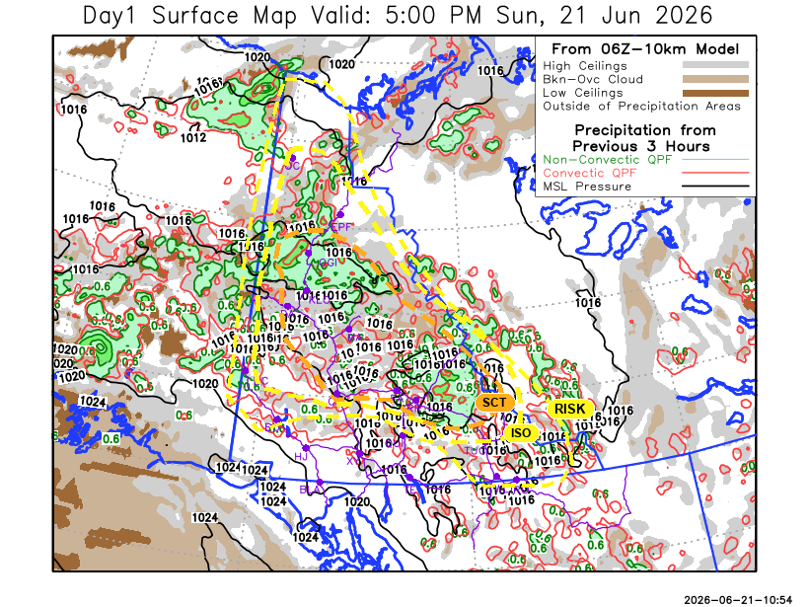
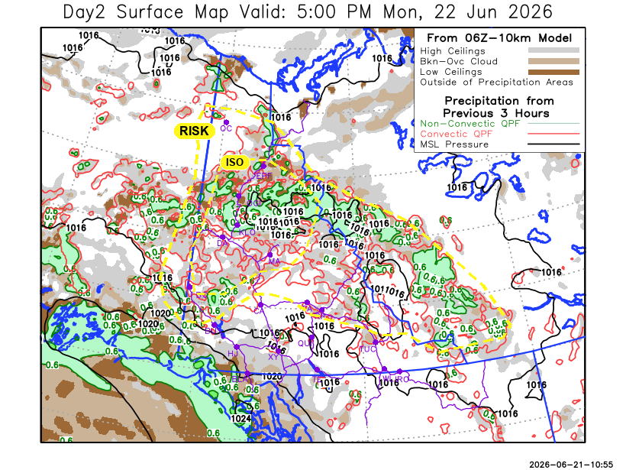

Forecast for | Monday | (Peak burning period and overnight)
Community | Clouds | Pcpn | POP | POL | Max Temp | Min RH | Min Temp | Max  RH | Wind Dir | Wind Speed
Old Crow | SCT | RW-/TRW- | 30 | RISK | 24 | 30 | 12 | 70 | 20 | 15-20
Klondike Fc | BKN | RW-/TRW- | 50 | ISO | 25 | 35 | 14 | 80 | 200 | 10
Mayo A | BKN | RW-/TRW- | 50 | ISO | 25 | 35 | 16 | 80 | 220 | 10
Carmacks | SCT | RW-/TRW- | 40 | RISK | 28 | 25 | 13 | 60 | 180 | 15
Faro | SCT | RW-/TRW- | 40 | RISK | 24 | 30 | 12 | 70 | 220 | 10
Ross River | SCT | RW-/TRW- | 40 | RISK | 26 | 25 | 10 | 70 | 250 | 10
Beaver Creek Town | BKN | RW-/TRW- | 30 | RISK | 23 | 35 | 9 | 90 | 270 | 10
Burwash A | SCT | RW-/TRW- | 30 | RISK | 21 | 35 | 9 | 80 | 140 | 20G35
Haines Junction | BKN | RW- | 30 | NIL | 23 | 35 | 9 | 90 | 240 | 20G30
Whitehorse Auto | BKN | RW- | 30 | NIL | 24 | 30 | 12 | 70 | 170 | 20G40
Teslin | SCT | RW- | 30 | NIL | 24 | 30 | 13 | 60 | 220 | 15-20
Watson Lake | SCT | RW- | 30 | NIL | 26 | 30 | 14 | 60 | 220 | 10

Forecast for |  | Tuesday |  |  |  | (Peak burning period and overnight)
Community |  | Clouds |  |  |  | Pcpn |  |  | POP |  | POL |  | Max Temp |  | Min RH | Min Temp | Max  RH | Wind Dir | Wind Speed
Old Crow |  | SCT |  |  |  | RW-/TRW- |  |  | 40 |  | RISK |  | 25 |  | 30 | 14 | 80 | 110 | 15-20
Klondike Fc |  | BKN |  |  |  | RW-/TRW- |  |  | 40 |  | RISK |  | 24 |  | 35 | 11 | 80 | 140 | 15-20
Mayo A |  | SCT |  |  |  | RW-/TRW- |  |  | 30 |  | RISK |  | 23 |  | 25 | 14 | 70 | 180 | 15
Carmacks |  | SCT |  |  |  | RW- |  |  | 30 |  | NIL |  | 25 |  | 25 | 9 | 60 | 180 | 20G35
Faro |  | SCT |  |  |  | RW- |  |  | 30 |  | NIL |  | 22 |  | 30 | 10 | 70 | 220 | 10-15
Ross River |  | SCT |  |  |  | RW- |  |  | 30 |  | RISK |  | 24 |  | 25 | 8 | 60 | 220 | 15
Beaver Creek Town |  | BKN |  |  |  | RW-/TRW- |  |  | 30 |  | RISK |  | 20 |  | 35 | 6 | 80 | 290 | 15
Burwash A |  | SCT |  |  |  | RW- |  |  | 30 |  | NIL |  | 19 |  | 35 | 6 | 70 | 160 | 20G35
Haines Junction |  | SCT |  |  |  |  |  |  | 20 |  | NIL |  | 22 |  | 30 | 5 | 90 | 180 | 20G40
Whitehorse Auto |  | SCT |  |  |  |  |  |  | 20 |  | NIL |  | 20 |  | 25 | 9 | 70 | 200 | 20G35
Teslin |  | SCT |  |  |  | RW- |  |  | 30 |  | NIL |  | 21 |  | 30 | 10 | 70 | 250 | 15
Watson Lake |  | SCT |  |  |  | RW-/TRW- |  |  | 40 |  | RISK |  | 22 |  | 25 | 14 | 70 | 240 | 10
3-Day Forecast Precipitation Totals from 13:00 Yesterday
OC | 2.7 |  |  | FA | 0.8 |  |  | JAK | 1.8
EPF | 2.6 |  |  | RR | 1.6 |  |  | TE | 0.0
ANT | 10.3 |  |  | BC | 17.3 |  |  | QUI | 0.7
DA | 5.8 |  |  | BCT | 14.9 |  |  | SWI | 0.0
FMI | 7.0 |  |  | BU | 0.5 |  |  | FL | 0.5
HEN | 5.7 |  |  | HJF | 0.0 |  |  | TUC | 0.9
BAR | 3.7 |  |  | RAI | 0.0 |  |  | HAS | 0.6
MA | 2.6 |  |  | CH | 0.0 |  |  | TC | 0.0
STW | 3.6 |  |  | BR | 0.1 |  |  | WL | 0.0
WIL | 3.0 |  |  | NU | 4.7
PE | 3.6 |  |  | XY | 0.7 |  |  | IRO | 0.0
CA | 4.4 |  |  | CC | 0.0
DRU | 1.8 |  |  | ATL | 0.0
Pallawi Paudel Meteorologist

Disclaimer : The information in these forecasts is collected and prepared for internal use by the Government of Yukon. The forecasts are specifically designed to meet the needs of the Wildland Fire Management and may not cover the requirements of other parties. Weather warnings or advisories are not included as part of the forecasts. Wildland Fire Management makes no representation and provides no warranty as to the accuracy of its weather forecasts. Any use the recipient chooses to make of the forecasts will be at its sole risk.

