YUKON WILDLAND FIRE MANAGEMENT WEATHER FORECAST - 9:00 AM ISSUE

25-Jun-2026
YESTERDAY'S VALUES
Community | Max  Temp  (°C) | Diff.  from  Normal | Min Temp  (°C) | Diff. from Normal | Pcpn  (mm) | Min RH | Max RH | L110 | L30
Old Crow | 23.6 | 3.3 | 9.9 | 2.1 | 0.2 | 31 | 80 | 2 | 0
Fort Mcpherson Airport | 27.9 |  | 15.1 |  | 0.0M | 30 | 74 | 0 | 0
Rock River Climate | 22.3 |  | 15.3 |  | 0.0 | 30 | 56 | NA | NA
Eagle Plains Fire | 24.0 |  | 15.1 |  | 0.0 | 27 | 56 | 0 | 0
Antimony Creek | 24.3 |  | 9.6 |  | 0.0 | 23 | 81 | 0 | 0
Klondike Fc | 26.7M | 4.2 | 10.4M | 3.3 | 0.0M | 19M | 84M | 0 | 0
Forty Mile | 23.7 |  | 11.1 |  | 0.0 | 21 | 70 | 0 | 0
Henderson | 20.9 |  | 13.0 |  | 0.0 | 28 | 53 | 0 | 0
Barlow | 23.8 |  | 12.4 |  | 0.3 | 25 | 71 | 0 | 0
Mayo A | 24.1 | 2.1 | 14.4 | 6.2 | 0.0 | 21 | 57 | 0 | 0
Stewart Crossing | 23.1 |  | 10.9 |  | 0.0 | 21 | 77 | 0 | 0
Willow Creek | 22.2 |  | 5.9 |  | 0.0 | 25 | 88 | 0 | 0
Pelly Farm | 24.3 | 2.3 | 7.2 | 0.1 | 0.0 | 24 | 94 | 0 | 0
Carmacks | 25.8 |  | 11.4 |  | 0.0 | 23 | 68 | 0 | 0
Drury Creek | 22.2 |  | 7.6 |  | 0.0 | 30 | 87 | 0 | 0
Faro | 22.1 | 1.7 | 8.4 | 0.6 | 0.0 | 43M | 95M | 0 | 0
Ross River | 23.5 |  | 5.2 |  | 0.0 | 26 | 96 | 4 | 0
Macmillan Pass | 20.4 |  | 5.9 |  | 0.0 | 21 | 78 | 0 | 0
Beaver Creek A | 16.5 | -3.3 | 7.1 | 0.8 | 0.9 | 48 | 96 | 0 | 0
Beaver Creek Town | 18.3 |  | 7.1 |  | 1.6 | 41 | 97 | 0 | 0
Burwash A | 16.6 | -1.9 | 2.2 | -2.7 | 0.0M | 46 | 92 | 0 | 0
Haines Junction | 17.8M | -1.5 | 3.5M | 0.0 | 0.0 | 44M | 98M | 0 | 0
Rainbow | 16.7 |  | 3.1 |  | 0.0 | 52 | 98 | 0 | 0
Champagne | 20.7 |  | 3.8 |  | 0.0 | 32 | 96 | 0 | 0
Braeburn | 23.7 |  | 9.3 |  | 1.1 | 25 | 96 | 1 | 0
Nursery | 24.4 |  | 6.9 |  | 1.3 | 22 | 97 | 2 | 0
Whitehorse Auto | 21.4 | 1.8 | 9.7 | 3.5 | 0.6 | 26 | 93 | 2 | 0
Mount Sima | 19.0 |  | 7.5 |  | 0.3 | 30 | 83 | 2 | 0
Carcross | 22.3 |  | 3.4 |  | 0.0 | 29 | 93 | 1 | 0
Atlin | 20.9 |  | 6.9 |  | 0.0 | 23 | 76 | 0 | 0
Jakes Corner | 22.8 |  | 6.9 |  | 2.3 | 20 | 97 | 9 | 0
Teslin | 21.7 |  | 7.2 |  | 0.0 | 29 | 97 | 34 | 0
Quiet Lake | 25.6 |  | 9.5 |  | 0.5 | 23 | 96 | 33 | 0
Swift River | 23.2 |  | 7.0 |  | 0.0 | 23 | 91 | 99 | 0
Tuchitua | 27.1 |  | 3.6 |  | 0.8 | 18 | 98 | 145 | 8
Hasselburg | 24.8 |  | 8.6 |  | 0.3 | 25 | 87 | 141 | 20
Tom Creek | 26.6 |  | 9.2 |  | 0.0 | 19 | 88 | 131 | 3
Watson Lake | 25.4 | 5.1 | 9.8 | 2.3 | 0.0 | 18 | 86 | 123 | 3
Iron Creek | 28.9 |  | 4.9 |  | 11.2 | 16 | 99 | 55 | 20
Max Temp is the actual maximum temperature in °C from yesterday afternoon or evening.
Min Temp is the actual overnight minimum temperature in °C up until 6:00 AM this morning.
Diff. from Normal is the difference from the 30 year average max or min temperature.
Pcpn is the precipitation in mm since 13:00 yesterday.
Min RH is the minimum observed RH in % from yesterday afternoon or evening.
Max RH is the maximum observed overnight RH in % up until 6:00 AM this morning.
L110 is the actual number of lightning strikes within 110 km and in the Yukon for 24 hours ending at 06:00 AM this morning.
L30 is the actual number of lightning strikes within 30 km and in the Yukon for 24 hours ending at 06:00 AM this morning.
M is missing data. * denotes precipitation at stations that failed to report for at least part of the evening and overnight period.

SYNOPSIS:
Today: Warm and unsettled conditions are expected over much of the territory, but a small pocket of dry air may develop over the north. On the Porcupine River basin around Old Crow, minimum relative humidity will descent to 20-25% and daytime highs will be in the mid-20s, but light winds will keep the fire weather threat low. Over southern and central Yukon, daytime highs will be in the low to mid-20s, and minimum RH will generally remain above 30%, however a few 25-30% readings are possible over Tatchun and Northern Tutchone. This combination of warmth and moisture will fuel scattered showers and thundershowers during the afternoon/evening right across the territory with convective rainfall totals of 10-20 mm. Watch out for a broken line of storms rolling in from BC into the Southern Lakes and Tintina region through the evening because it could contain scattered wind gusts up to 60 km/h.

Friday: Warm and unsettled conditions continue over much of the territory. Daytime highs will be in the low to mid-20s and minimum RHs generally above 35% for most locales, but a few stations over Tatchun and northern Klondike region may see readings near 30%. Scattered showers and thundershowers are expected throughout the territory, and convective rainfall totals will approach 10-15 mm. Convective activity will focus over northern Klondike, the Mackenzie/Ogilvie Mountains, and over the Tintina region.

Saturday: Warm and unsettled conditions continue over much of the territory, however precipitation activity will bias toward the southwestern regions. Daytime highs will be in the low to mid-20s and minimum relative humidity will generally be above 40% over much of the territory. The driest air will be found over eastern Tintina, eastern Tatchun, and northern Klondike region where a few instances of 30% RH are possible. Scattered showers and thundershowers will develop during the afternoon/evening and steady rain may develop over the southwest (Kluane, Southern Lakes) through the evening/overnight.

Sunday: Continued re-enforcement of Pacific moisture will bring rain showers and slightly cooler temperatures. Daytime highs will be in the high teens to low 20s and minimum RHs may remain above 35%. Showers activity will focus over southern and central Yukon because a surface low will attempt to develop over the western Yukon Plateau.

Monday: It will be notably cooler across the territory with daytime in the mid-teens and minimum relative humidity generally above 40%. Shower activity is expected over the southern and central Yukon but minimal shower activity is expected over the north.

Forecast for | Thursday | (Peak burning period and overnight)
Community | Clouds | Pcpn | POP | POL | Max Temp | Min RH | Min Temp | Max  RH | Wind Dir | Wind Speed
Old Crow | SCT | RW- TRW- | 20 | RISK | 25 | 20 | 12 | 70 | 270 | 5
Klondike Fc | BKN | RW TRW | 60 | ISO | 24 | 30 | 14 | 85 | 330 | 5
Mayo A | BKN | RW- TRW- | 40 | ISO | 25 | 30 | 17 | 80 | 20 | 5
Carmacks | BKN | RW- TRW- | 60 | ISO | 22 | 35 | 12 | 90 | 0 | 10
Faro | BKN | RW- TRW- | 40 | ISO | 24 | 30 | 11 | 90 | 120 | 15
Ross River | BKN | RW- TRW- | 40 | ISO | 22 | 30 | 10 | 80 | 120 | 10
Beaver Creek Town | OVC | RW- TRW- | 60 | ISO | 20 | 50 | 9 | 95 | 290 | 5
Burwash A | BKN | RW- TRW- | 60 | ISO | 17 | 50 | 8 | 95 | 290 | 20G35
Haines Junction | BKN | RW TRW | 60 | ISO | 21 | 35 | 7 | 95 | 290 | 10
Whitehorse Auto | BKN | RW TRW | 60 | ISO | 20 | 40 | 11 | 85 | 20 | 5
Teslin | BKN | RW TRW | 60 | SCT | 20 | 40 | 10 | 90 | 30 | 5
Watson Lake | BKN | RW TRW | 70 | SCT | 20 | 50 | 13 | 90 | 320 | 5
POP is probability of precipitation in %.
POL is probability of lightning in %.

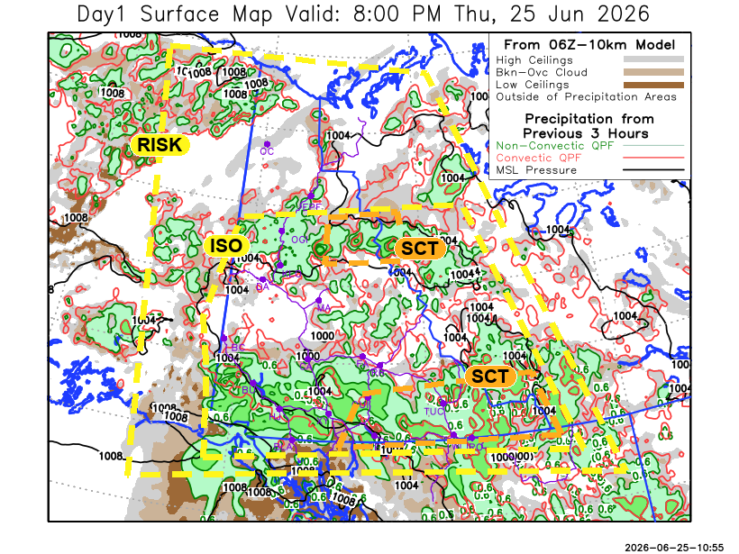
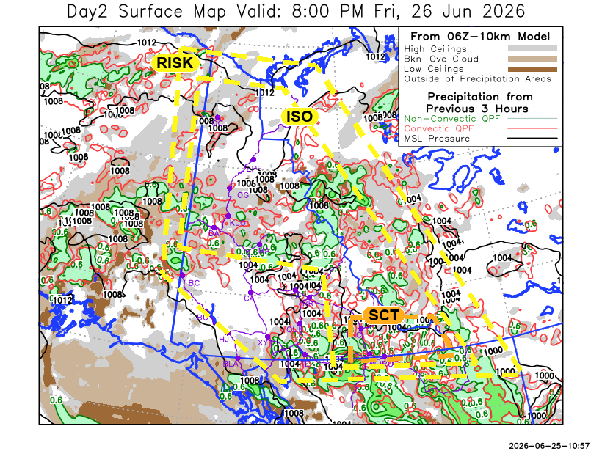

Forecast for | Friday | (Peak burning period and overnight)
Community | Clouds | Pcpn | POP | POL | Max Temp | Min RH | Min Temp | Max  RH | Wind Dir | Wind Speed
Old Crow | BKN | RW- TRW- | 40 | ISO | 24 | 35 | 11 | 80 | 20 | 15
Klondike Fc | BKN | RW- TRW- | 40 | ISO | 25 | 35 | 15 | 85 | 300 | 5
Mayo A | BKN | RW- TRW- | 20 | ISO | 24 | 40 | 17 | 80 | 250 | 5
Carmacks | BKN | RW- TRW- | 20 | RISK | 24 | 35 | 14 | 75 | 20 | 5
Faro | SCT | RW- TRW- | 20 | RISK | 25 | 30 | 13 | 85 | 300 | 5
Ross River | SCT | RW- TRW- | 20 | RISK | 26 | 30 | 11 | 85 | 110 | 5
Beaver Creek Town | BKN | RW- TRW- | 20 | RISK | 20 | 50 | 10 | 90 | 0 | 5
Burwash A | BKN |  | 15 | NIL | 15 | 55 | 9 | 90 | 120 | 5
Haines Junction | BKN |  | 15 | NIL | 20 | 45 | 9 | 90 | 280 | 5
Whitehorse Auto | BKN |  | 15 | NIL | 21 | 50 | 13 | 90 | 0 | 5
Teslin | BKN | RW- TRW- | 40 | ISO | 20 | 50 | 12 | 95 | 0 | 5
Watson Lake | SCT | RW TRW | 60 | SCT | 22 | 55 | 15 | 90 | 90 | 5

Forecast for |  |  | Saturday |  |  | (Peak burning period and overnight)
Community |  |  | Clouds |  |  | Pcpn | POP |  | POL |  | Max Temp |  | Min RH | Min Temp | Max  RH | Wind Dir | Wind Speed
Old Crow |  |  | BKN |  |  | RW- TRW- | 20 |  | RISK |  | 18 |  | 35 | 6 | 85 | 45 | 20G40
Klondike Fc |  |  | BKN |  |  | RW- TRW- | 60 |  | RISK |  | 25 |  | 40 | 13 | 95 | 300 | 5
Mayo A |  |  | BKN |  |  | RW- TRW- | 60 |  | RISK |  | 25 |  | 40 | 16 | 90 | 160 | 5
Carmacks |  |  | BKN |  |  | RW- TRW- | 80 |  | RISK |  | 21 |  | 50 | 12 | 75 | 180 | 5
Faro |  |  | BKN |  |  | RW- TRW- | 60 |  | RISK |  | 24 |  | 40 | 12 | 85 | 170 | 5
Ross River |  |  | BKN |  |  | RW- TRW- | 60 |  | RISK |  | 25 |  | 40 | 10 | 85 | 160 | 10
Beaver Creek Town |  |  | BKN |  |  | RW- TRW- | 80 |  | RISK |  | 20 |  | 50 | 6 | 90 | 300 | 5
Burwash A |  |  | SCT |  |  | R | 80 |  | NIL |  | 14 |  | 60 | 8 | 90 | 90 | 5
Haines Junction |  |  | SCT |  |  | R- | 80 |  | NIL |  | 19 |  | 50 | 7 | 90 | 220 | 5
Whitehorse Auto |  |  | BKN |  |  | RW- TRW- | 60 |  | RISK |  | 21 |  | 50 | 10 | 85 | 200 | 10
Teslin |  |  | BKN |  |  | RW- TRW- | 60 |  | RISK |  | 20 |  | 50 | 9 | 85 | 180 | 5
Watson Lake |  |  | SCT |  |  | RW- TRW- | 40 |  | RISK |  | 26 |  | 35 | 14 | 90 | 160 | 10
3-Day Forecast Precipitation Totals from 13:00 Yesterday
OC | 3.4 |  | FA | 4.1 |  | JAK | 12.4
EPF | 6.8 |  | RR | 3.7 |  | TE | 11.7
ANT | 4.7 |  | BC | 16.5 |  | QUI | 14.9
DA | 4.1 |  | BCT | 17.2 |  | SWI | 14.2
FMI | 2.9 |  | BU | 19.6 |  | FL | 10.5
HEN | 3.5 |  | HJF | 13.2 |  | TUC | 11.2
BAR | 4.9 |  | RAI | 10.9 |  | HAS | 13.1
MA | 1.9 |  | CH | 9.1 |  | TC | 13.6
STW | 2.3 |  | BR | 9.0 |  | WL | 13.4
WIL | 2.5 |  | NU | 7.6 |  | NA | NA
PE | 2.8 |  | XY | 7.7 |  | IRO | 20.4
CA | 3.8 |  | CC | 7.5 |  | NA | NA
DRU | 7.2 |  | ATL | 8.8 |  | NA | NA
Dylan Kikuta Meteorologist

Disclaimer : The information in these forecasts is collected and prepared for internal use by the Government of Yukon. The forecasts are specifically designed to meet the needs of the Wildland Fire Management and may not cover the requirements of other parties. Weather warnings or advisories are not included as part of the forecasts. Wildland Fire Management makes no representation and provides no warranty as to the accuracy of its weather forecasts. Any use the recipient chooses to make of the forecasts will be at its sole risk.

