YUKON WILDLAND FIRE MANAGEMENT WEATHER FORECAST - 9:00 AM ISSUE

26-Jun-2026
YESTERDAY'S VALUES
Community | Max  Temp  (°C) | Diff.  from  Normal | Min Temp  (°C) | Diff. from Normal | Pcpn  (mm) | Min RH | Max RH | L110 | L30
Old Crow | 25.6 | 5.2 | 14.6 | 6.6 | 0.0 | 20 | 72 | 0 | 0
Fort Mcpherson Airport | 29.1 |  | 15.8 |  | 0.0M | 30 | 78 | 39 | 0
Rock River Climate | 21.0 |  | 15.3 |  | 8.8 | 34 | 67 | NA | NA
Eagle Plains Fire | 22.8 |  | 14.3 |  | 1.0 | 34 | 74 | 194 | 26
Antimony Creek | 26.6 |  | 11.6 |  | 0.3 | 23 | 94 | 150 | 3
Klondike Fc | 28.8M | 6.2 | 16.8M | 9.6 | 0.0M | 21M | 64M | 185 | 0
Forty Mile | 26.4 |  | 10.9 |  | 0.0 | 27 | 78 | 191 | 27
Henderson | 22.4 |  | 13.2 |  | 0.0 | 29 | 66 | 107 | 1
Barlow | 25.7 |  | 13.7 |  | 0.3 | 28 | 74 | 26 | 2
Mayo A | 25.7 | 3.6 | 13.9 | 5.6 | 0.0 | 26 | 78 | 13 | 0
Stewart Crossing | 26.1 |  | 14.4 |  | 0.3 | 26 | 85 | 23 | 3
Willow Creek | 24.9 |  | 11.3 |  | 1.3 | 28 | 90 | 30 | 2
Pelly Farm | 27.3 | 5.2 | 12.3 | 5.1 | 0.0 | 21 | 90 | 153 | 0
Carmacks | 25.8 |  | 11.5 |  | 1.3 | 28 | 95 | 103 | 1
Drury Creek | 23.8 |  | 7.9 |  | 0.0 | 31 | 92 | 94 | 8
Faro | 22.0 | 1.5 | 9.3 | 1.4 | 1.8 | 51M | 89M | 136 | 22
Ross River | 23.8 |  | 8.0 |  | 6.4 | 34 | 98 | 285 | 18
Macmillan Pass | 21.8 |  | 5.5 |  | 1.8 | 27 | 90 | 111 | 3
Beaver Creek A | 20.0 | 0.1 | 10.4 | 4.0 | 6.0M | 54 | 97 | 219 | 31
Beaver Creek Town | 21.2 |  | 10.6 |  | 7.8 | 44 | 98 | 215 | 32
Burwash A | 14.9 | -3.7 | 8.8 | 3.8 | 10.4M | 56 | 99 | 116 | 0
Haines Junction | 15.5 | -2.8 | 8.4 | 4.6 | 7.4 | 60 | 98 | 33 | 0
Rainbow | 15.4 |  | 7.7 |  | 5.3 | 62 | 98 | 44 | 0
Champagne | 16.6 |  | 8.1 |  | 8.2 | 60 | 98 | 102 | 0
Braeburn | 22.5 |  | 9.7 |  | 6.9 | 33 | 99 | 119 | 8
Nursery | 21.4 |  | 7.2 |  | 8.7 | 40 | 99 | 115 | 29
Whitehorse Auto | 17.5 | -2.2 | 8.1 | 1.8 | 4.4 | 56 | 100 | 132 | 33
Mount Sima | 16.5 |  | 6.7 |  | 2.9 | 50 | 98 | 125 | 28
Carcross | 13.7 |  | 4.5 |  | 4.6 | 67 | 99 | 97 | 9
Atlin | 12.5 |  | 7.9 |  | 1.8 | 68 | 96 | 42 | 0
Jakes Corner | 19.1 |  | 8.7 |  | 0.6 | 50 | 96 | 187 | 10
Teslin | 16.9 |  | 9.1 |  | 4.4 | 59 | 99 | 204 | 16
Quiet Lake | 22.5 |  | 7.7 |  | 3.4 | 34 | 99 | 249 | 21
Swift River | 21.0 |  | 8.5 |  | 4.7 | 37 | 98 | 221 | 31
Tuchitua | 22.2 |  | 6.8 |  | 14.3 | 43 | 100 | 491 | 62
Hasselburg | 21.3 |  | 9.1 |  | 7.1 | 47 | 97 | 413 | 62
Tom Creek | 23.0 |  | 9.0 |  | 0.3 | 34 | 97 | 347 | 7
Watson Lake | 24.2 | 3.8 | 10.6 | 3.0 | 4.8 | 32 | 97 | 249 | 10
Iron Creek | 26.2 |  | 7.3 |  | 0.0 | 32 | 99 | 215 | 1
Max Temp is the actual maximum temperature in °C from yesterday afternoon or evening.
Min Temp is the actual overnight minimum temperature in °C up until 6:00 AM this morning.
Diff. from Normal is the difference from the 30 year average max or min temperature.
Pcpn is the precipitation in mm since 13:00 yesterday.
Min RH is the minimum observed RH in % from yesterday afternoon or evening.
Max RH is the maximum observed overnight RH in % up until 6:00 AM this morning.
L110 is the actual number of lightning strikes within 110 km and in the Yukon for 24 hours ending at 06:00 AM this morning.
L30 is the actual number of lightning strikes within 30 km and in the Yukon for 24 hours ending at 06:00 AM this morning.
M is missing data. * denotes precipitation at stations that failed to report for at least part of the evening and overnight period.

SYNOPSIS:
Today: Warm and unsettled conditions continue over much of the territory and lightning will be the main concern. Daytime highs will be in the low to mid-20s and minimum RHs generally above 35%, but isolated locales over Tatchun, southern Klondike, and southern Northern Tutchone may see readings near 25-30%. Scattered showers and thundershowers are expected throughout the territory with convective rainfall totals generally around 10-20 mm. The bulk of the convective activity will be north of the Tintina Trench, and with a focus over northern Klondike, the Mackenzie/Ogilvie Mountains, and over the Tintina region. Isolated convective wind gusts of 60-80 km/h are possible with storms over the Tintina region. Winds will be light and variable over southern and central regions, but a 20-30 km/h northeasterly flow is expected to develop on the Porcupine River.

Saturday: Warm and unsettled conditions continue over much of the territory and lightning will be the main concern. Daytime highs will be in the low to mid-20s, and minimum relative humidity will generally be above 40% over much of the territory. The driest air will be found over eastern Tintina, eastern Tatchun, and the southern Klondike region where a few instances of 25-30% RH are possible. Scattered showers and thundershowers will develop during the afternoon/evening with convective rainfall totals of 10-20mm (scattered instances of 50 mm over Klondike). Shower/thundershower activity on the Yukon Plateau will be more numerous than the last few days thanks to instability shifting northwest. Breezy northeasterly winds may continue around the Richardson Mountains and Porcupine River while light and variable winds persist over the southern half of the territory.

Sunday: Continued re-enforcement of Pacific moisture will bring rain showers and slightly cooler temperatures however there is considerable uncertainty in the placement of showers and likewise where the warmest and coolest conditions will establish. It appears that shower activity will focus over the Ogilvie Mountains and the western Yukon Plateau as a weak surface low attempts to form. Lightning potential will be substantially lower than Friday or Saturday thanks to reduced instability. Daytime highs will be in the mid-teens and RH generally above 50%. Dry air could develop over the southeastern Yukon Plateau.

Monday: The surface low will depart, and shower activity should decrease but not cease. Westerly winds ushering in Pacific air will keep daytime highs in the mid-teens and minimum relative humidity generally above 35%, however overall RH should be lower than Sunday. Shower activity is expected over the southern and central Yukon, but minimal shower activity is expected over the north where RH could be slightly lower than southern regions.

Tuesday: Light shower activity continues over southern and central Yukon and temperatures start to rise by a few degrees. Daytime highs in precipitation free zones should approach high-teens once again and minimum RH may approach 30%.

Forecast for | Friday | (Peak burning period and overnight)
Community | Clouds | Pcpn | POP | POL | Max Temp | Min RH | Min Temp | Max  RH | Wind Dir | Wind Speed
Old Crow | BKN | RW- TRW- | 40 | ISO | 24 | 40 | 12 | 80 | 70 | 20G35
Klondike Fc | BKN | RW- TRW- | 40 | ISO | 26 | 35 | 16 | 85 | 300 | 5
Mayo A | BKN | RW- TRW- | 40 | ISO | 26 | 35 | 19 | 85 | 300 | 5
Carmacks | BKN | RW- TRW- | 30 | RISK | 23 | 35 | 15 | 80 | 180 | 5
Faro | BKN | RW- TRW- | 30 | ISO | 25 | 30 | 13 | 85 | 150 | 10
Ross River | BKN | RW- TRW- | 40 | ISO | 23 | 35 | 11 | 85 | 150 | 5
Beaver Creek Town | BKN | RW- TRW- | 20 | RISK | 20 | 50 | 11 | 90 | 0 | 5
Burwash A | BKN | R- | 20 | NIL | 14 | 55 | 9 | 90 | 90 | 5
Haines Junction | BKN | R- | 40 | NIL | 17 | 50 | 10 | 85 | 180 | 5
Whitehorse Auto | BKN | R- | 20 | NIL | 20 | 55 | 14 | 90 | 0 | 5
Teslin | BKN | RW- TRW- | 40 | ISO | 19 | 55 | 12 | 90 | 330 | 5
Watson Lake | SCT | RW TRW | 60 | SCT | 21 | 55 | 14 | 90 | 40 | 5
POP is probability of precipitation in %.
POL is probability of lightning in %.

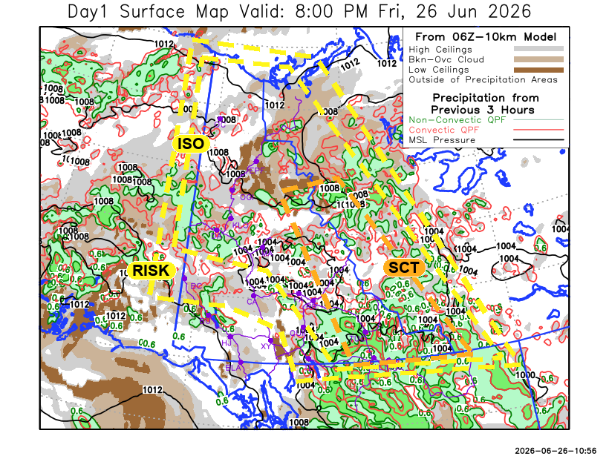
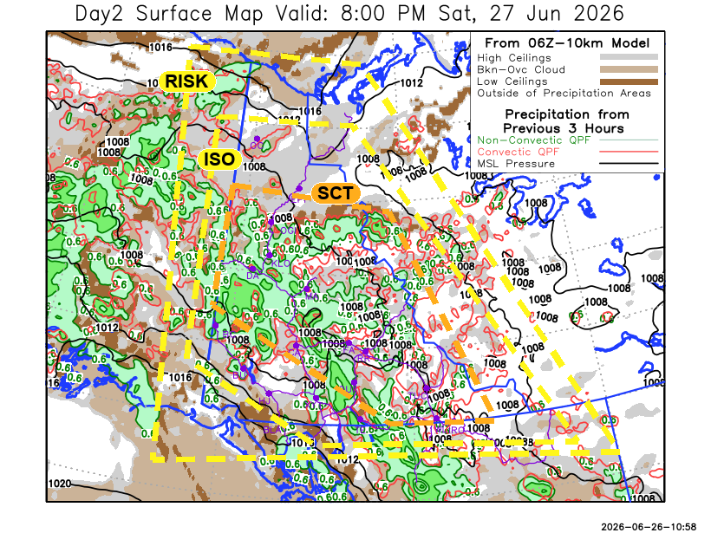

Forecast for | Saturday | (Peak burning period and overnight)
Community | Clouds | Pcpn | POP | POL | Max Temp | Min RH | Min Temp | Max  RH | Wind Dir | Wind Speed
Old Crow | BKN | RW TRW | 30 | ISO | 22 | 40 | 5 | 90 | 50 | 20G35
Klondike Fc | BKN | RW TRW | 60 | SCT | 26 | 35 | 14 | 90 | 220 | 5
Mayo A | BKN | RW TRW | 60 | SCT | 24 | 45 | 17 | 95 | 180 | 5
Carmacks | BKN | RW TRW | 40 | SCT | 25 | 35 | 13 | 80 | 180 | 5
Faro | BKN | RW TRW | 40 | SCT | 25 | 40 | 12 | 90 | 140 | 10
Ross River | BKN | RW TRW | 40 | SCT | 25 | 40 | 11 | 90 | 140 | 10
Beaver Creek Town | BKN | RW- TRW- | 40 | ISO | 20 | 40 | 8 | 80 | 170 | 5
Burwash A | BKN | RW- TRW- | 40 | ISO | 20 | 45 | 9 | 85 | 90 | 10
Haines Junction | BKN | RW- TRW- | 20 | ISO | 21 | 50 | 8 | 90 | 270 | 10
Whitehorse Auto | BKN | RW- TRW- | 20 | ISO | 18 | 60 | 10 | 85 | 180 | 10
Teslin | SCT | RW- TRW- | 20 | ISO | 18 | 60 | 10 | 85 | 200 | 10
Watson Lake | SCT | RW TRW | 40 | SCT | 25 | 35 | 15 | 85 | 160 | 10

Forecast for |  |  | Sunday |  |  | (Peak burning period and overnight)
Community |  |  | Clouds |  |  | Pcpn | POP |  | POL |  | Max Temp |  | Min RH | Min Temp | Max  RH | Wind Dir | Wind Speed
Old Crow |  |  | BKN |  |  | R- | 30 |  | NIL |  | 13 |  | 60 | 5 | 90 | 0 | 10
Klondike Fc |  |  | BKN |  |  | R- | 40 |  | NIL |  | 15 |  | 65 | 10 | 90 | 0 | 10
Mayo A |  |  | BKN |  |  | RW- TRW- | 40 |  | RISK |  | 15 |  | 65 | 13 | 85 | 270 | 10
Carmacks |  |  | BKN |  |  | R- | 40 |  | NIL |  | 15 |  | 65 | 11 | 90 | 300 | 10
Faro |  |  | BKN |  |  | RW- | 30 |  | NIL |  | 17 |  | 60 | 9 | 90 | 270 | 10
Ross River |  |  | BKN |  |  | RW- | 30 |  | NIL |  | 17 |  | 60 | 8 | 90 | 270 | 10
Beaver Creek Town |  |  | BKN |  |  | R- | 40 |  | NIL |  | 16 |  | 60 | 6 | 85 | 300 | 10
Burwash A |  |  | BKN |  |  | R- | 30 |  | NIL |  | 14 |  | 60 | 8 | 85 | 290 | 5
Haines Junction |  |  | BKN |  |  | R- | 30 |  | NIL |  | 15 |  | 60 | 6 | 90 | 240 | 10
Whitehorse Auto |  |  | BKN |  |  | R- | 20 |  | NIL |  | 15 |  | 55 | 8 | 85 | 240 | 10
Teslin |  |  | SCT |  |  |  | 15 |  | NIL |  | 16 |  | 50 | 8 | 80 | 250 | 10
Watson Lake |  |  | BKN |  |  | RW- TRW- | 30 |  | RISK |  | 16 |  | 55 | 11 | 80 | 270 | 10
3-Day Forecast Precipitation Totals from 13:00 Yesterday
OC | 17.9 |  | FA | 12.4 |  | JAK | 5.4
EPF | 7.7 |  | RR | 15.4 |  | TE | 11.8
ANT | 16.9 |  | BC | 13.5 |  | QUI | 14.9
DA | 14.9 |  | BCT | 15.3 |  | SWI | 19.3
FMI | 17.6 |  | BU | 16.2 |  | FL | 11.0
HEN | 13.9 |  | HJF | 10.5 |  | TUC | 27.2
BAR | 15.3 |  | RAI | 7.5 |  | HAS | 24.0
MA | 10.4 |  | CH | 12.0 |  | TC | 15.3
STW | 11.2 |  | BR | 11.6 |  | WL | 18.2
WIL | 11.6 |  | NU | 15.3 |  | NA | NA
PE | 8.9 |  | XY | 11.3 |  | IRO | 7.1
CA | 6.6 |  | CC | 8.7 |  | NA | NA
DRU | 10.9 |  | ATL | 5.3 |  | NA | NA
Dylan Kikuta Meteorologist

Disclaimer : The information in these forecasts is collected and prepared for internal use by the Government of Yukon. The forecasts are specifically designed to meet the needs of the Wildland Fire Management and may not cover the requirements of other parties. Weather warnings or advisories are not included as part of the forecasts. Wildland Fire Management makes no representation and provides no warranty as to the accuracy of its weather forecasts. Any use the recipient chooses to make of the forecasts will be at its sole risk.

