YUKON WILDLAND FIRE MANAGEMENT WEATHER FORECAST - 9:00 AM ISSUE

29-Jun-2026
YESTERDAY'S VALUES
Community | Max  Temp  (°C) | Diff.  from  Normal | Min Temp  (°C) | Diff. from Normal | Pcpn  (mm) | Min RH | Max RH | L110 | L30
Old Crow | 11.6 | -9.0 | 8.0 | -0.3 | 1.0 | 79 | 95 | 0 | 0
Fort Mcpherson Airport | 8.8 |  | 7.8 |  | 0.0 | 92 | 98 | 0 | 0
Rock River Climate | 13.4 |  | 8.2 |  | 3.8 | 68 | 100 | NA | NA
Eagle Plains Fire | 15.0 |  | 8.0 |  | 3.0 | 63 | 100 | 0 | 0
Antimony Creek | 15.2 |  | 5.0 |  | 5.2 | 83 | 99 | 0 | 0
Klondike Fc | 14.1M | -8.7 | 7.3M | -0.2 | 0.8M | 81M | 97M | 0 | 0
Forty Mile | 13.9 |  | 6.6 |  | 14.7 | 88 | 99 | 0 | 0
Henderson | 10.9 |  | 6.9 |  | 3.9 | 81 | 97 | 0 | 0
Barlow | 13.8 |  | 6.1 |  | 5.9 | 87 | 97 | 0 | 0
Mayo A | 15.7 | -6.6 | 8.2 | -0.5 | 1.5 | 75 | 96 | 0 | 0
Stewart Crossing | 15.4 |  | 6.8 |  | 3.1 | 69 | 94 | 0 | 0
Willow Creek | 16.9 |  | 2.4 |  | 2.5 | 58 | 97 | 0 | 0
Pelly Farm | 17.9 | -4.4 | 4.8 | -2.8 | 0.0 | 50 | 96 | 0 | 0
Carmacks | 16.7 |  | 9.8 |  | 8.9 | 74 | 98 | 0 | 0
Drury Creek | 15.9 |  | 9.4 |  | 1.1 | 59 | 98 | 0 | 0
Faro | 18.9 | -1.8 | 7.9 | -0.4 | 0.0 | 60M | 98M | 0 | 0
Ross River | 21.4 |  | 9.7 |  | 0.0 | 37 | 86 | 0 | 0
Macmillan Pass | 20.8 |  | 7.1 |  | 0.6 | 40 | 96 | 5 | 0
Beaver Creek A | 16.7 | -3.4 | 3.9 | -2.8 | 0.6 | 62 | 96 | 4 | 0
Beaver Creek Town | 16.3 |  | 5.4 |  | 0.0 | 54 | 94 | 4 | 0
Burwash A | 17.8 | -1.0 | 7.3 | 1.9 | 2.7M | 54 | 97 | 5 | 0
Haines Junction | 19.5M | 0.2 | 6.4M | 2.1 | 0.0 | 41M | 91M | 0 | 0
Rainbow | 19.1 |  | 5.3 |  | 0.0 | 38 | 85 | 0 | 0
Champagne | 17.2 |  | 7.4 |  | 0.0 | 37 | 71 | 0 | 0
Braeburn | 14.0 |  | 8.7 |  | 3.9 | 67 | 99 | 0 | 0
Nursery | 17.6 |  | 10.3 |  | 0.0 | 48 | 91 | 0 | 0
Whitehorse Auto | 16.0 | -3.9 | 9.4 | 2.8 | 0.2 | 53 | 79 | 0 | 0
Mount Sima | 12.6 |  | 7.0 |  | 0.0 | 55 | 79 | 0 | 0
Carcross | 19.3 |  | 7.9 |  | 0.0 | 39 | 79 | 0 | 0
Atlin | 18.8 |  | 3.1 |  | 0.0 | 33 | 85 | 0 | 0
Jakes Corner | 17.6 |  | 9.1 |  | 0.0 | 41 | 80 | 0 | 0
Teslin | 19.5 |  | 8.1 |  | 0.4 | 34 | 90 | 0 | 0
Quiet Lake | 16.3 |  | 7.9 |  | 0.0 | 49 | 94 | 0 | 0
Swift River | 20.6 |  | 7.3 |  | 0.0 | 32 | 71 | 0 | 0
Tuchitua | 16.2 |  | 6.2 |  | 0.6 | 71 | 99 | 1 | 0
Hasselburg | 16.5 |  | 7.8 |  | 0.0 | 48 | 84 | 0 | 0
Tom Creek | 14.1 |  | 8.0 |  | 2.4 | 73 | 100 | 0 | 0
Watson Lake | 15.4 | -5.2 | 8.7 | 0.7 | 2.4 | 60 | 99 | 0 | 0
Iron Creek | 19.7 |  | 9.5 |  | 7.5 | 51 | 100 | 11 | 0
Max Temp is the actual maximum temperature in °C from yesterday afternoon or evening.
Min Temp is the actual overnight minimum temperature in °C up until 6:00 AM this morning.
Diff. from Normal is the difference from the 30 year average max or min temperature.
Pcpn is the precipitation in mm since 13:00 yesterday.
Min RH is the minimum observed RH in % from yesterday afternoon or evening.
Max RH is the maximum observed overnight RH in % up until 6:00 AM this morning.
L110 is the actual number of lightning strikes within 110 km and in the Yukon for 24 hours ending at 06:00 AM this morning.
L30 is the actual number of lightning strikes within 30 km and in the Yukon for 24 hours ending at 06:00 AM this morning.
M is missing data. * denotes precipitation at stations that failed to report for at least part of the evening and overnight period.

SYNOPSIS:
Today: An upper-level trough will keep temperatures near to below seasonal values today, with highs in the teens to low twenties. Moderate relative humidity levels are anticipated as RHs remain 30% or higher throughout the Territory – no crossovers expected. Winds are forecast to be light to moderate across the Yukon, mostly out of the west or southwest. Gustiest conditions will be in the northern Territory, where gusts of 40-50 km/h are possible in Old Crow. Unsettled conditions take hold under the influence of the trough, with scattered convective showers and isolated thundershowers expected to develop by afternoon through much of central and southern Yukon. Locations along the BC border in Southern Lake and Tintina are less likely to see any convective activity develop today. A few showers in Old Crow.

Tuesday: The trough is expected to develop a surface low over central Yukon, bringing scattered to widespread showers with risk of embedded thunderstorms, particularly over the Klondike, Tatchun, Northern Tutchone, and Beaver Creek district. Moderate rainfall amounts possible Tuesday into Wednesday through these regions, amounting to 5-15 mm. Southern Lake and Tintina expected to avoid the bulk of the rainfall on Tuesday as it remains north. Temperatures remain cool, broadly in the teens with a few low twenties, and RHs remain 30% or higher. Winds light to moderate, out of the west through most regions.

Wednesday: Troughing continues to drive weather conditions across the Territory, brining unsettled weather in the form of showers with a risk of a thunderstorm through most regions. The only exception is in Southern Lakes and Tintina where showers are less likely. Temperatures remain below seasonal values in the teens, and winds light to moderate west/northwesterly. RHs near or above 30%.

Thursday: A strong low-pressure system is expected to develop and become centered over central Yukon. This will bring bands of showers, with a risk of thunderstorms through a broad area of the central, western, and northern Territory. Temperatures are expected to be near to below seasonal values: mildest and driest conditions likely in Tintina where there may be sunnier breaks and minimal rainfall from the system passing through central Yukon.

Friday: Broad upper-level troughing remains in place through the late-week. This will keep temperatures near to below seasonal values and continue to plague a large area of the Territory with showers and cloudier skies. Sunniest and drier conditions likely to be in Tintina again on Friday, but temperatures here remain in the upper teens.

Forecast for | Monday | (Peak burning period and overnight)
Community | Clouds | Pcpn | POP | POL | Max Temp | Min RH | Min Temp | Max  RH | Wind Dir | Wind Speed
Old Crow | BKN | R-/RW- | 30 |  | 15 | 60 | 9 | 85 | 250 | 30G50
Klondike Fc | BKN | RW-/TRW- | 60 | ISO | 19 | 50 | 10 | 86 | 320 | 10
Mayo A | SCT | RW-/TRW- | 40 | ISO | 20 | 40 | 14 | 78 | 270 | 10G25
Carmacks | BKN | RW-/TRW- | 60 | ISO | 20 | 50 | 9 | 87 | 180 | 10
Faro | SCT | RW-/TRW- | 60 | ISO | 19 | 40 | 9 | 82 | 270 | 10G25
Ross River | BKN | RW-/TRW- | 60 | ISO | 20 | 35 | 8 | 77 | 290 | 15G30
Beaver Creek Town | BKN | RW-/TRW- | 70 | ISO | 18 | 50 | 6 | 86 | 320 | 15
Burwash A | BKN | RW-/TRW- | 70 | ISO | 15 | 50 | 7 | 88 | 160 | 10
Haines Junction | SCT | RW-/TRW- | 20 | RISK | 20 | 35 | 4 | 93 | 200 | 10G25
Whitehorse Auto | SCT | RW-/TRW- | 30 | ISO | 18 | 40 | 8 | 76 | vrb | 5-10
Teslin | SCT |  | 10 |  | 18 | 35 | 8 | 73 | 250 | 10-15
Watson Lake | SCT |  | 10 |  | 20 | 35 | 11 | 68 | 290 | 10G25
POP is probability of precipitation in %.
POL is probability of lightning in %.

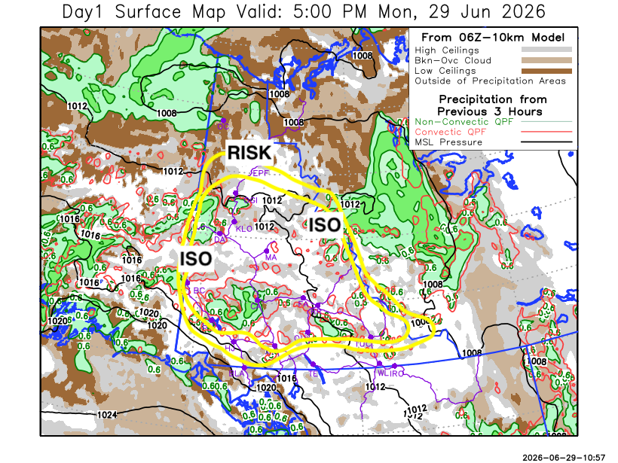
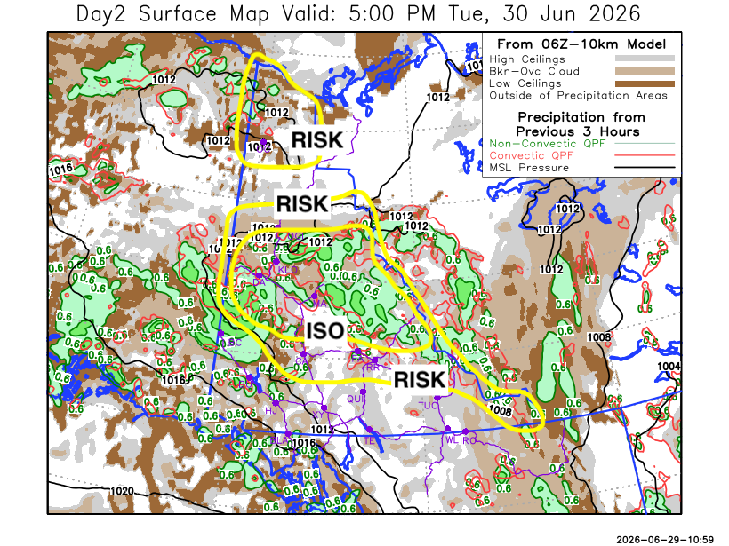

Forecast for | Tuesday | (Peak burning period and overnight)
Community | Clouds | Pcpn | POP | POL | Max Temp | Min RH | Min Temp | Max  RH | Wind Dir | Wind Speed
Old Crow | SCT | RW-/TRW- | 30 | RISK | 18 | 45 | 9 | 76 | 250 | 10G20
Klondike Fc | BKN | R-/TRW- | 80 | ISO | 17 | 65 | 10 | 93 | 0 | 10
Mayo A | BKN | R-/TRW- | 70 | ISO | 18 | 60 | 12 | 94 | 270 | 10
Carmacks | SCT | RW-/TRW- | 30 | RISK | 20 | 45 | 7 | 82 | 200 | 10
Faro | BKN | RW-/TRW- | 60 | RISK | 17 | 55 | 7 | 85 | 270 | 10
Ross River | BKN | RW-/TRW- | 60 | RISK | 19 | 45 | 6 | 81 | 270 | 10
Beaver Creek Town | OVC | R-/RW- | 70 |  | 13 | 70 | 5 | 93 | 290 | 15G25
Burwash A | BKN | R-/RW- | 80 |  | 12 | 70 | 5 | 95 | vrb | 10
Haines Junction | SCT | R-/RW- | 30 |  | 16 | 45 | 4 | 91 | 200 | 10G25
Whitehorse Auto | BKN |  | 0 |  | 16 | 35 | 8 | 71 | 240 | 10
Teslin | SCT |  | 0 |  | 16 | 35 | 6 | 72 | 250 | 10G20
Watson Lake | BKN | RW- | 30 |  | 20 | 35 | 11 | 70 | 270 | 10

Forecast for |  |  | Wednesday |  |  | (Peak burning period and overnight)
Community |  |  | Clouds |  |  | Pcpn |  | POP |  | POL |  | Max Temp |  | Min RH | Min Temp | Max  RH | Wind Dir | Wind Speed
Old Crow |  |  | OVC |  |  | R-/RW- |  | 60 |  |  |  | 19 |  | 40 | 8 | 83 | 90 | 15
Klondike Fc |  |  | BKN |  |  | RW-/TRW- |  | 60 |  | RISK |  | 18 |  | 60 | 8 | 90 | 0 | 10
Mayo A |  |  | BKN |  |  | RW-/TRW- |  | 60 |  | RISK |  | 17 |  | 60 | 11 | 90 | 0 | 10
Carmacks |  |  | BKN |  |  | RW-/TRW- |  | 40 |  | RISK |  | 19 |  | 40 | 9 | 90 | vrb | 5
Faro |  |  | BKN |  |  | RW-/TRW- |  | 60 |  | RISK |  | 14 |  | 65 | 6 | 93 | 270 | 10
Ross River |  |  | BKN |  |  | RW-/TRW- |  | 60 |  | RISK |  | 16 |  | 65 | 4 | 91 | 290 | 5
Beaver Creek Town |  |  | BKN |  |  | R-/RW- |  | 80 |  |  |  | 13 |  | 80 | 5 | 93 | 290 | 15G25
Burwash A |  |  | BKN |  |  | R-/RW- |  | 70 |  |  |  | 14 |  | 65 | 6 | 92 | 320 | 10
Haines Junction |  |  | BKN |  |  | R-/RW- |  | 30 |  |  |  | 17 |  | 35 | 5 | 92 | 200 | 10
Whitehorse Auto |  |  | BKN |  |  | RW-/TRW- |  | 40 |  | RISK |  | 15 |  | 40 | 7 | 90 | 290 | 5-10
Teslin |  |  | SCT |  |  |  |  | 10 |  |  |  | 15 |  | 35 | 6 | 79 | 250 | 10G20
Watson Lake |  |  | BKN |  |  | R-/RW- |  | 20 |  |  |  | 18 |  | 40 | 9 | 66 | 270 | 10G20
3-Day Forecast Precipitation Totals from 13:00 Yesterday
OC | 2.3 |  | FA | 8.5 |  |  | JAK | 0.0
EPF | 7.9 |  | RR | 6.0 |  |  | TE | 0.4
ANT | 17.8 |  | BC | 14.9 |  |  | QUI | 2.7
DA | 16.1 |  | BCT | 14.3 |  |  | SWI | 0.8
FMI | 29.6 |  | BU | 22.7 |  |  | FL | 8.3
HEN | 20.8 |  | HJF | 1.1 |  |  | TUC | 5.8
BAR | 20.6 |  | RAI | 0.4 |  |  | HAS | 1.1
MA | 14.2 |  | CH | 0.0 |  |  | TC | 4.3
STW | 11.8 |  | BR | 4.9 |  |  | WL | 4.2
WIL | 9.2 |  | NU | 0.3 |  |  | NA | NA
PE | 7.5 |  | XY | 0.9 |  |  | IRO | 13.1
CA | 14.0 |  | CC | 0.9 |  |  | NA | NA
DRU | 6.6 |  | ATL | 0.0 |  |  | NA | NA
Matt Desorcy Meteorologist

Disclaimer : The information in these forecasts is collected and prepared for internal use by the Government of Yukon. The forecasts are specifically designed to meet the needs of the Wildland Fire Management and may not cover the requirements of other parties. Weather warnings or advisories are not included as part of the forecasts. Wildland Fire Management makes no representation and provides no warranty as to the accuracy of its weather forecasts. Any use the recipient chooses to make of the forecasts will be at its sole risk.

