YUKON WILDLAND FIRE MANAGEMENT WEATHER FORECAST - 9:00 AM ISSUE

30-Jun-2026
YESTERDAY'S VALUES
Community | Max  Temp  (°C) | Diff.  from  Normal | Min Temp  (°C) | Diff. from Normal | Pcpn  (mm) | Min RH | Max RH | L110 | L30
Old Crow | 16.0 | -4.7 | 10.1 | 1.7 | 0.0 | 46 | 75 | 0 | 0
Fort Mcpherson Airport | 20.2 |  | 7.0 |  | 0.0 | 39 | 94 | 0 | 0
Rock River Climate | 14.0 |  | 6.7 |  | 0.6 | 51 | 86 | NA | NA
Eagle Plains Fire | 16.7 |  | 8.8 |  | 0.0 | 38 | 72 | 0 | 0
Antimony Creek | 20.7 |  | 5.8 |  | 3.5 | 29 | 98 | 1 | 0
Klondike Fc | 23.0M | 0.1 | 10.8M | 3.2 | 0.0M | 31M | 89M | 5 | 0
Forty Mile | 20.4 |  | 7.1 |  | 6.4 | 35 | 98 | 5 | 0
Henderson | 17.3 |  | 7.4 |  | 0.9 | 45 | 87 | 6 | 0
Barlow | 19.4 |  | 8.7 |  | 0.3 | 31 | 91 | 0 | 0
Mayo A | 21.1 | -1.3 | 10.6 | 1.8 | 0.0 | 27 | 87 | 0 | 0
Stewart Crossing | 20.1 |  | 10.2 |  | 0.3 | 33 | 93 | 0 | 0
Willow Creek | 19.4 |  | 6.9 |  | 4.7 | 35 | 98 | 0 | 0
Pelly Farm | 22.2 | -0.2 | 9.5 | 1.8 | 0.0 | 31 | 95 | 2 | 0
Carmacks | 17.1 |  | 5.9 |  | 6.9 | 69 | 98 | 4 | 1
Drury Creek | 18.9 |  | 8.8 |  | 4.0 | 44 | 98 | 3 | 0
Faro | 20.3 | -0.4 | 8.2 | -0.2 | 0.0 | 56M | 98M | 0 | 0
Ross River | 22.6 |  | 4.2 |  | 0.0 | 26 | 94 | 0 | 0
Macmillan Pass | 13.3 |  | 1.6 |  | 0.0 | 53 | 95 | 0 | 0
Beaver Creek A | 18.6 | -1.6 | 6.5 | -0.4 | 2.9 | 42 | 93 | 13 | 0
Beaver Creek Town | 19.7 |  | 7.1 |  | 2.3 | 33 | 95 | 13 | 0
Burwash A | 17.2 | -1.7 | 7.0 | 1.5 | 3.2M | 46 | 97 | 8 | 0
Haines Junction | 18.9 | 0.2 | 4.2 | 0.1 | 0.0 | 37 | 93 | 0 | 0
Rainbow | 19.4 |  | 6.8 |  | 0.0 | 36 | 72 | 0 | 0
Champagne | 19.2 |  | 6.5 |  | 0.0 | 34 | 68 | 0 | 0
Braeburn | 20.1 |  | 1.3 |  | 0.0 | 37 | 94 | 4 | 0
Nursery | 21.4 |  | 7.4 |  | 0.5 | 33 | 91 | 2 | 0
Whitehorse Auto | 18.3 | -1.7 | 8.6 | 1.9 | 0.2 | 40 | 67 | 0 | 0
Mount Sima | 14.0 |  | 5.6 |  | 0.3 | 46 | 74 | 0 | 0
Carcross | 18.4 |  | 2.0 |  | 0.0 | 38 | 96 | 0 | 0
Atlin | 17.8 |  | 5.5 |  | 0.0 | 34 | 74 | 0 | 0
Jakes Corner | 18.5 |  | 2.5 |  | 0.0 | 40 | 88 | 0 | 0
Teslin | 17.4 |  | 6.0 |  | 0.2 | 45 | 77 | 0 | 0
Quiet Lake | 19.2 |  | 6.9 |  | 1.6 | 38 | 97 | 2 | 0
Swift River | 18.7 |  | 2.7 |  | 0.0 | 40 | 89 | 2 | 0
Tuchitua | 21.3 |  | 3.5 |  | 0.5 | 37 | 99 | 0 | 0
Hasselburg | 19.9 |  | 8.9 |  | 1.1 | 37 | 83 | 2 | 0
Tom Creek | 18.3 |  | 7.8 |  | 1.1 | 41 | 88 | 0 | 0
Watson Lake | 19.6 | -1.1 | 7.8 | -0.3 | 0.2 | 39 | 95 | 0 | 0
Iron Creek | 22.1 |  | 3.9 |  | 0.0 | 36 | 99 | 0 | 0
Max Temp is the actual maximum temperature in °C from yesterday afternoon or evening.
Min Temp is the actual overnight minimum temperature in °C up until 6:00 AM this morning.
Diff. from Normal is the difference from the 30 year average max or min temperature.
Pcpn is the precipitation in mm since 13:00 yesterday.
Min RH is the minimum observed RH in % from yesterday afternoon or evening.
Max RH is the maximum observed overnight RH in % up until 6:00 AM this morning.
L110 is the actual number of lightning strikes within 110 km and in the Yukon for 24 hours ending at 06:00 AM this morning.
L30 is the actual number of lightning strikes within 30 km and in the Yukon for 24 hours ending at 06:00 AM this morning.
M is missing data. * denotes precipitation at stations that failed to report for at least part of the evening and overnight period.

SYNOPSIS:
Today: The trough is expected to develop a surface low over central Yukon, bringing scattered to widespread showers with risk of embedded thunderstorms, particularly over the southern Klondike, parts of Tatchun, Northern Tutchone, and Beaver Creek district. Moderate rainfall amounts possible today through Wednesday in these regions, amounting to 5-15 mm. Southern Lakes, Tintina, and Haines Junction district expected to avoid the bulk of the rainfall today as it remains north. Temperatures remain cool, broadly in the teens with a few low twenties. RHs remain 30% or higher through most regions, though a few upper-20s can’t be ruled out in southern Yukon where driest conditions will be. Winds light to moderate, out of the west through most regions. Gusty out of the northwest in Beaver Creek district.

Wednesday: Troughing continues to drive weather conditions across the Territory, brining unsettled weather in the form of showers with a risk of a thunderstorm through most regions. Intermittent rains with embedded thunder in parts of the Klondike and Kluane as the band of precipitation tied to the surface low pivots into these regions. Activity will be most isolated (spotty) through Southern Lakes and Tintina. Temperatures remain below seasonal values in the teens, and winds light to moderate west/northwesterly. RHs near or above 30%.

Thursday: A strong low-pressure system is expected to develop and become centered over the Yukon/NWT border. This will bring bands of rain, showers, with a risk of thunderstorms through a broad area of the Territory. Temperatures are expected to be near to below seasonal values, generally in the teens across much of the Yukon. Winds moderate westerly, with a westerly component to their direction.

Friday: Broad upper-level troughing remains in place through the late-week. This will keep temperatures near to below seasonal values and continue to plague a large area of the Territory with showers/light rain and cloudier skies. The only areas that may see some clearing on Friday are in southern Yukon, through the Haines Junction district, Southern Lakes, and Tintina, but temperatures here remain in the upper teens.

Saturday: Cloud and unsettled weather remain, particularly through central Yukon. Southern Yukon may see some sunnier breaks, but temperatures broadly remain below seasonal values in the teens.

Forecast for | Tuesday | (Peak burning period and overnight)
Community | Clouds | Pcpn | POP | POL | Max Temp | Min RH | Min Temp | Max  RH | Wind Dir | Wind Speed
Old Crow | SCT |  | 10 |  | 18 | 45 | 8 | 78 | 250 | 15G25
Klondike Fc | BKN | R-/TRW- | 80 | RISK | 16 | 60 | 10 | 91 | 0 | 10
Mayo A | BKN | R-/TRW- | 70 | RISK | 18 | 50 | 13 | 87 | vrb | 5
Carmacks | BKN | RW-/TRW- | 60 | RISK | 18 | 55 | 8 | 82 | 180 | 10G20
Faro | BKN | RW-/TRW- | 40 | RISK | 18 | 40 | 7 | 78 | 250 | 10G20
Ross River | BKN | RW-/TRW- | 40 | RISK | 20 | 40 | 6 | 78 | 270 | 10
Beaver Creek Town | OVC | R-/TRW- | 70 | RISK | 14 | 70 | 4 | 93 | 290 | 20G30
Burwash A | OVC | R-/TRW- | 80 | RISK | 12 | 70 | 5 | 94 | 270 | 10G20
Haines Junction | SCT | RW- | 20 |  | 17 | 40 | 3 | 92 | 200 | 10G25
Whitehorse Auto | BKN | RW- | 30 |  | 17 | 30 | 8 | 78 | 220 | 10G20
Teslin | SCT |  | 10 |  | 18 | 35 | 6 | 72 | 250 | 10G25
Watson Lake | BKN |  | 10 |  | 20 | 35 | 11 | 62 | 290 | 10G20
POP is probability of precipitation in %.
POL is probability of lightning in %.

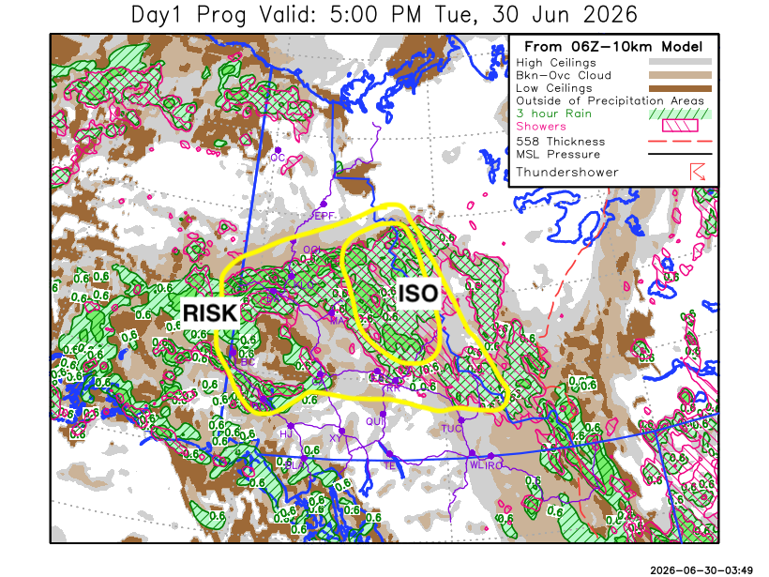
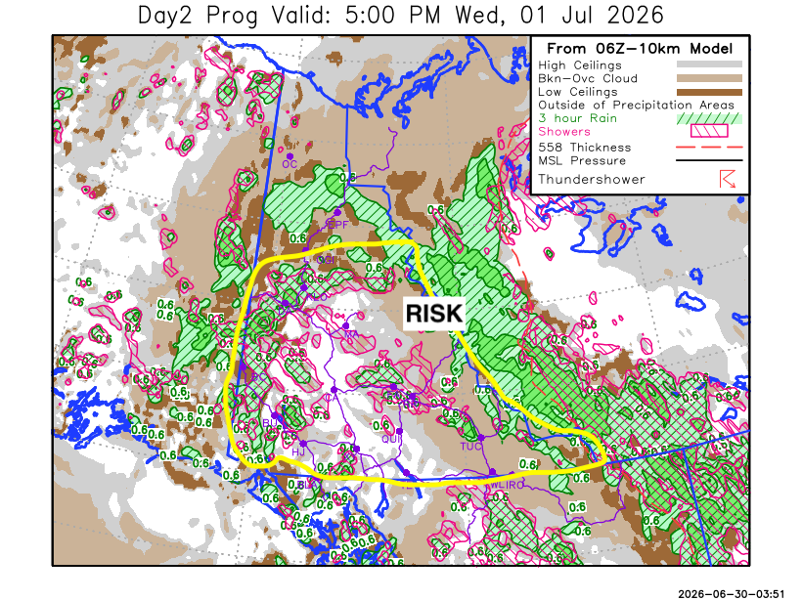

Forecast for | Wednesday | (Peak burning period and overnight)
Community | Clouds | Pcpn | POP | POL | Max Temp | Min RH | Min Temp | Max  RH | Wind Dir | Wind Speed
Old Crow | BKN | R-/RW- | 60 |  | 18 | 50 | 9 | 82 | 110 | 15
Klondike Fc | BKN | R-/TRW- | 70 | RISK | 18 | 60 | 9 | 91 | 320 | 10
Mayo A | BKN | RW-/TRW- | 60 | RISK | 18 | 55 | 12 | 89 | vrb | 5
Carmacks | BKN | RW-/TRW- | 60 | RISK | 18 | 35 | 9 | 89 | 180 | 5
Faro | BKN | RW-/TRW- | 70 | RISK | 16 | 50 | 6 | 90 | 250 | 10
Ross River | BKN | RW-/TRW- | 70 | RISK | 19 | 45 | 5 | 87 | 290 | 10
Beaver Creek Town | BKN | R-/TRW- | 80 | RISK | 14 | 70 | 6 | 91 | 290 | 20G30
Burwash A | BKN | R-/TRW- | 70 | RISK | 12 | 65 | 5 | 92 | 320 | 10G20
Haines Junction | BKN | RW-/TRW- | 40 | RISK | 17 | 35 | 5 | 91 | 220 | 10G20
Whitehorse Auto | BKN | RW-/TRW- | 60 | RISK | 15 | 40 | 7 | 86 | 220 | 10
Teslin | SCT | RW-/TRW- | 40 | RISK | 15 | 30 | 6 | 73 | 220 | 10G20
Watson Lake | BKN | RW-/TRW- | 40 | RISK | 18 | 40 | 8 | 72 | 250 | 10G25

Forecast for |  |  | Thursday |  |  | (Peak burning period and overnight)
Community |  |  | Clouds |  |  | Pcpn | POP |  | POL |  | Max Temp |  | Min RH | Min Temp | Max  RH | Wind Dir | Wind Speed
Old Crow |  |  | OVC |  |  | R | 80 |  |  |  | 14 |  | 75 | 5 | 92 | 20 | 20G40
Klondike Fc |  |  | OVC |  |  | R-/RW- | 60 |  |  |  | 15 |  | 65 | 8 | 94 | 320 | 10G20
Mayo A |  |  | BKN |  |  | R-/RW- | 70 |  |  |  | 15 |  | 70 | 10 | 92 | 300 | 10
Carmacks |  |  | BKN |  |  | R-/RW- | 70 |  |  |  | 16 |  | 60 | 7 | 92 | vrb | 5-10
Faro |  |  | BKN |  |  | R-/TRW- | 70 |  | RISK |  | 14 |  | 65 | 5 | 91 | 250 | 10G20
Ross River |  |  | BKN |  |  | R-/TRW- | 70 |  | RISK |  | 17 |  | 50 | 4 | 85 | 220 | 10
Beaver Creek Town |  |  | BKN |  |  | R-/RW- | 70 |  |  |  | 16 |  | 70 | 4 | 92 | 290 | 15G30
Burwash A |  |  | BKN |  |  | R-/RW- | 70 |  |  |  | 12 |  | 70 | 5 | 92 | 290 | 10G20
Haines Junction |  |  | BKN |  |  | R-/RW- | 60 |  |  |  | 16 |  | 45 | 4 | 92 | 200 | 15G25
Whitehorse Auto |  |  | BKN |  |  | R-/RW- | 70 |  |  |  | 13 |  | 60 | 5 | 84 | 220 | 10G20
Teslin |  |  | BKN |  |  | R-/RW- | 70 |  |  |  | 14 |  | 50 | 5 | 81 | 220 | 10G25
Watson Lake |  |  | BKN |  |  | R-/RW- | 70 |  |  |  | 14 |  | 50 | 7 | 69 | 220 | 10G25
3-Day Forecast Precipitation Totals from 13:00 Yesterday
OC | 10.1 |  | FA | 10.7 |  | JAK | 2.7
EPF | 28.3 |  | RR | 6.6 |  | TE | 2.8
ANT | 20.5 |  | BC | 24.9 |  | QUI | 3.9
DA | 19.6 |  | BCT | 24.3 |  | SWI | 1.5
FMI | 19.4 |  | BU | 21.6 |  | FL | 9.0
HEN | 21.0 |  | HJF | 5.7 |  | TUC | 6.9
BAR | 15.7 |  | RAI | 1.5 |  | HAS | 4.5
MA | 13.1 |  | CH | 3.3 |  | TC | 4.3
STW | 8.7 |  | BR | 7.9 |  | WL | 2.4
WIL | 11.0 |  | NU | 6.0 |  | NA | NA
PE | 8.6 |  | XY | 5.4 |  | IRO | 7.7
CA | 24.0 |  | CC | 2.8 |  | NA | NA
DRU | 14.3 |  | ATL | 1.4 |  | NA | NA
Matt Desorcy Meteorologist

Disclaimer : The information in these forecasts is collected and prepared for internal use by the Government of Yukon. The forecasts are specifically designed to meet the needs of the Wildland Fire Management and may not cover the requirements of other parties. Weather warnings or advisories are not included as part of the forecasts. Wildland Fire Management makes no representation and provides no warranty as to the accuracy of its weather forecasts. Any use the recipient chooses to make of the forecasts will be at its sole risk.

