YUKON WILDLAND FIRE MANAGEMENT WEATHER FORECAST - 9:00 AM ISSUE

1-Jul-2026
YESTERDAY'S VALUES
Community | Max  Temp  (°C) | Diff.  from  Normal | Min Temp  (°C) | Diff. from Normal | Pcpn  (mm) | Min RH | Max RH | L110 | L30
Old Crow | 18.9 | -1.9 | 7.3 | -1.2 | 2.4 | 36 | 91 | 0 | 0
Fort Mcpherson Airport | 18.8 |  | 9.3 |  | 0.0 | 42 | 82 | 0 | 0
Rock River Climate | 16.2 |  | 9.2 |  | 0.0 | 42 | 67 | NA | NA
Eagle Plains Fire | 19.2 |  | 6.7 |  | 4.4 | 30 | 99 | 0 | 0
Antimony Creek | 18.0 |  | 7.8 |  | 10.8 | 51 | 100 | 30 | 1
Klondike Fc | 20.0M | -3.0 | 10.0M | 2.3 | 8.0M | 60M | 100M | 29 | 0
Forty Mile | 17.2 |  | 8.9 |  | 8.0 | 49 | 96 | 0 | 0
Henderson | 13.8 |  | 6.0 |  | 12.2 | 64 | 100 | 30 | 2
Barlow | 20.3 |  | 6.1 |  | 12.6 | 41 | 99 | 33 | 9
Mayo A | 18.4 | -4.1 | 8.7 | -0.2 | 2.4 | 49 | 100 | 29 | 1
Stewart Crossing | 21.1 |  | 6.3 |  | 1.7 | 31 | 98 | 36 | 0
Willow Creek | 18.5 |  | 5.3 |  | 0.0 | 36 | 95 | 31 | 0
Pelly Farm | 20.9 | -1.6 | 6.5 | -1.3 | 0.0 | 36 | 96 | 27 | 1
Carmacks | 21.1 |  | 4.0 |  | 0.0 | 29 | 91 | 2 | 0
Drury Creek | 16.3 |  | 4.3 |  | 0.0 | 44 | 94 | 5 | 0
Faro | 15.0 | -5.8 | 3.0 | -5.5 | 1.6 | 71M | 94M | 29 | 0
Ross River | 17.9 |  | 1.0 |  | 0.0 | 48 | 96 | 52 | 1
Macmillan Pass | 18.7 |  | 4.6 |  | 6.8 | 26 | 100 | 58 | 0
Beaver Creek A | 10.8 | -9.4 | 6.0 | -1.0 | 18.0 | 73 | 97 | 0 | 0
Beaver Creek Town | 11.4 |  | 6.3 |  | 16.9 | 68 | 96 | 0 | 0
Burwash A | 9.5 | -9.5 | 5.2 | -0.4 | 3.0M | 81 | 98 | 0 | 0
Haines Junction | 17.9 | -1.1 | 0.9 | -3.2 | 0.0 | 35 | 94 | 0 | 0
Rainbow | 17.1 |  | 3.8 |  | 0.0 | 33 | 86 | 0 | 0
Champagne | 16.7 |  | 1.1 |  | 0.0 | 28 | 85 | 0 | 0
Braeburn | 16.5 |  | 2.6 |  | 0.0 | 34 | 91 | 0 | 0
Nursery | 17.1 |  | 6.3 |  | 0.0 | 32 | 91 | 0 | 0
Whitehorse Auto | 16.2 | -3.9 | 7.7 | 0.8 | 0.0 | 30 | 68 | 0 | 0
Mount Sima | 12.9 |  | 4.7 |  | 0.0 | 36 | 74 | 0 | 0
Carcross | 17.2 |  | 1.7 |  | 0.0 | 36 | 90 | 0 | 0
Atlin | 16.6 |  | 3.2 |  | 0.0 | 32 | 74 | 0 | 0
Jakes Corner | 16.1 |  | 2.5 |  | 0.0 | 33 | 84 | 0 | 0
Teslin | 16.3 |  | 2.5 |  | 0.0 | 33 | 85 | 0 | 0
Quiet Lake | 17.1 |  | 0.9 |  | 0.0 | 42 | 95 | 0 | 0
Swift River | 16.2 |  | -0.9 |  | 0.0 | 34 | 94 | 0 | 0
Tuchitua | 22.6 |  | 4.3 |  | 0.0 | 33 | 99 | 13 | 0
Hasselburg | 18.8 |  | 3.5 |  | 0.0 | 36 | 81 | 11 | 0
Tom Creek | 20.8 |  | 7.4 |  | 0.0 | 33 | 65 | 1 | 0
Watson Lake | 20.7 | -0.1 | 8.3 | 0.1 | 0.0 | 22 | 70 | 0 | 0
Iron Creek | 22.6 |  | 8.3 |  | 0.0 | 24 | 87 | 0 | 0
Max Temp is the actual maximum temperature in °C from yesterday afternoon or evening.
Min Temp is the actual overnight minimum temperature in °C up until 6:00 AM this morning.
Diff. from Normal is the difference from the 30 year average max or min temperature.
Pcpn is the precipitation in mm since 13:00 yesterday.
Min RH is the minimum observed RH in % from yesterday afternoon or evening.
Max RH is the maximum observed overnight RH in % up until 6:00 AM this morning.
L110 is the actual number of lightning strikes within 110 km and in the Yukon for 24 hours ending at 06:00 AM this morning.
L30 is the actual number of lightning strikes within 30 km and in the Yukon for 24 hours ending at 06:00 AM this morning.
M is missing data. * denotes precipitation at stations that failed to report for at least part of the evening and overnight period.

SYNOPSIS:
Today: Troughing continues to drive weather conditions across the Territory, brining unsettled weather in the form of showers with a risk of a thunderstorm through most regions. Intermittent rains with embedded thunder in parts of the Klondike and Kluane as the band of precipitation tied to the surface low pivots into these regions. Activity will be most isolated (spotty) through Southern Lakes, Tintina, western Tatchun, and Mayo district. Light rain arriving in Old Crow this afternoon. An area of steadier rain is forecast to push into the Territory from east to west overnight tonight as a deep surface low develops along the NWT/Yukon border. Temperatures remain below seasonal values in the teens with a few stations reaching low twenties, and winds light to moderate west/northwesterly. RHs near or above 30%.

Thursday: A strong low-pressure system is expected to develop and become centered over the Yukon/NWT border by tonight. This will push a band of moderate rain through a broad area of the Territory overnight tonight into Thursday. Heaviest rains are expected to fall through Tatchun, Kluane, Klondike, and Northern Tutchone – a broad area of 10-20 mm is likely to fall, with localized heavier amounts up to 20-40 mm. Lower and spottier rainfall amounts expected in southern Yukon, particularly Southern Lakes/Haines Junction district. Temperatures are expected to be near to below seasonal values, generally in the teens across much of the Yukon. Winds moderate southwesterly to westerly, except northerly in Old Crow.

Friday: Broad upper-level troughing (and associated surface low along the NWT/Yukon border) remains in place through the late-week. This will keep temperatures near to below seasonal values and continue to plague a large area of the Territory with showers/light rain and cloudier skies. The only areas that may see some clearing on Friday are in southern Yukon, through the Haines Junction district, Southern Lakes, and Tintina, but temperatures here remain in the teens with RHs in the 30-45% range.

Saturday: The surface low along the NWT/Yukon border exits the region, leaving broken cloud cover through a broad area of the Territory and a few isolated showers. Southern Yukon may see some sunnier breaks, but temperatures broadly remain below seasonal values in the teens. Skies begin to clear late in the day across much of the Territory.

Sunday: Upper low in the Gulf of Alaska may bring a few scattered convective showers or thundershowers to the western half of the Territory, while variable cloudiness is forecast through the eastern half. Temperatures generally remain in the teens to low twenties.

Forecast for | Wednesday | (Peak burning period and overnight)
Community | Clouds | Pcpn | POP | POL | Max Temp | Min RH | Min Temp | Max  RH | Wind Dir | Wind Speed
Old Crow | BKN | R- | 60 |  | 18 | 55 | 9 | 90 | 40 | 15
Klondike Fc | BKN | R-/TRW- | 70 | RISK | 18 | 55 | 9 | 88 | 320 | 10
Mayo A | BKN | RW-/TRW- | 40 | RISK | 19 | 40 | 12 | 91 | 320 | 10
Carmacks | BKN | R-/RW- | 40 |  | 20 | 30 | 10 | 82 | 290 | 10
Faro | BKN | R/TRW- | 80 | RISK | 17 | 45 | 8 | 93 | 270 | 10
Ross River | BKN | R/TRW- | 80 | RISK | 19 | 35 | 6 | 91 | 250 | 10
Beaver Creek Town | BKN | R-/TRW- | 80 | RISK | 13 | 75 | 5 | 90 | 290 | 20G30
Burwash A | BKN | R-/TRW- | 80 | RISK | 13 | 60 | 6 | 90 | 290 | 10-15
Haines Junction | BKN | RW-/TRW- | 40 | RISK | 18 | 30 | 6 | 89 | 220 | 10-15
Whitehorse Auto | BKN | RW-/TRW- | 30 | RISK | 16 | 35 | 8 | 81 | 250 | 10-15
Teslin | BKN | RW-/TRW- | 30 | RISK | 16 | 30 | 7 | 74 | 250 | 10-15
Watson Lake | BKN | R-/RW- | 40 |  | 17 | 35 | 7 | 82 | 290 | 10G25
POP is probability of precipitation in %.
POL is probability of lightning in %.

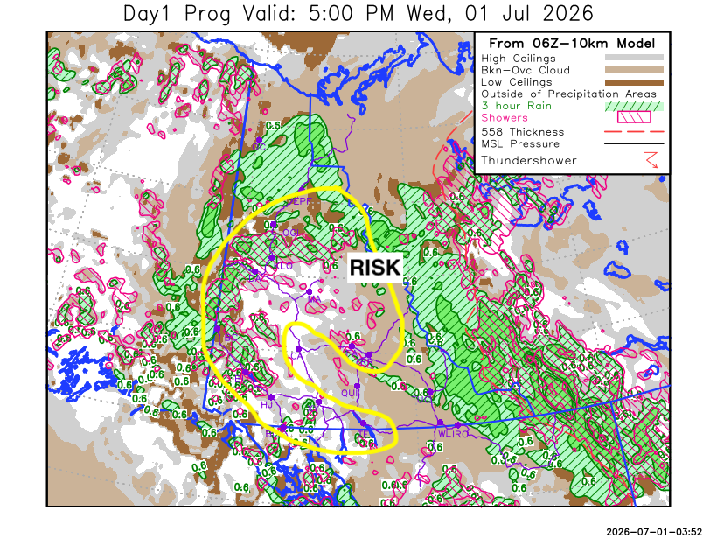
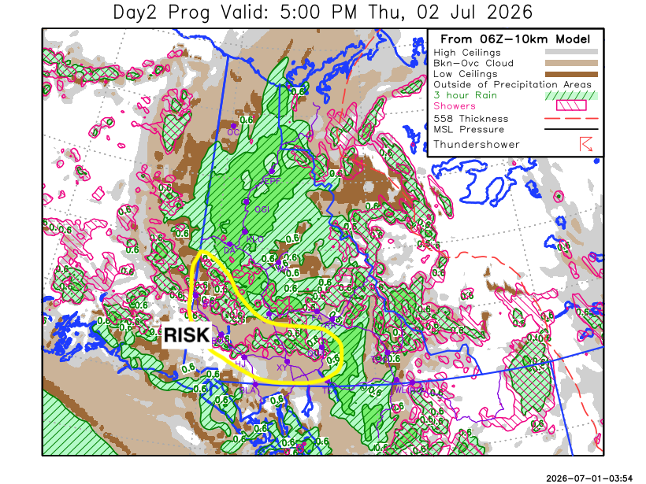

Forecast for | Thursday | (Peak burning period and overnight)
Community | Clouds | Pcpn | POP | POL | Max Temp | Min RH | Min Temp | Max  RH | Wind Dir | Wind Speed
Old Crow | OVC | R | 80 |  | 15 | 65 | 4 | 93 | 0 | 25G45
Klondike Fc | OVC | R | 80 |  | 14 | 75 | 8 | 93 | 290 | 10G25
Mayo A | OVC | R | 80 |  | 13 | 85 | 11 | 93 | 220 | 10
Carmacks | OVC | R | 80 |  | 16 | 55 | 8 | 91 | 290 | 15G30
Faro | OVC | R | 80 |  | 12 | 80 | 5 | 90 | 250 | 15G35
Ross River | OVC | R | 80 |  | 15 | 65 | 4 | 82 | 220 | 10G20
Beaver Creek Town | OVC | R/TRW- | 80 | RISK | 15 | 65 | 6 | 90 | 290 | 20G35
Burwash A | BKN | R-/TRW- | 70 | RISK | 14 | 60 | 6 | 88 | 290 | 15G30
Haines Junction | BKN | RW-/TRW- | 30 | RISK | 17 | 45 | 5 | 84 | 200 | 15G30
Whitehorse Auto | BKN | RW-/TRW- | 60 | RISK | 16 | 35 | 6 | 77 | 270 | 15G30
Teslin | SCT | R | 70 |  | 12 | 55 | 4 | 81 | 220 | 10G25
Watson Lake | BKN | R- | 70 |  | 13 | 55 | 6 | 83 | 220 | 15G30

Forecast for |  |  | Friday |  |  | (Peak burning period and overnight)
Community |  |  | Clouds |  |  | Pcpn | POP |  | POL |  | Max Temp |  | Min RH | Min Temp | Max  RH | Wind Dir | Wind Speed
Old Crow |  |  | OVC |  |  | R | 90 |  |  |  | 8 |  | 80 | 4 | 92 | 20 | 20G40
Klondike Fc |  |  | BKN |  |  | R- | 60 |  |  |  | 15 |  | 60 | 6 | 90 | 290 | 10G25
Mayo A |  |  | BKN |  |  | R-/TRW- | 70 |  | RISK |  | 14 |  | 75 | 9 | 89 | 270 | 10
Carmacks |  |  | OVC |  |  | R | 90 |  |  |  | 15 |  | 70 | 8 | 89 | 200 | 10
Faro |  |  | OVC |  |  | R- | 60 |  |  |  | 12 |  | 70 | 5 | 89 | 250 | 10G25
Ross River |  |  | BKN |  |  | R- | 40 |  |  |  | 15 |  | 50 | 4 | 81 | 250 | 10G25
Beaver Creek Town |  |  | OVC |  |  | R | 90 |  |  |  | 14 |  | 70 | 5 | 89 | 290 | 15G30
Burwash A |  |  | OVC |  |  | R | 90 |  |  |  | 13 |  | 65 | 6 | 89 | 270 | 10
Haines Junction |  |  | BKN |  |  | R- | 40 |  |  |  | 16 |  | 45 | 4 | 90 | 200 | 15G30
Whitehorse Auto |  |  | BKN |  |  | R- | 30 |  |  |  | 15 |  | 35 | 7 | 81 | 220 | 15G30
Teslin |  |  | SCT |  |  |  | 10 |  |  |  | 15 |  | 35 | 6 | 80 | 220 | 15G35
Watson Lake |  |  | SCT |  |  |  | 10 |  |  |  | 16 |  | 35 | 7 | 71 | 250 | 15G35
3-Day Forecast Precipitation Totals from 13:00 Yesterday
OC | 31.0 |  | FA | 20.5 |  | JAK | 2.5
EPF | 35.8 |  | RR | 10.7 |  | TE | 9.5
ANT | 22.4 |  | BC | 35.9 |  | QUI | 9.8
DA | 20.0 |  | BCT | 34.8 |  | SWI | 6.4
FMI | 21.9 |  | BU | 12.5 |  | FL | 19.6
HEN | 26.6 |  | HJF | 3.4 |  | TUC | 15.8
BAR | 29.3 |  | RAI | 3.3 |  | HAS | 13.2
MA | 18.2 |  | CH | 3.6 |  | TC | 11.7
STW | 20.2 |  | BR | 11.0 |  | WL | 11.4
WIL | 19.5 |  | NU | 5.7 |  | NA | NA
PE | 16.9 |  | XY | 6.0 |  | IRO | 6.8
CA | 14.8 |  | CC | 1.9 |  | NA | NA
DRU | 28.5 |  | ATL | 2.4 |  | NA | NA
Matt Desorcy Meteorologist

Disclaimer : The information in these forecasts is collected and prepared for internal use by the Government of Yukon. The forecasts are specifically designed to meet the needs of the Wildland Fire Management and may not cover the requirements of other parties. Weather warnings or advisories are not included as part of the forecasts. Wildland Fire Management makes no representation and provides no warranty as to the accuracy of its weather forecasts. Any use the recipient chooses to make of the forecasts will be at its sole risk.

