YUKON WILDLAND FIRE MANAGEMENT WEATHER FORECAST - 9:00 AM ISSUE

2-Jul-2026
YESTERDAY'S VALUES
Community | Max  Temp  (°C) | Diff.  from  Normal | Min Temp  (°C) | Diff. from Normal | Pcpn  (mm) | Min RH | Max RH | L110 | L30
Old Crow | 16.7 | -4.1 | 9.3 | 0.8 | 0.8 | 51 | 94 | 0 | 0
Fort Mcpherson Airport | 12.8 |  | 9.9 |  | 0.0 | 78 | 91 | 0 | 0
Rock River Climate | 9.2 |  | 5.5 |  | 4.2 | 60 | 100 | NA | NA
Eagle Plains Fire | 7.6 |  | 5.5 |  | 2.5 | 89 | 100 | 0 | 0
Antimony Creek | 20.0 |  | 6.8 |  | 0.0 | 38 | 97 | 11 | 2
Klondike Fc | 19.3M | -3.8 | 8.4M | 0.6 | 1.1M | 49M | 96M | 11 | 2
Forty Mile | 17.4 |  | 9.0 |  | 0.6 | 50 | 89 | 5 | 0
Henderson | 16.2 |  | 6.1 |  | 0.5 | 40 | 95 | 11 | 2
Barlow | 20.4 |  | 7.5 |  | 0.0 | 26 | 88 | 11 | 0
Mayo A | 20.3M | -2.3 | 10.8M | 1.9 | 0.0 | 28M | 76M | 3 | 0
Stewart Crossing | 21.3 |  | 11.1 |  | 0.0 | 24 | 69 | 5 | 0
Willow Creek | 20.1 |  | 5.7 |  | 0.0 | 24 | 87 | 6 | 0
Pelly Farm | 22.8 | 0.3 | 8.3 | 0.4 | 0.0 | 25 | 83 | 6 | 0
Carmacks | 22.8 |  | 8.4 |  | 0.0 | 22 | 74 | 3 | 0
Drury Creek | 21.0 |  | 8.8 |  | 0.3 | 27 | 96 | 3 | 2
Faro | 19.6 | -1.3 | 8.5 | -0.1 | 6.4 | 42M | 89M | 3 | 0
Ross River | 22.0 |  | 7.3 |  | 6.2 | 25 | 97 | 0 | 0
Macmillan Pass | 10.1 |  | 5.9 |  | 9.6 | 73 | 100 | 0 | 0
Beaver Creek A | 12.4 | -7.9 | 7.8 | 0.7 | 0.0 | 68 | 90 | 0 | 0
Beaver Creek Town | 12.3 |  | 7.8 |  | 0.0 | 67 | 93 | 0 | 0
Burwash A | 12.6 | -6.4 | 6.7 | 1.0 | 0.0M | 64 | 90 | 0 | 0
Haines Junction | 20.2 | 1.3 | 6.3 | 1.7 | 0.0 | 24 | 88 | 0 | 0
Rainbow | 18.0 |  | 5.3 |  | 1.6 | 32 | 95 | 0 | 0
Champagne | 17.7 |  | 5.7 |  | 5.8 | 30 | 96 | 0 | 0
Braeburn | 18.8 |  | 7.7 |  | 0.0 | 30 | 93 | 2 | 0
Nursery | 18.0 |  | 6.5 |  | 5.4 | 30 | 97 | 0 | 0
Whitehorse Auto | 15.6 | -4.5 | 5.7 | -1.3 | 3.0 | 30 | 97 | 0 | 0
Mount Sima | 12.5 |  | 4.1 |  | 0.5 | 32 | 88 | 0 | 0
Carcross | 15.8 |  | 3.4 |  | 0.0 | 35 | 83 | 0 | 0
Atlin | 14.4 |  | 4.1 |  | 0.0 | 30 | 73 | 0 | 0
Jakes Corner | 16.5 |  | 3.0 |  | 0.0 | 29 | 80 | 0 | 0
Teslin | 15.8 |  | 7.6 |  | 0.0 | 31 | 65 | 0 | 0
Quiet Lake | 22.2 |  | 5.7 |  | 1.3 | 33 | 97 | 0 | 0
Swift River | 17.9 |  | 5.6 |  | 0.0 | 28 | 77 | 0 | 0
Tuchitua | 17.4 |  | 6.7 |  | 1.7 | 44 | 99 | 0 | 0
Hasselburg | 18.3 |  | 5.0 |  | 0.0 | 31 | 96 | 0 | 0
Tom Creek | 16.7 |  | 4.8 |  | 3.8 | 35 | 98 | 0 | 0
Watson Lake | 17.7 | -3.1 | 7.4 | -0.9 | 1.6 | 34 | 97 | 0 | 0
Iron Creek | 16.6 |  | 5.0 |  | 0.0 | 47 | 99 | 0 | 0
Max Temp is the actual maximum temperature in °C from yesterday afternoon or evening.
Min Temp is the actual overnight minimum temperature in °C up until 6:00 AM this morning.
Diff. from Normal is the difference from the 30 year average max or min temperature.
Pcpn is the precipitation in mm since 13:00 yesterday.
Min RH is the minimum observed RH in % from yesterday afternoon or evening.
Max RH is the maximum observed overnight RH in % up until 6:00 AM this morning.
L110 is the actual number of lightning strikes within 110 km and in the Yukon for 24 hours ending at 06:00 AM this morning.
L30 is the actual number of lightning strikes within 30 km and in the Yukon for 24 hours ending at 06:00 AM this morning.
M is missing data. * denotes precipitation at stations that failed to report for at least part of the evening and overnight period.

SYNOPSIS:
Today: Wet and below seasonal temperatures continue. General amounts of 5-10mm are expected throughout much of the territory. The heaviest rain will fall over the Pelly Mountains where 40-60 mm is expected and 20-30 mm is expected from the Pelly to the Selwyn/Wernecke Mountains, and around 20 mm over the eastern Richardson Mountains. Over the southern half of the territory, rainfall will generally be showery but over the northern half steady rain will move in through the afternoon and continue overnight. Temperatures are expected to be near to below seasonal values, generally in the teens across much of the Yukon. Winds moderate southwesterly to westerly, except northerly in Old Crow.
Friday: Rain continues over northern and central Yukon and showers linger over the south. Broad upper-level troughing (and associated surface low along the NWT/Yukon border) remains in place and will keep temperatures near to below seasonal. Steady rain is expected throughout much of the day over Klondike and Northern Tutchone with general amounts of 5-15mm, and locally 40mm. The only areas that may see some clearing on Friday are in far southern regions of Tintina and Southern Lakes where minimum relative humidity will fall close to 35%.
Saturday: The surface low along the NWT/Yukon border exits the region, leaving broken cloud cover through a broad area of the Territory and a scattered shower. Southern Yukon may see some sunnier breaks, but temperatures broadly remain below seasonal values in the teens and minimum RH around 40%. Skies begin to clear late in the day across much of the Territory.
Sunday: Upper low in the Gulf of Alaska may bring a few scattered convective showers or thundershowers to the southern half of the Territory. Temperatures generally remain in the teens to low twenties and minimum RH values of 40% will be common.
Monday: Scattered showers and/or thundershowers continue over the southern half of the territory with daytime highs in the teens to low 20s. Over the northern half of the territory skies should remain precipitation free and minimum relative humidity values have a shot at approaching 30%.

Forecast for | Thursday | (Peak burning period and overnight)
Community | Clouds | Pcpn | POP | POL | Max Temp | Min RH | Min Temp | Max  RH | Wind Dir | Wind Speed
Old Crow | OVC | R- | 20 | NIL | 16 | 40 | 6 | 90 | 30 | 20G30
Klondike Fc | OVC | R- | 40 | NIL | 14 | 65 | 8 | 85 | 330 | 10
Mayo A | OVC | R- | 80 | NIL | 14 | 60 | 10 | 90 | 0 | 10
Carmacks | OVC | R | 60 | NIL | 15 | 55 | 10 | 95 | 330 | 10
Faro | OVC | R | 80 | NIL | 10 | 70 | 6 | 95 | 300 | 10
Ross River | OVC | R- | 40 | NIL | 16 | 50 | 3 | 90 | 200 | 10
Beaver Creek Town | BKN | RW-/TRW- | 40 | RISK | 17 | 50 | 7 | 85 | 290 | 15
Burwash A | BKN | RW-/TRW- | 40 | RISK | 15 | 55 | 8 | 90 | 320 | 15
Haines Junction | BKN | RW-/TRW- | 40 | RISK | 17 | 45 | 5 | 90 | 250 | 15
Whitehorse Auto | BKN | R | 80 | NIL | 12 | 75 | 6 | 95 | 220 | 5
Teslin | BKN | R- | 30 | NIL | 12 | 45 | 6 | 90 | 250 | 15
Watson Lake | BKN | RW-/TRW- | 40 | RISK | 16 | 40 | 6 | 85 | 220 | 10
POP is probability of precipitation in %.
POL is probability of lightning in %.

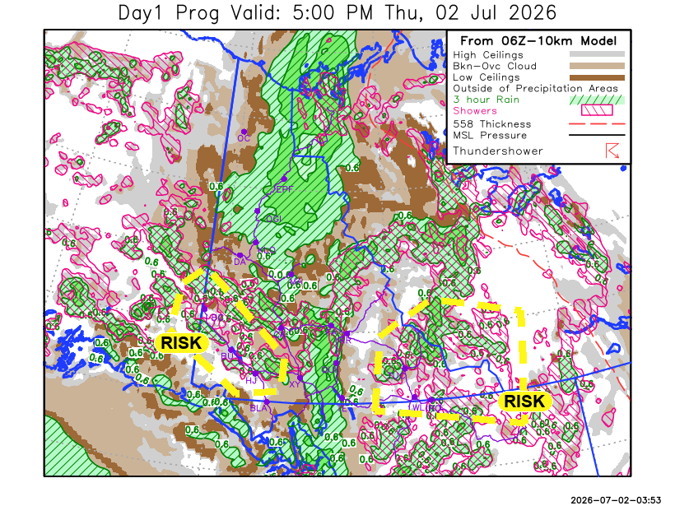
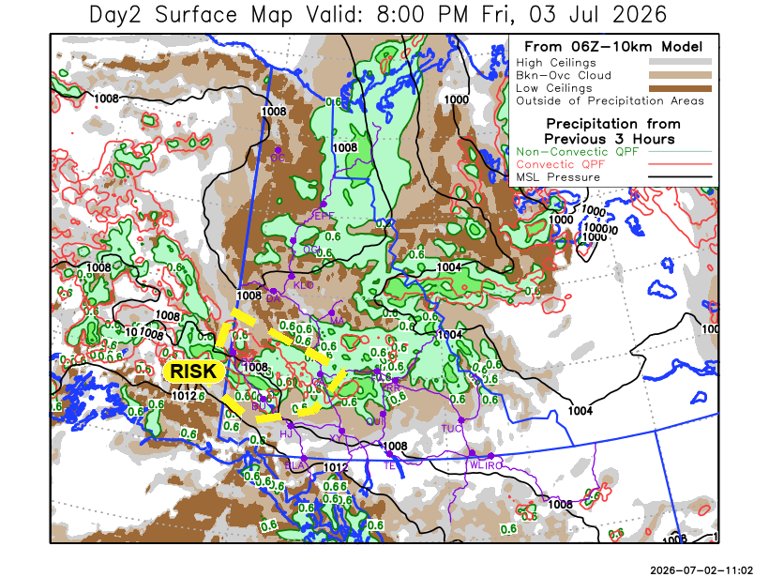

Forecast for | Friday | (Peak burning period and overnight)
Community | Clouds | Pcpn | POP | POL | Max Temp | Min RH | Min Temp | Max  RH | Wind Dir | Wind Speed
Old Crow | BKN | R | 80 | NIL | 11 | 70 | 7 | 90 | 150 | 10
Klondike Fc | BKN | RW- | 40 | NIL | 13 | 50 | 7 | 80 | 340 | 15
Mayo A | BKN | R | 80 | NIL | 12 | 80 | 9 | 80 | 320 | 10
Carmacks | OVC | RW-/TRW- | 80 | RISK | 15 | 70 | 8 | 85 | 350 | 10
Faro | OVC | R | 80 | NIL | 10 | 75 | 5 | 95 | 270 | 10
Ross River | OVC | R- | 80 | NIL | 10 | 70 | 4 | 85 | 250 | 10
Beaver Creek Town | BKN | RW-/TRW- | 60 | RISK | 17 | 50 | 6 | 85 | 290 | 10
Burwash A | BKN | R- | 60 | NIL | 14 | 65 | 7 | 90 | 270 | 5
Haines Junction | BKN | R- | 20 | NIL | 17 | 40 | 5 | 85 | 270 | 15
Whitehorse Auto | BKN | R- | 20 | NIL | 15 | 45 | 7 | 85 | 240 | 10
Teslin | SCT |  | 10 | NIL | 15 | 35 | 6 | 80 | 220 | 20G35
Watson Lake | SCT |  | 10 | NIL | 16 | 35 | 7 | 75 | 250 | 15

Forecast for |  |  | Saturday |  |  | (Peak burning period and overnight)
Community |  |  | Clouds |  |  | Pcpn | POP |  | POL |  | Max Temp |  | Min RH | Min Temp | Max  RH | Wind Dir | Wind Speed
Old Crow |  |  | BKN |  |  | R- | 40 |  | NIL |  | 12 |  | 65 | 5 | 85 | 90 | 5
Klondike Fc |  |  | SCT |  |  | R- | 20 |  | NIL |  | 16 |  | 35 | 10 | 85 | 50 | 5
Mayo A |  |  | FEW |  |  | R- | 20 |  | NIL |  | 14 |  | 40 | 10 | 85 | 0 | 5
Carmacks |  |  | SCT |  |  | RW- | 20 |  | NIL |  | 14 |  | 40 | 9 | 85 | 0 | 10
Faro |  |  | SCT |  |  | RW- | 20 |  | NIL |  | 13 |  | 40 | 6 | 90 | 300 | 5
Ross River |  |  | SCT |  |  | RW- | 20 |  | NIL |  | 13 |  | 40 | 4 | 85 | 330 | 5
Beaver Creek Town |  |  | BKN |  |  | RW- | 40 |  | NIL |  | 17 |  | 45 | 6 | 85 | 300 | 5
Burwash A |  |  | BKN |  |  | R- | 60 |  | NIL |  | 12 |  | 55 | 7 | 85 | 140 | 5
Haines Junction |  |  | FEW |  |  | R- | 20 |  | NIL |  | 13 |  | 45 | 4 | 95 | 180 | 10
Whitehorse Auto |  |  | BKN |  |  | R- | 20 |  | NIL |  | 13 |  | 55 | 8 | 85 | 220 | 10
Teslin |  |  | SCT |  |  | R- | 20 |  | NIL |  | 13 |  | 50 | 7 | 85 | 250 | 10
Watson Lake |  |  | SCT |  |  | R- | 20 |  | NIL |  | 13 |  | 45 | 9 | 75 | 270 | 15
3-Day Forecast Precipitation Totals from 13:00 Yesterday
OC | 21.3 |  | FA | 41.0 |  | JAK | 22.7
EPF | 25.4 |  | RR | 17.3 |  | TE | 8.7
ANT | 2.4 |  | BC | 10.6 |  | QUI | 21.3
DA | 3.3 |  | BCT | 10.6 |  | SWI | 7.5
FMI | 1.9 |  | BU | 7.0 |  | FL | 9.0
HEN | 3.4 |  | HJF | 1.0 |  | TUC | 8.5
BAR | 6.2 |  | RAI | 2.7 |  | HAS | 5.0
MA | 7.2 |  | CH | 10.0 |  | TC | 7.1
STW | 10.7 |  | BR | 23.4 |  | WL | 5.0
WIL | 9.8 |  | NU | 22.1 |  | NA | NA
PE | 9.0 |  | XY | 18.8 |  | IRO | 3.4
CA | 14.5 |  | CC | 12.0 |  | NA | NA
DRU | 24.3 |  | ATL | 6.1 |  | NA | NA
Dylan Kikuta Meteorologist

Disclaimer : The information in these forecasts is collected and prepared for internal use by the Government of Yukon. The forecasts are specifically designed to meet the needs of the Wildland Fire Management and may not cover the requirements of other parties. Weather warnings or advisories are not included as part of the forecasts. Wildland Fire Management makes no representation and provides no warranty as to the accuracy of its weather forecasts. Any use the recipient chooses to make of the forecasts will be at its sole risk.

