YUKON WILDLAND FIRE MANAGEMENT WEATHER FORECAST - 9:00 AM ISSUE

3-Jul-2026
YESTERDAY'S VALUES
Community | Max  Temp  (°C) | Diff.  from  Normal | Min Temp  (°C) | Diff. from Normal | Pcpn  (mm) | Min RH | Max RH | L110 | L30
Old Crow | 14.7 | -6.2 | 7.2 | -1.4 | 5.6 | 50 | 92 | 0 | 0
Fort Mcpherson Airport | 10.5 |  | 5.7 |  | 0.0 | 82 | 98 | 0 | 0
Rock River Climate | 7.1 |  | 2.1 |  | 29.8 | 97 | 100 | NA | NA
Eagle Plains Fire | 8.1 |  | 2.9 |  | 17.4 | 100 | 100 | 0 | 0
Antimony Creek | 17.2 |  | 9.2 |  | 3.3 | 51 | 95 | 0 | 0
Klondike Fc | 18.2M | -4.9 | 12.2M | 4.3 | 0.0M | 47M | 75M | 0 | 0
Forty Mile | 17.0 |  | 8.7 |  | 0.0 | 49 | 87 | 0 | 0
Henderson | 14.2 |  | 6.6 |  | 0.3 | 59 | 94 | 0 | 0
Barlow | 13.0 |  | 7.8 |  | 7.4 | 68 | 99 | 0 | 0
Mayo A | 12.6 | -10.0 | 9.1 | 0.1 | 2.3 | 76 | 96 | 0 | 0
Stewart Crossing | 14.8 |  | 9.2 |  | 1.9 | 63 | 93 | 0 | 0
Willow Creek | 14.3 |  | 8.0 |  | 4.1 | 60 | 98 | 0 | 0
Pelly Farm | 20.3 | -2.3 | 9.6 | 1.6 | 3.0 | 40 | 97 | 0 | 0
Carmacks | 16.7 |  | 7.7 |  | 14.8 | 51 | 98 | 7 | 0
Drury Creek | 10.7 |  | 6.7 |  | 4.4 | 80 | 98 | 0 | 0
Faro | 11.2 | -9.7 | 6.6 | -2.1 | 2.8 | 98M | NA | 0 | 0
Ross River | 14.7 |  | 6.4 |  | 1.2 | 50 | 97 | 0 | 0
Macmillan Pass | 12.5 |  | 3.1 |  | 1.0 | 60 | 92 | 0 | 0
Beaver Creek A | 15.7 | -4.6 | 7.1 | -0.1 | 3.2 | 54 | 95 | 0 | 0
Beaver Creek Town | 16.5 |  | 7.7 |  | 2.4 | 51 | 95 | 0 | 0
Burwash A | 16.1 | -3.0 | 7.6 | 1.8 | 0.4M | 52 | 96 | 0 | 0
Haines Junction | 18.3 | 0.2 | 5.6 | 2.1 | 0.0 | 38 | 91 | 6 | 0
Rainbow | 17.0 |  | 7.2 |  | 0.0 | 42 | 70 | 7 | 0
Champagne | 14.9 |  | 7.2 |  | 0.3 | 48 | 73 | 7 | 0
Braeburn | 11.7 |  | 6.8 |  | 6.3 | 79 | 98 | 7 | 4
Nursery | 7.1 |  | 6.1 |  | 7.8 | 93 | 97 | 7 | 0
Whitehorse Auto | 7.0 | -13.2 | 5.6 | -1.4 | 6.4 | 85 | 100 | 7 | 0
Mount Sima | 4.6 |  | 3.7 |  | 4.8 | 76 | 99 | 7 | 0
Carcross | 8.2 |  | 5.3 |  | 8.8 | 67 | 99 | 0 | 0
Atlin | 12.2 |  | 5.6 |  | 1.8 | 42 | 89 | 0 | 0
Jakes Corner | 8.7 |  | 4.6 |  | 10.6 | 68 | 97 | 0 | 0
Teslin | 14.5 |  | 5.7 |  | 5.6 | 41 | 96 | 0 | 0
Quiet Lake | 10.8 |  | 5.0 |  | 1.4 | 68 | 98 | 0 | 0
Swift River | 14.2 |  | 4.3 |  | 1.6 | 39 | 91 | 5 | 0
Tuchitua | 17.9 |  | 5.7 |  | 3.6 | 41 | 99 | 16 | 1
Hasselburg | 12.4 |  | 4.4 |  | 2.7 | 55 | 99 | 14 | 3
Tom Creek | 15.8 |  | 4.6 |  | 0.3 | 37 | 93 | 17 | 2
Watson Lake | 15.3 | -5.6 | 7.0 | -1.4 | 1.0 | 36 | 90 | 17 | 0
Iron Creek | 18.8 |  | 3.0 |  | 0.3 | 24 | 99 | 14 | 1
Max Temp is the actual maximum temperature in °C from yesterday afternoon or evening.
Min Temp is the actual overnight minimum temperature in °C up until 6:00 AM this morning.
Diff. from Normal is the difference from the 30 year average max or min temperature.
Pcpn is the precipitation in mm since 13:00 yesterday.
Min RH is the minimum observed RH in % from yesterday afternoon or evening.
Max RH is the maximum observed overnight RH in % up until 6:00 AM this morning.
L110 is the actual number of lightning strikes within 110 km and in the Yukon for 24 hours ending at 06:00 AM this morning.
L30 is the actual number of lightning strikes within 30 km and in the Yukon for 24 hours ending at 06:00 AM this morning.
M is missing data. * denotes precipitation at stations that failed to report for at least part of the evening and overnight period.

SYNOPSIS:
Today: Wet weather continues over the territory along with below seasonal temperatures. Steady rain will fall over the Klondike region, but south of the Ogilvie/Wernecke Mountains rain showers mill around (heavy at times) over Northern Tutchone, Tatchun, Kluane, and northern sections of the Southern Lakes and Tintina. Friday’s totals will push 20-30mm over the Klondike region and generally 5-15 mm over the southern half with higher amounts over the Pelly Mountains and Selwyn Mountains. The rain clears late overnight into Saturday morning. A sliver of 30-35% RH will push into southern Tintina and the Southern Lakes region along with gusty westerly winds during the afternoon.
Saturday: Much drier conditions are expected but convective showers will develop, and daytime highs remain below seasonal. Spotty showers and thundershowers will persist throughout the day between the Pelly and Logan Mountains. Scattered convective showers and thundershowers will bubble in the afternoon and evening over the Klondike region and maybe northern Kluane and Southern Lakes. Air will be notably drier over the western Yukon Plateau and eastern Tintina, where minimum RH values of 35-40% will be common, while other regions remain above 40%.
Sunday: The air mass dries out further, and daytime highs are inching higher, but spotty showers linger over the Mountains. A few showers will develop over the higher terrain of the Ogilvie, Wernecke, Selwyn, and Logan Mountains, however some showers may push onto the Yukon Plateau over the Kluane and Tintina region. Daytime highs will generally be in the teens, and minimum relative humidity will sit around 40% but a few 30-35% readings can’t be ruled out.
Monday: Spotty showers continue over the southern half of the territory, but warm and marginally dry conditions finally return. Daytime highs will hit the low 20s and minimum relative humidity will generally fall withing 35-40%, but 30% readings can’t be ruled out. Breezy easterly winds may develop on the north side of the Ogilvie and Wernecke Mountains, but confidence is not high.
Tuesday: Warm and marginally dry RH is expected over much of the territory thanks to a southeasterly flow. Daytime highs will be in the low 20s and minimum RH around 30-35% with potentially a few 25% readings. Watch out for breezy easterly winds once again north of the Ogilvie and Wernecke Mountains. Rain showers are expected to build over Kluane, Southern Lakes, and Tintina as the next Pacific low rolls ashore and ushers cooler and damper air in yet again.

Forecast for | Friday | (Peak burning period and overnight)
Community | Clouds | Pcpn | POP | POL | Max Temp | Min RH | Min Temp | Max  RH | Wind Dir | Wind Speed
Old Crow | OVC | R-. | 80 | NIL | 9 | 70 | 6 | 90 | 90 | 10
Klondike Fc | BKN | RW- | 40 | NIL | 14 | 50 | 8 | 80 | 320 | 15
Mayo A | BKN | RW- | 40 | NIL | 11 | 60 | 9 | 80 | 320 | 10
Carmacks | OVC | RW-/TRW- | 80 | RISK | 11 | 80 | 8 | 90 | 320 | 5
Faro | OVC | RW- | 80 | NIL | 10 | 80 | 5 | 95 | 320 | 5
Ross River | BKN | RW- | 60 | NIL | 12 | 60 | 5 | 90 | 300 | 10
Beaver Creek Town | BKN | RW-/TRW- | 60 | RISK | 15 | 60 | 6 | 90 | 300 | 10
Burwash A | BKN | RW-/TRW- | 60 | RISK | 12 | 70 | 7 | 90 | 300 | 5
Haines Junction | BKN | RW- | 20 | NIL | 15 | 45 | 6 | 90 | 270 | 15
Whitehorse Auto | BKN | RW- | 20 | NIL | 14 | 50 | 8 | 85 | 250 | 10
Teslin | SCT |  | 10 | NIL | 15 | 35 | 7 | 75 | 250 | 15G40
Watson Lake | SCT |  | 10 | NIL | 16 | 35 | 7 | 75 | 270 | 15G35
POP is probability of precipitation in %.
POL is probability of lightning in %.

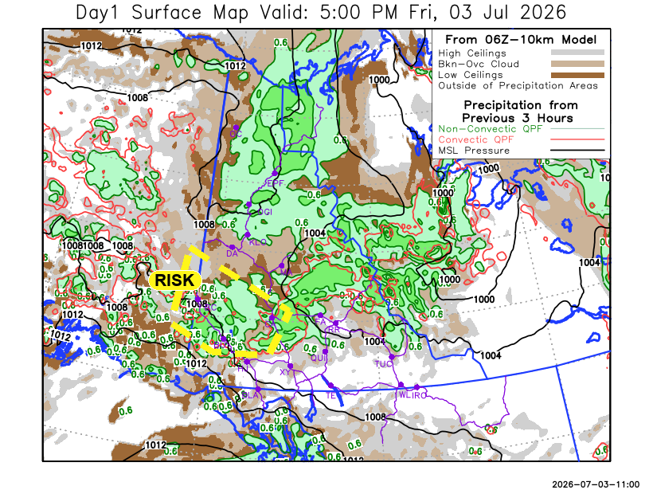
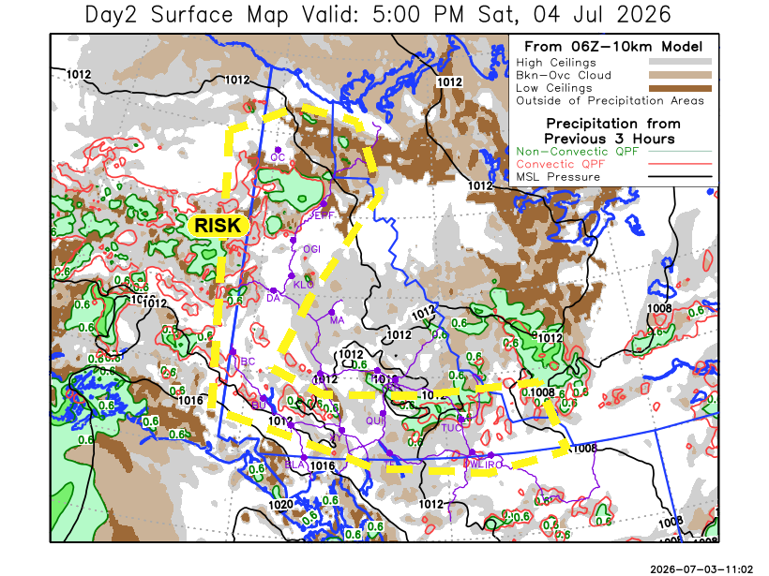

Forecast for | Saturday | (Peak burning period and overnight)
Community | Clouds | Pcpn | POP | POL | Max Temp | Min RH | Min Temp | Max  RH | Wind Dir | Wind Speed
Old Crow | BKN | RW-/TRW- | 40 | RISK | 14 | 55 | 7 | 90 | 90 | 10
Klondike Fc | BKN | RW-/TRW- | 40 | RISK | 18 | 35 | 10 | 90 | 200 | 5
Mayo A | SCT | RW- | 20 | NIL | 18 | 35 | 11 | 85 | 220 | 5
Carmacks | SCT |  | 10 | NIL | 17 | 40 | 8 | 85 | 180 | 5
Faro | SCT | RW- | 20 | NIL | 14 | 50 | 5 | 85 | 290 | 5
Ross River | SCT | RW- | 20 | NIL | 14 | 50 | 3 | 85 | 290 | 5
Beaver Creek Town | BKN | RW-/TRW- | 40 | RISK | 17 | 40 | 7 | 85 | 110 | 5
Burwash A | SCT | RW-/TRW- | 20 | RISK | 15 | 50 | 7 | 80 | 110 | 15
Haines Junction | FEW | RW-/TRW- | 15 | RISK | 17 | 40 | 5 | 90 | 270 | 10
Whitehorse Auto | BKN | RW-/TRW- | 20 | RISK | 17 | 45 | 7 | 85 | 180 | 5
Teslin | BKN | RW-/TRW- | 20 | RISK | 14 | 50 | 8 | 75 | 250 | 10
Watson Lake | SCT | RW-/TRW- | 20 | RISK | 16 | 45 | 8 | 75 | 270 | 15

Forecast for |  |  | Sunday |  |  | (Peak burning period and overnight)
Community |  |  | Clouds |  |  | Pcpn | POP |  | POL |  | Max Temp |  | Min RH | Min Temp | Max  RH | Wind Dir | Wind Speed
Old Crow |  |  | FEW |  |  |  | 0 |  | NIL |  | 20 |  | 35 | 10 | 75 | 100 | 5
Klondike Fc |  |  | BKN |  |  | RW-/TRW- | 20 |  | RISK |  | 20 |  | 40 | 9 | 80 | 40 | 5
Mayo A |  |  | SCT |  |  | RW-/TRW- | 40 |  | RISK |  | 18 |  | 45 | 11 | 80 | 40 | 5
Carmacks |  |  | SCT |  |  |  | 10 |  | NIL |  | 18 |  | 35 | 9 | 75 | 180 | 10
Faro |  |  | SCT |  |  | RW- | 20 |  | NIL |  | 15 |  | 50 | 7 | 85 | 300 | 5
Ross River |  |  | SCT |  |  | RW- | 20 |  | NIL |  | 15 |  | 40 | 6 | 75 | 300 | 5
Beaver Creek Town |  |  | BKN |  |  | RW-/TRW- | 60 |  | RISK |  | 15 |  | 55 | 6 | 90 | 290 | 5
Burwash A |  |  | SCT |  |  |  | 15 |  | NIL |  | 15 |  | 50 | 7 | 80 | 140 | 10
Haines Junction |  |  | BKN |  |  |  | 0 |  | NIL |  | 15 |  | 35 | 7 | 80 | 250 | 10
Whitehorse Auto |  |  | BKN |  |  |  | 0 |  | NIL |  | 15 |  | 40 | 9 | 80 | 180 | 10
Teslin |  |  | BKN |  |  |  | 10 |  | NIL |  | 15 |  | 40 | 8 | 80 | 220 | 10
Watson Lake |  |  | BKN |  |  | RW- | 20 |  | NIL |  | 17 |  | 40 | 10 | 75 | 250 | 10
3-Day Forecast Precipitation Totals from 13:00 Yesterday
OC | 12.5 |  | FA | 8.6 |  | JAK | 11.8
EPF | 31.4 |  | RR | 3.5 |  | TE | 6.4
ANT | 4.4 |  | BC | 13.6 |  | QUI | 3.4
DA | 1.7 |  | BCT | 12.8 |  | SWI | 1.8
FMI | 4.4 |  | BU | 6.8 |  | FL | 3.9
HEN | 2.6 |  | HJF | 1.0 |  | TUC | 6.1
BAR | 9.5 |  | RAI | 0.7 |  | HAS | 3.2
MA | 4.8 |  | CH | 1.7 |  | TC | 1.0
STW | 5.1 |  | BR | 16.0 |  | WL | 1.5
WIL | 7.2 |  | NU | 11.2 |  | NA | NA
PE | 5.6 |  | XY | 10.0 |  | IRO | 0.3
CA | 21.0 |  | CC | 9.5 |  | NA | NA
DRU | 13.4 |  | ATL | 1.8 |  | NA | NA
Dylan Kikuta Meteorologist

Disclaimer : The information in these forecasts is collected and prepared for internal use by the Government of Yukon. The forecasts are specifically designed to meet the needs of the Wildland Fire Management and may not cover the requirements of other parties. Weather warnings or advisories are not included as part of the forecasts. Wildland Fire Management makes no representation and provides no warranty as to the accuracy of its weather forecasts. Any use the recipient chooses to make of the forecasts will be at its sole risk.

