YUKON WILDLAND FIRE MANAGEMENT WEATHER FORECAST - 9:00 AM ISSUE

4-Jul-2026
YESTERDAY'S VALUES
Community | Max  Temp  (°C) | Diff.  from  Normal | Min Temp  (°C) | Diff. from Normal | Pcpn  (mm) | Min RH | Max RH | L110 | L30
Old Crow | 11.0 | -9.9 | 4.2 | -4.5 | 3.4 | 67 | 93 | 0 | 0
Fort Mcpherson Airport | 6.8 |  | 2.9 |  | 0.0M | 75 | 96 | 0 | 0
Rock River Climate | 3.1 |  | 1.2 |  | 17.0 | 93 | 100 | NA | NA
Eagle Plains Fire | 3.4 |  | 1.8 |  | 14.1 | 100 | 100 | 0 | 0
Antimony Creek | 14.1 |  | 4.7 |  | 0.0 | 43 | 92 | 0 | 0
Klondike Fc | 15.0M | -8.2 | 5.4M | -2.6 | 0.0M | 41M | 92M | 0 | 0
Forty Mile | 13.4 |  | 3.0 |  | 0.0 | 51 | 97 | 0 | 0
Henderson | 9.5 |  | 4.3 |  | 0.0 | 61 | 82 | 0 | 0
Barlow | 14.0 |  | 4.9 |  | 0.0 | 42 | 78 | 0 | 0
Mayo A | 14.8 | -7.9 | 6.1 | -3.0 | 0.2 | 43 | 76 | 0 | 0
Stewart Crossing | 15.4 |  | 6.7 |  | 0.0 | 40 | 71 | 0 | 0
Willow Creek | 12.6 |  | 4.6 |  | 1.1 | 54 | 85 | 0 | 0
Pelly Farm | 17.8 | -4.8 | 5.9 | -2.2 | 1.6 | 48 | 94 | 0 | 0
Carmacks | 15.2 |  | 6.7 |  | 11.3 | 67 | 98 | 0 | 0
Drury Creek | 13.8 |  | 6.2 |  | 6.1 | 66 | 98 | 0 | 0
Faro | 12.5 | -8.4 | 6.2 | -2.6 | 0.6 | 88M | 100M | 0 | 0
Ross River | 18.4 |  | 6.0 |  | 0.0 | 42 | 93 | 0 | 0
Macmillan Pass | 8.6 |  | 4.4 |  | 4.2 | 67 | 100 | 0 | 0
Beaver Creek A | 16.3 | -4.1 | 7.5 | 0.3 | 3.3M | 45 | 96 | 0 | 0
Beaver Creek Town | 16.6 |  | 7.8 |  | 2.3 | 40 | 97 | 0 | 0
Burwash A | 13.9 | -5.2 | 5.8 | -0.1 | 0.2M | 62 | 98 | 0 | 0
Haines Junction | 18.6 | -0.4 | 3.6 | -0.8 | 0.0 | 38 | 92 | 0 | 0
Rainbow | 17.5 |  | 6.3 |  | 0.0 | 37 | 74 | 0 | 0
Champagne | 16.6 |  | 7.9 |  | 0.0 | 40 | 68 | 0 | 0
Braeburn | 17.0 |  | 6.5 |  | 8.1 | 49 | 98 | 0 | 0
Nursery | 17.4 |  | 4.8 |  | 0.0 | 42 | 97 | 0 | 0
Whitehorse Auto | 15.3 | -4.9 | 5.3 | -1.8 | 1.0 | 46 | 98 | 0 | 0
Mount Sima | 12.8 |  | 4.9 |  | 0.0 | 46 | 87 | 0 | 0
Carcross | 16.6 |  | 3.7 |  | 0.0 | 37 | 92 | 0 | 0
Atlin | 16.2M |  | 2.3M |  | 0.0M | 31M | 83M | 0 | 0
Jakes Corner | 17.2 |  | 4.5 |  | 0.0 | 36 | 85 | 0 | 0
Teslin | 17.6 |  | 8.3 |  | 0.0 | 28 | 67 | 0 | 0
Quiet Lake | 13.9 |  | 5.5 |  | 0.0 | 59 | 96 | 0 | 0
Swift River | 17.2 |  | 1.0 |  | 0.0 | 27 | 93 | 0 | 0
Tuchitua | 13.7 |  | 4.7 |  | 0.0 | 58 | 99 | 0 | 0
Hasselburg | 14.5 |  | 4.1 |  | 0.0 | 52 | 91 | 0 | 0
Tom Creek | 14.5 |  | 3.4 |  | 0.0 | 46 | 88 | 0 | 0
Watson Lake | 17.3 | -3.7 | 5.8 | -2.7 | 0.0 | 33 | 80 | 0 | 0
Iron Creek | 20.6M |  | 2.0M |  | 0.0M | 26M | 98M | 0 | 0
Max Temp is the actual maximum temperature in °C from yesterday afternoon or evening.
Min Temp is the actual overnight minimum temperature in °C up until 6:00 AM this morning.
Diff. from Normal is the difference from the 30 year average max or min temperature.
Pcpn is the precipitation in mm since 13:00 yesterday.
Min RH is the minimum observed RH in % from yesterday afternoon or evening.
Max RH is the maximum observed overnight RH in % up until 6:00 AM this morning.
L110 is the actual number of lightning strikes within 110 km and in the Yukon for 24 hours ending at 06:00 AM this morning.
L30 is the actual number of lightning strikes within 30 km and in the Yukon for 24 hours ending at 06:00 AM this morning.
M is missing data. * denotes precipitation at stations that failed to report for at least part of the evening and overnight period.

SYNOPSIS:
Today: The steady rain is gone but rain showers are still expected today, and daytime highs remain below seasonal. Spotty showers and thundershowers over southern Yukon will drift south along a weak front extending from Kluane to the Logan Mountains. Also, a few showers and thundershowers will bubble over the Klondike region (generally north of the Ogilvie Mountains) with locally heavy downpours and convective wind gusts up to 50 km/h. Air will be notably drier than the last few days over southern Klondike and eastern Tintina, where minimum RH values of 35-40% will be common and a few 30% readings are possible, while other regions remain above 40%.
Sunday: Temperatures start to rebound even in the presence of spotty showers/thundershowers. A few 20C readings are expected over northern/central Yukon with minimum RH around 30-35%, but the odd 25% reading can’t be ruled out. Elsewhere, daytime highs will be in the teens with RH around 40%. Daytime heating will allow scattered showers and thundershowers to develop on the perimeter of the Mackenzie and Ogilvie Mountain ranges in addition to isolated activity over the Yukon Plateau.
Monday: Twenty-degree temperatures are expected once again over northern and central Yukon but rain showers over southern Yukon will keep conditions below seasonal. Rain shower coverage will be highest along the BC border and taper with northward extent to the Ogilvie Mountains. The driest air will be located over northern and central regions where 30-35% readings will be common along with the odd 25% readings here and there. Watch out for breezy winds just north of the Ogilvie and Wernecke Mountains.
Tuesday: Warm and marginally dry RH is expected over north and central Yukon thanks to a southeasterly flow but rain showers from the Pacific low will dampen conditions over the south. Daytime highs will be in the low 20s and minimum RH around 30-35% over northern and central Yukon with potentially a few 25% readings. Watch out for breezy easterly winds once again north of the Ogilvie and Wernecke Mountains.
Wednesday: Below seasonal conditions will return to the southern half of the Yukon yet again underneath unsettled skies, but northern Yukon may experience a warm and marginally dry afternoon. Forecast uncertainty is high regarding the northward extent of precipitation.

Forecast for | Saturday | (Peak burning period and overnight)
Community | Clouds | Pcpn | POP | POL | Max Temp | Min RH | Min Temp | Max  RH | Wind Dir | Wind Speed
Old Crow | BKN | RW-/TRW- | 40 | RISK | 15 | 50 | 8 | 90 | 90 | 10
Klondike Fc | SCT | RW- | 20 | NIL | 18 | 35 | 10 | 80 | 220 | 5
Mayo A | SCT |  | 10 | NIL | 16 | 40 | 11 | 80 | 180 | 5
Carmacks | SCT |  | 15 | NIL | 16 | 40 | 6 | 90 | 340 | 5
Faro | SCT | RW- | 20 | NIL | 12 | 45 | 8 | 85 | 300 | 5
Ross River | SCT | RW- | 40 | NIL | 12 | 50 | 3 | 85 | 300 | 5
Beaver Creek Town | BKN | RW-/TRW- | 60 | RISK | 18 | 50 | 8 | 85 | 120 | 5
Burwash A | BKN | RW-/TRW- | 40 | RISK | 14 | 60 | 8 | 85 | 130 | 10
Haines Junction | SCT | RW-/TRW- | 20 | RISK | 16 | 40 | 4 | 95 | 270 | 15
Whitehorse Auto | BKN | RW-/TRW- | 40 | RISK | 13 | 60 | 8 | 85 | 40 | 5
Teslin | BKN | RW-/TRW- | 60 | RISK | 14 | 50 | 8 | 80 | 290 | 10
Watson Lake | BKN | RW-/TRW- | 20 | RISK | 16 | 40 | 8 | 80 | 270 | 15
POP is probability of precipitation in %.
POL is probability of lightning in %.

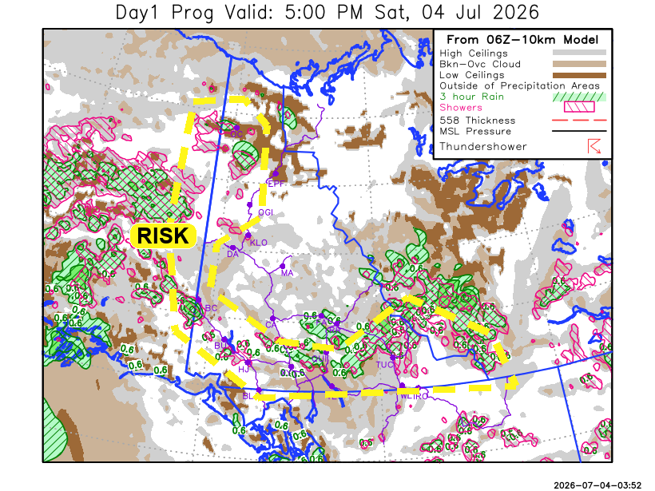
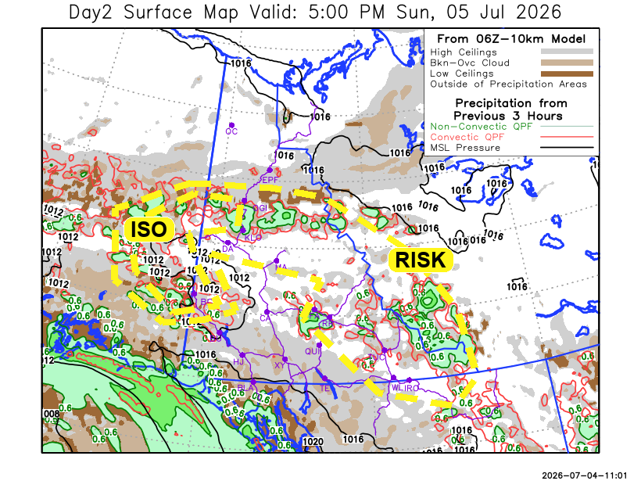

Forecast for | Sunday | (Peak burning period and overnight)
Community | Clouds | Pcpn | POP | POL | Max Temp | Min RH | Min Temp | Max  RH | Wind Dir | Wind Speed
Old Crow | FEW |  | 0 | NIL | 20 | 35 | 9 | 80 | 130 | 5
Klondike Fc | SCT | RW-/TRW- | 20 | RISK | 21 | 30 | 11 | 75 | 110 | 10
Mayo A | BKN | RW-/TRW- | 20 | RISK | 20 | 30 | 12 | 80 | 160 | 5
Carmacks | SCT |  | 15 | NIL | 18 | 30 | 9 | 75 | 180 | 10
Faro | SCT | RW-/TRW- | 20 | RISK | 16 | 45 | 7 | 85 | 250 | 5
Ross River | SCT | RW-/TRW- | 20 | RISK | 16 | 40 | 5 | 85 | 250 | 5
Beaver Creek Town | BKN | RW-/TRW- | 60 | ISO | 17 | 55 | 7 | 90 | 290 | 5
Burwash A | SCT |  | 10 | NIL | 14 | 45 | 6 | 80 | 140 | 20G40
Haines Junction | SCT |  | 0 | NIL | 16 | 40 | 5 | 90 | 200 | 10
Whitehorse Auto | SCT |  | 0 | NIL | 16 | 40 | 8 | 75 | 180 | 10
Teslin | BKN |  | 15 | NIL | 16 | 40 | 9 | 70 | 220 | 10
Watson Lake | SCT | RW-/TRW- | 20 | RISK | 17 | 40 | 9 | 75 | 250 | 10

Forecast for |  |  | Monday |  |  | (Peak burning period and overnight)
Community |  |  | Clouds |  |  | Pcpn | POP |  | POL |  | Max Temp |  | Min RH | Min Temp | Max  RH | Wind Dir | Wind Speed
Old Crow |  |  | FEW |  |  |  | 0 |  | NIL |  | 22 |  | 30 | 11 | 70 | 110 | 10
Klondike Fc |  |  | SCT |  |  | RW-/TRW- | 20 |  | RISK |  | 21 |  | 30 | 12 | 70 | 110 | 10
Mayo A |  |  | SCT |  |  | RW- | 20 |  | NIL |  | 21 |  | 30 | 14 | 70 | 100 | 10
Carmacks |  |  | BKN |  |  | RW- | 20 |  | NIL |  | 18 |  | 35 | 11 | 75 | 110 | 10
Faro |  |  | SCT |  |  | RW- | 20 |  | NIL |  | 17 |  | 40 | 9 | 75 | 110 | 10
Ross River |  |  | BKN |  |  | RW- | 20 |  | NIL |  | 18 |  | 35 | 8 | 75 | 110 | 10
Beaver Creek Town |  |  | BKN |  |  | RW-/TRW- | 20 |  | RISK |  | 18 |  | 40 | 7 | 80 | 110 | 10
Burwash A |  |  | BKN |  |  | RW- | 40 |  | NIL |  | 11 |  | 60 | 8 | 90 | 120 | 10
Haines Junction |  |  | OVC |  |  | RW- | 40 |  | NIL |  | 13 |  | 50 | 9 | 90 | 70 | 5
Whitehorse Auto |  |  | OVC |  |  | RW- | 40 |  | NIL |  | 15 |  | 50 | 11 | 90 | 160 | 10
Teslin |  |  | OVC |  |  | RW- | 40 |  | NIL |  | 15 |  | 50 | 11 | 85 | 160 | 10
Watson Lake |  |  | BKN |  |  | RW- | 20 |  | NIL |  | 18 |  | 35 | 13 | 70 | 130 | 15
3-Day Forecast Precipitation Totals from 13:00 Yesterday
OC | 3.8 |  | FA | 2.8 |  | JAK | 1.8
EPF | 16.4 |  | RR | 1.3 |  | TE | 1.2
ANT | 0.0 |  | BC | 10.3 |  | QUI | 2.4
DA | 0.0 |  | BCT | 9.3 |  | SWI | 1.9
FMI | 1.2 |  | BU | 1.7 |  | FL | 2.8
HEN | 0.0 |  | HJF | 0.3 |  | TUC | 1.2
BAR | 0.0 |  | RAI | 0.5 |  | HAS | 0.0
MA | 0.2 |  | CH | 0.7 |  | TC | 0.0
STW | 0.0 |  | BR | 9.1 |  | WL | 0.0
WIL | 1.1 |  | NU | 1.7 |  | NA | NA
PE | 1.6 |  | XY | 2.7 |  | IRO | 0.1
CA | 11.3 |  | CC | 1.9 |  | NA | NA
DRU | 7.6 |  | ATL | 0.7 |  | NA | NA
Dylan Kikuta Meteorologist

Disclaimer : The information in these forecasts is collected and prepared for internal use by the Government of Yukon. The forecasts are specifically designed to meet the needs of the Wildland Fire Management and may not cover the requirements of other parties. Weather warnings or advisories are not included as part of the forecasts. Wildland Fire Management makes no representation and provides no warranty as to the accuracy of its weather forecasts. Any use the recipient chooses to make of the forecasts will be at its sole risk.

