YUKON WILDLAND FIRE MANAGEMENT WEATHER FORECAST - 9:00 AM ISSUE

5-Jul-2026
YESTERDAY'S VALUES
Community | Max  Temp  (°C) | Diff.  from  Normal | Min Temp  (°C) | Diff. from Normal | Pcpn  (mm) | Min RH | Max RH | L110 | L30
Old Crow | 16.5 | -4.4 | 8.9 | 0.2 | 0.6 | 50 | 86
Fort Mcpherson Airport | 17.5 |  | 5.3 |  | 0.0M | 38 | 95
Rock River Climate | 12.8 |  | 6.4 |  | 0.2 | 44 | 76
Eagle Plains Fire | 15.4 |  | 7.2 |  | 0.3 | 50 | 87
Antimony Creek | 20.9 |  | 2.2 |  | 0.0 | 27 | 94
Klondike Fc | 21.1M | -2.1 | NA | NA | 0.0M | 31M | NA
Forty Mile | 20.7 |  | 6.2 |  | 0.0 | 30 | 85
Henderson | 15.9 |  | 8.7 |  | 0.0 | 33 | 61
Barlow | 19.3 |  | 8.0 |  | 0.0 | 26 | 67
Mayo A | 18.0 | -4.7 | 5.3 | -3.9 | 0.0 | 32 | 82
Stewart Crossing | 18.7 |  | 6.9 |  | 0.0 | 33 | 84
Willow Creek | 18.5 |  | 1.5 |  | 0.0 | 32 | 95
Pelly Farm | 20.9 | -1.8 | 6.3 | -1.9 | 0.0 | 30 | 88
Carmacks | 20.0 |  | 5.0 |  | 0.0 | 31 | 94
Drury Creek | 16.3 |  | 2.8 |  | 0.3 | 44 | 95
Faro | 15.8 | -5.2 | 5.3 | -3.5 | 0.0 | 59M | 93M
Ross River | 16.3 |  | 4.9 |  | 0.0 | 38 | 96
Macmillan Pass | 11.0 |  | 1.4 |  | 1.4 | 58 | 100
Beaver Creek A | 18.3 | -2.1 | 7.4 | 0.1 | 0.0 | 42 | 87
Beaver Creek Town | 19.1 |  | 8.2 |  | 0.0 | 31 | 90
Burwash A | 16.2 | -3.0 | 7.3 | 1.3 | 0.0M | 45 | 67
Haines Junction | 20.6 | 0.8 | 0.6 | -3.8 | 0.0 | 36 | 92
Rainbow | 19.3 |  | 6.2 |  | 0.0 | 35 | 74
Champagne | 19.5 |  | 2.6 |  | 0.0 | 33 | 87
Braeburn | 16.1 |  | 4.7 |  | 1.1 | 54 | 97
Nursery | 17.9 |  | 1.1 |  | 0.0 | 40 | 96
Whitehorse Auto | 15.2 | -5.1 | 5.7 | -1.5 | 0.0 | 51 | 79
Mount Sima | 11.8 |  | 4.2 |  | 0.0 | 52 | 86
Carcross | 16.9 |  | 2.7 |  | 0.0 | 43 | 96
Atlin | 17.8 |  | 2.9 |  | 0.0 | 34 | 81
Jakes Corner | 15.9 |  | 2.3 |  | 0.0 | 46 | 93
Teslin | 14.6 |  | 3.1 |  | 0.4 | 46 | 98
Quiet Lake | 15.7 |  | 2.7 |  | 0.0 | 44 | 96
Swift River | 16.4 |  | 6.8 |  | 5.5 | 36 | 98
Tuchitua | 18.9 |  | 1.9 |  | 0.0 | 35 | 98
Hasselburg | 15.7 |  | 1.5 |  | 0.8 | 46 | 98
Tom Creek | 17.5 |  | 5.0 |  | 0.0 | 37 | 94
Watson Lake | 18.0 | -3.0 | 5.9 | -2.7 | 0.0 | 34 | 90
Iron Creek | 20.1 |  | 4.3 |  | 0.0 | 31 | 97
Max Temp is the actual maximum temperature in °C from yesterday afternoon or evening.
Min Temp is the actual overnight minimum temperature in °C up until 6:00 AM this morning.
Diff. from Normal is the difference from the 30 year average max or min temperature.
Pcpn is the precipitation in mm since 13:00 yesterday.
Min RH is the minimum observed RH in % from yesterday afternoon or evening.
Max RH is the maximum observed overnight RH in % up until 6:00 AM this morning.
L110 is the actual number of lightning strikes within 110 km and in the Yukon for 24 hours ending at 06:00 AM this morning.
L30 is the actual number of lightning strikes within 30 km and in the Yukon for 24 hours ending at 06:00 AM this morning.
M is missing data. * denotes precipitation at stations that failed to report for at least part of the evening and overnight period.

SYNOPSIS:

Today: Temperatures are rebounding slightly today, and some showers activity is expected around the major mountain ranges. A few 20C readings are anticipated over northern/central Yukon with minimum RH around 30-35%, the driest of which will be over southern Klondike and southern Northern Tutchone where a few 20-25% readings are expected in the Tintina Trench. Elsewhere, daytime highs will be in the teens with RH around 40%. Daytime heating will allow scattered showers and thundershowers to develop on the perimeter of the Mackenzie and Ogilvie Mountain ranges especially around the west end of the Ogilvie Mountains, in addition to isolated activity over the Yukon Plateau.
Monday: Twenty-degree temperatures are expected once again over northern and central Yukon, but convective rain showers and thundershowers will develop over the southern half of the Yukon. Rain showers will switch to steady rain by late evening over Kluane, Southern Lakes, and parts of the Tintina region. Marginally dry air will be located over northern and central regions where 30-35% readings will be common along with a few 25% readings. Watch out for breezy winds just north of the Ogilvie and Wernecke Mountains.
Tuesday: Tuesday will crush hopes of summer once again over the southern Yukon thanks to a surge of pacific air, while the Klondike and Northern Tutchone regions enjoy warm and marginally dry RH before showers roll in overnight. Daytime highs will be in the low to mid 20s and minimum RH around 30-35% over Klondike and Northern Tutchone. Watch out for breezy easterly winds once again north of the Ogilvie and Wernecke Mountains. The southern half of the territory will see high RH, below seasonal temperatures, and gloomy rain showers. It remains unclear whether dry air wraps around the backside of the system into Kluane/Southern Lakes during the afternoon.
Wednesday: Rain showers and below seasonal conditions continue over the southern half of Yukon while the north basks around 25C and RH around 30%. Forecast uncertainty is high regarding the northward extent of precipitation and whether dry air wraps around the backside of the system into Kluane/Southern Lakes.
Thursday: More rain is expected over the southern half of the Yukon while the north should remain generally rain free and warm. Forecast uncertainty is high.

Forecast for | Sunday | (Peak burning period and overnight)
Community | Clouds | Pcpn | POP | POL | Max Temp | Min RH | Min Temp | Max  RH | Wind Dir | Wind Speed
Old Crow | FEW |  | 0 | NIL | 20 | 35 | 10 | 80 | 130 | 5
Klondike Fc | FEW | RW-/TRW- | 20 | RISK | 21 | 25 | 10 | 80 | 130 | 10
Mayo A | SCT | RW-/TRW- | 20 | RISK | 20 | 30 | 13 | 70 | 140 | 5
Carmacks | SCT |  | 15 | NIL | 20 | 30 | 8 | 75 | 160 | 10
Faro | SCT | RW-/TRW- | 20 | RISK | 15 | 40 | 7 | 80 | 160 | 5
Ross River | SCT | RW-/TRW- | 20 | RISK | 17 | 40 | 5 | 85 | 200 | 5
Beaver Creek Town | SCT | RW-/TRW- | 60 | ISO | 18 | 50 | 6 | 85 | 130 | 5
Burwash A | SCT |  | 15 | NIL | 15 | 40 | 6 | 80 | 140 | 25G35
Haines Junction | BKN |  | 0 | NIL | 17 | 40 | 6 | 85 | 210 | 10
Whitehorse Auto | BKN |  | 0 | NIL | 18 | 35 | 8 | 75 | 180 | 10
Teslin | BKN |  | 15 | NIL | 15 | 40 | 9 | 80 | 200 | 10
Watson Lake | SCT | RW-/TRW- | 20 | RISK | 18 | 40 | 10 | 75 | 270 | 10
POP is probability of precipitation in %.
POL is probability of lightning in %.

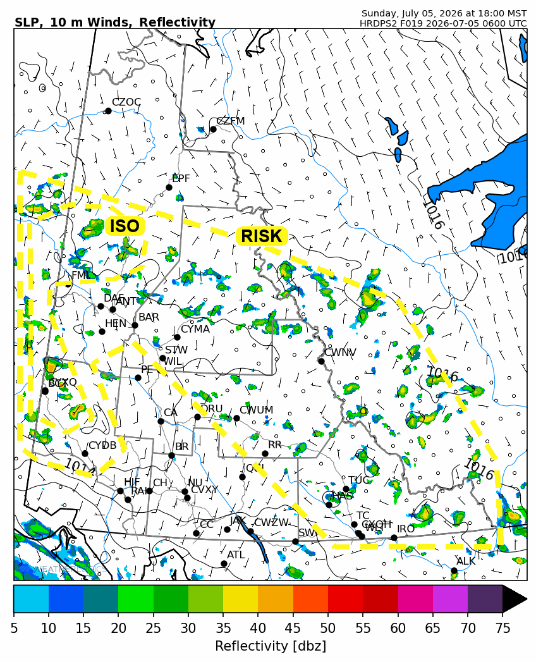
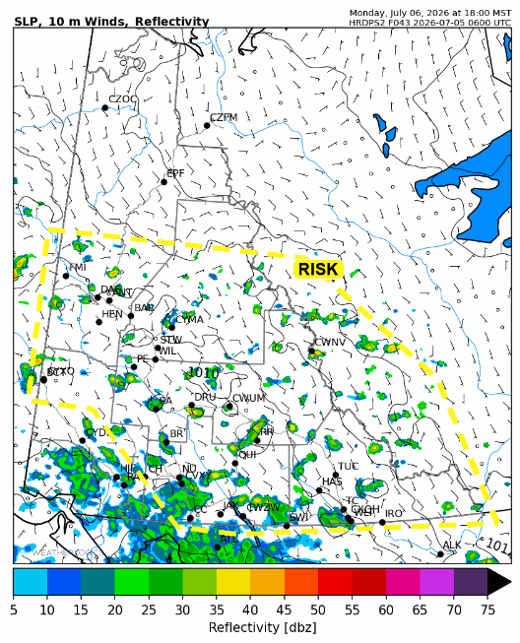

Forecast for | Monday | (Peak burning period and overnight)
Community | Clouds | Pcpn | POP | POL | Max Temp | Min RH | Min Temp | Max  RH | Wind Dir | Wind Speed
Old Crow | CLR |  | 0 | NIL | 22 | 30 | 11 | 70 | 110 | 10
Klondike Fc | SCT | RW-/TRW- | 30 | RISK | 21 | 30 | 12 | 70 | 90 | 5
Mayo A | SCT | RW-/TRW- | 30 | RISK | 21 | 30 | 15 | 60 | 90 | 10
Carmacks | BKN | RW-/TRW- | 30 | RISK | 18 | 30 | 12 | 80 | 120 | 10
Faro | BKN | RW-/TRW- | 30 | RISK | 18 | 35 | 11 | 75 | 120 | 15
Ross River | BKN | RW-/TRW- | 30 | RISK | 19 | 35 | 9 | 75 | 160 | 10
Beaver Creek Town | BKN | RW-/TRW- | 20 | RISK | 18 | 35 | 9 | 85 | 120 | 10
Burwash A | OVC | RW- | 40 | NIL | 14 | 50 | 9 | 95 | 110 | 5
Haines Junction | OVC | RW- | 40 | NIL | 18 | 45 | 9 | 95 | 70 | 5
Whitehorse Auto | OVC | RW-/TRW- | 60 | RISK | 16 | 45 | 11 | 95 | 160 | 10
Teslin | BKN | RW-/TRW- | 60 | RISK | 16 | 45 | 11 | 95 | 160 | 10
Watson Lake | BKN | RW-/TRW- | 40 | RISK | 20 | 35 | 13 | 75 | 110 | 15

Forecast for |  |  | Tuesday |  |  | (Peak burning period and overnight)
Community |  |  | Clouds |  |  | Pcpn | POP |  | POL |  | Max Temp |  | Min RH | Min Temp | Max  RH | Wind Dir | Wind Speed
Old Crow |  |  | FEW |  |  |  | 0 |  | NIL |  | 24 |  | 30 | 14 | 70 | 140 | 10
Klondike Fc |  |  | BKN |  |  | RW- | 30 |  | NIL |  | 23 |  | 35 | 13 | 80 | 120 | 10
Mayo A |  |  | BKN |  |  | RW- | 40 |  | NIL |  | 23 |  | 35 | 15 | 85 | 140 | 10
Carmacks |  |  | BKN |  |  | R | 60 |  | NIL |  | 16 |  | 50 | 10 | 80 | 160 | 10
Faro |  |  | OVC |  |  | R | 60 |  | NIL |  | 14 |  | 70 | 9 | 90 | 180 | 10
Ross River |  |  | OVC |  |  | R | 60 |  | NIL |  | 14 |  | 70 | 8 | 90 | 200 | 10
Beaver Creek Town |  |  | BKN |  |  | RW- | 60 |  | NIL |  | 14 |  | 60 | 6 | 85 | 110 | 5
Burwash A |  |  | BKN |  |  | R- | 60 |  | NIL |  | 15 |  | 60 | 6 | 90 | 140 | 10
Haines Junction |  |  | BKN |  |  | R- | 60 |  | NIL |  | 15 |  | 60 | 6 | 90 | 180 | 10
Whitehorse Auto |  |  | BKN |  |  | RW- | 60 |  | NIL |  | 14 |  | 45 | 9 | 90 | 180 | 10
Teslin |  |  | OVC |  |  | RW- | 60 |  | NIL |  | 14 |  | 50 | 9 | 90 | 200 | 5
Watson Lake |  |  | OVC |  |  | RW- | 60 |  | NIL |  | 14 |  | 70 | 11 | 90 | 140 | 5
3-Day Forecast Precipitation Totals from 13:00 Yesterday
OC | 0.6 |  | FA | 1.4 |  | JAK | 9.7
EPF | 0.3 |  | RR | 1.6 |  | TE | 7.1
ANT | 0.0 |  | BC | 6.7 |  | QUI | 16.1
DA | 0.0 |  | BCT | 6.7 |  | SWI | 17.3
FMI | 0.0 |  | BU | 9.9 |  | FL | 3.1
HEN | 0.0 |  | HJF | 13.9 |  | TUC | 6.2
BAR | 0.0 |  | RAI | 12.0 |  | HAS | 11.7
MA | 0.0 |  | CH | 7.9 |  | TC | 4.2
STW | 0.3 |  | BR | 6.3 |  | WL | 4.1
WIL | 0.6 |  | NU | 7.0 |  | NA | NA
PE | 0.4 |  | XY | 8.0 |  | IRO | 2.7
CA | 1.9 |  | CC | 10.6 |  | NA | NA
DRU | 3.3 |  | ATL | 8.8 |  | NA | NA
Dylan Kikuta Meteorologist

Disclaimer : The information in these forecasts is collected and prepared for internal use by the Government of Yukon. The forecasts are specifically designed to meet the needs of the Wildland Fire Management and may not cover the requirements of other parties. Weather warnings or advisories are not included as part of the forecasts. Wildland Fire Management makes no representation and provides no warranty as to the accuracy of its weather forecasts. Any use the recipient chooses to make of the forecasts will be at its sole risk.

