YUKON WILDLAND FIRE MANAGEMENT WEATHER FORECAST - 9:00 AM ISSUE

6-Jul-2026
YESTERDAY'S VALUES
Community | Max  Temp  (°C) | Diff.  from  Normal | Min Temp  (°C) | Diff. from Normal | Pcpn  (mm) | Min RH | Max RH | L110 | L30
Old Crow | 22.0 | 1.1 | 8.7 | -0.1 | 0.0 | 30 | 86 | 0 | 0
Fort Mcpherson Airport | 21.4 |  | 7.4 |  | 0.0 | 28 | 90 | 0 | 0
Rock River Climate | 17.1 |  | 9.8 |  | 0.0 | 28 | 51 | NA | NA
Eagle Plains Fire | 19.9 |  | 8.5 |  | 0.0 | 36 | 59 | 2 | 0
Antimony Creek | 23.5 |  | 2.9 |  | 0.0 | 22 | 95 | 1 | 0
Klondike Fc | M |  | M |  | M | M | M | 0 | 0
Forty Mile | 24.6 |  | 10.0 |  | 0.0 | 18 | 76 | 0 | 0
Henderson | 18.6 |  | 10.0 |  | 0.0 | 33 | 60 | 0 | 0
Barlow | 22.5 |  | 11.4 |  | 0.0 | 27 | 58 | 1 | 0
Mayo A | 21.9 | -0.9 | 8.6 | -0.7 | 0.0 | 27 | 70 | 0 | 0
Stewart Crossing | 22.2 |  | 6.0 |  | 0.0 | 27 | 92 | 0 | 0
Willow Creek | 20.9 |  | 4.1 |  | 0.5 | 32 | 92 | 0 | 0
Pelly Farm | 21.8 | -0.9 | 3.5 | -4.7 | 0.0 | 28 | 89 | 0 | 0
Carmacks | 23.9 |  | 6.0 |  | 0.0 | 23 | 76 | 0 | 0
Drury Creek | 20.5 |  | 5.6 |  | 0.0 | 31 | 95 | 0 | 0
Faro | 19.2 | -1.8 | 8.4 | -0.5 | 0.0 | 49M | 96M | 0 | 0
Ross River | 20.0 |  | 6.2 |  | 0.0 | 32 | 95 | 0 | 0
Macmillan Pass | 15.1 |  | 0.9 |  | 0.0 | 36 | 95 | 0 | 0
Beaver Creek A | 16.4 | -4.1 | 2.4 | -5.0 | 2.1 | 50 | 98 | 39 | 10
Beaver Creek Town | 18.7 |  | 3.1 |  | 2.5 | 46 | 97 | 39 | 10
Burwash A | 18.0 | -1.2 | 4.4 | -1.6 | 0.0M | 39 | 74 | 10 | 0
Haines Junction | 20.9 | 1.0 | 3.5 | -0.6 | 0.0 | 29 | 91 | 0 | 0
Rainbow | 20.0 |  | 6.2 |  | 0.0 | 34 | 88 | 0 | 0
Champagne | 19.2 |  | -0.3 |  | 0.0 | 28 | 92 | 0 | 0
Braeburn | 20.0 |  | 2.4 |  | 0.0 | 29 | 96 | 0 | 0
Nursery | 20.7 |  | 0.9 |  | 0.0 | 29 | 97 | 0 | 0
Whitehorse Auto | 18.3 | -2.0 | 6.4 | -0.9 | 0.0 | 33 | 76 | 0 | 0
Mount Sima | 15.0 |  | 5.8 |  | 0.0 | 38 | 71 | 0 | 0
Carcross | 18.7 |  | 4.9 |  | 0.0 | 33 | 92 | 0 | 0
Atlin | 18.0 |  | 8.0 |  | 0.0 | 33 | 74 | 0 | 0
Jakes Corner | 19.2 |  | 6.3 |  | 0.0 | 30 | 82 | 0 | 0
Teslin | 17.5 |  | 6.2 |  | 0.0 | 33 | 88 | 0 | 0
Quiet Lake | 21.7 |  | 3.3 |  | 0.0 | 33 | 91 | 0 | 0
Swift River | 18.4 |  | 4.7 |  | 0.0 | 29 | 85 | 0 | 0
Tuchitua | 21.0 |  | 0.0 |  | 0.0 | 36 | 98 | 0 | 0
Hasselburg | 18.0 |  | 4.6 |  | 2.3 | 36 | 95 | 0 | 0
Tom Creek | 19.1 |  | 6.9 |  | 0.3 | 36 | 85 | 0 | 0
Watson Lake | 18.8 | -2.3 | 7.1 | -1.5 | 0.0 | 36 | 98 | 0 | 0
Iron Creek | 21.6 |  | 2.8 |  | 0.0 | 34 | 99 | 0 | 0
Max Temp is the actual maximum temperature in °C from yesterday afternoon or evening.
Min Temp is the actual overnight minimum temperature in °C up until 6:00 AM this morning.
Diff. from Normal is the difference from the 30 year average max or min temperature.
Pcpn is the precipitation in mm since 13:00 yesterday.
Min RH is the minimum observed RH in % from yesterday afternoon or evening.
Max RH is the maximum observed overnight RH in % up until 6:00 AM this morning.
L110 is the actual number of lightning strikes within 110 km and in the Yukon for 24 hours ending at 06:00 AM this morning.
L30 is the actual number of lightning strikes within 30 km and in the Yukon for 24 hours ending at 06:00 AM this morning.
M is missing data. * denotes precipitation at stations that failed to report for at least part of the evening and overnight period.

SYNOPSIS:
Monday: Generally warm and marginally dry conditions are expected but scattered convective rain showers and thundershowers will develop over the southern half of the territory. As the Pacific moisture builds, showers will switch to steady rain by late evening and continue through the night over Kluane, Southern Lakes, and western Tintina region where RH will sit around 40%. Marginally dry air will overspread most areas and 30-35% readings will be common, and a few 20-25% readings are expected over the southern Klondike and southern Northern Tutchone. Watch out for 15-20 km/h winds over the Nahoni Range, north edge of the Wernecke Mountains, on the Dawson Range, and on the Cassier Mountains.
Tuesday: Tuesday will bring higher moisture to the southern Yukon thanks to a surge of pacific air and rain, while the Klondike and Northern Tutchone enjoy warm and marginally dry RH. Daytime highs will be in the low to mid 20s and minimum RH around 30-35% over Klondike and Northern Tutchone, however south of rain is expected to begin after the dinner hour over southern Klondike and Northern Tutchone. Watch out for breezy easterly winds once again north of the Ogilvie and Wernecke Mountains, and just ahead of the rain over eastern Tatchun. The southern half of the territory will see high RH, below seasonal temperatures, and gloomy rain showers. It remains unclear whether dry air wraps around the backside of the system into Kluane/Southern Lakes during the afternoon.
Wednesday: The Pacific front will push onto the Mountains and wrap marginally dry and warm air into the southern half of the Yukon while northern Yukon basks under a hot and dry airmass. Rain will be heaviest over the Ogilvie/Mackenzie Mountains, but isolated showers are possible over the Yukon Plateau and on the Porcupine River basin. The core of the wrap around dry air should develop over western Tatchun where daytime highs will sit around 20C and minimum RH around 30%. Elsewhere on the Plateau it will be cooler and damper. Over the north, daytime highs will hit mid to high 20s and minimum RH will tap 25-30%.
Thursday: Rain shower coverage is expected to increase compared to Wednesday. The highest odds of warm and dry air will be over northern Yukon. Forecast uncertainty is high.
Friday: Rain showers are expected with daytime highs around 20C. Forecast uncertainty is high.

Forecast for | Monday | (Peak burning period and overnight)
Community | Clouds | Pcpn | POP | POL | Max Temp | Min RH | Min Temp | Max  RH | Wind Dir | Wind Speed
Old Crow | FEW |  | 0 | NIL | 23 | 30 | 11 | 70 | 140 | 15
Klondike Fc | SCT | RW-/TRW- | 30 | RISK | 24 | 25 | 13 | 60 | 90 | 5
Mayo A | SCT | RW-/TRW- | 30 | RISK | 23 | 25 | 15 | 55 | 110 | 15
Carmacks | BKN | RW-/TRW- | 30 | RISK | 22 | 30 | 13 | 80 | 90 | 10
Faro | BKN | RW-/TRW- | 40 | RISK | 21 | 35 | 11 | 75 | 110 | 15
Ross River | BKN | RW-/TRW- | 40 | RISK | 22 | 30 | 10 | 75 | 110 | 15
Beaver Creek Town | BKN | RW-/TRW- | 30 | RISK | 18 | 35 | 8 | 85 | 90 | 10
Burwash A | OVC | R- | 60 | NIL | 15 | 50 | 10 | 95 | 110 | 5
Haines Junction | OVC | R- | 60 | NIL | 18 | 40 | 10 | 95 | 40 | 5
Whitehorse Auto | BKN | RW-/TRW- | 60 | RISK | 19 | 40 | 12 | 95 | 160 | 10
Teslin | OVC | RW-/TRW- | 60 | RISK | 18 | 40 | 12 | 95 | 160 | 10
Watson Lake | BKN | RW-/TRW- | 30 | RISK | 20 | 35 | 13 | 80 | 120 | 15
POP is probability of precipitation in %.
POL is probability of lightning in %.

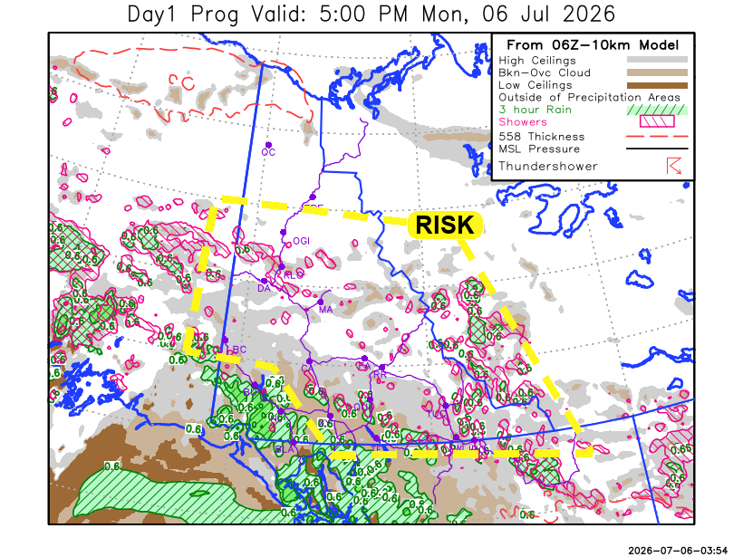
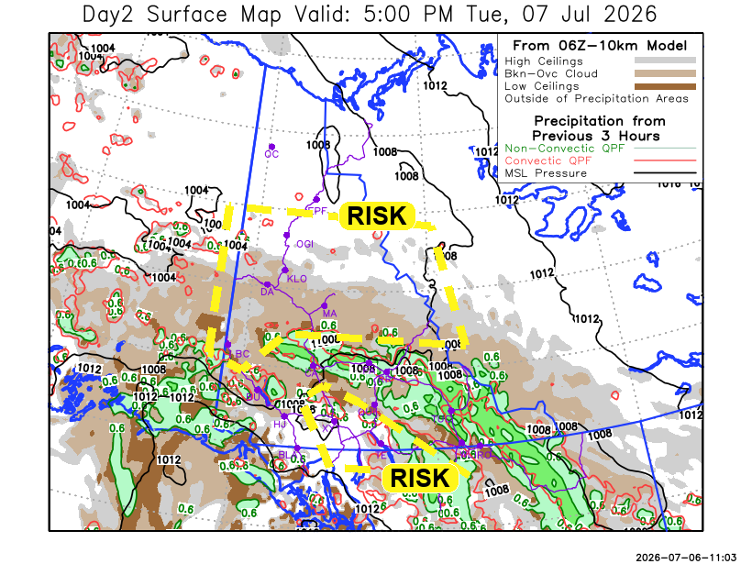

Forecast for | Tuesday | (Peak burning period and overnight)
Community | Clouds | Pcpn | POP | POL | Max Temp | Min RH | Min Temp | Max  RH | Wind Dir | Wind Speed
Old Crow | FEW |  | 15 | NIL | 25 | 30 | 13 | 70 | 120 | 10
Klondike Fc | BKN | RW-/TRW- | 20 | RISK | 24 | 30 | 14 | 80 | 150 | 10
Mayo A | BKN | RW-/TRW- | 30 | RISK | 24 | 35 | 16 | 90 | 150 | 10
Carmacks | BKN | R- | 80 | NIL | 16 | 50 | 10 | 80 | 160 | 10
Faro | BKN | R | 80 | NIL | 15 | 50 | 9 | 95 | 110 | 15
Ross River | BKN | R | 80 | NIL | 15 | 50 | 8 | 95 | 110 | 10
Beaver Creek Town | BKN | RW-/TRW- | 60 | RISK | 18 | 50 | 8 | 85 | 90 | 5
Burwash A | BKN | R- | 60 | NIL | 14 | 50 | 6 | 90 | 140 | 10
Haines Junction | BKN | R- | 60 | NIL | 17 | 45 | 5 | 90 | 200 | 10
Whitehorse Auto | BKN | RW-/TRW- | 60 | RISK | 15 | 40 | 7 | 90 | 180 | 10
Teslin | BKN | RW-/TRW- | 60 | RISK | 15 | 55 | 8 | 90 | 160 | 5
Watson Lake | BKN | RW- | 80 | NIL | 14 | 70 | 10 | 95 | 110 | 5

Forecast for |  |  | Wednesday |  |  | (Peak burning period and overnight)
Community |  |  | Clouds |  |  | Pcpn | POP |  | POL |  | Max Temp |  | Min RH | Min Temp | Max  RH | Wind Dir | Wind Speed
Old Crow |  |  | SCT |  |  |  | 10 |  | NIL |  | 26 |  | 25 | 15 | 70 | 90 | 10
Klondike Fc |  |  | BKN |  |  | RW- | 60 |  | NIL |  | 18 |  | 70 | 12 | 85 | 290 | 5
Mayo A |  |  | BKN |  |  |  | 15 |  | NIL |  | 20 |  | 35 | 14 | 85 | 300 | 5
Carmacks |  |  | BKN |  |  |  | 15 |  | NIL |  | 21 |  | 30 | 10 | 75 | 180 | 10
Faro |  |  | BKN |  |  |  | 15 |  | NIL |  | 15 |  | 35 | 8 | 90 | 300 | 5
Ross River |  |  | BKN |  |  |  | 15 |  | NIL |  | 17 |  | 35 | 6 | 85 | 300 | 5
Beaver Creek Town |  |  | BKN |  |  | RW- | 20 |  | NIL |  | 18 |  | 55 | 6 | 85 | 320 | 5
Burwash A |  |  | BKN |  |  | RW- | 20 |  | NIL |  | 14 |  | 45 | 8 | 90 | 140 | 10
Haines Junction |  |  | BKN |  |  |  | 15 |  | NIL |  | 14 |  | 40 | 5 | 89 | 200 | 10
Whitehorse Auto |  |  | BKN |  |  |  | 15 |  | NIL |  | 18 |  | 30 | 8 | 80 | 200 | 5
Teslin |  |  | BKN |  |  |  | 15 |  | NIL |  | 18 |  | 30 | 7 | 80 | 220 | 10
Watson Lake |  |  | OVC |  |  | RW- | 40 |  | NIL |  | 15 |  | 60 | 9 | 85 | 270 | 10
3-Day Forecast Precipitation Totals from 13:00 Yesterday
OC | 0.0 |  | FA | 8.5 |  | JAK | 9.9
EPF | 0.0 |  | RR | 10.6 |  | TE | 8.7
ANT | 2.4 |  | BC | 9.7 |  | QUI | 20.2
DA | 2.2 |  | BCT | 10.1 |  | SWI | 15.3
FMI | 1.2 |  | BU | 10.9 |  | FL | 21.1
HEN | 1.5 |  | HJF | 16.2 |  | TUC | 23.2
BAR | 3.6 |  | RAI | 11.7 |  | HAS | 22.7
MA | 4.1 |  | CH | 7.8 |  | TC | 16.5
STW | 3.3 |  | BR | 5.1 |  | WL | 15.1
WIL | 2.9 |  | NU | 8.6 |  | NA | NA
PE | 3.1 |  | XY | 9.9 |  | IRO | 14.2
CA | 3.5 |  | CC | 12.8 |  | NA | NA
DRU | 10.4 |  | ATL | 10.3 |  | NA | NA
Dylan Kikuta Meteorologist

Disclaimer : The information in these forecasts is collected and prepared for internal use by the Government of Yukon. The forecasts are specifically designed to meet the needs of the Wildland Fire Management and may not cover the requirements of other parties. Weather warnings or advisories are not included as part of the forecasts. Wildland Fire Management makes no representation and provides no warranty as to the accuracy of its weather forecasts. Any use the recipient chooses to make of the forecasts will be at its sole risk.

