YUKON WILDLAND FIRE MANAGEMENT WEATHER FORECAST - 9:00 AM ISSUE
11-Jul-2026
YESTERDAY'S VALUES
Community | Max  Temp  (°C) | Diff.  from  Normal | Min Temp  (°C) | Diff. from Normal | Pcpn  (mm) | Min RH | Max RH | L110 | L30
Old Crow | 27.0 | 6.0 | 13.3 | 4.4 | 0.0 | 25 | 84 | 3 | 0
Fort Mcpherson Airport | 24.9 |  | 12.6 |  | 0.0M(4) | 32 | 86 | 0 | 0
Rock River Climate | 21.5 |  | 13.9 |  | 0.0 | 40 | 67 | NA | NA
Eagle Plains Fire | 22.6 |  | 14.5 |  | 0.0 | 41 | 70 | 0 | 0
Antimony Creek | 25.2 |  | 7.7 |  | 0.0 | 36 | 99 | 205 | 2
Klondike Fc | M |  | M |  | M | M | M | 188 | 0
Forty Mile | 23.2 |  | 9.6 |  | 0.0 | 50 | 98 | 51 | 0
Henderson | 22.2 |  | 13.8 |  | 0.0 | 45 | 84 | 158 | 0
Barlow | 24.2 |  | 12.7 |  | 8.0 | 46 | 93 | 173 | 119
Mayo A | 24.3 | 1.4 | 9.2 | -0.3 | 0.0 | 51 | 96 | 170 | 15
Stewart Crossing | 24.4 |  | 8.3 |  | 1.3 | 44 | 96 | 181 | 4
Willow Creek | 24.0 |  | 7.3 |  | 0.0 | 38 | 96 | 189 | 0
Pelly Farm | 25.1 | 2.3 | 11.2 | 2.7 | 0.0 | 46 | 94 | 107 | 0
Carmacks | 24.2 |  | 12.8 |  | 0.0 | 43 | 83 | 329 | 6
Drury Creek | 24.6 |  | 7.5 |  | 0.0 | 35 | 96 | 520 | 9
Faro | 22.5M | 1.4 | 7.7M | -1.5 | 0.0M | 46M | 81M | 425 | 15
Ross River | 24.4 |  | 5.0 |  | 2.0 | 34 | 98 | 261 | 27
Macmillan Pass | 19.5 |  | 3.6 |  | 0.0 | 31 | 85 | 0 | 0
Beaver Creek A | 17.5 | -3.1 | 4.2 | -3.5 | 0.0 | 68 | 98 | 0 | 0
Beaver Creek Town | 18.3 |  | 5.5 |  | 0.0 | 64 | 96 | 0 | 0
Burwash A | 18.5 | -0.9 | 3.0 | -3.3 | 0.0M | 54 | 99 | 5 | 0
Haines Junction | 20.7 | -0.3 | 9.9 | 4.4 | 1.0 | 49 | 97 | 106 | 1
Rainbow | 17.6 |  | 8.3 |  | 0.8 | 64 | 99 | 127 | 9
Champagne | 18.9 |  | 7.5 |  | 22.9 | 57 | 99 | 479 | 51
Braeburn | 23.0 |  | 9.0 |  | 10.7 | 44 | 99 | 707 | 89
Nursery | 20.0 |  | 5.3 |  | 3.6 | 57 | 99 | 834 | 82
Whitehorse Auto | 19.5 | -1.0 | 8.0 | 0.3 | 2.6 | 57 | 100 | 719 | 16
Mount Sima | 16.3 |  | 8.2 |  | 0.0 | 55 | 94 | 621 | 24
Carcross | 20.3 |  | 7.5 |  | 0.0 | 52 | 96 | 402 | 50
Atlin | 12.7 |  | 6.9 |  | 3.4 | 74 | 98 | 195 | 0
Jakes Corner | 20.6 |  | 8.4 |  | 0.3 | 50 | 96 | 471 | 55
Teslin | 18.9 |  | 9.5 |  | 6.6 | 45 | 98 | 276 | 41
Quiet Lake | 23.2 |  | 6.1 |  | 0.6 | 32 | 98 | 550 | 2
Swift River | 15.1 |  | 9.3 |  | 2.6 | 71 | 95 | 94 | 1
Tuchitua | 15.8 |  | 2.5 |  | 0.3 | 67 | 99 | 7 | 0
Hasselburg | 14.1 |  | 6.8 |  | 0.0 | 70 | 100 | 44 | 0
Tom Creek | 11.3 |  | 5.1 |  | 0.0 | 76 | 99 | 1 | 0
Watson Lake | 12.0 | -9.3 | 7.0 | -1.9 | 0.0 | 78 | 99 | 0 | 0
Iron Creek | 15.1 |  | 4.5 |  | 0.8 | 71 | 99 | 2 | 0

Max Temp is the actual maximum temperature in °C from yesterday afternoon or evening.
Min Temp is the actual overnight minimum temperature in °C up until 6:00 AM this morning.
Diff. from Normal is the difference from the 30 year average max or min temperature.
Pcpn is the precipitation in mm since 13:00 yesterday.
Min RH is the minimum observed RH in % from yesterday afternoon or evening.
Max RH is the maximum observed overnight RH in % up until 6:00 AM this morning.
L110 is the actual number of lightning strikes within 110 km and in the Yukon for 24 hours ending at 06:00 AM this morning.
L30 is the actual number of lightning strikes within 30 km and in the Yukon for 24 hours ending at 06:00 AM this morning.
M is missing data. * denotes precipitation at stations that failed to report for at least part of the evening and overnight period.

SYNOPSIS:
Today: An Alaskan surface low and associated broad surface trough will extend across the northern half of Yukon, supporting scattered showers and isolated thunderstorms particularly across the Klondike and Northern Tutchone. The highest thundershower confidence lies across northern half of the Yukon, Tatchun, and the eastern Tintina region including near Watson Lake. Localized activity is also possible in Southern Lakes, including near Whitehorse. Temperatures will reach the mid to upper-20s in most areas, with near-crossover or crossover conditions possible particularly along the Carmacks-Faro-Ross River corridor if smoke does not significantly limit daytime heating, leading to minimum RHs in the mid to upper-20s.

Sunday: A broad trough of low pressure over the eastern half of the Territory will support convective showers and isolated thunderstorms across portions of central and eastern Yukon, particularly from Mayo through Faro, Ross River, and Watson Lake. Southern Lakes and Kluane should remain mainly dry, other than the odd convective thundershower. Temperatures will generally be in the low to upper-20s (warmest in Tatchun, Klondike, Northern Tutchone), while stronger west to southwest winds develop in several areas. The strongest winds are expected near Old Crow, with gusts potentially reaching 40 km/h.

Monday: Weak upper ridging will begin building across southern Yukon, bringing mainly dry conditions to Whitehorse, Haines Junction, and Teslin. Showers and isolated thunderstorms will remain possible across northern, central, and eastern Yukon as the weak trough of low-pressure continues to influence the region, combined with a slightly unstable air mass. The pressure gradient behind the trough may produce gusty west to southwest winds, particularly near Old Crow, Faro, Haines Junction, and Whitehorse. Temperatures will be slightly cooler, generally ranging from the upper teens to mid-20s, again remaining warmest through central and northern portions of the Territory (Tatchun, Klondike, Northern Tutchone).

Tuesday: The ridge will shift eastward but remain broad enough to maintain a drying trend across much of southern and central Yukon. An upper low approaching from Alaska will begin extending its trough into western Yukon, although shower coverage is expected to be similar or lower than on previous days.

Wednesday: The Alaskan upper-low and its broad trough are expected to move farther into the Yukon. This will bring a renewed possibility of showers and thunderstorms across much of the territory, as well as the potential for a slight cool-down to parts of the Territory.

Forecast for | Saturday | (Peak burning period and overnight)
Community | Clouds | Pcpn | POP | POL | Max Temp | Min RH | Min Temp | Max  RH | Wind Dir | Wind Speed
Old Crow | SCT | RW-/TRW- | 40 | SCT | 28 | 30 | 15 | 60 | 170 | 10-15
Klondike Fc | FEW | RW-/TRW- | 30 | RISK | 28 | 40 | 15 | 80 | 180 | 10
Mayo A | SCT | RW-/TRW- | 30 | ISO | 27 | 35 | 18 | 75 | 200 | 10
Carmacks | FEW | RW-/TRW- | 30 | RISK | 30 | 30 | 13 | 70 | 160 | 10-15
Faro | SCT | RW-/TRW- | 40 | SCT | 25 | 25 | 12 | 75 | 220 | 10
Ross River | FEW | RW-/TRW- | 40 | RISK | 27 | 25 | 9 | 70 | 140 | 10
Beaver Creek Town | FEW |  | 20 | NIL | 26 | 30 | 9 | 70 | 300 | 10
Burwash A | FEW | RW-/TRW- | 30 | RISK | 25 | 40 | 10 | 75 | 140 | 10G20
Haines Junction | FEW | RW-/TRW- | 30 | RISK | 27 | 35 | 7 | 90 | 200 | 10G25
Whitehorse Auto | FEW | RW-/TRW- | 40 | RISK | 24 | 35 | 11 | 85 | 140 | 10G20
Teslin | FEW | RW-/TRW- | 20 | RISK | 21 | 40 | 10 | 90 | 220 | 10
Watson Lake | SCT | RW-/TRW- | 60 | ISO | 22 | 45 | 11 | 85 | 250 | 5-15
POP is probability of precipitation in %.
POL is probability of lightning in %.
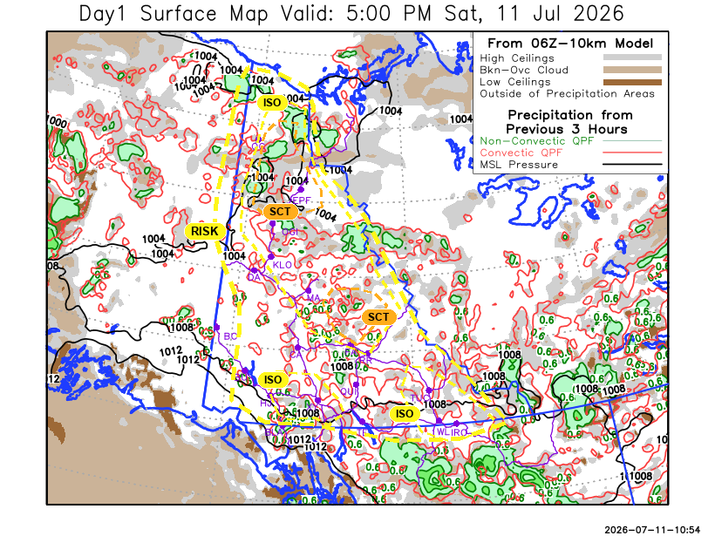

Forecast for | Sunday | (Peak burning period and overnight)
Community | Clouds | Pcpn | POP | POL | Max Temp | Min RH | Min Temp | Max  RH | Wind Dir | Wind Speed
Old Crow | FEW |  | 0 | NIL | 25 | 30 | 14 | 70 | 250 | 20G40
Klondike Fc | SCT | RW- | 0 | NIL | 28 | 30 | 15 | 75 | 290 | 5-10
Mayo A | BKN | RW-/TRW- | 50 | ISO | 27 | 35 | 17 | 70 | 250 | 10
Carmacks | SCT | RW-/TRW- | 40 | ISO | 29 | 30 | 12 | 80 | 160 | 10-15
Faro | BKN | RW-/TRW- | 40 | RISK | 25 | 40 | 11 | 75 | 270 | 15G25
Ross River | BKN | RW-/TRW- | 50 | RISK | 27 | 35 | 10 | 75 | 270 | 10-15
Beaver Creek Town | SCT |  | 0 | NIL | 23 | 35 | 9 | 70 | 320 | 5-10
Burwash A | SCT | RW-/TRW- | 30 | RISK | 23 | 35 | 10 | 80 | 180 | 15G25
Haines Junction | SCT |  | 0 | NIL | 22 | 35 | 7 | 90 | 200 | 15G30
Whitehorse Auto | SCT |  | 0 | NIL | 23 | 30 | 9 | 80 | 220 | 15G25
Teslin | SCT |  | 0 | NIL | 20 | 40 | 9 | 75 | 250 | 15G30
Watson Lake | BKN | R-/TRW- | 70 | ISO | 22 | 45 | 11 | 80 | 270 | 10G20

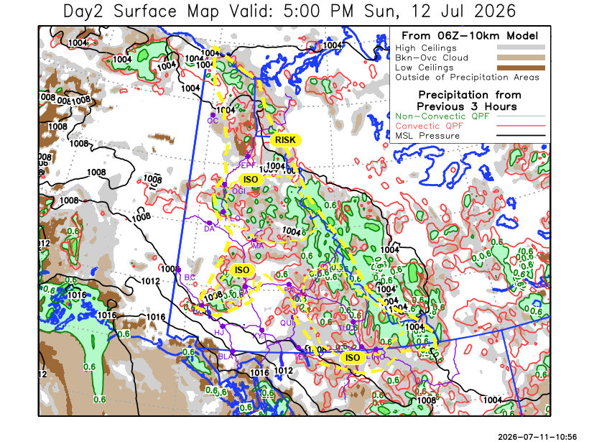
Forecast for |  |  | Monday |  | (Peak burning period and overnight)
Community |  |  | Clouds |  | Pcpn |  | POP |  | POL |  | Max Temp |  | Min RH | Min Temp | Max  RH | Wind Dir | Wind Speed
Old Crow |  |  | BKN |  | RW-/TRW- |  | 40 |  | RISK |  | 25 |  | 35 | 13 | 80 | 250 | 15G30
Klondike Fc |  |  | BKN |  | RW-/TRW- |  | 40 |  | RISK |  | 24 |  | 35 | 12 | 80 | 270 | 10-15
Mayo A |  |  | SCT |  | RW-/TRW- |  | 50 |  | RISK |  | 25 |  | 40 | 15 | 80 | 220 | 10-15
Carmacks |  |  | SCT |  | RW-/TRW- |  | 40 |  | RISK |  | 27 |  | 45 | 11 | 80 | 180 | 10-15
Faro |  |  | BKN |  | RW-/TRW- |  | 30 |  | RISK |  | 23 |  | 45 | 9 | 80 | 250 | 15G30
Ross River |  |  | BKN |  | RW-/TRW- |  | 40 |  | RISK |  | 26 |  | 45 | 8 | 80 | 250 | 10
Beaver Creek Town |  |  | BKN |  | RW- |  | 30 |  | NIL |  | 22 |  | 40 | 6 | 75 | 320 | 10-15
Burwash A |  |  | SCT |  | RW-/TRW- |  | 50 |  | RISK |  | 21 |  | 40 | 8 | 80 | 140 | 15G25
Haines Junction |  |  | FEW |  |  |  | 0 |  | NIL |  | 20 |  | 35 | 6 | 90 | 180 | 15G35
Whitehorse Auto |  |  | FEW |  |  |  | 0 |  | NIL |  | 21 |  | 35 | 8 | 80 | 200 | 15G30
Teslin |  |  | BKN |  |  |  | 0 |  | NIL |  | 18 |  | 35 | 8 | 80 | 220 | 15G25
Watson Lake |  |  | BKN |  | RW-/TRW- |  | 40 |  | RISK |  | 19 |  | 45 | 10 | 80 | 270 | 10G20
3-Day Forecast Precipitation Totals from 13:00 Yesterday
OC | 0.8 |  | FA | 1.0 |  | JAK | 0.8
EPF | 2.2 |  | RR | 4.0 |  | TE | 6.6
ANT | 0.4 |  | BC | 0.0 |  | QUI | 1.6
DA | 1.0 |  | BCT | 0.0 |  | SWI | 7.2
FMI | 0.9 |  | BU | 1.2 |  | FL | 9.2
HEN | 1.1 |  | HJF | 1.0 |  | TUC | 8.6
BAR | 8.7 |  | RAI | 0.8 |  | HAS | 8.1
MA | 1.3 |  | CH | 22.9 |  | TC | 4.2
STW | 2.3 |  | BR | 10.7 |  | WL | 4.1
WIL | 0.9 |  | NU | 3.6
PE | 2.0 |  | XY | 2.7 |  | IRO | 10.2
CA | 1.1 |  | CC | 0.4
DRU | 0.5 |  | ATL | 4.2

Pallawi Paudel Meteorologist

Disclaimer : The information in these forecasts is collected and prepared for internal use by the Government of Yukon. The forecasts are specifically designed to meet the needs of the Wildland Fire Management and may not cover the requirements of other parties. Weather warnings or advisories are not included as part of the forecasts. Wildland Fire Management makes no representation and provides no warranty as to the accuracy of its weather forecasts. Any use the recipient chooses to make of the forecasts will be at its sole risk.

