YUKON WILDLAND FIRE MANAGEMENT WEATHER FORECAST - 9:00 AM ISSUE

14-Jul-2026
YESTERDAY'S VALUES
Community | Max  Temp  (°C) | Diff.  from  Normal | Min Temp  (°C) | Diff. from Normal | Pcpn  (mm) | Min RH | Max RH | L110 | L30
Old Crow | 22.9 | 2.0 | 10.3 | 1.4 | 0.2 | 39 | 88 | 104 | 0
Fort Mcpherson Airport | 23.6 |  | 14.3 |  | 0.0M | 59 | 87 | 358 | 0
Rock River Climate | 22.3 |  | 9.2 |  | 10.6 | 45 | 100 | NA | NA
Eagle Plains Fire | 22.9 |  | 10.9 |  | 0.0 | 43 | 89 | 908 | 2
Antimony Creek | 23.2 |  | 4.7 |  | 1.8 | 35 | 96 | 143 | 0
Klondike Fc | M |  | M |  | M | M | M | 91 | 2
Forty Mile | 22.4 |  | 6.6 |  | 0.0 | 31 | 87 | 11 | 0
Henderson | 20.8 |  | 10.0 |  | 0.3 | 36 | 57 | 130 | 0
Barlow | 22.3 |  | 10.3 |  | 0.0 | 39 | 80 | 210 | 4
Mayo A | 24.2 | 1.3 | 10.1 | 0.5 | 4.6 | 38 | 99 | 241 | 7
Stewart Crossing | 24.0 |  | 12.6 |  | 0.0 | 35 | 88 | 230 | 14
Willow Creek | 24.4 |  | 10.1 |  | 2.4 | 32 | 98 | 221 | 12
Pelly Farm | 25.9 | 3.1 | 10.9 | 2.3 | 1.8 | 31 | 97 | 172 | 58
Carmacks | 26.0 |  | 9.9 |  | 1.5 | 30 | 96 | 44 | 0
Drury Creek | 22.4 |  | 6.5 |  | 0.0 | 34 | 93 | 15 | 0
Faro | 22.2 | 1.1 | 10.3 | 1.1 | 0.0 | 37 | 71 | 13 | 0
Ross River | 23.4 |  | 5.2 |  | 0.0 | 38 | 97 | 19 | 0
Macmillan Pass | 21.1 |  | 7.7 |  | 2.2 | 36 | 100 | 154 | 10
Beaver Creek A | 20.7 | 0.1 | 1.3 | -6.4 | 0.0M | 35 | 87 | 0 | 0
Beaver Creek Town | 22.7 |  | 2.9 |  | 0.0 | 28 | 90 | 0 | 0
Burwash A | 20.3 | 0.8 | 9.0 | 2.5 | 0.0M | 37 | 65 | 1 | 0
Haines Junction | 20.3 | 0.6 | 2.5 | -3.1 | 0.0 | 37 | 94 | 0 | 0
Rainbow | 19.4 |  | 7.5 |  | 0.0 | 38 | 79 | 0 | 0
Champagne | 20.2 |  | 8.7 |  | 0.0 | 32 | 69 | 0 | 0
Braeburn | 23.3 |  | 7.3 |  | 0.0 | 32 | 78 | 3 | 0
Nursery | 23.6 |  | 3.5 |  | 0.0 | 29 | 94 | 0 | 0
Whitehorse Auto | 22.0 | 1.5 | 6.8 | -1.0 | 0.0 | 28 | 78 | 0 | 0
Mount Sima | 19.7 |  | 7.6 |  | 0.0 | 31 | 63 | 0 | 0
Carcross | 19.2 |  | 4.5 |  | 0.0 | 41 | 92 | 0 | 0
Atlin | 19.7M |  | 5.2M |  | 0.0M | 34M | 82M | 0 | 0
Jakes Corner | 21.3 |  | 4.8 |  | 0.0 | 34 | 85 | 0 | 0
Teslin | 18.1 |  | 4.9 |  | 0.0 | 43 | 95 | 0 | 0
Quiet Lake | 24.4 |  | 6.3 |  | 0.0 | 37 | 92 | 0 | 0
Swift River | 17.9 |  | 1.9 |  | 0.0 | 42 | 95 | 0 | 0
Tuchitua | 26.1 |  | 4.0 |  | 0.0 | 32 | 98 | 111 | 2
Hasselburg | 23.5 |  | 5.2 |  | 0.0 | 35 | 93 | 62 | 0
Tom Creek | 21.8 |  | 6.7 |  | 0.0 | 38 | 83 | 30 | 0
Watson Lake | 21.0 | -0.3 | 7.5 | -1.5 | 0.0 | 40 | 83 | 21 | 0
Iron Creek | 22.1 |  | 2.5 |  | 0.0 | 39 | 98 | 32 | 0
Max Temp is the actual maximum temperature in °C from yesterday afternoon or evening.
Min Temp is the actual overnight minimum temperature in °C up until 6:00 AM this morning.
Diff. from Normal is the difference from the 30 year average max or min temperature.
Pcpn is the precipitation in mm since 13:00 yesterday.
Min RH is the minimum observed RH in % from yesterday afternoon or evening.
Max RH is the maximum observed overnight RH in % up until 6:00 AM this morning.
L110 is the actual number of lightning strikes within 110 km and in the Yukon for 24 hours ending at 06:00 AM this morning.
L30 is the actual number of lightning strikes within 30 km and in the Yukon for 24 hours ending at 06:00 AM this morning.
M is missing data. * denotes precipitation at stations that failed to report for at least part of the evening and overnight period.

SYNOPSIS:
Today: The ridge will expand across the southern half of the Yukon, enough to maintain a drying trend across much of southern and central Yukon. Convection decreasing in coverage across the Territory as a result of the ridge. Highs climb into the low to mid-twenties with minimum RHs in the 25-30% range. An upper low approaching from Alaska will begin extending its trough into western Yukon by late-day, leading to cloud cover advancing into the area. Other than pushing cloud cover into western regions, this upper low will have minimal impacts on the Territory until Wednesday.

Wednesday: The Alaskan upper low and its broad trough are expected to push farther into the Yukon by Wednesday, bringing a renewed chance of convective showers and thunderstorms across much of the Territory. Confidence is highest across the Klondike, Northern Tutchone, and Beaver Creek regions. A slight cooling trend is also possible across parts of the Territory. Farther south and east, the Southern Lakes and Tintina regions are expected to remain drier, with only a few to scattered clouds and minimum RH values still approaching 25-30%.

Thursday: As the low-pressure system advances farther east into NWT, it will continue to bring showers and thundershowers across much of the central and northern Yukon, especially through the Old Crow, Northern Tutchone, and Tatchun regions. Showers end during the first half of the day in the Klondike. Gusty westerly winds are also expected from Old Crow through the Klondike, extending into the Southern Lakes and Tintina regions. The ridge may hang on in southern Yukon, keeping conditions warmer and drier (and sunnier) here on Thursday.

Friday: Broad low pressure will slowly track into the western portions of the Territory from Alaska, bringing renewed chances of showers across the western half of the Yukon. Confidence remains low in the exact placement of precipitation although the Tintina/eastern Tatchun areas will remain the driest. South to southwesterly winds will prevail across the Territory. Extensive cloud cover should keep RH values relatively high (30%+) through western regions, with temperatures generally in the low to mid-20s and cooler conditions across northern areas.

Saturday: The low-pressure system will bring widespread cloud cover across most regions, along with spotty showers and embedded thundershowers. The Southern Lakes and Tintina regions may be the main exceptions, where drier conditions could persist. Winds will once again have a strong westerly component across much of the Territory.

Forecast for | Tuesday | (Peak burning period and overnight)
Community | Clouds | Pcpn | POP | POL | Max Temp | Min RH | Min Temp | Max  RH | Wind Dir | Wind Speed
Old Crow | SCT | RW-/TRW- | 40 | RISK | 22 | 30 | 11 | 85 | 220 | 15G30
Klondike Fc | SCT |  | 20 | NIL | 24 | 30 | 12 | 80 | 160 | 10-15G25
Mayo A | SCT |  | 20 | NIL | 25 | 30 | 13 | 60 | 180 | 10-15G25
Carmacks | SCT |  | 0 | NIL | 25 | 30 | 10 | 70 | 160 | 15G35
Faro | SCT |  | 0 | NIL | 24 | 35 | 10 | 70 | 200 | 10-15
Ross River | SCT |  | 0 | NIL | 25 | 25 | 8 | 65 | 180 | 15G25
Beaver Creek Town | BKN |  | 0 | NIL | 22 | 30 | 9 | 70 | 200 | 10G20
Burwash A | SCT |  | 0 | NIL | 20 | 35 | 9 | 75 | 140 | 20G40
Haines Junction | SCT |  | 0 | NIL | 17 | 40 | 7 | 80 | 180 | 15G35
Whitehorse Auto | BKN |  | 0 | NIL | 22 | 30 | 10 | 75 | 160 | 20G35
Teslin | SCT |  | 0 | NIL | 21 | 35 | 8 | 75 | 180 | 15G25
Watson Lake | CLR |  | 0 | NIL | 23 | 30 | 10 | 65 | 200 | 10-15G20
POP is probability of precipitation in %.
POL is probability of lightning in %.
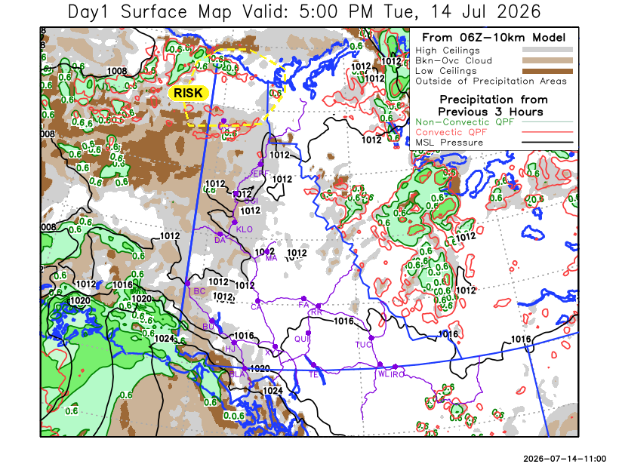

Forecast for | Wednesday | (Peak burning period and overnight)
Community | Clouds | Pcpn | POP | POL | Max Temp | Min RH | Min Temp | Max  RH | Wind Dir | Wind Speed
Old Crow | BKN | RW- | 60 | NIL | 17 | 60 | 10 | 90 | 250 | 15-20G35
Klondike Fc | BKN | RW-/TRW- | 60 | RISK | 21 | 35 | 9 | 80 | 250 | 10G20
Mayo A | BKN | RW-/TRW- | 60 | RISK | 20 | 45 | 13 | 80 | 250 | 10
Carmacks | BKN | RW-/TRW- | 40 | RISK | 24 | 35 | 9 | 80 | 270 | 15G25
Faro | BKN |  | 20 | NIL | 21 | 35 | 8 | 85 | 220 | 15G35
Ross River | BKN |  | 0 | NIL | 24 | 30 | 8 | 65 | 220 | 15G35
Beaver Creek Town | SCT | RW-/TRW- | 60 | RISK | 20 | 30 | 4 | 75 | 250 | 20G30
Burwash A | SCT | RW-/TRW- | 30 | RISK | 19 | 40 | 7 | 75 | 160 | 15G30
Haines Junction | SCT |  | 0 | NIL | 19 | 40 | 5 | 90 | 200 | 20G35
Whitehorse Auto | SCT |  | 0 | NIL | 20 | 30 | 8 | 75 | 180 | 20G40
Teslin | SCT |  | 0 | NIL | 21 | 35 | 10 | 75 | 250 | 20G35
Watson Lake | FEW |  | 0 | NIL | 24 | 30 | 12 | 65 | 270 | 15G25

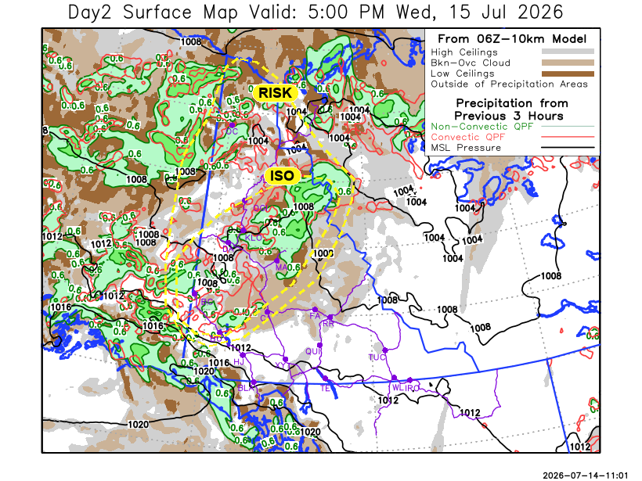

Forecast for |  |  | Thursday |  |  | (Peak burning period and overnight)
Community |  |  | Clouds |  |  | Pcpn | POP |  | POL |  | Max Temp |  | Min RH | Min Temp | Max  RH | Wind Dir | Wind Speed
Old Crow |  |  | BKN |  |  | RW- | 40 |  | NIL |  | 17 |  | 60 | 10 | 85 | 250 | 20G45
Klondike Fc |  |  | BKN |  |  | RW- | 30 |  | NIL |  | 20 |  | 35 | 11 | 70 | 200 | 5-10
Mayo A |  |  | SCT |  |  | RW- | 30 |  | NIL |  | 20 |  | 35 | 13 | 70 | 250 | 15G25
Carmacks |  |  | SCT |  |  |  | 20 |  | NIL |  | 23 |  | 25 | 10 | 70 | 270 | 10G20
Faro |  |  | SCT |  |  |  | 20 |  | NIL |  | 20 |  | 40 | 8 | 70 | 250 | 20G35
Ross River |  |  | SCT |  |  |  | 0 |  | NIL |  | 22 |  | 30 | 6 | 70 | 270 | 20G30
Beaver Creek Town |  |  | BKN |  |  |  | 0 |  | NIL |  | 21 |  | 40 | 6 | 70 | 110 | 10-15
Burwash A |  |  | BKN |  |  |  | 0 |  | NIL |  | 19 |  | 35 | 7 | 75 | 110 | 10G25
Haines Junction |  |  | FEW |  |  |  | 0 |  | NIL |  | 20 |  | 30 | 6 | 85 | 180 | 15G30
Whitehorse Auto |  |  | SCT |  |  |  | 0 |  | NIL |  | 21 |  | 25 | 10 | 75 | 180 | 10
Teslin |  |  | CLR |  |  |  | 0 |  | NIL |  | 20 |  | 30 | 9 | 75 | 220 | 10-15
Watson Lake |  |  | FEW |  |  |  | 0 |  | NIL |  | 22 |  | 30 | 12 | 65 | 270 | 15G30
3-Day Forecast Precipitation Totals from 13:00 Yesterday
OC | 6.2 |  | FA | 0.6 |  | JAK | 0.0
EPF | 5.5 |  | RR | 0.0 |  | TE | 0.0
ANT | 11.2 |  | BC | 2.1 |  | QUI | 0.0
DA | 7.4 |  | BCT | 2.1 |  | SWI | 0.0
FMI | 8.5 |  | BU | 2.2 |  | FL | 0.0
HEN | 9.4 |  | HJF | 0.0 |  | TUC | 0.0
BAR | 9.4 |  | RAI | 0.1 |  | HAS | 0.0
MA | 11.9 |  | CH | 0.0 |  | TC | 0.0
STW | 5.8 |  | BR | 0.2 |  | WL | 0.0
WIL | 7.1 |  | NU | 0.0
PE | 4.7 |  | XY | 0.0 |  | IRO | 0.0
CA | 5.9 |  | CC | 0.0
DRU | 2.0 |  | ATL | 0.0
Pallawi Paudel Meteorologist

Disclaimer : The information in these forecasts is collected and prepared for internal use by the Government of Yukon. The forecasts are specifically designed to meet the needs of the Wildland Fire Management and may not cover the requirements of other parties. Weather warnings or advisories are not included as part of the forecasts. Wildland Fire Management makes no representation and provides no warranty as to the accuracy of its weather forecasts. Any use the recipient chooses to make of the forecasts will be at its sole risk.

