YUKON WILDLAND FIRE MANAGEMENT WEATHER FORECAST - 9:00 AM ISSUE

18-Jul-2026
YESTERDAY'S VALUES
Community | Max  Temp  (°C) | Diff.  from  Normal | Min Temp  (°C) | Diff. from Normal | Pcpn  (mm) | Min RH | Max RH | L110 | L30
Old Crow | 19.6 | -1.2 | 12.2 | 3.4 | 0.2 | 48 | 90 | 0 | 0
Fort Mcpherson Airport | 20.3 |  | 10.2 |  | 0.0M | 56 | 96 | 0 | 0
Rock River Climate | 18.0 |  | 10.3 |  | 0.0 | 45 | 84 | NA | NA
Eagle Plains Fire | 20.6 |  | 10.7 |  | 0.0 | 34 | 82 | 0 | 0
Antimony Creek | 18.6 |  | 7.6 |  | 0.3 | 51 | 99 | 0 | 0
Klondike Fc | 15.4M | -8.0 | 10.2M | 1.9 | 0.3 | 65M | 96M | 0 | 0
Forty Mile | 14.6 |  | 8.2 |  | 3.0 | 62 | 99 | 0 | 0
Henderson | 15.1 |  | 8.6 |  | 0.3 | 51 | 93 | 0 | 0
Barlow | 20.8 |  | 8.7 |  | 2.0 | 31 | 97 | 0 | 0
Mayo A | 25.1 | 2.2 | 12.2 | 2.6 | 0.1 | 28 | 73 | 0 | 0
Stewart Crossing | 25.4 |  | 11.1 |  | 0.3 | 22 | 92 | 0 | 0
Willow Creek | 24.7 |  | 9.1 |  | 2.1 | 23 | 97 | 0 | 0
Pelly Farm | 23.0 | 0.2 | 11.1 | 2.5 | 0.3 | 25 | 93 | 0 | 0
Carmacks | 27.3 |  | 10.7 |  | 3.0 | 22 | 97 | 0 | 0
Drury Creek | 28.1 |  | 11.0 |  | 0.0 | 19 | 79 | 0 | 0
Faro | 28.0 | 6.9 | 14.5 | 5.3 | 0.0 | 20 | 57 | 0 | 0
Ross River | 28.4 |  | 12.9 |  | 0.0 | 16 | 71 | 0 | 0
Macmillan Pass | 20.2 |  | 7.5 |  | 0.0 | 29 | 76 | 0 | 0
Beaver Creek A | 14.3 | -6.3 | 6.4 | -1.3 | 0.3 | 61 | 95 | 0 | 0
Beaver Creek Town | 15.2 |  | 7.1 |  | 0.3 | 53 | 95 | 0 | 0
Burwash A | 16.3 | -3.2 | 6.2 | -0.3 | 0.0M | 40 | 95 | 0 | 0
Haines Junction | 23.3 | 3.1 | 7.8 | 3.0 | 0.0 | 27 | 91 | 0 | 0
Rainbow | 24.2 |  | 8.5 |  | 0.0 | 27 | 69 | 0 | 0
Champagne | 23.5 |  | 9.1 |  | 1.5 | 24 | 85 | 0 | 0
Braeburn | 28.1 |  | 9.0 |  | 0.3 | 22 | 91 | 0 | 0
Nursery | 28.4 |  | 10.3 |  | 0.0 | 18 | 73 | 0 | 0
Whitehorse Auto | 25.7 | 5.1 | 11.9 | 4.0 | 0.0 | 19 | 65 | 0 | 0
Mount Sima | 23.2 |  | 8.7 |  | 0.0 | 21 | 70 | 0 | 0
Carcross | 23.3 |  | 9.9 |  | 0.0 | 22 | 74 | 0 | 0
Atlin | 24.1 |  | 12.3 |  | 0.0 | 20 | 61 | 0 | 0
Jakes Corner | 26.5 |  | 8.3 |  | 0.0 | 9 | 73 | 0 | 0
Teslin | 26.7 |  | 10.2 |  | 0.0 | 16 | 68 | 0 | 0
Quiet Lake | 28.7 |  | 13.2 |  | 0.0 | 19 | 63 | 0 | 0
Swift River | 27.6 |  | 8.1 |  | 0.0 | 15 | 75 | 0 | 0
Tuchitua | 29.5 |  | 5.2 |  | 0.0 | 14 | 98 | 0 | 0
Hasselburg | 26.4 |  | 10.9 |  | 0.0 | 23 | 77 | 0 | 0
Tom Creek | 26.6 |  | 12.6 |  | 0.0 | 21 | 53 | 0 | 0
Watson Lake | 27.4 | 6.0 | 10.6 | 1.5 | 0.0 | 21 | 83 | 0 | 0
Iron Creek | 28.9 |  | 7.0 |  | 0.0 | 19 | 98 | 0 | 0
Max Temp is the actual maximum temperature in °C from yesterday afternoon or evening.
Min Temp is the actual overnight minimum temperature in °C up until 6:00 AM this morning.
Diff. from Normal is the difference from the 30 year average max or min temperature.
Pcpn is the precipitation in mm since 13:00 yesterday.
Min RH is the minimum observed RH in % from yesterday afternoon or evening.
Max RH is the maximum observed overnight RH in % up until 6:00 AM this morning.
L110 is the actual number of lightning strikes within 110 km and in the Yukon for 24 hours ending at 06:00 AM this morning.
L30 is the actual number of lightning strikes within 30 km and in the Yukon for 24 hours ending at 06:00 AM this morning.
M is missing data. * denotes precipitation at stations that failed to report for at least part of the evening and overnight period.

SYNOPSIS:
Today: A broadly quiet day of weather is expected as a departing low-pressure system brings scattered showers to the Northern Tutchone and Klondike regions. The best chance of rain showers will be the Old Crow area, with more isolated showers in the southern Klondike and Northern Tutchone regions. There is also a slight risk of a thunderstorm in these areas. Temperatures will mostly be in the low to mid-twenties, with crossovers unlikely. Light winds are expected in general, with a slightly stronger westerly flow around Watson Lake.
Sunday: A strong upper ridge starts to build over the Yukon on Sunday, bringing warmer temperatures and dry conditions. The only concern with this ridge will be increasing temperatures, as weather conditions otherwise look very quiet with no precipitation or thunderstorm risk. Temperatures will mainly be in the mid to upper twenties, with crossovers possible where temperatures reach the mid-twenties or higher. Note: Winds are expected to be light, but as a result directions will be highly variable. The tabular forecast indicates the wind direction that is expected to be most common, but it is likely to vary considerably.
Monday: The upper ridge remains in place, cementing a warm but very quiet weather pattern. Temperatures will warm further, with highs ranging from the mid-twenties to low thirties. Crossovers are likely where temperatures reach the upper twenties or warmer. Otherwise, little active weather is expected, with no precipitation or thunderstorm chances. Winds will remain light in general, with east to southeast winds being most common. However, due to low wind speeds, directions will still be variable at times.
Tuesday: The next upper low is presently forecast to begin entering the Yukon on Tuesday. This will start a cooling trend and raise the chances for precipitation. At this point, it doesn’t appear the impact of this low will be felt significantly on Tuesday, with perhaps a chance of showers developing in the Kluane and Klondike regions, along with slightly lower temperatures. For most of the territory, it still looks to be a broadly warm and dry day.
Wednesday: The upper low should make its way farther into the Yukon by Wednesday, dropping temperatures and increasing the chances for precipitation. It appears this upper low will dominate the late-week period, with cooler weather and greater chances for precipitation.

Forecast for | Saturday | (Peak burning period and overnight)
Community | Clouds | Pcpn | POP | POL | Max Temp | Min RH | Min Temp | Max  RH | Wind Dir | Wind Speed
Old Crow | BKN | RW-/TRW- | 70 | RISK | 18 | 50 | 9 | 95 | 200 | 10
Klondike Fc | SCT | RW-/TRW- | 30 | RISK | 23 | 35 | 9 | 90 | 290 | 10
Mayo A | SCT | RW-/TRW- | 30 | RISK | 22 | 35 | 10 | 90 | 270 | 10
Carmacks | FEW |  | 20 | NIL | 24 | 30 | 8 | 95 | 270 | 10
Faro | FEW |  | 0 | NIL | 22 | 35 | 7 | 85 | 300 | 15
Ross River | FEW |  | 0 | NIL | 23 | 30 | 6 | 85 | 300 | 15
Beaver Creek Town | FEW |  | 0 | NIL | 22 | 35 | 5 | 95 | 250 | 10
Burwash A | FEW |  | 0 | NIL | 18 | 40 | 6 | 95 | 120 | 10
Haines Junction | FEW |  | 0 | NIL | 22 | 30 | 5 | 95 | 270 | 20
Whitehorse Auto | FEW |  | 0 | NIL | 22 | 30 | 7 | 85 | 300 | 15
Teslin | FEW |  | 0 | NIL | 23 | 30 | 8 | 80 | 300 | 15
Watson Lake | FEW |  | 0 | NIL | 24 | 30 | 10 | 90 | 290 | 15 G 25
POP is probability of precipitation in %.
POL is probability of lightning in %.

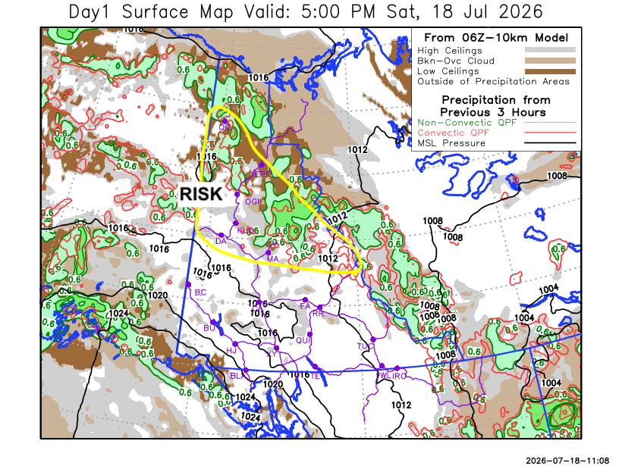
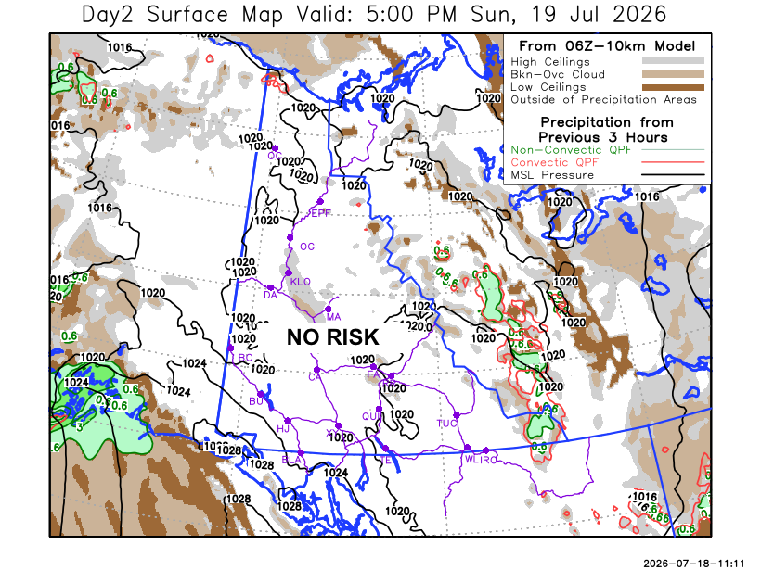

Forecast for | Sunday | (Peak burning period and overnight)
Community | Clouds | Pcpn | POP | POL | Max Temp | Min RH | Min Temp | Max  RH | Wind Dir | Wind Speed
Old Crow | FEW |  | 0 | NIL | 24 | 30 | 10 | 85 | 200 | 10
Klondike Fc | FEW |  | 0 | NIL | 27 | 25 | 10 | 85 | 220 | 10
Mayo A | FEW |  | 0 | NIL | 26 | 25 | 13 | 85 | 270 | 10
Carmacks | CLR |  | 0 | NIL | 28 | 20 | 10 | 80 | 140 | 10
Faro | FEW |  | 0 | NIL | 27 | 25 | 10 | 80 | 320 | 10
Ross River | FEW |  | 0 | NIL | 27 | 25 | 9 | 80 | 320 | 10
Beaver Creek Town | CLR |  | 0 | NIL | 26 | 20 | 7 | 90 | 110 | 10
Burwash A | CLR |  | 0 | NIL | 22 | 30 | 7 | 90 | 110 | 10
Haines Junction | CLR |  | 0 | NIL | 25 | 25 | 6 | 95 | 270 | 20
Whitehorse Auto | CLR |  | 0 | NIL | 25 | 20 | 9 | 85 | 140 | 10-15
Teslin | CLR |  | 0 | NIL | 25 | 20 | 10 | 85 | 180 | 10
Watson Lake | FEW |  | 0 | NIL | 25 | 25 | 11 | 90 | 320 | 10

Forecast for |  |  | Monday |  |  | (Peak burning period and overnight)
Community |  |  | Clouds |  |  | Pcpn | POP |  | POL |  | Max Temp |  | Min RH | Min Temp | Max  RH | Wind Dir | Wind Speed
Old Crow |  |  | FEW |  |  |  | 0 |  | NIL |  | 29 |  | 20 | 13 | 80 | 110 | 20
Klondike Fc |  |  | FEW |  |  |  | 0 |  | NIL |  | 30 |  | 20 | 13 | 80 | 110 | 10-15
Mayo A |  |  | FEW |  |  |  | 0 |  | NIL |  | 29 |  | 20 | 15 | 80 | 110 | 10
Carmacks |  |  | FEW |  |  |  | 0 |  | NIL |  | 31 |  | 15 | 13 | 75 | 140 | 15
Faro |  |  | FEW |  |  |  | 0 |  | NIL |  | 29 |  | 20 | 12 | 75 | 140 | 10
Ross River |  |  | FEW |  |  |  | 0 |  | NIL |  | 29 |  | 20 | 10 | 75 | 140 | 10
Beaver Creek Town |  |  | FEW |  |  |  | 0 |  | NIL |  | 28 |  | 25 | 10 | 85 | 110 | 5-10
Burwash A |  |  | FEW |  |  |  | 0 |  | NIL |  | 24 |  | 25 | 8 | 85 | 140 | 10-20
Haines Junction |  |  | FEW |  |  |  | 0 |  | NIL |  | 28 |  | 20 | 8 | 90 | 270 | 20
Whitehorse Auto |  |  | FEW |  |  |  | 0 |  | NIL |  | 28 |  | 20 | 11 | 75 | 140 | 15
Teslin |  |  | FEW |  |  |  | 0 |  | NIL |  | 28 |  | 25 | 12 | 75 | 140 | 10
Watson Lake |  |  | FEW |  |  |  | 0 |  | NIL |  | 28 |  | 25 | 12 | 80 | 140 | 10
3-Day Forecast Precipitation Totals from 13:00 Yesterday
OC | 3.9 |  | FA | 0.0 |  | JAK | 0.0
EPF | 4.4 |  | RR | 0.0 |  | TE | 0.0
ANT | 0.8 |  | BC | 0.3 |  | QUI | 0.0
DA | 0.3 |  | BCT | 0.3 |  | SWI | 0.0
FMI | 3.7 |  | BU | 0.0 |  | FL | 1.3
HEN | 0.8 |  | HJF | 0.0 |  | TUC | 0.1
BAR | 2.6 |  | RAI | 0.0 |  | HAS | 0.0
MA | 1.3 |  | CH | 1.5 |  | TC | 0.3
STW | 0.8 |  | BR | 0.5 |  | WL | 0.0
WIL | 2.9 |  | NU | 0.0 |  | NA | NA
PE | 0.5 |  | XY | 0.0 |  | IRO | 0.6
CA | 4.2 |  | CC | 0.0 |  | NA | NA
DRU | 0.4 |  | ATL | 0.0 |  | NA | NA
Scott Kehler Meteorologist

Disclaimer : The information in these forecasts is collected and prepared for internal use by the Government of Yukon. The forecasts are specifically designed to meet the needs of the Wildland Fire Management and may not cover the requirements of other parties. Weather warnings or advisories are not included as part of the forecasts. Wildland Fire Management makes no representation and provides no warranty as to the accuracy of its weather forecasts. Any use the recipient chooses to make of the forecasts will be at its sole risk.

