YUKON WILDLAND FIRE MANAGEMENT WEATHER FORECAST - 9:00 AM ISSUE

19-Jul-2026
YESTERDAY'S VALUES
Community | Max  Temp  (°C) | Diff.  from  Normal | Min Temp  (°C) | Diff. from Normal | Pcpn  (mm) | Min RH | Max RH | L110 | L30
Old Crow | 18.6 | -2.1 | 9.5 | 0.7 | 1.4 | 54 | 95 | 0 | 0
Fort Mcpherson Airport | 17.1 |  | 11.4 |  | 0.0 | 78 | 97 | 0 | 0
Rock River Climate | 12.7 |  | 9.6 |  | 3.4 | 70 | 100 | NA | NA
Eagle Plains Fire | 14.4 |  | 10.1 |  | 0.9 | 73 | 87 | 0 | 0
Antimony Creek | 22.5 |  | 5.6 |  | 0.0 | 31 | 97 | 0 | 0
Klondike Fc | 23.8 | 0.5 | 7.0 | -1.3 | 0.0 | 28 | 96 | 0 | 0
Forty Mile | 20.8 |  | 8.0 |  | 0.0 | 36 | 80 | 0 | 0
Henderson | 19.4 |  | 9.4 |  | 0.0 | 28 | 56 | 0 | 0
Barlow | 20.9 |  | 11.5 |  | 0.3 | 37 | 73 | 0 | 0
Mayo A | 21.8 | -1.1 | 10.1 | 0.6 | 0.0 | 34 | 81 | 0 | 0
Stewart Crossing | 22.1 |  | 12.5 |  | 0.3 | 36 | 75 | 0 | 0
Willow Creek | 20.4 |  | 4.9 |  | 0.0 | 39 | 95 | 0 | 0
Pelly Farm | 24.1 | 1.3 | 7.1 | -1.5 | 0.3 | 29 | 95 | 0 | 0
Carmacks | 23.7 |  | 7.4 |  | 0.0 | 33 | 79 | 0 | 0
Drury Creek | 21.2 |  | 4.5 |  | 0.0 | 37 | 94 | 0 | 0
Faro | 19.3 | -1.8 | 5.1 | -4.1 | 0.0 | 39 | 94 | 0 | 0
Ross River | 22.4 |  | 1.6 |  | 0.0 | 34 | 96 | 0 | 0
Macmillan Pass | 19.7 |  | 4.1 |  | 0.0 | 39 | 94 | 0 | 0
Beaver Creek A | 18.8 | -1.7 | 2.8 | -4.9 | 0.0 | 33 | 86 | 0 | 0
Beaver Creek Town | 20.2 |  | 2.0 |  | 0.0 | 27 | 89 | 0 | 0
Burwash A | 20.3 | 0.8 | 3.7 | -2.8 | 0.0M | 36 | 83 | 0 | 0
Haines Junction | 20.7 | 1.1 | 2.3 | -3.3 | 0.0 | 31 | 93 | 0 | 0
Rainbow | 21.4 |  | 5.8 |  | 0.0 | 28 | 84 | 0 | 0
Champagne | 21.5 |  | 4.7 |  | 0.0 | 25 | 79 | 0 | 0
Braeburn | 22.5 |  | 3.4 |  | 0.0 | 34 | 92 | 0 | 0
Nursery | 21.9 |  | 2.0 |  | 0.0 | 30 | 93 | 0 | 0
Whitehorse Auto | 20.0 | -0.6 | 5.5 | -2.4 | 0.0 | 34 | 80 | 0 | 0
Mount Sima | 18.0 |  | 8.6 |  | 0.0 | 36 | 59 | 0 | 0
Carcross | 21.3 |  | 5.1 |  | 0.0 | 34 | 91 | 0 | 0
Atlin | 20.3 |  | 5.5 |  | 0.0 | 32 | 76 | 0 | 0
Jakes Corner | 22.5 |  | 4.9 |  | 0.0 | 29 | 85 | 0 | 0
Teslin | 20.4 |  | 7.5 |  | 0.0 | 33 | 81 | 0 | 0
Quiet Lake | 20.4 |  | 3.9 |  | 0.0 | 35 | 91 | 0 | 0
Swift River | 21.3 |  | 1.4 |  | 0.0 | 29 | 95 | 0 | 0
Tuchitua | 26.8 |  | 1.9 |  | 0.0 | 22 | 97 | 0 | 0
Hasselburg | 22.2 |  | 9.0 |  | 0.0 | 28 | 68 | 0 | 0
Tom Creek | 23.8 |  | 10.2 |  | 0.0 | 26 | 64 | 0 | 0
Watson Lake | 23.9 | 2.5 | 9.2 | 0.1 | 0.0 | 25 | 75 | 0 | 0
Iron Creek | 26.4 |  | 6.6 |  | 0.0 | 23 | 94 | 1 | 0
Max Temp is the actual maximum temperature in °C from yesterday afternoon or evening.
Min Temp is the actual overnight minimum temperature in °C up until 6:00 AM this morning.
Diff. from Normal is the difference from the 30 year average max or min temperature.
Pcpn is the precipitation in mm since 13:00 yesterday.
Min RH is the minimum observed RH in % from yesterday afternoon or evening.
Max RH is the maximum observed overnight RH in % up until 6:00 AM this morning.
L110 is the actual number of lightning strikes within 110 km and in the Yukon for 24 hours ending at 06:00 AM this morning.
L30 is the actual number of lightning strikes within 30 km and in the Yukon for 24 hours ending at 06:00 AM this morning.
M is missing data. * denotes precipitation at stations that failed to report for at least part of the evening and overnight period.

SYNOPSIS:
Today: A strong upper ridge starts to build over the Yukon on Sunday, bringing warmer temperatures and dry conditions. The concern with this ridge will be increasing temperatures and decreasing RHs, as weather conditions otherwise look very quiet with no precipitation or thunderstorm risk. A slight risk of showers and thundershowers remains in the far southeast, mainly east of Watson Lake. Temperatures will mainly be in the mid to upper twenties, with crossovers possible most areas. Note: Winds are expected to be generally light, but as a result directions will be highly variable. The tabular forecast indicates the wind direction that is expected to be most common, but it is likely to vary considerably.
Monday: The upper ridge will remain in place, maintaining a warm and generally quiet weather pattern. Temperatures will continue to rise, with daytime highs ranging from the mid-20s to low-30s. Crossovers are likely where temperatures reach the upper-20s or warmer, resulting in a fairly widespread crossover risk. Deep crossovers in a few locations, such as western Tatchun. No precipitation or thunderstorms are expected during the main burning period. Winds will generally remain light, with east to southeast directions most common. However, the light wind speeds may allow directions to vary at times.
Tuesday: The next upper low and associated trough will begin moving into the Yukon, bringing increasing shower and thunderstorm activity along with the start of a cooling trend. Isolated showers and thundershowers are expected to develop through the Klondike and Northern Tutchone regions, with additional isolated activity possible across much of the southern half of the territory. Precipitation coverage will remain spotty, and some locations may stay dry. Temperatures will still be warm across central and eastern Yukon, with highs in the upper 20s to near 30°C, while cooler conditions develop in Kluane and parts of Southern Lakes. Crossover conditions will remain possible in the drier central, eastern, and southern areas.
Wednesday: The upper low will move farther into the Yukon, bringing cooler temperatures generally in the low to mid-20s, along with continued shower and thundershower activity and widespread cloud cover. Most precipitation is expected across the northern half of the territory and near the northeastern border, as much of the thunderstorm activity shifts eastward toward the Northwest Territories. Conditions should become drier across portions of central and southern Yukon. Winds will increase behind the system, with moderate west to southwesterly winds developing across much of the territory.
Thursday: Moderate southwesterly winds and the Yukon’s position between two upper-waves will result in generally cloudy conditions across much of the Territory. Temperatures will remain in the low to mid-20s, with localized minimum RH values near 30%. Although widespread precipitation is not expected, isolated showers and thundershowers may occur near the Alaska and Northwest Territories borders.

Forecast for | Sunday | (Peak burning period and overnight)
Community | Clouds | Pcpn | POP | POL | Max Temp | Min RH | Min Temp | Max  RH | Wind Dir | Wind Speed
Old Crow | CLR |  | 0 | NIL | 24 | 30 | 11 | 85 | 200 | 10
Klondike Fc | CLR |  | 0 | NIL | 26 | 25 | 10 | 65 | 160 | 10
Mayo A | FEW |  | 0 | NIL | 27 | 25 | 12 | 70 | 240 | 10
Carmacks | CLR |  | 0 | NIL | 28 | 20 | 10 | 70 | 140 | 10
Faro | FEW |  | 0 | NIL | 26 | 25 | 10 | 75 | 270 | 10
Ross River | FEW |  | 0 | NIL | 27 | 20 | 8 | 80 | 320 | 10
Beaver Creek Town | FEW |  | 0 | NIL | 26 | 25 | 6 | 70 | 110 | 15G25
Burwash A | CLR |  | 0 | NIL | 24 | 30 | 7 | 75 | 110 | 15G30
Haines Junction | CLR |  | 0 | NIL | 25 | 25 | 6 | 90 | 200 | 15G30
Whitehorse Auto | CLR |  | 0 | NIL | 26 | 20 | 10 | 65 | 140 | 10-15
Teslin | CLR |  | 0 | NIL | 24 | 20 | 11 | 70 | 220 | 10
Watson Lake | CLR |  | 0 | NIL | 27 | 20 | 12 | 65 | 320 | 15G25
POP is probability of precipitation in %.
POL is probability of lightning in %.

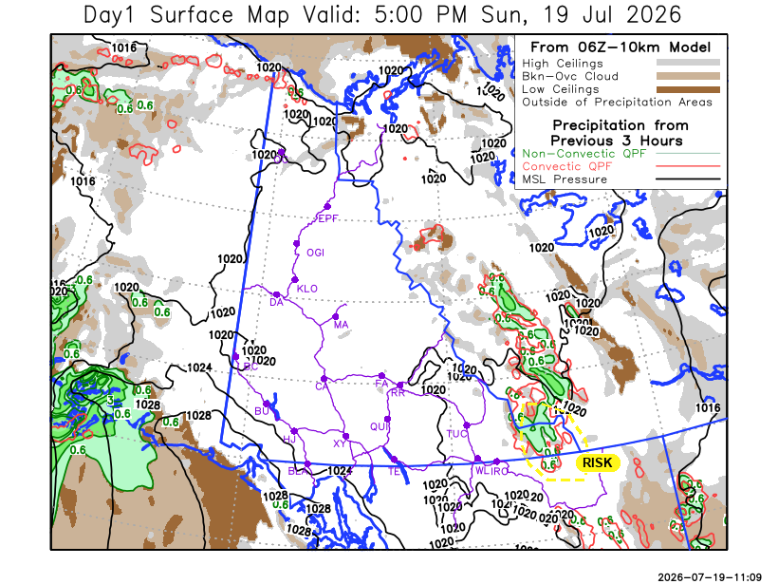

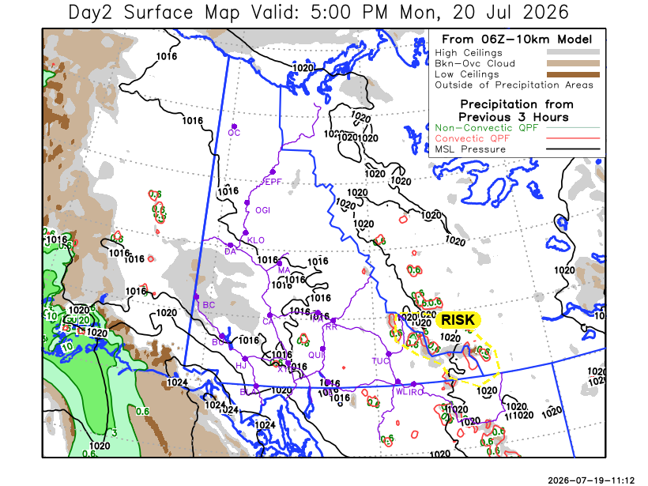

Forecast for | Monday | (Peak burning period and overnight)
Community | Clouds | Pcpn | POP | POL | Max Temp | Min RH | Min Temp | Max  RH | Wind Dir | Wind Speed
Old Crow | FEW |  | 0 | NIL | 28 | 25 | 13 | 75 | 90 | 15-20
Klondike Fc | FEW |  | 0 | NIL | 29 | 20 | 13 | 70 | 140 | 15G30
Mayo A | FEW |  | 0 | NIL | 30 | 20 | 16 | 70 | 110 | 10-15
Carmacks | CLR |  | 0 | NIL | 31 | 15 | 12 | 55 | 160 | 15
Faro | CLR |  | 0 | NIL | 29 | 20 | 11 | 65 | 140 | 10-15
Ross River | CLR |  | 0 | NIL | 31 | 20 | 9 | 65 | 140 | 10
Beaver Creek Town | SCT |  | 20 | NIL | 26 | 25 | 8 | 70 | 110 | 10
Burwash A | FEW |  | 0 | NIL | 24 | 25 | 7 | 70 | 140 | 15G30
Haines Junction | FEW |  | 0 | NIL | 26 | 20 | 7 | 85 | 180 | 20
Whitehorse Auto | CLR |  | 0 | NIL | 28 | 20 | 10 | 70 | 140 | 15G30
Teslin | CLR |  | 0 | NIL | 28 | 20 | 12 | 60 | 160 | 10
Watson Lake | CLR |  | 0 | NIL | 29 | 25 | 14 | 65 | 140 | 10

Forecast for |  |  | Tuesday |  | (Peak burning period and overnight)
Community |  |  | Clouds |  | Pcpn |  | POP |  | POL |  | Max Temp |  | Min RH | Min Temp | Max  RH | Wind Dir | Wind Speed
Old Crow |  |  | SCT |  | RW-/TRW- |  | 50 |  | ISO |  | 28 |  | 30 | 14 | 80 | 110 | 15G30
Klondike Fc |  |  | SCT |  | RW-/TRW- |  | 30 |  | RISK |  | 25 |  | 40 | 12 | 82 | 220 | 15
Mayo A |  |  | SCT |  | RW-/TRW- |  | 30 |  | RISK |  | 28 |  | 25 | 16 | 77 | 220 | 15
Carmacks |  |  | SCT |  | RW-/TRW- |  | 50 |  | ISO |  | 28 |  | 25 | 11 | 81 | 220 | 10-15
Faro |  |  | SCT |  | RW-/TRW- |  | 50 |  | ISO |  | 27 |  | 25 | 10 | 83 | 250 | 10-15
Ross River |  |  | SCT |  | RW-/TRW- |  | 50 |  | ISO |  | 30 |  | 20 | 9 | 80 | 190 | 10
Beaver Creek Town |  |  | BKN |  | R-/TRW- |  | 50 |  | ISO |  | 19 |  | 40 | 5 | 81 | 290 | 10-15
Burwash A |  |  | BKN |  | RW-/TRW- |  | 50 |  | ISO |  | 19 |  | 45 | 7 | 84 | 270 | 10-15
Haines Junction |  |  | SCT |  |  |  | 20 |  | NIL |  | 22 |  | 30 | 6 | 91 | 200 | 15G30
Whitehorse Auto |  |  | FEW |  | RW-/TRW- |  | 50 |  | ISO |  | 22 |  | 25 | 9 | 77 | 250 | 15
Teslin |  |  | FEW |  | RW-/TRW- |  | 40 |  | ISO |  | 25 |  | 25 | 10 | 76 | 250 | 15
Watson Lake |  |  | FEW |  | RW-/TRW- |  | 40 |  | RISK |  | 29 |  | 25 | 14 | 62 | 140 | 10-15
3-Day Forecast Precipitation Totals from 13:00 Yesterday
OC | 1.4 |  | FA | 0.0 |  | JAK | 0.0
EPF | 0.9 |  | RR | 0.0 |  | TE | 0.0
ANT | 0.0 |  | BC | 1.2 |  | QUI | 0.0
DA | 0.0 |  | BCT | 1.2 |  | SWI | 0.0
FMI | 0.2 |  | BU | 0.0 |  | FL | 0.0
HEN | 0.0 |  | HJF | 0.0 |  | TUC | 0.0
BAR | 0.3 |  | RAI | 0.0 |  | HAS | 0.0
MA | 0.0 |  | CH | 0.0 |  | TC | 0.0
STW | 0.3 |  | BR | 0.0 |  | WL | 0.0
WIL | 0.0 |  | NU | 0.0 |  | POR3 | 0.0
PE | 0.3 |  | XY | 0.0 |  | IRO | 0.0
CA | 0.0 |  | CC | 0.0
DRU | 0.0 |  | ATL | 0.0
Pallawi Paudel Meteorologist

Disclaimer : The information in these forecasts is collected and prepared for internal use by the Government of Yukon. The forecasts are specifically designed to meet the needs of the Wildland Fire Management and may not cover the requirements of other parties. Weather warnings or advisories are not included as part of the forecasts. Wildland Fire Management makes no representation and provides no warranty as to the accuracy of its weather forecasts. Any use the recipient chooses to make of the forecasts will be at its sole risk.

