YUKON WILDLAND FIRE MANAGEMENT WEATHER FORECAST - 9:00 AM ISSUE

20-Jul-2026
YESTERDAY'S VALUES
Community | Max  Temp  (°C) | Diff.  from  Normal | Min Temp  (°C) | Diff. from Normal | Pcpn  (mm) | Min RH | Max RH | L110 | L30
Old Crow | 23.9 | 3.3 | 9.7 | 1.0 | 0.0 | 33 | 88 | 0 | 0
Fort Mcpherson Airport | 26.2 |  | 11.9 |  | 0.0 | 36 | 92 | 0 | 0
Rock River Climate | 21.2 |  | 12.9 |  | 0.0 | 38 | 64 | NA | NA
Eagle Plains Fire | 23.9M |  | 14.7M |  | 0.0 | 30M | 54M | 0 | 0
Antimony Creek | 26.4 |  | 5.4 |  | 0.0 | 22 | 93 | 0 | 0
Klondike Fc | 27.0 | 3.7 | 9.7 | 1.4 | 0.0 | 23 | 80 | 0 | 0
Forty Mile | 26.1 |  | 9.9 |  | 0.0 | 27 | 87 | 0 | 0
Henderson | 23.2 |  | 13.8 |  | 0.0 | 25 | 55 | 0 | 0
Barlow | 25.9 |  | 16.1 |  | 0.0 | 24 | 51 | 0 | 0
Mayo A | 26.1 | 3.3 | 11.5 | 2.0 | 0.0 | 23 | 70 | 0 | 0
Stewart Crossing | 26.9 |  | 10.3 |  | 0.0 | 22 | 87 | 0 | 0
Willow Creek | 26.9 |  | 6.9 |  | 0.0 | 23 | 94 | 0 | 0
Pelly Farm | 27.3 | 4.5 | 7.2 | -1.4 | 0.0 | 22 | 91 | 0 | 0
Carmacks | 28.7 |  | 9.4 |  | 0.0 | 16 | 74 | 0 | 0
Drury Creek | 25.8 |  | 7.0 |  | 0.0 | 24 | 88 | 0 | 0
Faro | 26.6 | 5.6 | 7.7 | -1.5 | 0.0 | 22 | 86 | 0 | 0
Ross River | 26.8 |  | 3.9 |  | 0.0 | 19 | 95 | 0 | 0
Macmillan Pass | 20.4M |  | 4.2M |  | 0.0 | 31M | 87M | 0 | 0
Beaver Creek A | 27.3 | 6.8 | 6.0 | -1.7 | 0.0 | 23 | 77 | 0 | 0
Beaver Creek Town | 27.8 |  | 5.4 |  | 0.0 | 20 | 82 | 0 | 0
Burwash A | 23.8 | 4.3 | 11.2 | 4.7 | 0.0M | 30 | 61 | 0 | 0
Haines Junction | 24.0 | 5.0 | 4.6 | -0.5 | 0.0 | 27 | 91 | 0 | 0
Rainbow | 23.4 |  | 9.1 |  | 0.0 | 28 | 83 | 0 | 0
Champagne | 24.8 |  | 5.8 |  | 0.0 | 21 | 89 | 0 | 0
Braeburn | 26.3 |  | 4.2 |  | 0.0 | 24 | 96 | 0 | 0
Nursery | 26.4 |  | 2.6 |  | 0.0 | 24 | 95 | 0 | 0
Whitehorse Auto | 24.5 | 3.9 | 9.3 | 1.3 | 0.0 | 23 | 71 | 0 | 0
Mount Sima | 22.0 |  | 12.6 |  | 0.0 | 28 | 52 | 0 | 0
Carcross | 23.8 |  | 4.2 |  | 0.0 | 28 | 92 | 0 | 0
Atlin | 23.5 |  | 7.2 |  | 0.0 | 25 | 71 | 0 | 0
Jakes Corner | 24.8 |  | 6.7 |  | 0.0 | 24 | 81 | 0 | 0
Teslin | 24.9 |  | 7.6 |  | 0.0 | 25 | 87 | 0 | 0
Quiet Lake | 28.2 |  | 7.4 |  | 0.0 | 19 | 87 | 0 | 0
Swift River | 25.3 |  | 4.2 |  | 0.0 | 23 | 90 | 0 | 0
Tuchitua | 28.7 |  | 1.7 |  | 0.0 | 22 | 97 | 0 | 0
Hasselburg | 26.7 |  | 8.7 |  | 0.0 | 24 | 73 | 0 | 0
Tom Creek | 26.0 |  | 12.9 |  | 0.0 | 20 | 54 | 0 | 0
Watson Lake | 26.9 | 5.5 | 9.1 | 0.0 | 0.0 | 19 | 81 | 0 | 0
Iron Creek | 28.1 |  | 4.8 |  | 0.0 | 20 | 98 | 0 | 0
Max Temp is the actual maximum temperature in °C from yesterday afternoon or evening.
Min Temp is the actual overnight minimum temperature in °C up until 6:00 AM this morning.
Diff. from Normal is the difference from the 30 year average max or min temperature.
Pcpn is the precipitation in mm since 13:00 yesterday.
Min RH is the minimum observed RH in % from yesterday afternoon or evening.
Max RH is the maximum observed overnight RH in % up until 6:00 AM this morning.
L110 is the actual number of lightning strikes within 110 km and in the Yukon for 24 hours ending at 06:00 AM this morning.
L30 is the actual number of lightning strikes within 30 km and in the Yukon for 24 hours ending at 06:00 AM this morning.
M is missing data. * denotes precipitation at stations that failed to report for at least part of the evening and overnight period.

SYNOPSIS:
Today: The upper ridge will peak over the Territory, maintaining a warm and generally quiet weather pattern. Temperatures will continue to rise, with daytime highs exceeding 30°C across parts of central Yukon. Therefore, widespread crossovers are likely across the Territory. Deep crossovers in a few regions, such as southern Klondike, Northern Tutchone, Tatchun and Southern Lakes. No precipitation or thunderstorms are expected during the main burning period. Winds will generally remain light to moderate, with east to southeast directions most common. However, the light wind speeds may allow directions to be variable at times.
Tuesday: The next upper low and associated trough will begin moving into the Yukon, bringing increasing shower and thunderstorm activity along with the start of a cooling trend. Scattered showers and thundershowers are expected to develop through eastern Tatchun, and Tintina regions, with isolated activity possible across the Klondike, Northern Tutchone regions and much of the southern half of the Territory. Precipitation coverage will remain spotty. Temperatures will still be warm across central and eastern Yukon, with highs in the upper 20s to near 30°C, while cooler conditions develop in Klondike, Kluane and parts of Southern Lakes. Crossover conditions will remain possible in the drier central, eastern, and southern areas (particularly Tatchun, Mayo district, and Tintina).
Wednesday: The upper low will move farther into the Yukon, bringing cooler temperatures generally in the low to mid-20s, along with continued shower and thundershower activity and widespread cloud cover. Most precipitation is expected across the northern half of the Territory and near the eastern border, as much of the thunderstorm activity shifts eastward toward the Northwest Territories. Conditions should become drier across portions of central and southern Yukon. Winds will increase behind the system, with light to moderate west to southwesterly winds developing across much of the Territory.
Thursday: Moderate southwesterly winds and the Yukon’s position between two upper waves will result in generally cloudy conditions across much of the Territory. Temperatures will remain in the low to mid-20s, with localized minimum RH values as low as 30%. Although widespread precipitation is not expected, isolated showers and thundershowers may occur near the Alaska and Northwest Territories borders.
Friday: Another day of cooler conditions is expected on Friday as the upper trough continues to influence the region. A thick cloud deck and widespread precipitation are forecast along the system’s path across much of the Territory. Temperatures will generally remain in the upper teens to low-20s, while RH values are expected to stay elevated above 40%. Light to moderate north to northwesterly winds will prevail.

Forecast for | Monday | (Peak burning period and overnight)
Community | Clouds | Pcpn | POP | POL | Max Temp | Min RH | Min Temp | Max  RH | Wind Dir | Wind Speed
Old Crow | FEW |  | 0 | NIL | 29 | 25 | 13 | 75 | 90 | 15-20
Klondike Fc | FEW |  | 0 | NIL | 30 | 20 | 13 | 60 | 110 | 15G30
Mayo A | FEW |  | 0 | NIL | 31 | 20 | 14 | 65 | 110 | 15
Carmacks | CLR |  | 0 | NIL | 32 | 15 | 11 | 55 | 160 | 15G25
Faro | CLR |  | 0 | NIL | 30 | 20 | 11 | 60 | 110 | 10-15
Ross River | CLR |  | 0 | NIL | 31 | 15 | 9 | 60 | 160 | 10
Beaver Creek Town | SCT |  | 20 | NIL | 28 | 25 | 8 | 70 | 110 | 10
Burwash A | FEW |  | 0 | NIL | 25 | 25 | 7 | 70 | 140 | 20G35
Haines Junction | FEW |  | 0 | NIL | 26 | 20 | 7 | 85 | 180 | 15G25
Whitehorse Auto | CLR |  | 0 | NIL | 29 | 15 | 10 | 75 | 180 | 15G30
Teslin | CLR |  | 0 | NIL | 29 | 20 | 12 | 60 | 160 | 10-15
Watson Lake | FEW |  | 0 | NIL | 29 | 20 | 15 | 65 | 140 | 10-15
POP is probability of precipitation in %.
POL is probability of lightning in %.

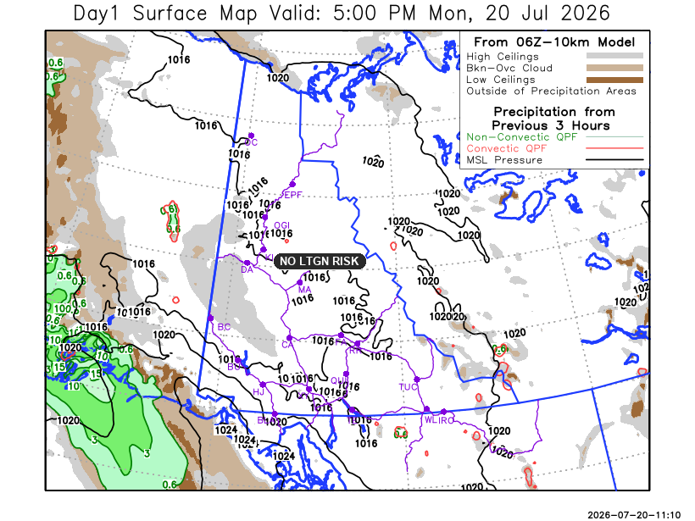

Forecast for | Tuesday | (Peak burning period and overnight)
Community | Clouds | Pcpn | POP | POL | Max Temp | Min RH | Min Temp | Max  RH | Wind Dir | Wind Speed
Old Crow | SCT | RW-/TRW- | 40 | RISK | 28 | 30 | 14 | 80 | 110 | 15G30
Klondike Fc | SCT | RW-/TRW- | 30 | RISK | 25 | 35 | 12 | 75 | 250 | 15G20
Mayo A | SCT | RW-/TRW- | 30 | RISK | 28 | 25 | 16 | 85 | 220 | 15G30
Carmacks | BKN | RW-/TRW- | 50 | ISO | 28 | 25 | 12 | 80 | 180 | 10-15
Faro | SCT | RW-/TRW- | 60 | ISO | 27 | 25 | 10 | 80 | 270 | 10-15
Ross River | SCT | RW-/TRW- | 60 | ISO | 31 | 20 | 9 | 80 | 240 | 10-15
Beaver Creek Town | BKN | RW-/TRW- | 70 | ISO | 20 | 35 | 5 | 75 | 290 | 10
Burwash A | BKN | RW-/TRW- | 70 | ISO | 19 | 30 | 8 | 75 | 270 | 15
Haines Junction | SCT | RW-/TRW- | 30 | RISK | 22 | 25 | 6 | 90 | 200 | 15G30
Whitehorse Auto | SCT | RW-/TRW- | 60 | ISO | 22 | 25 | 9 | 75 | 220 | 15G25
Teslin | SCT | RW-/TRW- | 40 | ISO | 24 | 25 | 12 | 70 | 220 | 15
Watson Lake | FEW | RW-/TRW- | 40 | ISO | 30 | 20 | 14 | 60 | 140 | 10-15

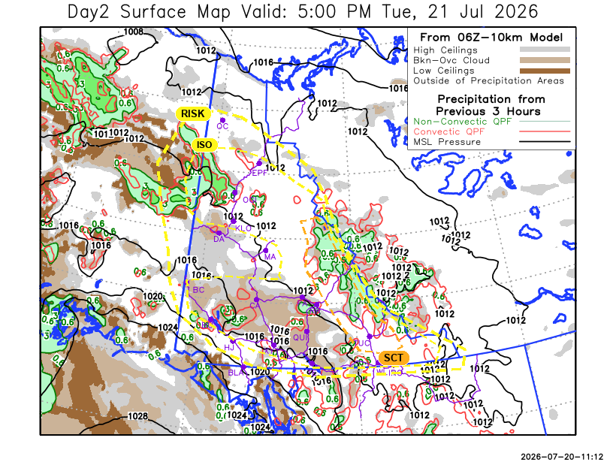

Forecast for |  |  | Wednesday |  |  | (Peak burning period and overnight)
Community |  |  | Clouds |  |  | Pcpn | POP |  | POL |  | Max Temp |  | Min RH | Min Temp | Max  RH | Wind Dir | Wind Speed
Old Crow |  |  | BKN |  |  | RW- | 40 |  | NIL |  | 22 |  | 50 | 12 | 80 | 220 | 15
Klondike Fc |  |  | BKN |  |  | RW- | 30 |  | NIL |  | 22 |  | 45 | 11 | 75 | 220 | 5-10
Mayo A |  |  | SCT |  |  |  | 20 |  | NIL |  | 24 |  | 25 | 13 | 80 | 250 | 15
Carmacks |  |  | BKN |  |  |  | 20 |  | NIL |  | 26 |  | 25 | 11 | 70 | 160 | 10
Faro |  |  | SCT |  |  | RW- | 30 |  | NIL |  | 22 |  | 30 | 10 | 75 | 250 | 10-15
Ross River |  |  | BKN |  |  | RW- | 30 |  | NIL |  | 23 |  | 30 | 8 | 75 | 270 | 10-15
Beaver Creek Town |  |  | BKN |  |  | RW- | 30 |  | NIL |  | 20 |  | 35 | 6 | 70 | 330 | 5-10
Burwash A |  |  | BKN |  |  |  | 0 |  | NIL |  | 20 |  | 35 | 9 | 75 | 140 | 10
Haines Junction |  |  | BKN |  |  |  | 0 |  | NIL |  | 19 |  | 35 | 6 | 90 | 200 | 15
Whitehorse Auto |  |  | SCT |  |  |  | 0 |  | NIL |  | 23 |  | 30 | 10 | 75 | 250 | 15G25
Teslin |  |  | BKN |  |  |  | 0 |  | NIL |  | 22 |  | 30 | 10 | 75 | 250 | 15
Watson Lake |  |  | BKN |  |  |  | 0 |  | NIL |  | 24 |  | 25 | 12 | 65 | 270 | 15G30
3-Day Forecast Precipitation Totals from 13:00 Yesterday
OC | 2.9 |  | FA | 3.9 |  | JAK | 0.3
EPF | 6.7 |  | RR | 3.6 |  | TE | 0.5
ANT | 0.6 |  | BC | 2.4 |  | QUI | 0.8
DA | 0.9 |  | BCT | 2.4 |  | SWI | 0.6
FMI | 0.7 |  | BU | 4.0 |  | FL | 4.1
HEN | 0.2 |  | HJF | 2.1 |  | TUC | 1.3
BAR | 2.4 |  | RAI | 1.9 |  | HAS | 1.5
MA | 2.9 |  | CH | 0.8 |  | TC | 0.9
STW | 2.5 |  | BR | 1.5 |  | WL | 0.3
WIL | 4.6 |  | NU | 1.0 |  | POR3 | 2.0
PE | 2.7 |  | XY | 1.8 |  | IRO | 1.7
CA | 2.5 |  | CC | 0.0
DRU | 2.4 |  | ATL | 0.2
Pallawi Paudel Meteorologist

Disclaimer : The information in these forecasts is collected and prepared for internal use by the Government of Yukon. The forecasts are specifically designed to meet the needs of the Wildland Fire Management and may not cover the requirements of other parties. Weather warnings or advisories are not included as part of the forecasts. Wildland Fire Management makes no representation and provides no warranty as to the accuracy of its weather forecasts. Any use the recipient chooses to make of the forecasts will be at its sole risk.

