YUKON WILDLAND FIRE MANAGEMENT WEATHER FORECAST - 9:00 AM ISSUE

21-Jul-2026
YESTERDAY'S VALUES
Community | Max  Temp  (°C) | Diff.  from  Normal | Min Temp  (°C) | Diff. from Normal | Pcpn  (mm) | Min RH | Max RH | L110 | L30
Old Crow | 29.8 | 9.2 | 18.0 | 9.3 | 0.0 | 24 | 65 | 0 | 0
Fort Mcpherson Airport | 30.2 |  | 12.3 |  | 0.0 | 27 | 89 | 0 | 0
Rock River Climate | 25.3M |  | 17.8M |  | 0.0M | 35M | 49M | NA | NA
Eagle Plains Fire | 28.9M |  | 16.3M |  | 0.0M | 23M | 54M | 0 | 0
Antimony Creek | 29.9 |  | 7.4 |  | 0.0 | 22 | 89 | 0 | 0
Klondike Fc | 30.4 | 7.2 | 11.4 | 3.2 | 0.0 | 19 | 75 | 0 | 0
Forty Mile | 29.6M |  | 11.3M |  | 0.0M | 24M | 85M | 0 | 0
Henderson | 25.9 |  | 16.4 |  | 0.0 | 25 | 39 | 0 | 0
Barlow | 29.7 |  | 16.8 |  | 0.0 | 23 | 45 | 0 | 0
Mayo A | 30.6 | 7.8 | 11.2 | 1.7 | 0.0 | 22 | 83 | 0 | 0
Stewart Crossing | 30.3 |  | 11.9 |  | 0.0 | 16 | 80 | 0 | 0
Willow Creek | 28.8 |  | 10.0 |  | 0.0 | 19 | 89 | 0 | 0
Pelly Farm | 30.0 | 7.3 | 11.2 | 2.7 | 0.0 | 18 | 79 | 0 | 0
Carmacks | 31.5 |  | 11.9 |  | 0.0 | 18 | 62 | 0 | 0
Drury Creek | 30.7 |  | 7.8 |  | 0.0 | 23 | 86 | 0 | 0
Faro | 31.1 | 10.1 | 8.3 | -0.8 | 0.0 | 14 | 77 | 0 | 0
Ross River | 31.2 |  | 5.0 |  | 0.0 | 18 | 92 | 0 | 0
Macmillan Pass | 24.5M |  | 7.4M |  | 0.0M | 24M | 77M | 0 | 0
Beaver Creek A | 26.9 | 6.4 | 9.7 | 2.0 | 0.0M | 28 | 69 | 0 | 0
Beaver Creek Town | 28.4M |  | 9.5M |  | 0.0M | 23M | 81M | 0 | 0
Burwash A | 24.3 | 4.8 | 12.0 | 5.5 | 0.0M | 34 | 58 | 0 | 0
Haines Junction | 25.9M | 6.7 | 5.2M | -0.1 | 0.0M | 32M | 93M | 0 | 0
Rainbow | 26.1 |  | 11.7 |  | 0.0 | 28 | 70 | 0 | 0
Champagne | 27.4 |  | 10.2 |  | 0.0 | 24 | 77 | 0 | 0
Braeburn | 29.9 |  | 5.8 |  | 0.0 | 20 | 93 | 0 | 0
Nursery | 29.6 |  | 3.6 |  | 0.0 | 19 | 95 | 0 | 0
Whitehorse Auto | 28.1 | 7.5 | 11.3 | 3.3 | 0.0 | 19 | 62 | 0 | 0
Mount Sima | 24.6M |  | 11.9M |  | 0.0M | 22M | 51M | 0 | 0
Carcross | 26.4 |  | 7.4 |  | 0.0 | 23 | 92 | 0 | 0
Atlin | 27.8 |  | 9.5 |  | 0.0 | 15 | 66 | 0 | 0
Jakes Corner | 29.7M |  | 8.3M |  | 0.0M | 16M | 67M | 0 | 0
Teslin | 28.8 |  | 7.9 |  | 0.0 | 19 | 82 | 0 | 0
Quiet Lake | 31.7 |  | 6.6 |  | 0.0 | 21 | 79 | 0 | 0
Swift River | 30.2 |  | 3.5 |  | 0.0 | 17 | 89 | 0 | 0
Tuchitua | 31.8 |  | 5.8 |  | 0.0 | 19 | 98 | 0 | 0
Hasselburg | 29.0 |  | 10.6 |  | 0.0 | 21 | 77 | 0 | 0
Tom Creek | 28.6 |  | 15.3 |  | 0.0 | 21 | 74 | 0 | 0
Watson Lake | 29.5 | 8.2 | 14.0 | 4.9 | 0.0 | 21 | 80 | 0 | 0
Iron Creek | 30.8 |  | 8.8 |  | 0.0 | 20 | 99 | 0 | 0
Max Temp is the actual maximum temperature in °C from yesterday afternoon or evening.
Min Temp is the actual overnight minimum temperature in °C up until 6:00 AM this morning.
Diff. from Normal is the difference from the 30 year average max or min temperature.
Pcpn is the precipitation in mm since 13:00 yesterday.
Min RH is the minimum observed RH in % from yesterday afternoon or evening.
Max RH is the maximum observed overnight RH in % up until 6:00 AM this morning.
L110 is the actual number of lightning strikes within 110 km and in the Yukon for 24 hours ending at 06:00 AM this morning.
L30 is the actual number of lightning strikes within 30 km and in the Yukon for 24 hours ending at 06:00 AM this morning.
M is missing data. * denotes precipitation at stations that failed to report for at least part of the evening and overnight period.

SYNOPSIS:
Today: The next upper low and associated trough will begin moving into Yukon, bringing increasing shower and thunderstorm activity along with the start of a cooling trend. Scattered showers and thundershowers are expected to develop through eastern Tatchun, and Tintina regions, with isolated activity possible across the Klondike, Northern Tutchone regions and much of the southern half of the Territory. Precipitation coverage will remain spotty. Temperatures will still be warm across central and eastern Yukon, with highs in the upper-20s to near 30°C, while cooler conditions develop in Klondike, Kluane and parts of Southern Lakes. Crossover conditions will remain possible in the drier central, eastern, and southern areas (particularly Tatchun, Mayo district, and Tintina) as minimum RHs drop into the 20-30% range.
Wednesday: The upper low will move farther into the Yukon, bringing cooler temperatures generally in the low to mid-20s, along with continued shower and thundershower activity and widespread cloud cover. The only exception is in Tatchun and Mayo district where a few upper-20s may still linger, leading to a risk of crossovers. Most precipitation is expected across the northern half of the Territory and near the eastern border, as much of the thunderstorm activity shifts eastward toward the Northwest Territories. Conditions should become drier across portions of central and southern Yukon. Winds will increase behind the system, with light to moderate west to southwesterly winds developing across much of the Territory.
Thursday: Moderate southwesterly winds and the Yukon’s position between two upper waves will result in generally cloudy conditions across much of the Territory. Temperatures will remain in the low to mid-20s, with localized minimum RH values as low as 30%, but broadly put RHs improve compared to previous days. Although widespread precipitation is not expected, isolated showers and thundershowers may occur near the Alaska and Northwest Territories borders.
Friday: Another day of cooler conditions is expected on Friday as the upper trough continues to influence the region. A thick cloud deck and widespread precipitation are forecast along the system’s path across much of the Territory. Temperatures will generally remain in the upper teens to low-20s, while RH values are expected to stay elevated above 40%. Light to moderate north to northwesterly winds will prevail.
Saturday: Cool and humid conditions are expected under the upper trough through Saturday. Cloud cover will remain widespread, while showers and thundershowers gradually shift southeastward into the Tatchun, Southern Lakes, and Tintina regions. Temperatures will generally range from the mid-teens to low 20s, with minimum RH values around 30-40%. Driest conditions will develop across the Old Crow and Klondike regions.

Forecast for | Tuesday | (Peak burning period and overnight)
Community | Clouds | Pcpn | POP | POL | Max Temp | Min RH | Min Temp | Max  RH | Wind Dir | Wind Speed
Old Crow | SCT | RW-/TRW- | 60 | RISK | 30 | 35 | 14 | 85 | 110 | 15-20G30
Klondike Fc | SCT | RW-/TRW- | 30 | RISK | 25 | 30 | 12 | 75 | 250 | 10-15
Mayo A | FEW | RW-/TRW- | 40 | RISK | 28 | 25 | 17 | 70 | 250 | 10-15G25
Carmacks | SCT | RW-/TRW- | 40 | ISO | 30 | 20 | 13 | 65 | 180 | 10
Faro | SCT | RW-/TRW- | 50 | ISO | 28 | 20 | 12 | 70 | 270 | 15G25
Ross River | SCT | RW-/TRW- | 60 | ISO | 31 | 20 | 11 | 75 | 270 | 15G25
Beaver Creek Town | SCT | RW-/TRW- | 40 | ISO | 23 | 35 | 7 | 70 | 220 | 10
Burwash A | SCT | RW-/TRW- | 40 | ISO | 22 | 30 | 9 | 65 | 160 | 10-15
Haines Junction | SCT | RW-/TRW- | 30 | RISK | 23 | 25 | 6 | 90 | 200 | 15
Whitehorse Auto | BKN | RW-/TRW- | 60 | ISO | 25 | 25 | 11 | 75 | 220 | 10-15G25
Teslin | BKN | RW-/TRW- | 80 | ISO | 24 | 20 | 12 | 80 | 250 | 15G30
Watson Lake | FEW | RW-/TRW- | 70 | ISO | 30 | 20 | 13 | 75 | 160 | 10-15
POP is probability of precipitation in %.
POL is probability of lightning in %.

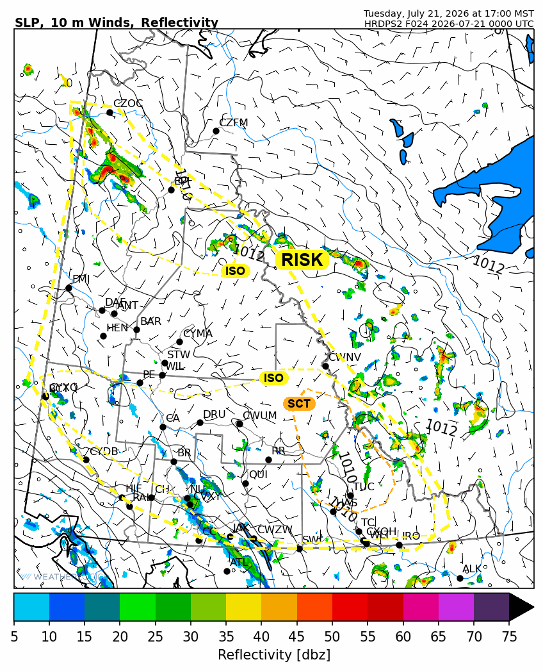
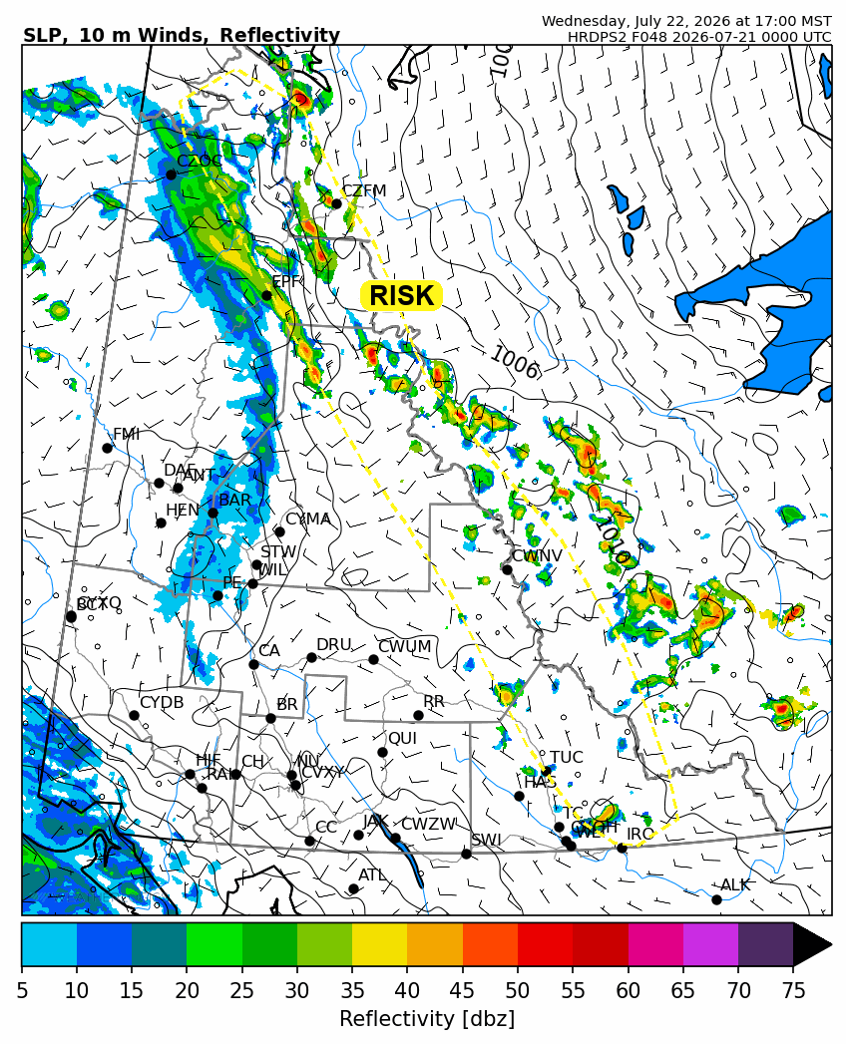

Forecast for | Wednesday | (Peak burning period and overnight)
Community | Clouds | Pcpn | POP | POL | Max Temp | Min RH | Min Temp | Max  RH | Wind Dir | Wind Speed
Old Crow | SCT | RW-/TRW- | 50 | RISK | 23 | 55 | 10 | 80 | 250 | 20G35
Klondike Fc | BKN | RW- | 30 | NIL | 21 | 40 | 11 | 65 | 250 | 10
Mayo A | BKN |  | 0 | NIL | 26 | 25 | 14 | 75 | 250 | 15G30
Carmacks | BKN |  | 0 | NIL | 27 | 25 | 12 | 70 | 160 | 10-15
Faro | BKN | RW- | 30 | NIL | 25 | 25 | 11 | 70 | 270 | 10G20
Ross River | SCT | RW- | 30 | NIL | 28 | 25 | 10 | 65 | 270 | 10-15
Beaver Creek Town | BKN | RW- | 30 | NIL | 22 | 35 | 7 | 65 | 270 | 10
Burwash A | BKN |  | 0 | NIL | 20 | 35 | 9 | 75 | 140 | 10-15
Haines Junction | BKN |  | 0 | NIL | 19 | 35 | 7 | 90 | 180 | 15
Whitehorse Auto | SCT |  | 20 | NIL | 24 | 25 | 11 | 75 | 250 | 15
Teslin | SCT |  | 20 | NIL | 23 | 25 | 11 | 75 | 250 | 10G20
Watson Lake | SCT |  | 20 | NIL | 24 | 25 | 12 | 70 | 270 | 15G30

Forecast for |  |  | Thursday |  |  | (Peak burning period and overnight)
Community |  |  | Clouds |  |  | Pcpn | POP |  | POL |  | Max Temp |  | Min RH | Min Temp | Max  RH | Wind Dir | Wind Speed
Old Crow |  |  | BKN |  |  | RW- | 70 |  | NIL |  | 18 |  | 55 | 9 | 89 | 250 | 15G30
Klondike Fc |  |  | BKN |  |  | RW- | 60 |  | NIL |  | 19 |  | 55 | 8 | 88 | 270 | 10
Mayo A |  |  | BKN |  |  | RW- | 60 |  | NIL |  | 24 |  | 35 | 12 | 91 | 250 | 10-15
Carmacks |  |  | BKN |  |  | RW- | 40 |  | NIL |  | 27 |  | 30 | 10 | 87 | 160 | 15G25
Faro |  |  | BKN |  |  | RW- | 30 |  | NIL |  | 25 |  | 30 | 9 | 90 | 250 | 10-15
Ross River |  |  | BKN |  |  | RW- | 30 |  | NIL |  | 27 |  | 30 | 8 | 83 | 200 | 15G25
Beaver Creek Town |  |  | BKN |  |  | RW- | 60 |  | NIL |  | 22 |  | 40 | 4 | 86 | 290 | 10-15
Burwash A |  |  | BKN |  |  | RW- | 50 |  | NIL |  | 22 |  | 40 | 7 | 89 | 320 | 15G30
Haines Junction |  |  | BKN |  |  | RW- | 30 |  | NIL |  | 18 |  | 40 | 8 | 91 | 200 | 15
Whitehorse Auto |  |  | BKN |  |  | RW- | 30 |  | NIL |  | 21 |  | 35 | 11 | 84 | 200 | 20G30
Teslin |  |  | SCT |  |  |  | 20 |  | NIL |  | 21 |  | 35 | 10 | 80 | 220 | 15G25
Watson Lake |  |  | SCT |  |  |  | 20 |  | NIL |  | 26 |  | 30 | 13 | 68 | 250 | 15G25
3-Day Forecast Precipitation Totals from 13:00 Yesterday
OC | 5.7 |  | FA | 0.8 |  | JAK | 5.4
EPF | 4.1 |  | RR | 3.1 |  | TE | 2.6
ANT | 1.7 |  | BC | 0.6 |  | QUI | 7.9
DA | 1.6 |  | BCT | 0.6 |  | SWI | 3.6
FMI | 4.5 |  | BU | 0.1 |  | FL | 8.1
HEN | 0.5 |  | HJF | 0.0 |  | TUC | 6.1
BAR | 0.3 |  | RAI | 0.0 |  | HAS | 6.0
MA | 0.0 |  | CH | 0.0 |  | TC | 3.9
STW | 0.2 |  | BR | 0.0 |  | WL | 3.1
WIL | 0.0 |  | NU | 0.6 |  | POR3 | 0.0
PE | 0.0 |  | XY | 1.4 |  | IRO | 5.3
CA | 0.0 |  | CC | 3.2
DRU | 0.9 |  | ATL | 2.8
Pallawi Paudel Meteorologist

Disclaimer : The information in these forecasts is collected and prepared for internal use by the Government of Yukon. The forecasts are specifically designed to meet the needs of the Wildland Fire Management and may not cover the requirements of other parties. Weather warnings or advisories are not included as part of the forecasts. Wildland Fire Management makes no representation and provides no warranty as to the accuracy of its weather forecasts. Any use the recipient chooses to make of the forecasts will be at its sole risk.

