YUKON WILDLAND FIRE MANAGEMENT WEATHER FORECAST - 9:00 AM ISSUE

25-Jul-2026
YESTERDAY'S VALUES
Community | Max  Temp  (°C) | Diff.  from  Normal | Min Temp  (°C) | Diff. from Normal | Pcpn  (mm) | Min RH | Max RH | L110 | L30
Old Crow | 8.7 | -11.6 | 4.0 | -4.4 | 0.0 | 56 | 87 | 0 | 0
Fort Mcpherson Airport | 6.4 |  | -0.9 |  | 0.0M | 67 | 96 | 0 | 0
Rock River Climate | 5.3 |  | -0.8 |  | 0.0 | 81 | 97 | NA | NA
Eagle Plains Fire | 6.7 |  | 0.1 |  | 2.2 | 88 | 99 | 0 | 0
Antimony Creek | 17.0 |  | 5.8 |  | 0.0 | 54 | 89 | 0 | 0
Klondike Fc | 17.5 | -5.5 | 8.2 | 0.2 | 0.5 | 49 | 80 | 0 | 0
Forty Mile | 10.4 |  | 4.7 |  | 0.0 | 69 | 87 | 0 | 0
Henderson | 13.0 |  | 4.1 |  | 0.0 | 57 | 93 | 0 | 0
Barlow | 16.7 |  | 5.9 |  | 5.9 | 52 | 93 | 0 | 0
Mayo A | 17.0 | -5.6 | 7.3 | -2.0 | 0.0 | 45 | 54 | 2 | 0
Stewart Crossing | 17.6 |  | 8.5 |  | 1.9 | 46 | 93 | 2 | 0
Willow Creek | 17.2 |  | 6.5 |  | 1.1 | 46 | 93 | 2 | 0
Pelly Farm | 18.4 | -4.2 | 8.5 | 0.2 | 0.5 | 48 | 86 | 2 | 0
Carmacks | 19.8 |  | 7.9 |  | 3.2 | 42 | 96 | 2 | 0
Drury Creek | 14.8 |  | 8.8 |  | 0.3 | 48 | 89 | 1 | 0
Faro | 12.1 | -8.7 | 7.2 | -1.7 | 0.6 | 54 | 86 | 0 | 0
Ross River | 11.3 |  | 7.7 |  | 4.4 | 61 | 92 | 0 | 0
Macmillan Pass | 8.5 |  | 1.7 |  | 4.4 | 67 | 83 | 0 | 0
Beaver Creek A | 9.8 | -10.5 | 5.9 | -1.6 | 1.0 | 70 | 95 | 0 | 0
Beaver Creek Town | 10.6 |  | 6.2 |  | 1.8 | 64 | 95 | 0 | 0
Burwash A | 12.9 | -6.5 | 5.3 | -1.1 | 0.0M | 67 | 94 | 0 | 0
Haines Junction | 19.7 | -0.1 | 9.2 | 5.2 | 0.0 | 40 | 69 | 0 | 0
Rainbow | 17.7 |  | 7.0 |  | 0.3 | 42 | 83 | 0 | 0
Champagne | 17.3 |  | 8.4 |  | 0.0 | 39 | 81 | 0 | 0
Braeburn | 17.4 |  | 7.5 |  | 4.0 | 44 | 97 | 0 | 0
Nursery | 14.5 |  | 8.7 |  | 3.8 | 56 | 98 | 0 | 0
Whitehorse Auto | 14.8 | -5.7 | 8.7 | 0.7 | 5.6 | 50 | 98 | 0 | 0
Mount Sima | 12.1 |  | 5.6 |  | 2.4 | 56 | 97 | 0 | 0
Carcross | 15.3 |  | 9.5 |  | 0.5 | 59 | 95 | 0 | 0
Atlin | 13.3 |  | 9.3 |  | 1.2 | 51 | 92 | 0 | 0
Jakes Corner | 11.7 |  | 7.6 |  | 4.2 | 83 | 97 | 0 | 0
Teslin | 12.2 |  | 7.9 |  | 3.4 | 60 | 97 | 0 | 0
Quiet Lake | 12.9 |  | 8.7 |  | 0.0 | 63 | 81 | 0 | 0
Swift River | 15.3 |  | 7.5 |  | 0.6 | 52 | 95 | 0 | 0
Tuchitua | 17.2 |  | 8.7 |  | 6.2 | 45 | 99 | 0 | 0
Hasselburg | 16.2 |  | 7.9 |  | 0.0 | 45 | 84 | 0 | 0
Tom Creek | 17.7 |  | 6.7 |  | 0.3 | 40 | 92 | 0 | 0
Watson Lake | 18.6 | -2.7 | 9.8 | 0.8 | 0.8 | 37 | 79 | 0 | 0
Iron Creek | 22.9 |  | 8.4 |  | 0.0 | 25 | 86 | 0 | 0
Max Temp is the actual maximum temperature in °C from yesterday afternoon or evening.
Min Temp is the actual overnight minimum temperature in °C up until 6:00 AM this morning.
Diff. from Normal is the difference from the 30 year average max or min temperature.
Pcpn is the precipitation in mm since 13:00 yesterday.
Min RH is the minimum observed RH in % from yesterday afternoon or evening.
Max RH is the maximum observed overnight RH in % up until 6:00 AM this morning.
L110 is the actual number of lightning strikes within 110 km and in the Yukon for 24 hours ending at 06:00 AM this morning.
L30 is the actual number of lightning strikes within 30 km and in the Yukon for 24 hours ending at 06:00 AM this morning.
M is missing data. * denotes precipitation at stations that failed to report for at least part of the evening and overnight period.

SYNOPSIS:
Today: High pressure gains a footing and as a result quiet skies are expected today with cooler, but still mild temperatures. Daytime highs will comfortably sit in the mid to low teens across the territory and minimum RH will generally remain above 40%. The driest air will develop along the Hwy 2 corridor through Western Tatchun and maybe Southern Lakes where a few readings in the 25-35% range are expected along with wind gusts up to 35 km/h.. Spotty showers are expected over the eastern half of Tintina throughout the day and overnight. Light, northerly winds are expected over the southern half of the territory, however, gusts may push 20-30 km/h. Over the northern half of the territory, light westerly winds are in play with gusts up to 20 km/h.
Sunday: It will rain in southeast high pressure remains in place for everywhere else. Rain showers and damp conditions are expected over Tintina throughout the day, the rain showers will push into Southern Lakes late afternoon. Elsewhere across southern/central Yukon, daytime highs will be in the mid to high teens and minimum RH generally bottoms at 35% along with a few 30% readings. Over northern Yukon, warm gusty winds develop during the day. Minimum RH will sit around 35-40% and sustained winds will be out of the west at 15-20 km/h gusting 40 km/h. A sharp cold front moves in from the north late evening/overnight with showers and an abrupt shift to northerly winds.
Monday: - Damp, unsettled conditions overtake the north and the southeast while generally warm and marginally low RH remain on the Yukon Plateau. Over the Yukon Plateau excluding Tintina and parts of Southern Lakes, daytime highs will be in the mid to high teens and minimum RH 35-40%. There is potential for a few 30% readings again but uncertainty is bit too high to highlight regions. Over Tintina and eastern Southern Lakes, rain showers continue along with breezy westerly winds sustained at 10-15 km/h gusting 30-40 km/h. Over the northern Yukon, daytime highs will be in the single digits with rain and snow showers.
Tuesday: Rain showers clear over northern Yukon but damp and cool conditions remain. Over the southern half of the territory, spotty rain showers are possible across the region, the highest probability of showers will be over Tintina and Southern Lakes yet again. Areas impacted by showers will see cooler temperatures and higher RH, but in general daytime highs will be in the mid to high teens and RH 35-40%. The driest air is expected over Tatchun, daytime highs will be around 20C and minimum RH of 30-35%.
Wednesday: Temperatures back off a few degrees and RH increases overall across the territory. Showers are expected to continue and potentially increase in coverage over southern Yukon, and another cold front will push into northern Yukon with showers. Moderate winds are possible both ahead and behind the cold front over northern Yukon.

Forecast for | Saturday | (Peak burning period and overnight)
Community | Clouds | Pcpn | POP | POL | Max Temp | Min RH | Min Temp | Max  RH | Wind Dir | Wind Speed
Old Crow | SCT |  | 0 | NIL | 16 | 45 | 10 | 75 | 270 | 10G20
Klondike Fc | FEW |  | 0 | NIL | 15 | 40 | 5 | 75 | 320 | 5G20
Mayo A | SCT |  | 10 | NIL | 14 | 40 | 5 | 80 | 10 | 5G25
Carmacks | SCT |  | 0 | NIL | 16 | 30 | 5 | 80 | 0 | 10G35
Faro | SCT |  | 0 | NIL | 11 | 40 | 4 | 75 | 0 | 10G25
Ross River | SCT |  | 10 | NIL | 10 | 45 | 2 | 90 | 350 | 10G25
Beaver Creek Town | SCT |  | 10 | NIL | 12 | 45 | 3 | 90 | 180 | 5
Burwash A | BKN | RW- | 40 | NIL | 11 | 60 | 3 | 90 | 330 | 5G20
Haines Junction | BKN | RW- | 20 | NIL | 12 | 55 | 6 | 80 | 310 | 10G25
Whitehorse Auto | BKN |  | 0 | NIL | 13 | 40 | 5 | 70 | 0 | 10G35
Teslin | BKN | RW- | 20 | NIL | 12 | 45 | 7 | 75 | 30 | 5G20
Watson Lake | BKN |  | 15 | NL | 15 | 45 | 8 | 90 | 320 | 10G25
POP is probability of precipitation in %.
POL is probability of lightning in %.

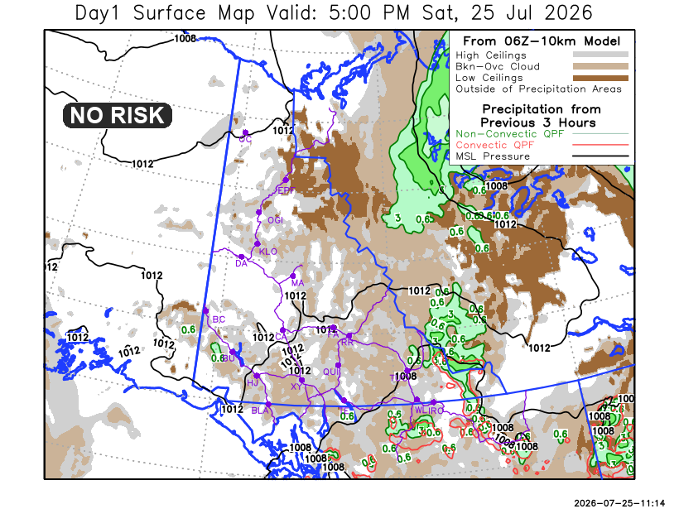
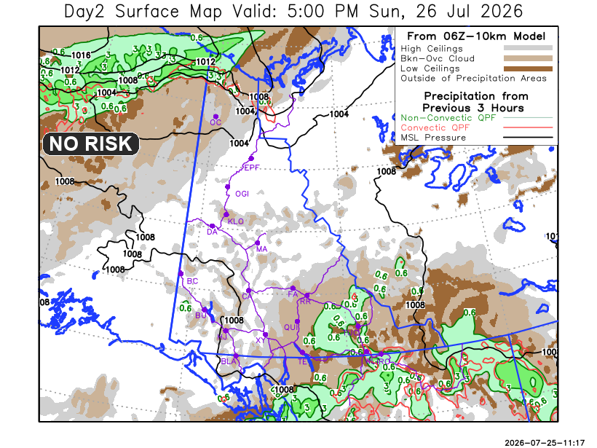

Forecast for | Sunday | (Peak burning period and overnight)
Community | Clouds | Pcpn | POP | POL | Max Temp | Min RH | Min Temp | Max  RH | Wind Dir | Wind Speed
Old Crow | BKN | RW- SW- | 80 | NIL | 20 | 40 | 0 | 90 | 250 | 20G40
Klondike Fc | SCT |  | 15 | NIL | 21 | 30 | 11 | 75 | 250 | 5
Mayo A | SCT |  | 0 | NIL | 18 | 35 | 12 | 75 | 180 | 5
Carmacks | SCT |  | 0 | NIL | 18 | 30 | 8 | 70 | 30 | 5
Faro | SCT |  | 0 | NIL | 12 | 40 | 7 | 70 | 180 | 5
Ross River | BKN |  | 0 | NIL | 16 | 30 | 5 | 75 | 170 | 5
Beaver Creek Town | SCT |  | 0 | NIL | 18 | 30 | 5 | 75 | 170 | 5
Burwash A | SCT |  | 15 | NIL | 15 | 40 | 6 | 75 | 70 | 10G30
Haines Junction | SCT |  | 20 | NIL | 18 | 35 | 6 | 85 | 340 | 10G25
Whitehorse Auto | BKN |  | 0 | NIL | 16 | 35 | 9 | 75 | 0 | 10G30
Teslin | BKN | RW- | 60 | NIL | 15 | 35 | 8 | 90 | 70 | 5
Watson Lake | BKN | RW- | 80 | NIL | 12 | 75 | 8 | 90 | 90 | 5

Forecast for |  |  | Monday |  |  | (Peak burning period and overnight)
Community |  |  | Clouds |  |  | Pcpn | POP |  | POL |  | Max Temp |  | Min RH | Min Temp | Max  RH | Wind Dir | Wind Speed
Old Crow |  |  | SCT |  |  | R-/SN- | 60 |  | NIL |  | 1 |  | 80 | -1 | 95 | 20 | 20G45
Klondike Fc |  |  | BKN |  |  |  | 15 |  | NIL |  | 18 |  | 35 | 8 | 85 | 0 | 5
Mayo A |  |  | BKN |  |  |  | 10 |  | NIL |  | 17 |  | 35 | 12 | 80 | 220 | 5
Carmacks |  |  | SCT |  |  |  | 15 |  | NIL |  | 20 |  | 38 | 10 | 80 | 180 | 5
Faro |  |  | BKN |  |  |  | 15 |  | NIL |  | 15 |  | 35 | 7 | 80 | 280 | 10G20
Ross River |  |  | BKN |  |  | RW- | 20 |  | NIL |  | 15 |  | 40 | 5 | 80 | 290 | 10G20
Beaver Creek Town |  |  | OVC |  |  | RW- | 20 |  | NIL |  | 18 |  | 35 | 6 | 90 | 290 | 10G20
Burwash A |  |  | SCT |  |  | R- | 30 |  | NIL |  | 15 |  | 45 | 7 | 88 | 290 | 5
Haines Junction |  |  | FEW |  |  |  | 0 |  | NIL |  | 15 |  | 35 | 5 | 90 | 200 | 10G30
Whitehorse Auto |  |  | SCT |  |  | RW- | 20 |  | NIL |  | 15 |  | 40 | 7 | 85 | 200 | 10G20
Teslin |  |  | BKN |  |  | RW- | 30 |  | NIL |  | 15 |  | 50 | 7 | 85 | 220 | 10G25
Watson Lake |  |  | BKN |  |  | RW- | 30 |  | NIL |  | 16 |  | 45 | 9 | 80 | 290 | 10G30
3-Day Forecast Precipitation Totals from 13:00 Yesterday
OC | 10.9 |  | FA | 0.6 |  | JAK | 5.4
EPF | 6.0 |  | RR | 4.4 |  | TE | 5.1
ANT | 0.2 |  | BC | 1.2 |  | QUI | 1.3
DA | 1.2 |  | BCT | 2.0 |  | SWI | 6.9
FMI | 1.4 |  | BU | 0.5 |  | FL | 3.5
HEN | 0.5 |  | HJF | 0.4 |  | TUC | 10.4
BAR | 6.0 |  | RAI | 0.4 |  | HAS | 3.3
MA | 0.0 |  | CH | 0.0 |  | TC | 6.3
STW | 1.9 |  | BR | 4.0 |  | WL | 7.2
WIL | 1.1 |  | NU | 3.8 |  | NA | NA
PE | 0.5 |  | XY | 5.6 |  | IRO | 7.5
CA | 3.2 |  | CC | 0.5 |  | NA | NA
DRU | 0.3 |  | ATL | 5.4 |  | NA | NA
Dylan Kikuta Meteorologist

Disclaimer : The information in these forecasts is collected and prepared for internal use by the Government of Yukon. The forecasts are specifically designed to meet the needs of the Wildland Fire Management and may not cover the requirements of other parties. Weather warnings or advisories are not included as part of the forecasts. Wildland Fire Management makes no representation and provides no warranty as to the accuracy of its weather forecasts. Any use the recipient chooses to make of the forecasts will be at its sole risk.

