YUKON WILDLAND FIRE MANAGEMENT WEATHER FORECAST - 9:00 AM ISSUE

26-Jul-2026
YESTERDAY'S VALUES
Community | Max  Temp  (°C) | Diff.  from  Normal | Min Temp  (°C) | Diff. from Normal | Pcpn  (mm) | Min RH | Max RH | L110 | L30
Old Crow | 18.3 | -1.9 | 7.3 | -1.0 | 0.2 | 36 | 91 | 0 | 0
Fort Mcpherson Airport | 16.1 |  | 6.4 |  | 0.0M | 49 | 86 | 0 | 0
Rock River Climate | 11.1 |  | 4.3 |  | 0.2 | 53 | 81 | NA | NA
Eagle Plains Fire | 13.8 |  | 8.4 |  | 0.0 | 43 | 65 | 0 | 0
Antimony Creek | 18.2 |  | -0.6 |  | 0.0 | 31 | 97 | 0 | 0
Klondike Fc | 20.6 | -2.3 | 2.1 | -5.8 | 0.0 | 28 | 93 | 0 | 0
Forty Mile | 17.7 |  | 4.1 |  | 0.0 | 31 | 95 | 0 | 0
Henderson | 15.8 |  | 6.4 |  | 0.0 | 33 | 74 | 0 | 0
Barlow | 17.1 |  | 5.4 |  | 0.0 | 25 | 79 | 0 | 0
Mayo A | 16.3 | -6.3 | 6.0 | -3.2 | 0.0 | 29 | 80 | 0 | 0
Stewart Crossing | 17.5 |  | 6.2 |  | 0.0 | 25 | 92 | 0 | 0
Willow Creek | 17.0 |  | 2.9 |  | 0.0 | 25 | 89 | 0 | 0
Pelly Farm | 20.2 | -2.3 | 2.8 | -5.5 | 0.0 | 20 | 94 | 0 | 0
Carmacks | 20.4 |  | 3.1 |  | 0.0 | 25 | 78 | 0 | 0
Drury Creek | 17.7 |  | -0.3 |  | 0.0 | 25 | 93 | 0 | 0
Faro | 12.9 | -7.9 | 1.3 | -7.6 | 0.0 | 40 | 96 | 0 | 0
Ross River | 13.9 |  | 0.4 |  | 0.0 | 38 | 95 | 0 | 0
Macmillan Pass | 7.7 |  | 1.0 |  | 0.0 | 48 | 82 | 0 | 0
Beaver Creek A | 13.5 | -6.8 | 0.6 | -6.8 | 0.0 | 52 | 95 | 0 | 0
Beaver Creek Town | 14.0 |  | -0.1 |  | 0.0 | 50 | 95 | 0 | 0
Burwash A | 13.4 | -5.9 | 2.6 | -3.8 | 0.0M | 58 | 95 | 0 | 0
Haines Junction | 18.6 | -1.6 | 4.6 | -0.4 | 0.0 | 39 | 91 | 0 | 0
Rainbow | 17.0 |  | 4.3 |  | 2.3 | 39 | 89 | 0 | 0
Champagne | 17.9 |  | -1.5 |  | 0.0 | 25 | 91 | 0 | 0
Braeburn | 18.3 |  | -1.7 |  | 0.0 | 30 | 95 | 0 | 0
Nursery | 17.5 |  | -2.3 |  | 0.0 | 32 | 97 | 0 | 0
Whitehorse Auto | 15.7 | -4.8 | 2.1 | -5.8 | 0.2 | 34 | 89 | 0 | 0
Mount Sima | 13.2 |  | 4.8 |  | 0.0 | 39 | 61 | 0 | 0
Carcross | 18.1 |  | -1.3 |  | 0.0 | 29 | 92 | 0 | 0
Atlin | 16.0 |  | 5.9 |  | 0.0 | 35 | 82 | 0 | 0
Jakes Corner | 16.4 |  | 1.4 |  | 0.0 | 34 | 92 | 0 | 0
Teslin | 15.4 |  | 3.5 |  | 0.6 | 47 | 96 | 0 | 0
Quiet Lake | 15.2 |  | 4.7 |  | 0.0 | 39 | 89 | 0 | 0
Swift River | 16.5 |  | 8.6 |  | 0.0 | 40 | 84 | 0 | 0
Tuchitua | 18.0 |  | 6.7 |  | 0.0 | 43 | 96 | 0 | 0
Hasselburg | 15.1 |  | 6.7 |  | 0.6 | 47 | 95 | 0 | 0
Tom Creek | 17.0 |  | 8.2 |  | 0.0 | 42 | 95 | 0 | 0
Watson Lake | 17.1 | -4.1 | 9.3 | 0.3 | 1.2 | 43 | 89 | 0 | 0
Iron Creek | 19.3 |  | 5.8 |  | 0.6 | 43 | 98 | 0 | 0
Max Temp is the actual maximum temperature in °C from yesterday afternoon or evening.
Min Temp is the actual overnight minimum temperature in °C up until 6:00 AM this morning.
Diff. from Normal is the difference from the 30 year average max or min temperature.
Pcpn is the precipitation in mm since 13:00 yesterday.
Min RH is the minimum observed RH in % from yesterday afternoon or evening.
Max RH is the maximum observed overnight RH in % up until 6:00 AM this morning.
L110 is the actual number of lightning strikes within 110 km and in the Yukon for 24 hours ending at 06:00 AM this morning.
L30 is the actual number of lightning strikes within 30 km and in the Yukon for 24 hours ending at 06:00 AM this morning.
M is missing data. * denotes precipitation at stations that failed to report for at least part of the evening and overnight period.

SYNOPSIS:
Today: Quiet skies dominate much of the Yukon with marginally low RH, but the top edge of a Pacific low will push light rain into the southeast. Cool, damp, showery conditions are expected over Tintina and Southern Lakes. Rain showers will taper into the evening but may redevelop late overnight/Monday AM. Elsewhere across southern/central Yukon, it will be warm with light winds and minimum RH values generally at 30-35%. Over northern Yukon, it will be warm with westerly winds gusting 30-40km/h. A sharp cold front accompanied by showers moves in from the north overnight and will produce an abrupt shift to northerly winds.
Monday: Damp, unsettled conditions overtake the north and the southeast while generally warm and low RH conditions remain on the Yukon Plateau. Over the Yukon Plateau excluding Tintina and parts of Southern Lakes, minimum RH values drop to 30% and may include isolated 20-25% readings. Isolated showers are possible over high terrain, but more widespread rain is expected over Tintina. These showers over Tintina will be accompanied by breezy westerly winds gusting 30-40km/h. Over northern Yukon, rain showers and cool, breezy conditions are expected in the wake of the AM cold front. A few rumbles of thunder are possible over the southern half of the Klondike region.
Tuesday: Cool and damp conditions remain over the northern Yukon, while warm and marginally low RH conditions hold over much of the Yukon Plateau. Over the southern half of the territory, spotty rain showers are possible across the region, the highest probability of showers will be over Tintina and Southern Lakes yet again. Despite this, daytime highs recover into the high teens over Tintina and Southern Lakes. In general daytime highs will be in the high teens and RH 35-40%. The driest air is expected over Tatchun where daytime highs will be around 20C and minimum RH of 30-35%.
Wednesday: Temperatures back off a few degrees and RH increases overall across the territory. Showers continue and potentially increase in coverage over southeastern Yukon, and another cold front will push into northern Yukon with showers. Moderate winds are possible both ahead and behind the cold front over northern Yukon.
Thursday: RH will increase across the territory, and temperatures cool by another few degrees. Scattered showers are possible throughout the territory, but the greatest chances will be over centra;/southern Yukon. Breezy northwesterly winds are possible across the territory,

Forecast for | Sunday | (Peak burning period and overnight)
Community | Clouds | Pcpn | POP | POL | Max Temp | Min RH | Min Temp | Max  RH | Wind Dir | Wind Speed
Old Crow | BKN | R- | 40 | NIL | 22 | 35 | 1 | 85 | 260 | 20G45
Klondike Fc | SCT |  | 0 | NIL | 23 | 30 | 7 | 80 | 250 | 5
Mayo A | FEW |  | 0 | NIL | 20 | 35 | 7 | 75 | 170 | 5
Carmacks | SCT |  | 0 | NIL | 20 | 30 | 5 | 80 | 0 | 5G25
Faro | SCT |  | 0 | NIL | 16 | 30 | 5 | 70 | 220 | 5G20
Ross River | SCT |  | 0 | NIL | 18 | 30 | 7 | 75 | 300 | 5
Beaver Creek Town | SCT |  | 0 | NIL | 20 | 30 | 5 | 80 | 110 | 5
Burwash A | SCT | RW- | 30 | NIL | 15 | 50 | 8 | 80 | 320 | 10G30
Haines Junction | SCT | RW- | 20 | NIL | 20 | 35 | 6 | 70 | 340 | 5G20
Whitehorse Auto | SCT |  | 15 | NIL | 19 | 30 | 8 | 75 | 0 | 10G30
Teslin | OVC | R- | 80 | NIL | 12 | 55 | 8 | 100 | 30 | 10G20
Watson Lake | OVC | R- | 80 | NIL | 14 | 75 | 9 | 100 | 90 | 10G20
POP is probability of precipitation in %.
POL is probability of lightning in %.

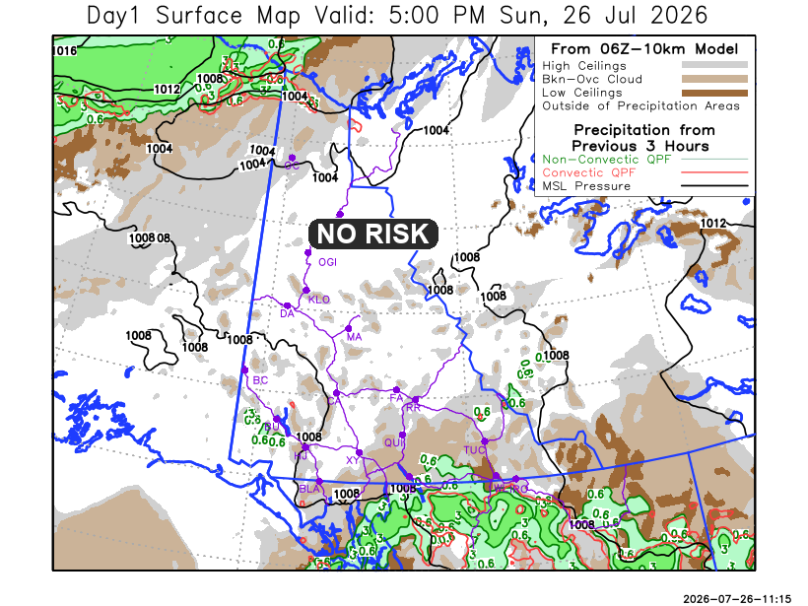
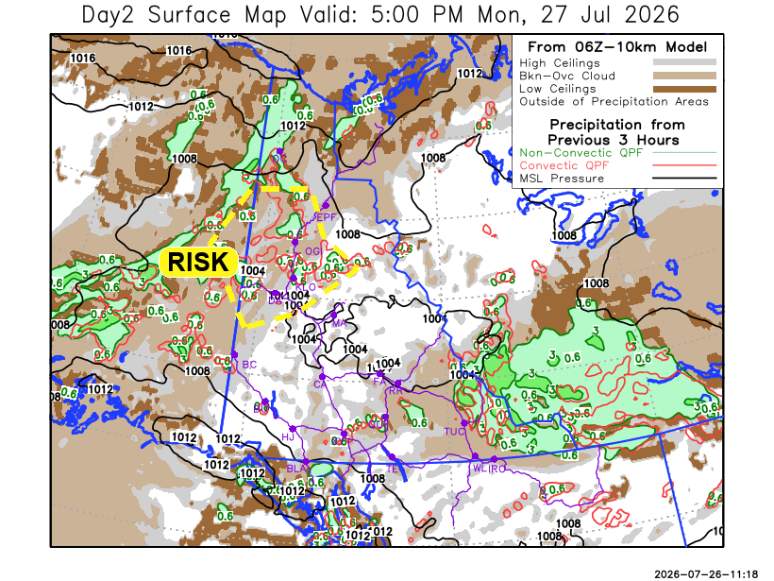

Forecast for | Monday | (Peak burning period and overnight)
Community | Clouds | Pcpn | POP | POL | Max Temp | Min RH | Min Temp | Max  RH | Wind Dir | Wind Speed
Old Crow | BKN | RW-/SN- | 60 | NIL | 3 | 75 | 0 | 90 | 40 | 20G40
Klondike Fc | BKN | RW-/TRW- | 20 | RISK | 20 | 40 | 11 | 85 | 0 | 5
Mayo A | SCT |  | 15 | NIL | 22 | 30 | 12 | 80 | 200 | 5
Carmacks | SCT |  | 10 | NIL | 23 | 25 | 10 | 70 | 180 | 5G20
Faro | BKN | R- | 20 | NIL | 19 | 30 | 8 | 80 | 270 | 10G20
Ross River | BKN | R- | 20 | NIL | 20 | 30 | 6 | 80 | 280 | 10G25
Beaver Creek Town | BKN | RW- | 20 | NIL | 21 | 30 | 8 | 85 | 100 | 5G20
Burwash A | SCT | RW- | 20 | NIL | 16 | 40 | 8 | 80 | 110 | 5
Haines Junction | FEW |  | 15 | NIL | 20 | 35 | 5 | 95 | 200 | 10G30
Whitehorse Auto | BKN | RW- | 30 | NIL | 18 | 35 | 9 | 85 | 200 | 5
Teslin | SCT | RW- | 20 | NIL | 17 | 40 | 8 | 85 | 240 | 10G30
Watson Lake | BKN | R- | 80 | NIL | 13 | 75 | 8 | 95 | 250 | 10G30

Forecast for |  |  | Tuesday |  |  | (Peak burning period and overnight)
Community |  |  | Clouds |  |  | Pcpn | POP |  | POL |  | Max Temp |  | Min RH | Min Temp | Max  RH | Wind Dir | Wind Speed
Old Crow |  |  | SCT |  |  |  | 10 |  | NIL |  | 10 |  | 60 | 2 | 90 | 40 | 5
Klondike Fc |  |  | BKN |  |  | RW- | 20 |  | NIL |  | 18 |  | 45 | 9 | 85 | 320 | 10G30
Mayo A |  |  | SCT |  |  | RW- | 20 |  | NIL |  | 20 |  | 40 | 13 | 80 | 320 | 5
Carmacks |  |  | BKN |  |  | RW- | 20 |  | NIL |  | 22 |  | 30 | 11 | 80 | 340 | 5
Faro |  |  | BKN |  |  |  | 15 |  | NIL |  | 18 |  | 35 | 9 | 85 | 250 | 5
Ross River |  |  | BKN |  |  |  | 15 |  | NIL |  | 21 |  | 35 | 6 | 85 | 340 | 5
Beaver Creek Town |  |  | BKN |  |  | R- | 20 |  | NIL |  | 18 |  | 50 | 7 | 80 | 320 | 10G25
Burwash A |  |  | BKN |  |  | RW- | 60 |  | NIL |  | 15 |  | 60 | 8 | 90 | 0 | 5
Haines Junction |  |  | BKN |  |  | R- | 20 |  | NIL |  | 20 |  | 30 | 8 | 85 | 270 | 5
Whitehorse Auto |  |  | BKN |  |  | R- | 40 |  | NIL |  | 18 |  | 50 | 10 | 85 | 250 | 5
Teslin |  |  | BKN |  |  | R- | 40 |  | NIL |  | 18 |  | 40 | 9 | 85 | 0 | 5
Watson Lake |  |  | BKN |  |  | RW- | 40 |  | NIL |  | 19 |  | 40 | 10 | 90 | 250 | 5
3-Day Forecast Precipitation Totals from 13:00 Yesterday
OC | 5.6 |  | FA | 1.4 |  | JAK | 4.0
EPF | 2.2 |  | RR | 1.1 |  | TE | 6.7
ANT | 0.0 |  | BC | 0.8 |  | QUI | 6.6
DA | 0.3 |  | BCT | 0.8 |  | SWI | 10.5
FMI | 1.6 |  | BU | 0.9 |  | FL | 9.9
HEN | 0.7 |  | HJF | 1.7 |  | TUC | 12.4
BAR | 0.0 |  | RAI | 3.3 |  | HAS | 10.0
MA | 0.0 |  | CH | 0.9 |  | TC | 15.1
STW | 0.0 |  | BR | 0.3 |  | WL | 15.5
WIL | 0.0 |  | NU | 1.0 |  | NA | NA
PE | 0.0 |  | XY | 1.3 |  | IRO | 12.6
CA | 0.0 |  | CC | 1.6 |  | NA | NA
DRU | 1.2 |  | ATL | 6.0 |  | NA | NA
Dylan KIkuta Meteorologist

Disclaimer : The information in these forecasts is collected and prepared for internal use by the Government of Yukon. The forecasts are specifically designed to meet the needs of the Wildland Fire Management and may not cover the requirements of other parties. Weather warnings or advisories are not included as part of the forecasts. Wildland Fire Management makes no representation and provides no warranty as to the accuracy of its weather forecasts. Any use the recipient chooses to make of the forecasts will be at its sole risk.

