YUKON WILDLAND FIRE MANAGEMENT WEATHER FORECAST - 9:00 AM ISSUE

27-Jul-2026
YESTERDAY'S VALUES
Community | Max  Temp  (°C) | Diff.  from  Normal | Min Temp  (°C) | Diff. from Normal | Pcpn  (mm) | Min RH | Max RH | L110 | L30
Old Crow | 23.2 | 3.1 | 0.9 | -7.4 | 5.6 | 35 | 89 | 0 | 0
Fort Mcpherson Airport | 26.3 |  | 3.2 |  | 0.0 | 29 | 86 | 0 | 0
Rock River Climate | 19.9 |  | 5.4 |  | 0.6 | 36 | 99 | NA | NA
Eagle Plains Fire | 21.5 |  | 7.9 |  | 0.0 | 31 | 84 | 0 | 0
Antimony Creek | 21.9 |  | 6.0 |  | 0.0 | 29 | 87 | 0 | 0
Klondike Fc | 23.3 | 0.5 | 4.7 | -3.1 | 0.0 | 25 | 93 | 0 | 0
Forty Mile | 22.1 |  | 8.1 |  | 0.0 | 33 | 90 | 0 | 0
Henderson | 18.0 |  | 10.6 |  | 0.0 | 35 | 61 | 0 | 0
Barlow | 19.5 |  | 10.3 |  | 0.0 | 31 | 63 | 0 | 0
Mayo A | 19.9 | -2.6 | 8.3 | -0.8 | 0.0 | 31 | 82 | 0 | 0
Stewart Crossing | 20.8 |  | 8.3 |  | 0.0 | 26 | 76 | 0 | 0
Willow Creek | 20.5 |  | 1.3 |  | 0.0 | 25 | 93 | 0 | 0
Pelly Farm | 22.3 | -0.2 | 4.6 | -3.6 | 0.0 | 27 | 94 | 0 | 0
Carmacks | 22.4 |  | 4.4 |  | 0.0 | 26 | 88 | 0 | 0
Drury Creek | 20.5 |  | 1.6 |  | 0.0 | 24 | 92 | 0 | 0
Faro | 18.8 | -1.9 | 3.9 | -4.9 | 0.0 | 24 | 89 | 0 | 0
Ross River | 19.6 |  | 4.5 |  | 0.0 | 25 | 93 | 0 | 0
Macmillan Pass | 13.7 |  | 1.2 |  | 0.0 | 36 | 81 | 0 | 0
Beaver Creek A | 20.1 | -0.1 | 3.5 | -3.8 | 0.0 | 32 | 87 | 0 | 0
Beaver Creek Town | 21.3 |  | 4.8 |  | 0.0 | 27 | 88 | 0 | 0
Burwash A | 16.0 | -3.3 | 3.4 | -2.9 | 0.0M | 41 | 96 | 0 | 0
Haines Junction | 19.9 | -0.2 | 6.3 | 0.6 | 0.0 | 31 | 91 | 0 | 0
Rainbow | 17.7 |  | 6.0 |  | 0.0 | 32 | 90 | 0 | 0
Champagne | 18.7 |  | -0.7 |  | 0.0 | 25 | 92 | 0 | 0
Braeburn | 20.1 |  | -0.9 |  | 0.0 | 25 | 96 | 0 | 0
Nursery | 19.4 |  | 5.8 |  | 0.0 | 25 | 88 | 0 | 0
Whitehorse Auto | 17.9 | -2.6 | 8.7 | 0.8 | 0.0 | 27 | 81 | 0 | 0
Mount Sima | 15.0 |  | 8.6 |  | 0.0 | 32 | 68 | 0 | 0
Carcross | 19.3 |  | 9.0 |  | 0.0 | 28 | 82 | 0 | 0
Atlin | 12.4 |  | 8.1 |  | 2.4 | 57 | 96 | 0 | 0
Jakes Corner | 17.6 |  | 8.8 |  | 0.0 | 34 | 88 | 0 | 0
Teslin | 12.9 |  | 9.0 |  | 1.0 | 61 | 98 | 0 | 0
Quiet Lake | 19.1 |  | 6.3 |  | 0.0 | 31 | 91 | 0 | 0
Swift River | 14.6 |  | 8.3 |  | 5.6 | 58 | 98 | 0 | 0
Tuchitua | 14.0 |  | 8.5 |  | 3.4 | 68 | 99 | 0 | 0
Hasselburg | 12.1 |  | 7.3 |  | 3.6 | 75 | 99 | 0 | 0
Tom Creek | 11.0 |  | 7.5 |  | 8.1 | 86 | 99 | 0 | 0
Watson Lake | 11.9 | -9.3 | 9.2 | 0.3 | 9.6 | 73 | 97 | 0 | 0
Iron Creek | 13.2 |  | 8.8 |  | 13.3 | 71 | 99 | 0 | 0
Max Temp is the actual maximum temperature in °C from yesterday afternoon or evening.
Min Temp is the actual overnight minimum temperature in °C up until 6:00 AM this morning.
Diff. from Normal is the difference from the 30 year average max or min temperature.
Pcpn is the precipitation in mm since 13:00 yesterday.
Min RH is the minimum observed RH in % from yesterday afternoon or evening.
Max RH is the maximum observed overnight RH in % up until 6:00 AM this morning.
L110 is the actual number of lightning strikes within 110 km and in the Yukon for 24 hours ending at 06:00 AM this morning.
L30 is the actual number of lightning strikes within 30 km and in the Yukon for 24 hours ending at 06:00 AM this morning.
M is missing data. * denotes precipitation at stations that failed to report for at least part of the evening and overnight period.

SYNOPSIS:
Today: Damp, unsettled conditions overtake the north and the southeast while generally warm and low RH conditions remain on the Yukon Plateau. Over the Yukon Plateau excluding Tintina and parts of Southern Lakes, minimum RH values drop to 30% and may include isolated 20-25% readings. Isolated showers/thundershowers will develop in the afternoon and the steady rain over Tintina tapers to showers by evening. Gusty winds are expected over th eastern half of Tintina this afternoon into the overnight sustained 10-15 km/h gusting 30-40 km/h. Over northern Yukon, rain showers and cool, breezy conditions are expected in the wake of the AM cold front. However, a weak surface low will track east across the Nahoni Range and could spur a few rumbles of thunder over the southern half of the Klondike region down to the border of Kluane.
Tuesday: Skies clear over northern Yukon and warm, marginally low RH conditions continue to hold over much of the Yukon Plateau. Over the southern half of the territory, numerous convective showers/thundershowers are expected in the afternoon and evening. Daytime highs finally recover into the high teens/low twenties over Tintina and Southern Lakes. Over the rest of southern/central Yukon, daytime highs will be in the high teens/low twenties and minimum RH 30-35%, however shower activity may snub forecast values for some locations. The dries air may develop over Tatchun and Southern Lakes where RH could locally visit 25%. Over northern Yukon, daytime highs will be around 10C and the winds will be lighter than the last few days.
Wednesday: RH and rain shower activity increases yet again over the south while somewhat breezy and quiet skies develop over the rest of the territory. The driest air will be over the Yukon Plateau where minimum RH values of 35-40% are expected with wind gusts of 20-30 km/h are possible despite sustained winds generally at 5-10 km/h. Over the northern Yukon, winds will gust 30-50 km/h and minimum RH will sit around 40%. A cold front with rain moves through the Klondike region overnight into Thursday AM.
Thursday: RH will increase across the territory, and temperatures cool by another few degrees. Scattered showers are possible throughout the territory, but the greatest chances will be over centra;/southern Yukon as a cold front moves through. Breezy northwesterly winds are possible over the southern half of the territory.
Friday: Showers remain over the southeast while the rest of the territory will experience warm, marginally low RH conditions with a slight southeasterly flow thanks to a ridging attempt.

Forecast for | Monday | (Peak burning period and overnight)
Community | Clouds | Pcpn | POP | POL | Max Temp | Min RH | Min Temp | Max  RH | Wind Dir | Wind Speed
Old Crow | BKN | R- SW- | 80 | NIL | 3 | 75 | 1 | 85 | 40 | 20G40
Klondike Fc | BKN | RW-/TRW- | 30 | RISK | 21 | 40 | 8 | 95 | 300 | 5
Mayo A | SCT | RW- | 20 | NIL | 23 | 30 | 8 | 80 | 200 | 5
Carmacks | SCT | RW- | 20 | NIL | 23 | 25 | 8 | 80 | 200 | 5
Faro | BKN |  | 10 | NIL | 20 | 25 | 6 | 80 | 290 | 5G20
Ross River | BKN | RW- | 20 | NIL | 21 | 30 | 6 | 90 | 290 | 10G20
Beaver Creek Town | BKN | R- | 20 | NIL | 22 | 30 | 7 | 100 | 70 | 10
Burwash A | SCT |  | 15 | NIL | 15 | 40 | 5 | 80 | 110 | 5G20
Haines Junction | SCT | RW- | 20 | NIL | 20 | 30 | 3 | 90 | 200 | 10G30
Whitehorse Auto | BKN | RW-/TRW- | 40 | RISK | 18 | 35 | 6 | 90 | 180 | 10G20
Teslin | BKN | RW-/TRW- | 30 | RISK | 16 | 45 | 6 | 80 | 220 | 10G25
Watson Lake | BKN | R- | 60 | NIL | 13 | 75 | 6 | 100 | 270 | 10G30
POP is probability of precipitation in %.
POL is probability of lightning in %.

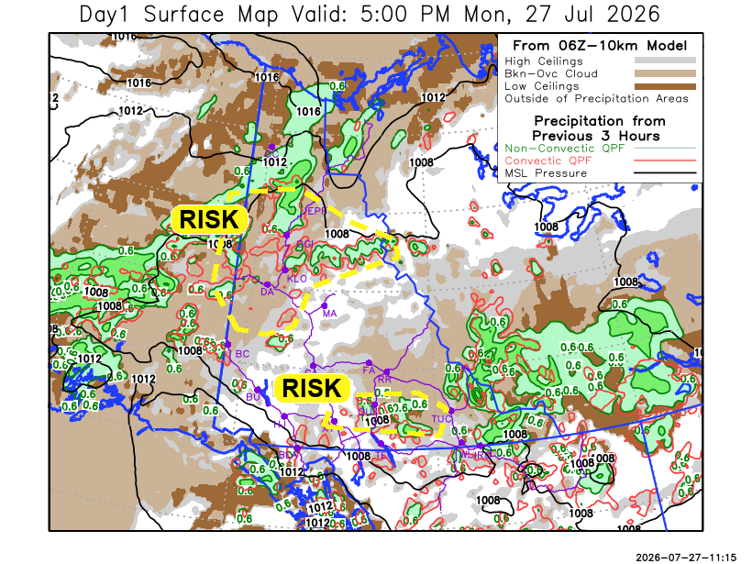
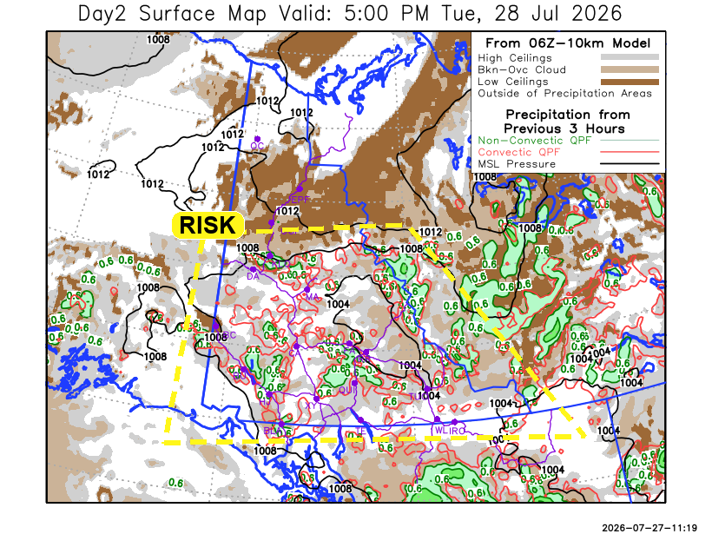

Forecast for | Tuesday | (Peak burning period and overnight)
Community | Clouds | Pcpn | POP | POL | Max Temp | Min RH | Min Temp | Max  RH | Wind Dir | Wind Speed
Old Crow | FEW |  | 0 | NIL | 12 | 50 | 3 | 90 | 20 | 5
Klondike Fc | SCT |  | 15 | NIL | 20 | 50 | 7 | 85 | 320 | 10G30
Mayo A | SCT | RW-/TRW- | 40 | RISK | 22 | 45 | 11 | 85 | 270 | 10G30
Carmacks | SCT | RW-/TRW- | 40 | RISK | 24 | 30 | 10 | 80 | 320 | 10G30
Faro | BKN | RW-/TRW- | 40 | RISK | 21 | 30 | 8 | 85 | 290 | 10
Ross River | BKN | RW-/TRW- | 40 | RISK | 22 | 30 | 7 | 80 | 290 | 5
Beaver Creek Town | BKN | RW-/TRW- | 20 | RISK | 16 | 55 | 6 | 90 | 290 | 10G30
Burwash A | BKN | RW-/TRW- | 40 | RISK | 16 | 60 | 9 | 90 | 320 | 5
Haines Junction | SCT | RW-/TRW- | 40 | RISK | 22 | 35 | 9 | 90 | 320 | 10G30
Whitehorse Auto | SCT | RW-/TRW- | 20 | RISK | 20 | 35 | 11 | 90 | 0 | 5
Teslin | BKN | RW-/TRW- | 20 | RISK | 20 | 35 | 10 | 85 | 290 | 5
Watson Lake | BKN | RW-/TRW- | 20 | RISK | 20 | 35 | 10 | 85 | 220 | 5

Forecast for |  |  | Wednesday |  |  | (Peak burning period and overnight)
Community |  |  | Clouds |  |  | Pcpn | POP |  | POL |  | Max Temp |  | Min RH | Min Temp | Max  RH | Wind Dir | Wind Speed
Old Crow |  |  | BKN |  |  | R- | 40 |  | NIL |  | 17 |  | 40 | 8 | 90 | 250 | 25G50
Klondike Fc |  |  | BKN |  |  |  | 10 |  | NIL |  | 22 |  | 35 | 10 | 80 | 290 | 10G25
Mayo A |  |  | SCT |  |  |  | 10 |  | NIL |  | 23 |  | 30 | 13 | 75 | 270 | 10G30
Carmacks |  |  | SCT |  |  | RW- | 20 |  | NIL |  | 24 |  | 40 | 11 | 75 | 320 | 10G25
Faro |  |  | SCT |  |  | RW- | 20 |  | NIL |  | 20 |  | 40 | 9 | 75 | 290 | 5
Ross River |  |  | SCT |  |  | RW- | 30 |  | NIL |  | 22 |  | 40 | 7 | 75 | 290 | 5
Beaver Creek Town |  |  | BKN |  |  |  | 15 |  | NIL |  | 20 |  | 45 | 7 | 75 | 320 | 5
Burwash A |  |  | BKN |  |  | R- | 30 |  | NIL |  | 16 |  | 60 | 9 | 85 | 320 | 5
Haines Junction |  |  | SCT |  |  | R- | 60 |  | NIL |  | 18 |  | 50 | 8 | 90 | 220 | 5
Whitehorse Auto |  |  | BKN |  |  | R- | 60 |  | NIL |  | 18 |  | 50 | 11 | 90 | 250 | 5
Teslin |  |  | BKN |  |  | R- | 30 |  | NIL |  | 17 |  | 55 | 9 | 90 | 220 | 10G25
Watson Lake |  |  | BKN |  |  | R- | 20 |  | NIL |  | 16 |  | 50 | 10 | 90 | 220 | 10G25
3-Day Forecast Precipitation Totals from 13:00 Yesterday
OC | 7.9 |  | FA | 2.3 |  | JAK | 5.9
EPF | 9.0 |  | RR | 2.3 |  | TE | 4.9
ANT | 0.5 |  | BC | 2.7 |  | QUI | 8.7
DA | 0.5 |  | BCT | 2.7 |  | SWI | 10.0
FMI | 3.5 |  | BU | 5.4 |  | FL | 6.2
HEN | 0.4 |  | HJF | 3.4 |  | TUC | 8.7
BAR | 0.7 |  | RAI | 3.6 |  | HAS | 7.8
MA | 0.7 |  | CH | 3.9 |  | TC | 12.1
STW | 0.9 |  | BR | 1.5 |  | WL | 14.3
WIL | 0.8 |  | NU | 2.3 |  | NA | NA
PE | 1.2 |  | XY | 3.6 |  | IRO | 21.5
CA | 1.4 |  | CC | 3.0 |  | NA | NA
DRU | 2.4 |  | ATL | 6.5 |  | NA | NA
Dylan Kikuta Meteorologist

Disclaimer : The information in these forecasts is collected and prepared for internal use by the Government of Yukon. The forecasts are specifically designed to meet the needs of the Wildland Fire Management and may not cover the requirements of other parties. Weather warnings or advisories are not included as part of the forecasts. Wildland Fire Management makes no representation and provides no warranty as to the accuracy of its weather forecasts. Any use the recipient chooses to make of the forecasts will be at its sole risk.

