YUKON WILDLAND FIRE MANAGEMENT WEATHER FORECAST - 9:00 AM ISSUE

28-Jul-2026
YESTERDAY'S VALUES
Community | Max  Temp  (°C) | Diff.  from  Normal | Min Temp  (°C) | Diff. from Normal | Pcpn  (mm) | Min RH | Max RH | L110 | L30
Old Crow | 3.1 | -16.9 | 2.5 | -5.7 | 1.4 | 67 | 81 | 0 | 0
Fort Mcpherson Airport | 5.8 |  | 2.4 |  | 0.0M | 75 | 96 | 0 | 0
Rock River Climate | 5.9 |  | -0.6 |  | 1.4 | 83 | 100 | NA | NA
Eagle Plains Fire | 12.3M |  | 0.2M |  | 1.1 | 60M | 99M | 19 | 0
Antimony Creek | 22.5 |  | 7.4 |  | 0.0 | 35 | 98 | 16 | 0
Klondike Fc | 23.3 | 0.6 | 6.4 | -1.4 | 0.0 | 36 | 99 | 19 | 1
Forty Mile | 21.6 |  | 8.0 |  | 3.4 | 37 | 95 | 15 | 5
Henderson | 18.2 |  | 7.9 |  | 0.0 | 42 | 92 | 18 | 1
Barlow | 22.5 |  | 6.2 |  | 4.8 | 28 | 96 | 5 | 1
Mayo A | 23.0 | 0.6 | 7.7 | -1.4 | 0.0 | 25 | 83 | 1 | 0
Stewart Crossing | 23.7 |  | 9.3 |  | 0.0 | 23 | 80 | 1 | 0
Willow Creek | 22.7 |  | 3.9 |  | 0.0 | 22 | 91 | 1 | 0
Pelly Farm | 24.2 | 1.8 | 7.8 | -0.3 | 0.0 | 24 | 85 | 1 | 0
Carmacks | 25.1 |  | 9.6 |  | 1.0 | 26 | 96 | 0 | 0
Drury Creek | 22.9 |  | 5.8 |  | 0.0 | 26 | 91 | 0 | 0
Faro | 20.1 | -0.6 | 7.6 | -1.1 | 0.0 | 27 | 78 | 0 | 0
Ross River | 22.1 |  | 6.0 |  | 0.0 | 22 | 88 | 3 | 0
Macmillan Pass | 16.8 |  | 4.0 |  | 0.2 | 35 | 100 | 0 | 0
Beaver Creek A | 21.2 | 1.1 | 8.5 | 1.3 | 1.1 | 30 | 95 | 6 | 1
Beaver Creek Town | 23.4 |  | 8.8 |  | 0.0 | 23 | 93 | 6 | 1
Burwash A | 20.2 | 0.9 | 9.5 | 3.2 | 0.0M | 30 | 87 | 0 | 0
Haines Junction | 21.4 | 1.2 | 2.1 | -2.1 | 0.0 | 36 | 95 | 0 | 0
Rainbow | 21.7 |  | 3.2 |  | 0.0 | 34 | 93 | 0 | 0
Champagne | 22.1 |  | -0.7 |  | 0.0 | 26 | 93 | 0 | 0
Braeburn | 21.7 |  | 9.3 |  | 0.0 | 27 | 80 | 0 | 0
Nursery | 21.1 |  | 2.8 |  | 0.0 | 31 | 92 | 0 | 0
Whitehorse Auto | 19.2 | -1.2 | 4.7 | -3.2 | 0.0 | 35 | 84 | 1 | 0
Mount Sima | 15.3 |  | 6.2 |  | 0.0 | 38 | 76 | 1 | 0
Carcross | 19.2 |  | 0.4 |  | 0.0 | 42 | 93 | 2 | 0
Atlin | 14.1 |  | 4.6 |  | 0.2 | 54 | 89 | 2 | 0
Jakes Corner | 18.7 |  | 2.8 |  | 0.5 | 41 | 94 | 4 | 0
Teslin | 15.7 |  | 4.8 |  | 9.2 | 58 | 99 | 10 | 1
Quiet Lake | 22.7 |  | 5.8 |  | 0.3 | 44 | 93 | 12 | 0
Swift River | 13.1 |  | -0.6 |  | 0.0 | 63 | 97 | 2 | 0
Tuchitua | 11.8 |  | 7.0 |  | 8.5 | 83 | 99 | 0 | 0
Hasselburg | 11.1 |  | 5.8 |  | 5.4 | 83 | 100 | 0 | 0
Tom Creek | 13.1 |  | 5.0 |  | 9.0 | 82 | 99 | 0 | 0
Watson Lake | 14.3 | -6.9 | 6.4 | -2.5 | 2.6 | 73 | 99 | 0 | 0
Iron Creek | 17.0 |  | 0.9 |  | 0.8 | 64 | 98 | 0 | 0
Max Temp is the actual maximum temperature in °C from yesterday afternoon or evening.
Min Temp is the actual overnight minimum temperature in °C up until 6:00 AM this morning.
Diff. from Normal is the difference from the 30 year average max or min temperature.
Pcpn is the precipitation in mm since 13:00 yesterday.
Min RH is the minimum observed RH in % from yesterday afternoon or evening.
Max RH is the maximum observed overnight RH in % up until 6:00 AM this morning.
L110 is the actual number of lightning strikes within 110 km and in the Yukon for 24 hours ending at 06:00 AM this morning.
L30 is the actual number of lightning strikes within 30 km and in the Yukon for 24 hours ending at 06:00 AM this morning.
M is missing data. * denotes precipitation at stations that failed to report for at least part of the evening and overnight period.

SYNOPSIS:
Today: Widespread instability will lead to numerous convective showers over the southern half of Yukon, but conversely, clearing skies and cool temperatures are expected over the north. Daytime highs north of the Ogilvie Mountains will be in the low teens, and winds will be light and variable for a change. Over southern and central Yukon, numerous thundershowers will develop during the afternoon and evening. For the most part this activity will focus on Southern Lakes, Tatchun, and southern Northern Tutchone. Daytime highs will be in the low twenties and minimum RH around 30-35%, including Tintina, however, shower activity may snub forecast values for some locations. The driest and warmest air should develop over Tatchun, Southern Lakes, and eastern Tintina.
Wednesday: Persistent convective showers are expected over southern Yukon while marginally dry to dry conditions are expected elsewhere across the Territory. The driest air will be located over the western half of the Yukon Plateau and Ogilvie Mountains (Klondike) where minimum RH of 25-30% are expected, and a few 20% readings are quite possible. This region will see northwesterly winds sustained at 10km/h and gusting up to 30 km/h. North of the Ogilvie Mountains, there will be moderate westerly winds gusting 30-50 km/h and minimum RH will hit 40%. Late evening/overnight a weak cold front will slide through the Klondike region with rain showers, but a sudden weather change is not expected.
Thursday: A weak cold front will stall on the Ogilvie/MacKenzie Mountains with some rain shower activity, ahead of the front, generally warm and marginally low RH conditions continue over the Yukon Plateau. Over the Plateau, daytime highs will be around 20C and minimum RH around 35-40% however, persistent cloud cover and light shower activity may snub conditions over parts of the Southern Lakes and Tintina.
Friday: Warm temperatures and marginally low RH conditions are expected over much of the territory. Winds should be light, but 20-30 km/h gusts are possible here and there. Spotty rain showers are possible over the southeast.
Saturday: Warm temperatures and marginally low RH conditions are expected over much of the territory. It should be a degree or two warmer than Friday and minimum RH will be a few points lower. There’s potential for 20-30% RH on the Yukon Plateau. Winds should be light, but 20-30 km/h gusts are possible here and there. Spotty rain showers are possible over the southeast.

Forecast for | Tuesday | (Peak burning period and overnight)
Community | Clouds | Pcpn | POP | POL | Max Temp | Min RH | Min Temp | Max  RH | Wind Dir | Wind Speed
Old Crow | FEW |  | 0 | NIL | 13 | 40 | 4 | 90 | 0 | 5
Klondike Fc | BKN | RW-/TRW- | 20 | RISK | 20 | 45 | 5 | 90 | 300 | 10G30
Mayo A | SCT | RW-/TRW- | 60 | ISO | 22 | 35 | 7 | 95 | 300 | 10G20
Carmacks | BKN | RW-/TRW- | 40 | ISO | 23 | 35 | 7 | 90 | 300 | 10G20
Faro | BKN | RW-/TRW- | 40 | ISO | 22 | 30 | 7 | 90 | 320 | 10
Ross River | BKN | RW-/TRW- | 60 | ISO | 23 | 30 | 7 | 95 | 320 | 5
Beaver Creek Town | BKN | R- | 20 | NIL | 16 | 60 | 8 | 90 | 300 | 10G30
Burwash A | BKN | RW-/TRW- | 60 | RISK | 18 | 60 | 6 | 95 | 340 | 10G20
Haines Junction | BKN | RW-/TRW- | 60 | RISK | 22 | 30 | 7 | 95 | 350 | 5
Whitehorse Auto | BKN | RW-/TRW- | 40 | RISK | 20 | 35 | 7 | 95 | 250 | 5
Teslin | BKN | RW-/TRW- | 40 | RISK | 20 | 35 | 8 | 95 | 90 | 5
Watson Lake | BKN | RW-/TRW- | 20 | RISK | 21 | 35 | 9 | 90 | 140 | 5
POP is probability of precipitation in %.
POL is probability of lightning in %.

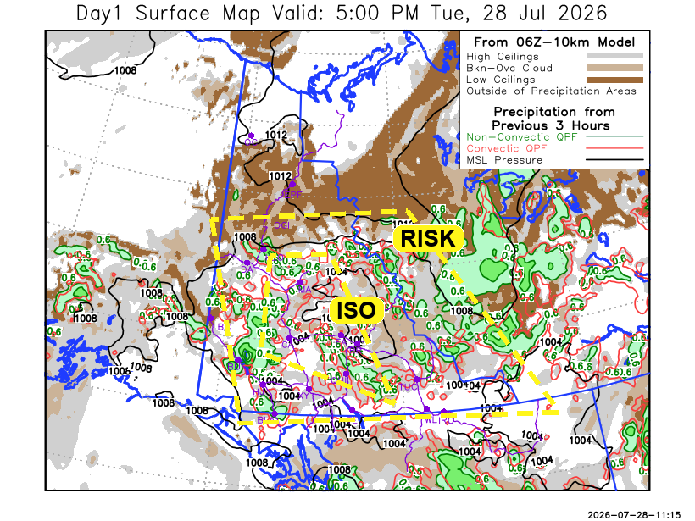
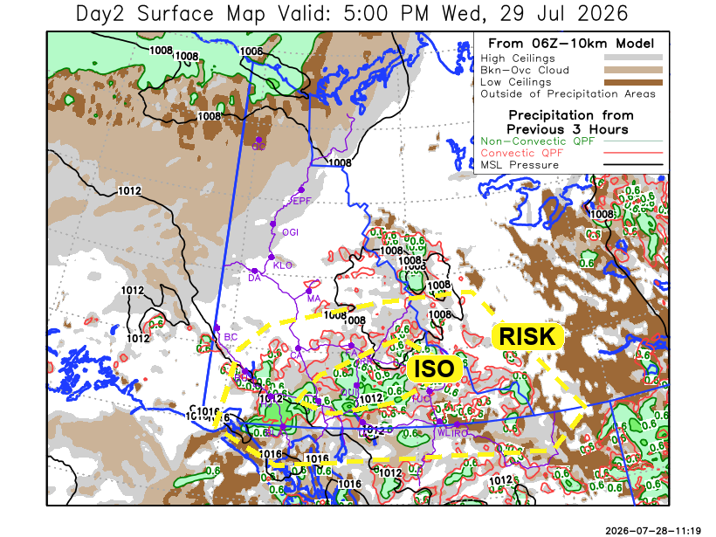

Forecast for | Wednesday | (Peak burning period and overnight)
Community | Clouds | Pcpn | POP | POL | Max Temp | Min RH | Min Temp | Max  RH | Wind Dir | Wind Speed
Old Crow | BKN | R- | 60 | NIL | 19 | 40 | 9 | 85 | 240 | 20G45
Klondike Fc | BKN |  | 0 | NIL | 24 | 25 | 11 | 75 | 320 | 10G30
Mayo A | SCT | RW- | 20 | NIL | 22 | 30 | 12 | 70 | 270 | 10G30
Carmacks | SCT | RW-/TRW- | 20 | RISK | 23 | 30 | 11 | 70 | 0 | 5
Faro | SCT | RW-/TRW- | 40 | RISK | 23 | 35 | 8 | 85 | 300 | 10G20
Ross River | BKN | RW-/TRW- | 40 | ISO | 22 | 40 | 8 | 85 | 300 | 5
Beaver Creek Town | BKN |  | 10 | NIL | 20 | 40 | 8 | 75 | 330 | 5
Burwash A | BKN | RW-/TRW- | 60 | RISK | 17 | 55 | 9 | 90 | 340 | 5
Haines Junction | BKN | RW-/TRW- | 60 | RISK | 16 | 65 | 9 | 90 | 220 | 5
Whitehorse Auto | BKN | RW-/TRW- | 60 | ISO | 20 | 40 | 11 | 90 | 180 | 10
Teslin | BKN | RW-/TRW- | 20 | RISK | 17 | 50 | 9 | 85 | 250 | 10G30
Watson Lake | BKN | RW-/TRW- | 30 | RISK | 15 | 50 | 10 | 85 | 200 | 5

Forecast for |  |  | Thursday |  |  | (Peak burning period and overnight)
Community |  |  | Clouds |  |  | Pcpn | POP |  | POL |  | Max Temp |  | Min RH | Min Temp | Max  RH | Wind Dir | Wind Speed
Old Crow |  |  | SCT |  |  | R- | 20 |  | NIL |  | 15 |  | 50 | 9 | 85 | 40 | 10G20
Klondike Fc |  |  | BKN |  |  |  | 15 |  | NIL |  | 20 |  | 45 | 10 | 80 | 240 | 5
Mayo A |  |  | BKN |  |  | R- | 20 |  | NIL |  | 18 |  | 40 | 12 | 80 | 290 | 10
Carmacks |  |  | BKN |  |  |  | 0 |  | NIL |  | 22 |  | 30 | 11 | 75 | 0 | 10G30
Faro |  |  | BKN |  |  |  | 15 |  | NIL |  | 19 |  | 40 | 8 | 80 | 300 | 10G30
Ross River |  |  | BKN |  |  |  | 15 |  | NIL |  | 20 |  | 40 | 7 | 75 | 300 | 10G30
Beaver Creek Town |  |  | BKN |  |  |  | 10 |  | NIL |  | 19 |  | 40 | 6 | 75 | 320 | 10
Burwash A |  |  | BKN |  |  | R- | 20 |  | NIL |  | 18 |  | 45 | 9 | 80 | 340 | 5
Haines Junction |  |  | BKN |  |  | R- | 30 |  | NIL |  | 19 |  | 45 | 10 | 85 | 340 | 5
Whitehorse Auto |  |  | SCT |  |  | RW-/TRW- | 30 |  | RISK |  | 19 |  | 45 | 11 | 85 | 0 | 5
Teslin |  |  | SCT |  |  | RW-/TRW- | 20 |  | RISK |  | 20 |  | 40 | 11 | 80 | 270 | 5
Watson Lake |  |  | SCT |  |  | RW-/TRW- | 20 |  | RISK |  | 21 |  | 35 | 11 | 80 | 250 | 5
3-Day Forecast Precipitation Totals from 13:00 Yesterday
OC | 4.4 |  | FA | 4.2 |  | JAK | 5.1
EPF | 6.8 |  | RR | 2.8 |  | TE | 12.8
ANT | 1.2 |  | BC | 2.8 |  | QUI | 6.5
DA | 0.6 |  | BCT | 1.7 |  | SWI | 3.9
FMI | 4.1 |  | BU | 4.7 |  | FL | 1.8
HEN | 1.2 |  | HJF | 13.6 |  | TUC | 9.7
BAR | 7.6 |  | RAI | 11.5 |  | HAS | 8.5
MA | 1.0 |  | CH | 10.9 |  | TC | 10.6
STW | 1.1 |  | BR | 5.0 |  | WL | 4.7
WIL | 1.3 |  | NU | 7.6 |  | NA | NA
PE | 0.9 |  | XY | 8.1 |  | IRO | 7.5
CA | 2.9 |  | CC | 4.4 |  | NA | NA
DRU | 6.3 |  | ATL | 4.2 |  | NA | NA
Dylan Kikuta Meteorologist

Disclaimer : The information in these forecasts is collected and prepared for internal use by the Government of Yukon. The forecasts are specifically designed to meet the needs of the Wildland Fire Management and may not cover the requirements of other parties. Weather warnings or advisories are not included as part of the forecasts. Wildland Fire Management makes no representation and provides no warranty as to the accuracy of its weather forecasts. Any use the recipient chooses to make of the forecasts will be at its sole risk.

