YUKON WILDLAND FIRE MANAGEMENT WEATHER FORECAST - 9:00 AM ISSUE

29-Jul-2026
YESTERDAY'S VALUES
Community | Max  Temp  (°C) | Diff.  from  Normal | Min Temp  (°C) | Diff. from Normal | Pcpn  (mm) | Min RH | Max RH | L110 | L30
Old Crow | 13.5 | -6.3 | 1.8 | -6.3 | 0.0 | 37 | 94 | 0 | 0
Fort Mcpherson Airport | 11.7 |  | 2.9 |  | 0.0M | 56 | 95 | 0 | 0
Rock River Climate | 7.4 |  | 4.5 |  | 0.0 | 74 | 96 | NA | NA
Eagle Plains Fire | 8.4 |  | 5.1 |  | 0.0 | 67 | 89 | 19 | 0
Antimony Creek | 22.1 |  | 5.5 |  | 1.0 | 40 | 97 | 16 | 0
Klondike Fc | 22.6 | 0.0 | 3.1 | -4.6 | 0.0 | 37 | 99 | 19 | 1
Forty Mile | 15.6 |  | 2.7 |  | 0.0 | 57 | 97 | 15 | 5
Henderson | 18.6 |  | 7.1 |  | 3.3 | 46 | 91 | 18 | 1
Barlow | 20.3 |  | 6.6 |  | 1.3 | 42 | 96 | 5 | 1
Mayo A | 22.0 | -0.3 | 8.3 | -0.7 | 1.0 | 41 | 96 | 1 | 0
Stewart Crossing | 22.2 |  | 9.9 |  | 0.8 | 38 | 95 | 1 | 0
Willow Creek | 23.8 |  | 7.3 |  | 2.3 | 29 | 97 | 1 | 0
Pelly Farm | 24.1 | 1.8 | 8.6 | 0.6 | 17.0 | 38 | 96 | 1 | 0
Carmacks | 23.2 |  | 7.4 |  | 0.0 | 37 | 95 | 0 | 0
Drury Creek | 21.0 |  | 5.8 |  | 0.0 | 36 | 96 | 0 | 0
Faro | 21.4 | 0.8 | 8.3 | -0.3 | 1.4 | 27 | 96 | 0 | 0
Ross River | 22.3 |  | 5.0 |  | 4.9 | 29 | 98 | 3 | 0
Macmillan Pass | 13.1 |  | 1.1 |  | 3.8 | 58 | 100 | 0 | 0
Beaver Creek A | 16.6 | -3.5 | 9.0 | 1.9 | 0.0 | 59 | 90 | 6 | 1
Beaver Creek Town | 17.9 |  | 9.6 |  | 0.0 | 50 | 88 | 6 | 1
Burwash A | 17.6 | -1.6 | 9.1 | 2.9 | 0.2M | 49 | 85 | 0 | 0
Haines Junction | 23.8 | 3.4 | 8.1 | 3.4 | 5.6 | 28 | 98 | 0 | 0
Rainbow | 21.2 |  | 7.8 |  | 0.6 | 29 | 97 | 0 | 0
Champagne | 21.3 |  | 6.7 |  | 0.0 | 28 | 89 | 0 | 0
Braeburn | 23.8 |  | 6.6 |  | 0.0 | 34 | 97 | 0 | 0
Nursery | 21.2 |  | 8.5 |  | 2.0 | 34 | 98 | 0 | 0
Whitehorse Auto | 19.4 | -1.0 | 9.9 | 2.0 | 0.0 | 35 | 87 | 1 | 0
Mount Sima | 19.2 |  | 8.1 |  | 1.9 | 36 | 90 | 1 | 0
Carcross | 21.4 |  | 8.8 |  | 1.3 | 32 | 98 | 2 | 0
Atlin | 19.4 |  | 8.7 |  | 0.0 | 32 | 92 | 2 | 0
Jakes Corner | 19.9 |  | 8.9 |  | 0.6 | 38 | 95 | 4 | 0
Teslin | 18.7 |  | 9.5 |  | 8.2 | 39 | 98 | 10 | 1
Quiet Lake | 22.0 |  | 7.8 |  | 1.9 | 38 | 99 | 12 | 0
Swift River | 21.5 |  | 6.3 |  | 4.8 | 30 | 98 | 2 | 0
Tuchitua | 19.3 |  | 3.9 |  | 0.0 | 48 | 99 | 0 | 0
Hasselburg | 17.0 |  | 8.0 |  | 0.0 | 49 | 96 | 0 | 0
Tom Creek | 19.6 |  | 6.6 |  | 0.0 | 37 | 99 | 0 | 0
Watson Lake | 20.4M | -0.7 | 8.4M | -0.4 | 0.0M | 28M | 94M | 0 | 0
Iron Creek | 22.4 |  | 5.3 |  | 0.0 | 29 | 99 | 0 | 0
Max Temp is the actual maximum temperature in °C from yesterday afternoon or evening.
Min Temp is the actual overnight minimum temperature in °C up until 6:00 AM this morning.
Diff. from Normal is the difference from the 30 year average max or min temperature.
Pcpn is the precipitation in mm since 13:00 yesterday.
Min RH is the minimum observed RH in % from yesterday afternoon or evening.
Max RH is the maximum observed overnight RH in % up until 6:00 AM this morning.
L110 is the actual number of lightning strikes within 110 km and in the Yukon for 24 hours ending at 06:00 AM this morning.
L30 is the actual number of lightning strikes within 30 km and in the Yukon for 24 hours ending at 06:00 AM this morning.
M is missing data. * denotes precipitation at stations that failed to report for at least part of the evening and overnight period.

SYNOPSIS:
Today: Persistent convective showers are expected over southern Yukon while marginally dry conditions are expected elsewhere across the Territory. In general daytime highs will be in the low twenties and RH around 35-40%, however plentiful thundershower activity over the eastern half of the Yukon Plateau may snub some forecast values. The driest air will be located over the southern Klondike region where minimum RH of 25-30% is possible and may coincide with sustained winds of 10km/h gusting 30 km/h. North of the Ogilvie Mountains, there will be moderate westerly/southwesterly winds gusting 30-40 km/h and minimum RH around 40%. Late evening/overnight a weak cold front will slide through the Klondike region with rain showers, but a sudden weather change is not expected.
Thursday: A weak trough moves south with shower activity and northwesterly winds, despite this, generally warm and marginally low RH conditions continue over the Yukon Plateau. Over the Plateau, daytime highs will be around 20C and minimum RH around 35-40%. Showers and a few rumbles of thunder are possible over the southern half of the territory ahead of and along the trough. Slightly breezy conditions are expected over Tatchun and Northern Tutchone where skies are clearing.
Friday: Warm temperatures and marginally low RH conditions are expected over much of the territory. Northwesterly winds should be light, but 20-30 km/h gusts are possible here and there. Spotty rain showers continue over the southeast. The warmest and driest air will be over southern and central Yukon where daytime highs will be in the low twenties and RH around 35%.
Saturday: It’ll finally feel like summer, marginally low RH conditions are expected over much of the territory. Daytime highs should climb into the mid-twenties, and RH will be a few points lower than Friday. The warmest and driest conditions will be on the Yukon Plateau once again, and there’s potential for a few 20-30% RH readings. Northwesterly winds should be light, but 20-30 km/h gusts are possible here and there. Spotty rain showers are possible over the southeast.
Sunday: It will be warm and marginally dry throughout the territory. Westerly winds will prevail and temperatures will be in the low to mid-twenties. Minimum RH should be around 30-35% but there’s potential for 20-30% on the Yukon Plateau. The forecast is more uncertain over northern Yukon thanks to a nearby shortwave which could lead to shower activity and stronger winds.

Forecast for | Wednesday | (Peak burning period and overnight)
Community | Clouds | Pcpn | POP | POL | Max Temp | Min RH | Min Temp | Max  RH | Wind Dir | Wind Speed
Old Crow | BKN | R- | 60 | NIL | 19 | 40 | 8 | 95 | 240 | 20G40
Klondike Fc | BKN |  | 0 | NIL | 23 | 25 | 10 | 75 | 300 | 10G30
Mayo A | SCT | RW- | 20 | NIL | 23 | 30 | 10 | 75 | 270 | 10G30
Carmacks | BKN | RW-/TRW- | 20 | RISK | 23 | 35 | 9 | 90 | 0 | 10G20
Faro | SCT | RW-/TRW- | 60 | ISO | 23 | 35 | 9 | 90 | 300 | 10G20
Ross River | BKN | RW-/TRW- | 60 | ISO | 22 | 35 | 7 | 95 | 300 | 5
Beaver Creek Town | BKN | RW- | 20 | NIL | 21 | 40 | 9 | 80 | 330 | 5
Burwash A | BKN | RW-/TRW- | 60 | RISK | 17 | 55 | 7 | 95 | 80 | 5
Haines Junction | BKN | RW-/TRW- | 60 | ISO | 16 | 65 | 7 | 100 | 220 | 5
Whitehorse Auto | BKN | RW-/TRW- | 60 | RISK | 20 | 40 | 7 | 90 | 180 | 10
Teslin | SCT | RW-/TRW- | 20 | RISK | 18 | 50 | 8 | 90 | 250 | 10G20
Watson Lake | SCT | RW-/TRW- | 20 | RISK | 18 | 45 | 10 | 95 | 200 | 10G20
POP is probability of precipitation in %.
POL is probability of lightning in %.

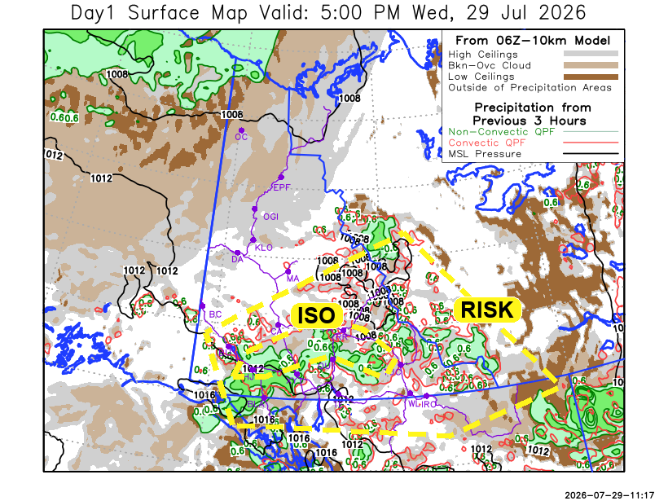
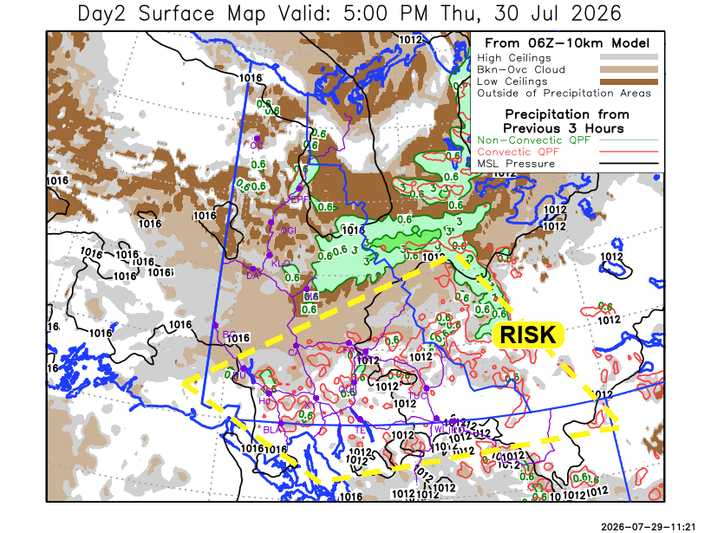

Forecast for | Thursday | (Peak burning period and overnight)
Community | Clouds | Pcpn | POP | POL | Max Temp | Min RH | Min Temp | Max  RH | Wind Dir | Wind Speed
Old Crow | SCT | R- | 30 | NIL | 15 | 50 | 8 | 90 | 220 | 5
Klondike Fc | BKN | R- | 30 | NIL | 18 | 45 | 8 | 90 | 290 | 5
Mayo A | BKN | R- | 30 | NIL | 21 | 35 | 12 | 90 | 270 | 10G35
Carmacks | BKN | RW-/TRW- | 20 | RISK | 20 | 35 | 10 | 75 | 0 | 10G30
Faro | BKN | RW-/TRW- | 20 | RISK | 23 | 35 | 8 | 85 | 300 | 10G30
Ross River | BKN | RW-/TRW- | 20 | RISK | 23 | 35 | 8 | 85 | 290 | 10G30
Beaver Creek Town | BKN |  | 0 | NIL | 19 | 40 | 7 | 80 | 340 | 5
Burwash A | BKN | RW-/TRW- | 20 | RISK | 18 | 45 | 9 | 85 | 320 | 10G20
Haines Junction | BKN | RW-/TRW- | 30 | RISK | 21 | 45 | 10 | 90 | 0 | 5
Whitehorse Auto | BKN | RW-/TRW- | 30 | RISK | 20 | 35 | 12 | 85 | 350 | 5
Teslin | SCT | RW-/TRW- | 20 | RISK | 22 | 35 | 12 | 80 | 270 | 5
Watson Lake | FEW | RW-/TRW- | 20 | RISK | 22 | 35 | 11 | 75 | 220 | 5

Forecast for |  |  | Friday |  |  | (Peak burning period and overnight)
Community |  |  | Clouds |  |  | Pcpn | POP |  | POL |  | Max Temp |  | Min RH | Min Temp | Max  RH | Wind Dir | Wind Speed
Old Crow |  |  | SCT |  |  |  | 0 |  | NIL |  | 20 |  | 40 | 10 | 85 | 270 | 10G25
Klondike Fc |  |  | SCT |  |  |  | 0 |  | NIL |  | 21 |  | 40 | 10 | 80 | 290 | 5
Mayo A |  |  | SCT |  |  |  | 0 |  | NIL |  | 22 |  | 35 | 11 | 80 | 270 | 5
Carmacks |  |  | SCT |  |  |  | 0 |  | NIL |  | 23 |  | 35 | 10 | 70 | 0 | 5
Faro |  |  | SCT |  |  |  | 0 |  | NIL |  | 21 |  | 35 | 8 | 75 | 300 | 5
Ross River |  |  | SCT |  |  |  | 0 |  | NIL |  | 20 |  | 35 | 6 | 75 | 300 | 5
Beaver Creek Town |  |  | SCT |  |  |  | 0 |  | NIL |  | 21 |  | 35 | 7 | 75 | 40 | 5
Burwash A |  |  | SCT |  |  |  | 15 |  | NIL |  | 19 |  | 40 | 9 | 75 | 40 | 5
Haines Junction |  |  | SCT |  |  |  | 15 |  | NIL |  | 21 |  | 35 | 11 | 80 | 0 | 5
Whitehorse Auto |  |  | SCT |  |  |  | 0 |  | NIL |  | 21 |  | 40 | 11 | 80 | 340 | 10G20
Teslin |  |  | SCT |  |  |  | 15 |  | NIL |  | 21 |  | 35 | 11 | 80 | 340 | 10G20
Watson Lake |  |  | BKN |  |  | RW-/TRW- | 30 |  | RISK |  | 22 |  | 40 | 11 | 90 | 320 | 5
3-Day Forecast Precipitation Totals from 13:00 Yesterday
OC | 3.5 |  | FA | 4.3 |  | JAK | 2.8
EPF | 7.5 |  | RR | 6.6 |  | TE | 9.6
ANT | 1.6 |  | BC | 0.0 |  | QUI | 7.4
DA | 0.6 |  | BCT | 0.0 |  | SWI | 7.7
FMI | 1.4 |  | BU | 1.9 |  | FL | 2.2
HEN | 3.9 |  | HJF | 16.2 |  | TUC | 2.3
BAR | 2.5 |  | RAI | 11.6 |  | HAS | 1.7
MA | 2.7 |  | CH | 7.8 |  | TC | 1.6
STW | 1.9 |  | BR | 3.3 |  | WL | 1.3
WIL | 2.9 |  | NU | 9.9 |  | NA | NA
PE | 17.3 |  | XY | 8.1 |  | IRO | 3.1
CA | 0.3 |  | CC | 3.5 |  | NA | NA
DRU | 4.8 |  | ATL | 2.2 |  | NA | NA
Dylan Kikuta Meteorologist

Disclaimer : The information in these forecasts is collected and prepared for internal use by the Government of Yukon. The forecasts are specifically designed to meet the needs of the Wildland Fire Management and may not cover the requirements of other parties. Weather warnings or advisories are not included as part of the forecasts. Wildland Fire Management makes no representation and provides no warranty as to the accuracy of its weather forecasts. Any use the recipient chooses to make of the forecasts will be at its sole risk.

