YUKON WILDLAND FIRE MANAGEMENT WEATHER FORECAST - 9:00 AM ISSUE

8-Aug-2026
YESTERDAY'S VALUES
Community | Max  Temp  (°C) | Diff.  from  Normal | Min Temp  (°C) | Diff. from Normal | Pcpn  (mm) | Min RH | Max RH | L110 | L30
Old Crow | 23.6 | 5.2 | 12.7 | 5.9 | 0.0 | 43 | 83 | 20 | 0
Fort Mcpherson Airport | 28.3 |  | 15.8 |  | 0.0M | 42 | 78 | 4 | 0
Rock River Climate | 21.8 |  | 9.2 |  | 0.0 | 46 | 92 | NA | NA
Eagle Plains Fire | 23.6 |  | 11.1 |  | 3.9 | 46 | 96 | 86 | 2
Antimony Creek | 28.4 |  | 9.2 |  | 0.0 | 23 | 92 | 35 | 2
Klondike Fc | 29.7 | 8.3 | 7.9 | 1.4 | 0.0 | 24 | 99 | 33 | 4
Forty Mile | 25.9 |  | 13.4 |  | 0.0 | 35 | 82 | 34 | 1
Henderson | 25.6 |  | 11.6 |  | 0.0 | 24 | 82 | 17 | 2
Barlow | 25.8 |  | 10.1 |  | 0.0 | 23 | 84 | 18 | 0
Mayo A | 27.2 | 6.0 | 12.1 | 4.3 | 0.6 | 31 | 81 | 34 | 0
Stewart Crossing | 27.0 |  | 9.9 |  | 0.0 | 24 | 83 | 12 | 1
Willow Creek | 27.1 |  | 7.3 |  | 0.0 | 26 | 91 | 26 | 1
Pelly Farm | 30.0 | 8.6 | 9.6 | 2.8 | 0.0 | 21 | 93 | 16 | 1
Carmacks | 29.2 |  | 13.0 |  | 0.0 | 28 | 77 | 100 | 2
Drury Creek | 25.3 |  | 8.6 |  | 0.3 | 40 | 94 | 266 | 38
Faro | 26.9 | 7.2 | 8.6 | 1.1 | 0.4 | 27 | 95 | 406 | 30
Ross River | 27.4 |  | 6.3 |  | 0.0 | 31 | 97 | 480 | 23
Macmillan Pass | 21.4 |  | 8.5 |  | 0.6 | 41 | 91 | 95 | 1
Beaver Creek A | 25.6 | 6.4 | 10.4 | 4.4 | 2.8 | 31 | 93 | 2 | 0
Beaver Creek Town | 27.5 |  | 11.1 |  | 2.5 | 25 | 96 | 2 | 0
Burwash A | 24.9 | 6.3 | 11.3 | 5.9 | 4.8M | 36 | 96 | 16 | 1
Haines Junction | 26.3M | 7.6 | 9.8M | 4.6 | 0.0M | 35M | 88M | 57 | 2
Rainbow | 23.8 |  | 8.4 |  | 0.0 | 42 | 93 | 64 | 2
Champagne | 26.4 |  | 10.3 |  | 0.0 | 31 | 82 | 155 | 10
Braeburn | 28.4 |  | 12.1 |  | 2.0 | 28 | 96 | 228 | 9
Nursery | 26.0 |  | 8.2 |  | 6.1 | 33 | 98 | 216 | 38
Whitehorse Auto | 23.6 | 3.8 | 10.6 | 3.3 | 1.0 | 38 | 93 | 219 | 32
Mount Sima | 20.1 |  | 10.8 |  | 4.8 | 53 | 91 | 205 | 19
Carcross | 21.8 |  | 8.6 |  | 0.0 | 46 | 94 | 140 | 1
Atlin | 21.5 |  | 11.7 |  | 0.0 | 40 | 78 | 22 | 0
Jakes Corner | 24.9 |  | 11.7 |  | 0.0 | 35 | 90 | 223 | 5
Teslin | 21.7 |  | 12.5 |  | 0.4 | 53 | 98 | 173 | 9
Quiet Lake | 22.0 |  | 8.4 |  | 0.0 | 44 | 94 | 444 | 12
Swift River | 26.8 |  | 10.0 |  | 1.9 | 28 | 98 | 94 | 14
Tuchitua | 28.0 |  | 11.3 |  | 4.9 | 26 | 99 | 28 | 0
Hasselburg | 25.2 |  | 12.9 |  | 0.0 | 27 | 81 | 87 | 0
Tom Creek | 25.5 |  | 12.0 |  | 0.0 | 26 | 81 | 0 | 0
Watson Lake | 25.4 | 5.0 | 11.4 | 3.4 | 0.0 | 24 | 86 | 0 | 0
Iron Creek | 27.1 |  | 9.2 |  | 0.0 | 27 | 97 | 0 | 0
Max Temp is the actual maximum temperature in °C from yesterday afternoon or evening.
Min Temp is the actual overnight minimum temperature in °C up until 6:00 AM this morning.
Diff. from Normal is the difference from the 30 year average max or min temperature.
Pcpn is the precipitation in mm since 13:00 yesterday.
Min RH is the minimum observed RH in % from yesterday afternoon or evening.
Max RH is the maximum observed overnight RH in % up until 6:00 AM this morning.
L110 is the actual number of lightning strikes within 110 km and in the Yukon for 24 hours ending at 06:00 AM this morning.
L30 is the actual number of lightning strikes within 30 km and in the Yukon for 24 hours ending at 06:00 AM this morning.
M is missing data. * denotes precipitation at stations that failed to report for at least part of the evening and overnight period.

SYNOPSIS:
Today: Warm temperatures and breezy northwesterly winds continue Saturday along with the potential for more thunderstorms in the south. The warmest and driest air will be found over the western/central Yukon Plateau where daytime highs will be in the mid to high twenties and minimum RH of 30-40% (locally 25%). Within this region, winds will be sustained at 10-15 km/h and gusting 30-40 km/h. Elsewhere across the southern half of the Yukon, scattered thunderstorms will accompany daytime highs will be in the low to mid-twenties and minimum RH generally above 40%. Thunderstorms may produce isolated gusts up to 50 km/h, small hail, and locally heavy rainfall. Dry lightning is not a big concern thanks to ample moisture in the atmospheric column. Skies will be relatively quiet over the northern half of the Yukon, but a stray shower or storm can’t be ruled out over higher terrain. Winds will be out of the wester/northwest gusting up to 35 km/h and daytime highs will be in the high teens to low twenties.
Sunday: Warm and breezy weather continues across the territory, but thundershowers are still expected over the southern half of the territory. The driest and warmest weather will be found over the western half of the Yukon Plateau along with breezy winds. Elsewhere over the southern half of the Yukon, scattered to numerous thundershowers will develop during the day, especially over Tintina, eastern Tatchun, and eastern Southern Lakes. These storms will be even weaker than Saturday’s activity. The increased cloud cover will cap daytime highs in the low twenties and keep minimum RH generally above 40% for regions impacted by shower activity. Over the northern half of the Yukon, northerly/northwesterly flow may be accompanied by isolated showers.
Monday: Spotty shower activity is expected over a good chunk of the territory on Monday, and temperatures will cool off over the north. The driest and warmest regions will be southern Klondike and eastern Tintina where daytime highs should be in the low twenties and minimum RH of 30-40%, while elsewhere across the territory minimum RH will generally be above 40%. The highest odds of shower activity will be over the southeastern corner of the territory and there might be enough instability for a few rumbles of thunder.
Tuesday: Rain shower coverage will be lower than Monday and temperatures should rebound by a few degrees as high pressure wiggles back in. Daytime highs in the low to mid-twenties will be found over the southern half of the territory while daytime highs in the teens will be found over the northern half of the territory.
Wednesday: - Upper-level ridging further strengthens and as a result warm temperatures are expected throughout the territory. Convective shower activity is possible over the southeast.

Forecast for | Saturday | (Peak burning period and overnight)
Community | Clouds | Pcpn | POP | POL | Max Temp | Min RH | Min Temp | Max  RH | Wind Dir | Wind Speed
Old Crow | SCT |  | 15 | NIL | 21 | 40 | 11 | 90 | 250 | 15G35
Klondike Fc | BKN | RW-/TRW- | 20 | RISK | 25 | 35 | 10 | 85 | 300 | 15G40
Mayo A | BKN | RW-/TRW- | 40 | RISK | 26 | 35 | 11 | 90 | 320 | 15G30
Carmacks | BKN | RW-/TRW- | 30 | RISK | 27 | 30 | 11 | 80 | 330 | 15G35
Faro | BKN | RW-/TRW- | 60 | ISO | 26 | 30 | 9 | 90 | 310 | 10G30
Ross River | BKN | RW/TRW | 60 | SCT | 24 | 35 | 10 | 90 | 310 | 10G30
Beaver Creek Town | BKN | RW-/TRW- | 20 | RISK | 24 | 35 | 12 | 75 | 330 | 10G25
Burwash A | BKN | RW-/TRW- | 40 | RISK | 22 | 45 | 10 | 95 | 310 | 10G25
Haines Junction | BKN | RW-/TRW- | 40 | RISK | 25 | 35 | 11 | 95 | 340 | 10G20
Whitehorse Auto | BKN | RW/TRW | 60 | SCT | 25 | 40 | 11 | 95 | 290 | 10
Teslin | BKN | RW-/TRW- | 40 | ISO | 20 | 55 | 11 | 100 | 270 | 10G20
Watson Lake | BKN | RW-/TRW- | 30 | RISK | 24 | 40 | 12 | 100 | 270 | 10G20
POP is probability of precipitation in %.
POL is probability of lightning in %.

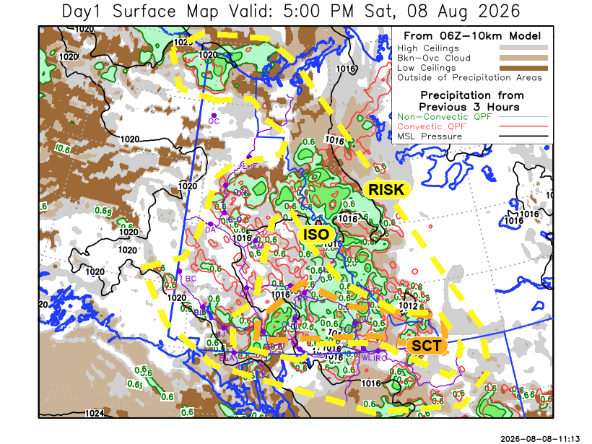
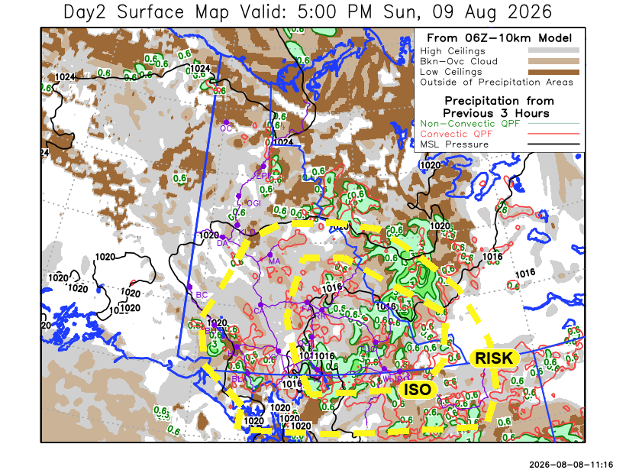

Forecast for | Sunday | (Peak burning period and overnight)
Community | Clouds | Pcpn | POP | POL | Max Temp | Min RH | Min Temp | Max  RH | Wind Dir | Wind Speed
Old Crow | BKN | RW- | 20 | NIL | 19 | 50 | 10 | 80 | 40 | 10G20
Klondike Fc | BKN |  | 15 | NIL | 24 | 30 | 11 | 75 | 330 | 10G25
Mayo A | BKN | RW-/TRW- | 30 | RISK | 22 | 40 | 14 | 80 | 40 | 10
Carmacks | BKN | RW-/TRW- | 20 | RISK | 26 | 25 | 13 | 75 | 0 | 15G35
Faro | BKN | RW-/TRW- | 60 | ISO | 21 | 40 | 11 | 90 | 320 | 10G20
Ross River | BKN | RW-/TRW- | 60 | ISO | 22 | 40 | 10 | 90 | 320 | 10G20
Beaver Creek Town | BKN |  | 10 | NIL | 23 | 35 | 11 | 70 | 300 | 10G25
Burwash A | BKN | RW-/TRW- | 20 | RISK | 20 | 45 | 11 | 85 | 320 | 10G30
Haines Junction | BKN | RW-/TRW- | 20 | RISK | 22 | 45 | 11 | 90 | 330 | 10G30
Whitehorse Auto | BKN | RW-/TRW- | 20 | RISK | 23 | 35 | 14 | 85 | 0 | 15G35
Teslin | OVC | RW-/TRW- | 60 | ISO | 21 | 45 | 14 | 90 | 320 | 5
Watson Lake | BKN | RW-/TRW- | 60 | ISO | 21 | 55 | 13 | 90 | 100 | 5

Forecast for |  |  | Monday |  |  | (Peak burning period and overnight)
Community |  |  | Clouds |  |  | Pcpn | POP |  | POL |  | Max Temp |  | Min RH | Min Temp | Max  RH | Wind Dir | Wind Speed
Old Crow |  |  | BKN |  |  | RW- | 20 |  | NIL |  | 15 |  | 50 | 8 | 90 | 60 | 10G30
Klondike Fc |  |  | SCT |  |  | RW- | 20 |  | NIL |  | 22 |  | 35 | 10 | 80 | 340 | 10G25
Mayo A |  |  | BKN |  |  | RW- | 30 |  | NIL |  | 20 |  | 50 | 11 | 85 | 60 | 10G20
Carmacks |  |  | BKN |  |  | RW- | 20 |  | NIL |  | 24 |  | 30 | 11 | 80 | 0 | 10G30
Faro |  |  | OVC |  |  | RW- | 60 |  | NIL |  | 18 |  | 65 | 9 | 95 | 330 | 10G20
Ross River |  |  | OVC |  |  | RW- | 60 |  | NIL |  | 20 |  | 60 | 8 | 95 | 320 | 10G20
Beaver Creek Town |  |  | SCT |  |  |  | 15 |  | NIL |  | 23 |  | 35 | 8 | 80 | 320 | 10G30
Burwash A |  |  | BKN |  |  | RW- | 20 |  | NIL |  | 19 |  | 50 | 10 | 85 | 320 | 10G30
Haines Junction |  |  | BKN |  |  | RW- | 20 |  | NIL |  | 23 |  | 30 | 11 | 85 | 320 | 10G30
Whitehorse Auto |  |  | BKN |  |  | RW- | 20 |  | NIL |  | 21 |  | 40 | 12 | 90 | 340 | 10G30
Teslin |  |  | BKN |  |  | RW-/TRW- | 20 |  | RISK |  | 21 |  | 40 | 12 | 90 | 340 | 10G30
Watson Lake |  |  | BKN |  |  | RW-/TRW- | 40 |  | RISK |  | 21 |  | 45 | 13 | 90 | 110 | 5
3-Day Forecast Precipitation Totals from 13:00 Yesterday
OC | 1.1 |  | FA | 8.9 |  | JAK | 8.2
EPF | 7.2 |  | RR | 6.9 |  | TE | 12.0
ANT | 0.0 |  | BC | 2.8 |  | QUI | 8.0
DA | 0.0 |  | BCT | 2.5 |  | SWI | 15.5
FMI | 0.0 |  | BU | 9.6 |  | FL | 17.2
HEN | 0.0 |  | HJF | 8.6 |  | TUC | 24.6
BAR | 0.8 |  | RAI | 7.5 |  | HAS | 18.3
MA | 3.6 |  | CH | 6.7 |  | TC | 16.3
STW | 0.6 |  | BR | 4.0 |  | WL | 11.7
WIL | 0.1 |  | NU | 11.3 |  | NA | NA
PE | 0.2 |  | XY | 8.7 |  | IRO | 7.0
CA | 0.5 |  | CC | 6.4 |  | NA | NA
DRU | 6.7 |  | ATL | 9.2 |  | NA | NA
Dylan Kikuta Meteorologist

Disclaimer : The information in these forecasts is collected and prepared for internal use by the Government of Yukon. The forecasts are specifically designed to meet the needs of the Wildland Fire Management and may not cover the requirements of other parties. Weather warnings or advisories are not included as part of the forecasts. Wildland Fire Management makes no representation and provides no warranty as to the accuracy of its weather forecasts. Any use the recipient chooses to make of the forecasts will be at its sole risk.

