YUKON WILDLAND FIRE MANAGEMENT WEATHER FORECAST - 9:00 AM ISSUE

9-Aug-2026
YESTERDAY'S VALUES
Community | Max  Temp  (°C) | Diff.  from  Normal | Min Temp  (°C) | Diff. from Normal | Pcpn  (mm) | Min RH | Max RH | L110 | L30
Old Crow | 19.9 | 1.6 | 8.3 | 1.7 | 0.0 | 43 | 86
Fort Mcpherson Airport | 22.4 |  | 11.6 |  | 0.0 | 38 | 89
Rock River Climate | 16.7 |  | 7.3 |  | 0.0 | 48 | 90
Eagle Plains Fire | 17.0 |  | 11.0 |  | 0.0 | 48 | 74
Antimony Creek | 23.2 |  | 9.0 |  | 0.0 | 37 | 87
Klondike Fc | 23.6 | 2.4 | 10.5 | 4.2 | 0.0 | 36 | 81
Forty Mile | 20.0 |  | 9.4 |  | 0.0 | 47 | 85
Henderson | 20.4 |  | 8.6 |  | 0.0 | 44 | 76
Barlow | 23.2 |  | 7.9 |  | 0.0 | 38 | 90
Mayo A | 25.7 | 4.6 | 10.8 | 3.1 | 2.1 | 37 | 91
Stewart Crossing | 26.0 |  | 13.2 |  | 0.0 | 33 | 66
Willow Creek | 25.9 |  | 9.6 |  | 0.0 | 31 | 88
Pelly Farm | 26.8 | 5.5 | 10.6 | 3.9 | 0.0 | 34 | 84
Carmacks | 28.4 |  | 13.0 |  | 0.0 | 30 | 78
Drury Creek | 27.2 |  | 11.8 |  | 0.0 | 32 | 89
Faro | 25.3 | 5.7 | 10.6 | 3.3 | 0.2 | 29 | 89
Ross River | 27.3 |  | 8.8 |  | 11.2 | 26 | 98
Macmillan Pass | 20.4 |  | 5.6 |  | 4.8 | 47 | 100
Beaver Creek A | 21.3 | 2.2 | 12.8 | 7.0 | 0.0 | 50 | 69
Beaver Creek Town | 22.4 |  | 13.2 |  | 0.0 | 44 | 71
Burwash A | 22.1 | 3.6 | 11.9 | 6.6 | 5.9M | 46 | 98
Haines Junction | 24.5 | 5.6 | 10.1 | 5.3 | 0.6 | 42 | 94
Rainbow | 21.0 |  | 10.2 |  | 0.0 | 56 | 94
Champagne | 21.3 |  | 8.4 |  | 0.0 | 54 | 95
Braeburn | 24.8 |  | 12.4 |  | 0.3 | 40 | 92
Nursery | 23.3 |  | 5.2 |  | 0.8 | 47 | 98
Whitehorse Auto | 21.9 | 2.2 | 7.8 | 0.5 | 0.2 | 46 | 100
Mount Sima | 18.6 |  | 10.5 |  | 0.6 | 61 | 89
Carcross | 16.8 |  | 9.8 |  | 0.5 | 66 | 97
Atlin | 17.1 |  | 11.7 |  | 0.0 | 58 | 86
Jakes Corner | 20.0 |  | 10.3 |  | 12.2 | 55 | 97
Teslin | 17.8 |  | 12.7 |  | 2.6 | 68 | 98
Quiet Lake | 26.0 |  | 8.7 |  | 17.3 | 48 | 100
Swift River | 21.3 |  | 11.6 |  | 1.6 | 50 | 98
Tuchitua | 24.2 |  | 10.1 |  | 0.3 | 43 | 99
Hasselburg | 21.5 |  | 11.9 |  | 13.2 | 61 | 90
Tom Creek | 22.4 |  | 11.4 |  | 0.0 | 42 | 96
Watson Lake | 23.1 | 2.8 | 12.9 | 5.0 | 0.2 | 39 | 96
Iron Creek | 26.5 |  | 10.7 |  | 0.0 | 36 | 99
Max Temp is the actual maximum temperature in °C from yesterday afternoon or evening.
Min Temp is the actual overnight minimum temperature in °C up until 6:00 AM this morning.
Diff. from Normal is the difference from the 30 year average max or min temperature.
Pcpn is the precipitation in mm since 13:00 yesterday.
Min RH is the minimum observed RH in % from yesterday afternoon or evening.
Max RH is the maximum observed overnight RH in % up until 6:00 AM this morning.
L110 is the actual number of lightning strikes within 110 km and in the Yukon for 24 hours ending at 06:00 AM this morning.
L30 is the actual number of lightning strikes within 30 km and in the Yukon for 24 hours ending at 06:00 AM this morning.
M is missing data. * denotes precipitation at stations that failed to report for at least part of the evening and overnight period.

SYNOPSIS:
Today: It will be a warm day across the territory but unsettled conditions are expected over the eastern half while marginally dry air holds over the western half. Over the northern half of the territory, the driest air will be found over the Nahoni Mountains and Taiga range. Minimum RH values will be around 35-45% here with light northerly/northwesterly winds. Elsewhere, RH will be higher and isolated shower activity is possible. Over the southern half of the territory, the driest air will be found over the western half of the Yukon Plateau and down the Hwy 2 corridor to B.C. Minimum RH will sit around 30-40% and a few 20-25% readings can’t be ruled out. This region will see breezy northerly/northwesterly winds gusting up to 35 km/h. Elsewhere, winds will be lighter and RH will be higher thanks to plenty of thundershower activity. Thundershower activity concentration will be highest over eastern Tatchun, eastern Southern Lakes, and western Tintina.
Monday: Temperatures cool off over the north while marginally dry air and thundershowers battle it out over the southern half of the territory. The driest air will be over the western half of the Yukon Plateau and Hwy 2 corridor to B.C. Minimum RH will be around 30-40% and a few 25% readings can’t be ruled out. Within this region, winds will be lighter and more variable in direction than Sunday, but nonetheless wind gusts of 20-30 km/h are still in the cards. Isolated to scattered thundershowers are possible over the southern half of the territory with the highest concentration over eastern Tatchun and eastern Southern Lakes. An axis of steady rain may park over the western half of Tintina for much of the day. Over the northern half of the territory, temperatures drop a few degrees and slow-moving showers linger.
Tuesday: Slightly below seasonal temperatures continue over the northern Yukon while slightly above seasonal temperatures continue over the southern half of the Yukon. Spotty showers are expected yet again across a good chunk of the territory, however the showers should be more isolated than the last few days. Marginally dry air will be found over the western half of the Yukon Plateau and along the Hwy 2 corridor to B.C. where minimum RH should be around 35-40%.
Wednesday: The upper-level ridge strengthens and marginally dry air (30-40% RH) is expected over much of the territory. Winds should be light and daytime highs will be in the low to mid-twenties. Isolated showers are possible over the southern half of the territory.
Thursday: Marginally dry air (30-40% RH) is expected over much of the territory. Winds should be light and daytime highs will be in the low to mid-twenties. Isolated showers are possible over the southern half of the territory.

Forecast for | Sunday | (Peak burning period and overnight)
Community | Clouds | Pcpn | POP | POL | Max Temp | Min RH | Min Temp | Max  RH | Wind Dir | Wind Speed
Old Crow | BKN | RW- | 20 | NIL | 19 | 50 | 9 | 95 | 40 | 10G20
Klondike Fc | BKN |  | 10 | NIL | 24 | 30 | 9 | 85 | 310 | 10G25
Mayo A | BKN | RW-/TRW- | 40 | RISK | 22 | 40 | 10 | 90 | 40 | 10
Carmacks | BKN | RW-/TRW- | 20 | RISK | 26 | 25 | 10 | 85 | 0 | 15G40
Faro | BKN | RW-/TRW- | 60 | ISO | 22 | 35 | 9 | 95 | 320 | 10G25
Ross River | BKN | RW-/TRW- | 60 | ISO | 24 | 35 | 10 | 95 | 330 | 10G20
Beaver Creek Town | BKN |  | 10 | NIL | 23 | 35 | 10 | 80 | 320 | 10G30
Burwash A | BKN | R- | 40 | NIL | 19 | 45 | 9 | 85 | 320 | 5G30
Haines Junction | BKN | RW-/TRW- | 60 | RISK | 22 | 40 | 8 | 95 | 340 | 5
Whitehorse Auto | BKN | RW-/TRW- | 40 | RISK | 24 | 35 | 10 | 90 | 0 | 15G35
Teslin | BKN | RW-/TRW- | 60 | ISO | 21 | 45 | 11 | 95 | 330 | 10G20
Watson Lake | BKN | RW-/TRW- | 60 | ISO | 20 | 55 | 11 | 100 | 140 | 5
POP is probability of precipitation in %.
POL is probability of lightning in %.

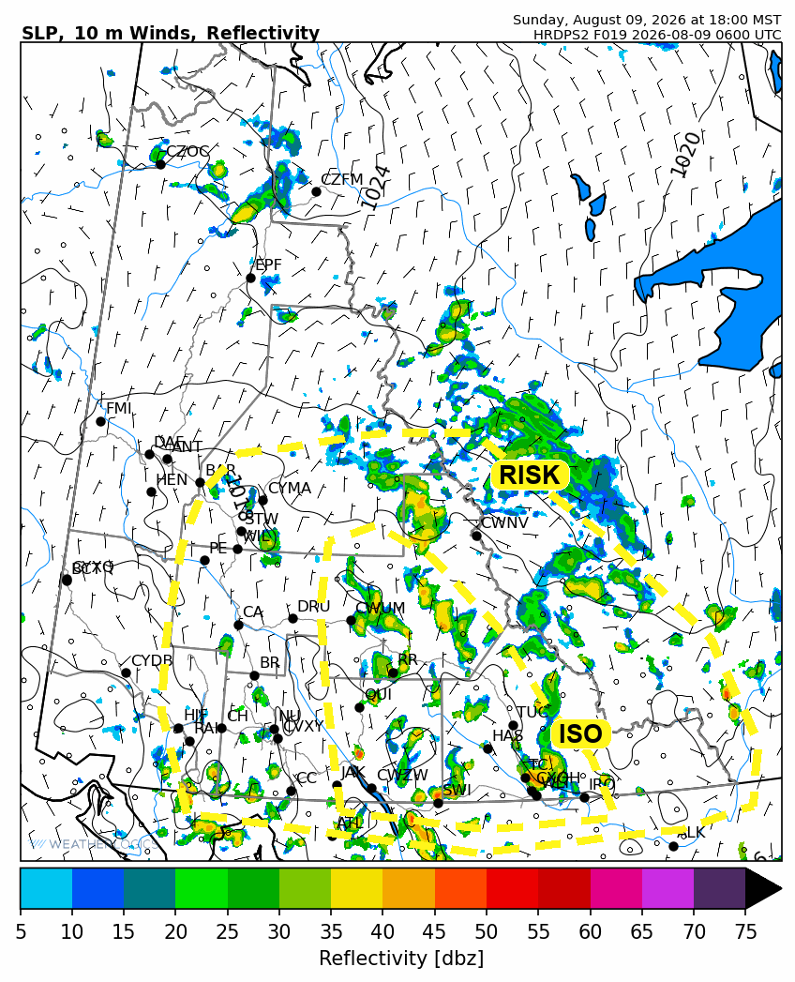
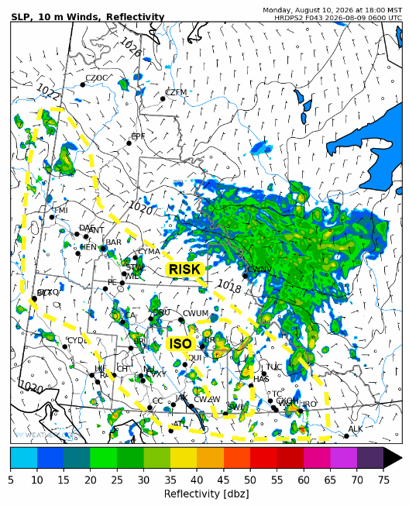

Forecast for | Monday | (Peak burning period and overnight)
Community | Clouds | Pcpn | POP | POL | Max Temp | Min RH | Min Temp | Max  RH | Wind Dir | Wind Speed
Old Crow | BKN | R- | 20 | NIL | 15 | 45 | 8 | 80 | 40 | 10G30
Klondike Fc | SCT | RW-/TRW- | 30 | RISK | 23 | 30 | 9 | 85 | 0 | 5G20
Mayo A | BKN | RW-/RISK | 40 | RISK | 20 | 45 | 12 | 85 | 30 | 5G20
Carmacks | SCT | RW-/TRW- | 40 | RISK | 24 | 30 | 11 | 75 | 20 | 10G30
Faro | BKN | RW-/TRW- | 60 | RISK | 21 | 35 | 9 | 95 | 320 | 10G20
Ross River | BKN | RW-/TRW- | 60 | ISO | 20 | 40 | 8 | 95 | 340 | 10G20
Beaver Creek Town | BKN | RW-/TRW- | 20 | RISK | 23 | 30 | 9 | 85 | 340 | 10G25
Burwash A | BKN | RW- | 40 | NIL | 20 | 40 | 11 | 85 | 350 | 10G20
Haines Junction | BKN | RW- | 20 | NIL | 24 | 35 | 11 | 85 | 320 | 5G20
Whitehorse Auto | SCT | RW-/TRW- | 20 | RISK | 24 | 30 | 12 | 85 | 340 | 10G30
Teslin | BKN | RW-/TRW- | 40 | RISK | 21 | 40 | 13 | 85 | 320 | 10G20
Watson Lake | BKN | RW-/TRW- | 80 | RISK | 21 | 50 | 13 | 85 | 90 | 10G20

Forecast for |  |  | Tuesday |  |  | (Peak burning period and overnight)
Community |  |  | Clouds |  |  | Pcpn | POP |  | POL |  | Max Temp |  | Min RH | Min Temp | Max  RH | Wind Dir | Wind Speed
Old Crow |  |  | BKN |  |  | RW- | 20 |  | NIL |  | 16 |  | 50 | 9 | 85 | 90 | 10G20
Klondike Fc |  |  | SCT |  |  | RW- | 20 |  | NIL |  | 22 |  | 35 | 11 | 80 | 320 | 5G20
Mayo A |  |  | SCT |  |  | RW- | 20 |  | NIL |  | 21 |  | 40 | 12 | 80 | 300 | 5
Carmacks |  |  | SCT |  |  | RW- | 20 |  | NIL |  | 25 |  | 30 | 12 | 80 | 340 | 5G20
Faro |  |  | FEW |  |  | RW- | 20 |  | NIL |  | 22 |  | 35 | 9 | 85 | 320 | 5G20
Ross River |  |  | SCT |  |  | RW- | 20 |  | NIL |  | 23 |  | 35 | 7 | 85 | 340 | 5G20
Beaver Creek Town |  |  | SCT |  |  | RW- | 20 |  | NIL |  | 23 |  | 35 | 8 | 80 | 300 | 5G20
Burwash A |  |  | SCT |  |  | RW- | 20 |  | NIL |  | 20 |  | 45 | 10 | 85 | 140 | 5G20
Haines Junction |  |  | SCT |  |  | RW- | 20 |  | NIL |  | 23 |  | 35 | 9 | 90 | 200 | 5G20
Whitehorse Auto |  |  | SCT |  |  | RW- | 20 |  | NIL |  | 21 |  | 40 | 12 | 90 | 340 | 5G20
Teslin |  |  | BKN |  |  | RW- | 20 |  | NIL |  | 21 |  | 40 | 12 | 90 | 300 | 5G20
Watson Lake |  |  | BKN |  |  | RW- | 20 |  | NIL |  | 21 |  | 45 | 12 | 95 | 340 | 5
3-Day Forecast Precipitation Totals from 13:00 Yesterday
OC | 0.8 |  | FA | 6.5 |  | JAK | 12.3
EPF | 0.8 |  | RR | 16.7 |  | TE | 9.3
ANT | 0.4 |  | BC | 0.3 |  | QUI | 21.8
DA | 0.0 |  | BCT | 0.3 |  | SWI | 18.3
FMI | 0.0 |  | BU | 10.3 |  | FL | 23.7
HEN | 0.0 |  | HJF | 3.8 |  | TUC | 16.8
BAR | 0.2 |  | RAI | 2.1 |  | HAS | 32.3
MA | 2.1 |  | CH | 2.2 |  | TC | 9.4
STW | 0.8 |  | BR | 0.3 |  | WL | 8.7
WIL | 0.1 |  | NU | 0.9 |  | NA | NA
PE | 0.0 |  | XY | 0.3 |  | IRO | 6.4
CA | 0.1 |  | CC | 1.3 |  | NA | NA
DRU | 3.4 |  | ATL | 5.6 |  | NA | NA
Dylan Kikuta Meteorologist

Disclaimer : The information in these forecasts is collected and prepared for internal use by the Government of Yukon. The forecasts are specifically designed to meet the needs of the Wildland Fire Management and may not cover the requirements of other parties. Weather warnings or advisories are not included as part of the forecasts. Wildland Fire Management makes no representation and provides no warranty as to the accuracy of its weather forecasts. Any use the recipient chooses to make of the forecasts will be at its sole risk.

