YUKON WILDLAND FIRE MANAGEMENT WEATHER FORECAST - 9:00 AM ISSUE

10-Aug-2026
YESTERDAY'S VALUES
Community | Max  Temp  (°C) | Diff.  from  Normal | Min Temp  (°C) | Diff. from Normal | Pcpn  (mm) | Min RH | Max RH | L110 | L30
Old Crow | 18.7 | 0.6 | 8.9 | 2.4 | 0.0 | 52 | 78 | 0 | 0
Fort Mcpherson Airport | 15.4 |  | 7.7 |  | 0.0 | 70 | 93 | 0 | 0
Rock River Climate | 15.1 |  | 7.3 |  | 2.2 | 62 | 100 | NA | NA
Eagle Plains Fire | 18.7 |  | 6.8 |  | 0.0 | 41 | 98 | 0 | 0
Antimony Creek | 23.0 |  | 8.4 |  | 0.0 | 32 | 85 | 0 | 0
Klondike Fc | 25.0 | 3.9 | 8.5 | 2.3 | 0.0 | 30 | 88 | 0 | 0
Forty Mile | 21.6 |  | 7.6 |  | 0.0 | 32 | 86 | 0 | 0
Henderson | 19.6 |  | 9.7 |  | 0.0 | 35 | 70 | 0 | 0
Barlow | 21.7 |  | 10.1 |  | 0.0 | 37 | 72 | 0 | 0
Mayo A | 21.1 | 0.1 | 11.6 | 4.0 | 3.7 | 47 | 91 | 6 | 0
Stewart Crossing | 22.8 |  | 11.6 |  | 0.0 | 33 | 90 | 0 | 0
Willow Creek | 22.5 |  | 11.1 |  | 0.0 | 32 | 81 | 0 | 0
Pelly Farm | 23.7 | 2.5 | 10.7 | 4.1 | 0.0 | 29 | 81 | 0 | 0
Carmacks | 22.1 |  | 11.3 |  | 0.0 | 39 | 91 | 5 | 0
Drury Creek | 22.8 |  | 9.1 |  | 0.0 | 34 | 90 | 8 | 0
Faro | 21.1 | 1.6 | 9.4 | 2.2 | 0.0 | 37 | 81 | 8 | 0
Ross River | 24.0 |  | 8.4 |  | 0.0 | 37 | 94 | 13 | 4
Macmillan Pass | 14.6 |  | 6.8 |  | 1.8 | 65 | 100 | 1 | 0
Beaver Creek A | 20.4 | 1.5 | 10.6 | 4.9 | 0.0 | 37 | 77 | 0 | 0
Beaver Creek Town | 21.4 |  | 11.9 |  | 0.0 | 31 | 76 | 0 | 0
Burwash A | 17.8 | -0.6 | 9.6 | 4.4 | 0.0M | 60 | 89 | 1 | 0
Haines Junction | 20.3 | 1.3 | 11.5 | 8.0 | 0.9 | 51 | 97 | 11 | 1
Rainbow | 21.3 |  | 10.5 |  | 0.3 | 52 | 97 | 12 | 1
Champagne | 21.3 |  | 9.6 |  | 3.3 | 57 | 97 | 16 | 6
Braeburn | 22.3 |  | 9.9 |  | 5.6 | 43 | 99 | 13 | 2
Nursery | 23.6 |  | 7.4 |  | 6.1 | 42 | 99 | 34 | 1
Whitehorse Auto | 22.0 | 2.4 | 10.7 | 3.5 | 0.4 | 41 | 100 | 41 | 2
Mount Sima | 18.9 |  | 10.6 |  | 0.3 | 51 | 89 | 39 | 3
Carcross | 23.8 |  | 12.1 |  | 0.0 | 37 | 90 | 43 | 0
Atlin | 23.1 |  | 11.2 |  | 0.0 | 41 | 88 | 30 | 0
Jakes Corner | 24.0 |  | 10.1 |  | 0.0 | 39 | 91 | 66 | 5
Teslin | 22.3 |  | 9.5 |  | 0.2 | 49 | 98 | 97 | 9
Quiet Lake | 22.2 |  | 10.1 |  | 0.0 | 44 | 93 | 72 | 6
Swift River | 21.1 |  | 10.4 |  | 7.1 | 55 | 98 | 71 | 8
Tuchitua | 25.0 |  | 11.5 |  | 7.7 | 45 | 99 | 48 | 1
Hasselburg | 21.8 |  | 11.0 |  | 4.6 | 54 | 99 | 65 | 7
Tom Creek | 18.5 |  | 11.4 |  | 17.1 | 69 | 99 | 69 | 2
Watson Lake | 20.4 | 0.2 | 13.0 | 5.3 | 0.4 | 60 | 97 | 71 | 8
Iron Creek | 23.2 |  | 6.7 |  | 1.8 | 50 | 99 | 81 | 7
Max Temp is the actual maximum temperature in °C from yesterday afternoon or evening.
Min Temp is the actual overnight minimum temperature in °C up until 6:00 AM this morning.
Diff. from Normal is the difference from the 30 year average max or min temperature.
Pcpn is the precipitation in mm since 13:00 yesterday.
Min RH is the minimum observed RH in % from yesterday afternoon or evening.
Max RH is the maximum observed overnight RH in % up until 6:00 AM this morning.
L110 is the actual number of lightning strikes within 110 km and in the Yukon for 24 hours ending at 06:00 AM this morning.
L30 is the actual number of lightning strikes within 30 km and in the Yukon for 24 hours ending at 06:00 AM this morning.
M is missing data. * denotes precipitation at stations that failed to report for at least part of the evening and overnight period.

SYNOPSIS:
Today: Temperatures cool off over the north while warm and marginally dry air battles thundershowers over the southern half of the territory. The driest air will be over the western half of the Yukon Plateau and potentially the Hwy 2 corridor from Carmacks to B.C (The Hwy corridor could be snubbed by afternoon showers). Minimum RH will be around 30-40% and an isolated 25% readings can’t be ruled out. Within this region, winds will be lighter and more variable in direction than Sunday, but nonetheless wind gusts of 20-30 km/h are still in the cards. Isolated to scattered thundershowers are possible over the southern half of the territory with the highest concentration of showers over Northern Tutchone, Tatchun, Southern Lakes, and Tintina. An axis of steady rain may park over the western half of Tintina during the afternoon. Over the northern half of the territory, temperatures drop a few degrees, and isolated slow-moving showers linger through the afternoon.
Tuesday: Slightly below seasonal temperatures continue over the northern Yukon while above seasonal temperatures continue over the southern half of the Yukon. Isolated showers/thundershowers are expected throughout the territory, and the greatest probabilities of shower activity will be over the southern half of the territory albeit much lower than the last few days. Marginally dry air expands in coverage over the southern half of the territory compared to the last few days but once again the driest air will be found over the western half of the Yukon Plateau and along the Hwy 2 corridor to B.C. where minimum RH should be around 30-40%, including isolated 25% readings. Winds will be light and rather variable in direction. Breezy southeasterly winds are possible over the northern Yukon but RH remains elevated and daytime highs are still in the teens.
Wednesday: The upper-level ridge strengthens which will cause temperatures to rise, winds to back off, and marginally dry air (30-40% RH) will overspread much of the territory. Thanks to generally clear skies, daytime highs will be in the low to mid-twenties throughout the territory. Daytime heating may produce isolated showers in the afternoon with slightly higher odds over eastern Tintina. The driest air will be found over the southern half of the territory where RH will be 30-35% and a few zones of 20-25% RH are possible.
Thursday: Marginally dry air (30-40% RH), warm temperatures (low to mid-twenties), and light winds are expected throughout the territory under generally clear skies. Isolated showers may develop in the afternoon with the highest odds over central Northern Tutchone and eastern Tintina. The driest air will be found over the southern half of the Yukon where stretches of 20-25% RH readings are possible.
Friday: The air mass will dry out further under clear skies, light winds and warm to hot temperatures. Marginally dry (30-35% RH) conditions are expected over the northern half of the territory while dry (20-30% RH) conditions are expected over the southern half of the territory. Isolated showers remain a possibility with the highest odds over Tintina.

Forecast for | Monday | (Peak burning period and overnight)
Community | Clouds | Pcpn | POP | POL | Max Temp | Min RH | Min Temp | Max  RH | Wind Dir | Wind Speed
Old Crow | BKN | R- | 20 | NIL | 15 | 50 | 9 | 80 | 40 | 15G30
Klondike Fc | SCT | RW-/TRW- | 30 | RISK | 23 | 30 | 8 | 90 | 330 | 10G20
Mayo A | BKN | RW-/TRW- | 40 | RISK | 20 | 40 | 8 | 90 | 50 | 5G20
Carmacks | SCT | RW-/TRW- | 40 | RISK | 23 | 35 | 8 | 95 | 20 | 10G25
Faro | BKN | RW-/TRW- | 60 | ISO | 21 | 45 | 7 | 100 | 30 | 10G20
Ross River | BKN | RW-/TRW- | 60 | ISO | 20 | 45 | 8 | 100 | 0 | 5G20
Beaver Creek Town | SCT | RW-/TRW- | 20 | RISK | 21 | 35 | 8 | 90 | 320 | 10G20
Burwash A | BKN | RW-/TRW- | 20 | RISK | 18 | 50 | 8 | 80 | 0 | 10G20
Haines Junction | SCT | RW-/TRW- | 20 | RISK | 23 | 35 | 9 | 85 | 0 | 10G25
Whitehorse Auto | SCT | RW-/TRW- | 20 | RISK | 23 | 35 | 10 | 90 | 0 | 10G30
Teslin | SCT | RW-/TRW- | 20 | RISK | 22 | 35 | 11 | 90 | 320 | 10G30
Watson Lake | BKN | RW-/TRW- | 60 | RISK | 20 | 50 | 11 | 100 | 90 | 5
POP is probability of precipitation in %.
POL is probability of lightning in %.

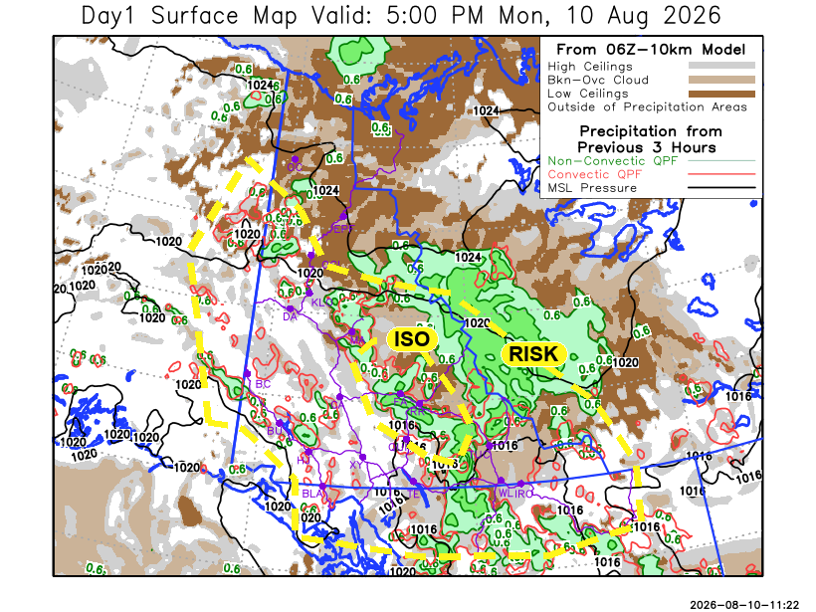
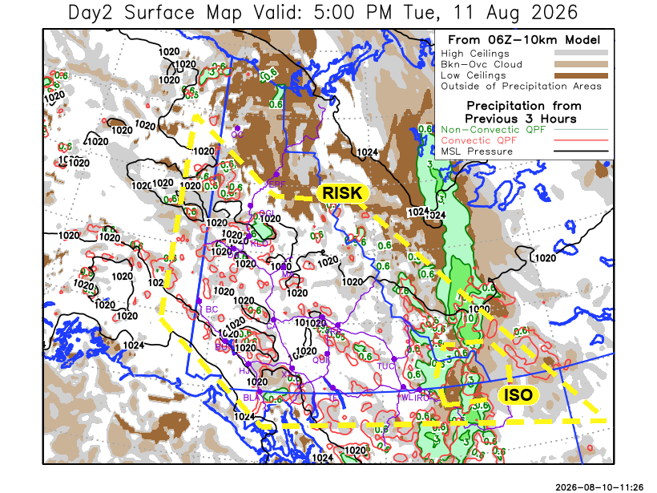

Forecast for | Tuesday | (Peak burning period and overnight)
Community | Clouds | Pcpn | POP | POL | Max Temp | Min RH | Min Temp | Max  RH | Wind Dir | Wind Speed
Old Crow | SCT |  | 15 | NIL | 17 | 45 | 9 | 90 | 110 | 10G20
Klondike Fc | SCT | RW-/TRW- | 20 | RISK | 24 | 30 | 11 | 85 | 320 | 5
Mayo A | SCT | RW-/TRW- | 20 | RISK | 23 | 35 | 12 | 85 | 320 | 5
Carmacks | SCT | RW-/TRW- | 20 | RISK | 24 | 30 | 12 | 80 | 240 | 5G20
Faro | SCT | RW-/TRW- | 40 | RISK | 22 | 35 | 9 | 85 | 320 | 5G20
Ross River | SCT | RW-/TRW- | 40 | RISK | 22 | 40 | 7 | 85 | 320 | 5G20
Beaver Creek Town | SCT | RW-/TRW- | 20 | RISK | 23 | 30 | 9 | 75 | 340 | 5
Burwash A | SCT | RW-/TRW- | 20 | RISK | 20 | 45 | 10 | 80 | 110 | 5G20
Haines Junction | SCT | RW-/TRW- | 20 | RISK | 25 | 30 | 8 | 90 | 200 | 5G20
Whitehorse Auto | SCT | RW-/TRW- | 20 | RISK | 23 | 35 | 12 | 85 | 340 | 5G20
Teslin | SCT | RW-/TRW- | 20 | RISK | 22 | 35 | 13 | 80 | 320 | 5G20
Watson Lake | SCT | RW-/TRW- | 20 | RISK | 21 | 40 | 11 | 90 | 320 | 5

Forecast for |  |  | Wednesday |  |  | (Peak burning period and overnight)
Community |  |  | Clouds |  |  | Pcpn | POP |  | POL |  | Max Temp |  | Min RH | Min Temp | Max  RH | Wind Dir | Wind Speed
Old Crow |  |  | SCT |  |  |  | 10 |  | NIL |  | 21 |  | 40 | 11 | 80 | 270 | 10G20
Klondike Fc |  |  | FEW |  |  |  | 10 |  | NIL |  | 25 |  | 30 | 12 | 75 | 340 | 5
Mayo A |  |  | FEW |  |  |  | 10 |  | NIL |  | 23 |  | 30 | 14 | 80 | 340 | 5
Carmacks |  |  | FEW |  |  |  | 10 |  | NIL |  | 25 |  | 30 | 12 | 70 | 0 | 5
Faro |  |  | FEW |  |  |  | 10 |  | NIL |  | 21 |  | 35 | 10 | 70 | 320 | 5
Ross River |  |  | FEW |  |  |  | 10 |  | NIL |  | 23 |  | 30 | 8 | 75 | 340 | 5
Beaver Creek Town |  |  | FEW |  |  |  | 10 |  | NIL |  | 25 |  | 30 | 9 | 70 | 220 | 5
Burwash A |  |  | FEW |  |  |  | 15 |  | NL |  | 22 |  | 40 | 10 | 75 | 150 | 5
Haines Junction |  |  | FEW |  |  |  | 15 |  | NIL |  | 25 |  | 30 | 10 | 80 | 40 | 5
Whitehorse Auto |  |  | SCT |  |  |  | 15 |  | NIL |  | 23 |  | 35 | 12 | 75 | 340 | 5
Teslin |  |  | SCT |  |  |  | 10 |  | NIL |  | 23 |  | 35 | 12 | 75 | 0 | 5
Watson Lake |  |  | SCT |  |  | RW-/TRW- | 20 |  | RISK |  | 22 |  | 35 | 12 | 80 | 40 | 5
3-Day Forecast Precipitation Totals from 13:00 Yesterday
OC | 0.0 |  | FA | 4.6 |  | JAK | 0.0
EPF | 0.5 |  | RR | 4.5 |  | TE | 0.2
ANT | 0.2 |  | BC | 0.0 |  | QUI | 2.2
DA | 0.0 |  | BCT | 0.0 |  | SWI | 14.4
FMI | 0.0 |  | BU | 0.1 |  | FL | 15.7
HEN | 0.3 |  | HJF | 0.9 |  | TUC | 19.4
BAR | 0.0 |  | RAI | 1.0 |  | HAS | 13.0
MA | 4.5 |  | CH | 3.9 |  | TC | 24.1
STW | 0.0 |  | BR | 5.6 |  | WL | 6.9
WIL | 0.1 |  | NU | 6.1 |  | NA | NA
PE | 0.0 |  | XY | 0.5 |  | IRO | 9.2
CA | 0.0 |  | CC | 1.2 |  | NA | NA
DRU | 3.3 |  | ATL | 0.6 |  | NA | NA
Dylan Kikuta Meteorologist

Disclaimer : The information in these forecasts is collected and prepared for internal use by the Government of Yukon. The forecasts are specifically designed to meet the needs of the Wildland Fire Management and may not cover the requirements of other parties. Weather warnings or advisories are not included as part of the forecasts. Wildland Fire Management makes no representation and provides no warranty as to the accuracy of its weather forecasts. Any use the recipient chooses to make of the forecasts will be at its sole risk.

