YUKON WILDLAND FIRE MANAGEMENT WEATHER FORECAST - 9:00 AM ISSUE

15-Aug-2026
YESTERDAY'S VALUES
Community | Max  Temp  (°C) | Diff.  from  Normal | Min Temp  (°C) | Diff. from Normal | Pcpn  (mm) | Min RH | Max RH | L110 | L30
Old Crow | 21.7 | 4.6 | 5.6 | -0.1 | 0.0 | 41 | 94 | 0 | 0
Fort Mcpherson Airport | 21.1 |  | 8.8 |  | 0.0 | 62 | 97 | 0 | 0
Rock River Climate | 19.6 |  | 9.7 |  | 0.0 | 40 | 94 | NA | NA
Eagle Plains Fire | 17.3 |  | 10.2 |  | 0.0 | 42 | 95 | 0 | 0
Antimony Creek | 24.7 |  | 11.0 |  | 0.0 | 35 | 93 | 0 | 0
Klondike Fc | 25.3 | 5.1 | 9.8 | 4.3 | 0.0 | 36 | 97 | 0 | 0
Forty Mile | 22.3 |  | 11.6 |  | 0.0 | 52 | 98 | 0 | 0
Henderson | 23.9 |  | 13.2 |  | 0.0 | 34 | 83 | 0 | 0
Barlow | 23.8 |  | 12.4 |  | 0.3 | 37 | 93 | 0 | 0
Mayo A | 23.4 | 3.2 | 14.8 | 7.9 | 0.0 | 45 | 81 | 0 | 0
Stewart Crossing | 24.6 |  | 13.6 |  | 0.0 | 33 | 82 | 0 | 0
Willow Creek | 25.3 |  | 12.6 |  | 0.0 | 27 | 90 | 0 | 0
Pelly Farm | 25.6 | 5.1 | 12.3 | 6.4 | 0.0 | 34 | 92 | 0 | 0
Carmacks | 27.9 |  | 10.6 |  | 0.0 | 26 | 77 | 0 | 0
Drury Creek | 26.5 |  | 10.2 |  | 0.0 | 21 | 88 | 0 | 0
Faro | 25.6 | 6.8 | 11.2 | 4.7 | 0.0 | 21 | 77 | 0 | 0
Ross River | 26.3 |  | 6.0 |  | 0.0 | 18 | 91 | 0 | 0
Macmillan Pass | 19.4 |  | 9.1 |  | 3.0 | 32 | 97 | 0 | 0
Beaver Creek A | 26.8 | 8.5 | 9.9 | 5.0 | 0.0 | 30 | 83 | 0 | 0
Beaver Creek Town | 27.5 |  | 10.5 |  | 0.0 | 26 | 84 | 0 | 0
Burwash A | 24.9 | 7.0 | 9.4 | 4.9 | 0.0M | 29 | 86 | 0 | 0
Haines Junction | 29.5 | 10.4 | 8.1 | 3.8 | 0.0 | 20 | 77 | 0 | 0
Rainbow | 28.0 |  | 9.2 |  | 0.0 | 21 | 78 | 0 | 0
Champagne | 28.7 |  | 6.1 |  | 0.0 | 19 | 84 | 0 | 0
Braeburn | 27.8 |  | 4.7 |  | 0.0 | 23 | 97 | 0 | 0
Nursery | 28.2 |  | 7.1 |  | 0.0 | 20 | 97 | 0 | 0
Whitehorse Auto | 26.1 | 7.0 | 11.4 | 4.7 | 0.0 | 19 | 75 | 0 | 0
Mount Sima | 23.8 |  | 16.5 |  | 0.0 | 20 | 42 | 0 | 0
Carcross | 26.9 |  | 8.9 |  | 0.0 | 22 | 86 | 0 | 0
Atlin | 26.8 |  | 12.1 |  | 0.0 | 21 | 58 | 0 | 0
Jakes Corner | 28.0 |  | 13.6 |  | 0.0 | 20 | 68 | 0 | 0
Teslin | 25.0 |  | 12.4 |  | 0.0 | 25 | 83 | 0 | 0
Quiet Lake | 27.8 |  | 7.0 |  | 0.0 | 23 | 88 | 0 | 0
Swift River | 25.6 |  | 4.8 |  | 0.0 | 22 | 94 | 0 | 0
Tuchitua | 25.2 |  | 3.3 |  | 0.0 | 29 | 99 | 3 | 0
Hasselburg | 24.5 |  | 7.0 |  | 0.0 | 28 | 93 | 2 | 0
Tom Creek | 23.1 |  | 10.0 |  | 0.0 | 35 | 83 | 4 | 2
Watson Lake | 23.2 | 3.6 | 7.7 | 0.5 | 0.0 | 30 | 95 | 4 | 0
Iron Creek | 25.3 |  | 2.3 |  | 0.0 | 32 | 98 | 4 | 0
Max Temp is the actual maximum temperature in °C from yesterday afternoon or evening.
Min Temp is the actual overnight minimum temperature in °C up until 6:00 AM this morning.
Diff. from Normal is the difference from the 30 year average max or min temperature.
Pcpn is the precipitation in mm since 13:00 yesterday.
Min RH is the minimum observed RH in % from yesterday afternoon or evening.
Max RH is the maximum observed overnight RH in % up until 6:00 AM this morning.
L110 is the actual number of lightning strikes within 110 km and in the Yukon for 24 hours ending at 06:00 AM this morning.
L30 is the actual number of lightning strikes within 30 km and in the Yukon for 24 hours ending at 06:00 AM this morning.
M is missing data. * denotes precipitation at stations that failed to report for at least part of the evening and overnight period.

SYNOPSIS:
Today: Upper-level ridging is in place across the Yukon, which will bring another day of warm to hot temperatures, with the hottest weather in the Kluane, Southern Lakes, and Tatchun regions. High temperatures will be in the mid to upper twenties across most of the Territory, with some of the hottest areas reaching near or just above 30 C. Crossovers are likely where temperatures reach the upper twenties or warmer. A band of cloud will move through the central Yukon today, from the Klondike region eastward through the Northern Tutchone region and southeastward into parts of Tatchun and Tintina. Some shower activity is possible within this cloud deck along with a risk of thunderstorms. Outside of this area, no precipitation is expected. Winds today will be light and variable across the Territory.

Sunday: Upper-level ridging remains in place on Sunday, bringing another day of warm and dry conditions. With daytime heating, there is again a risk of afternoon convective showers with a risk of thunderstorms in the Klondike, Northern Tutchone, and Tatchun regions, but this activity is expected to be very isolated. High temperatures will mostly be in the mid- to upper twenties, with the highest values again in the southwest. Crossovers remain possible where temperatures reach the mid twenties or higher. Winds are expected to be light across the Territory, with variable direction.

Monday: A shift in the weather pattern begins on Monday as a strong Pacific low begins to approach the coast. This will bring a cooling trend across the Yukon along with more widespread shower activity and increasing southerly wind speeds, especially in the Kluane and Southern Lakes. Temperatures are expected to remain warm (mid- to upper twenties) in the southwestern portion of the Territory, with lower values in the upper teens to low twenties elsewhere.

Tuesday: An upper trough over Alaska is expected to be the main influence on the Yukon’s weather through midweek, keeping temperatures cooler with highs likely to be near normal (upper teens to lower twenties). At this time, it does not appear there will be chances for significant precipitation, but this will need to be monitored.

Wednesday: Little change is expected in the pattern by Wednesday, with an upper trough remaining over Alaska. This is expected to maintain near-normal temperatures and may bring more frequent chances for rain showers. Some models do build weak ridging into the southern Yukon by Wednesday, but it does not appear this will significantly alter the expected weather conditions.

Forecast for | Saturday | (Peak burning period and overnight)
Community | Clouds | Pcpn | POP | POL | Max Temp | Min RH | Min Temp | Max  RH | Wind Dir | Wind Speed
Old Crow | FEW |  | 0 | 0 | 24 | 35 | 10 | 95 | Var | 10
Klondike Fc | BKN | RW-/TRW- | 50 | 20 | 23 | 35 | 11 | 95 | Var | 2
Mayo A | BKN | RW-/TRW- | 50 | 20 | 23 | 45 | 13 | 95 | Var | 5
Carmacks | SCT | RW-/TRW- | 30 | 20 | 31 | 20 | 12 | 80 | 140 | 5-10
Faro | BKN | RW-/TRW- | 50 | 20 | 27 | 20 | 12 | 80 | Var | 5
Ross River | BKN | RW-/TRW- | 50 | 20 | 28 | 20 | 10 | 85 | Var | 5
Beaver Creek Town | SCT | RW-/TRW- | 30 | 10 | 29 | 20 | 9 | 85 | Var | 5
Burwash A | FEW |  | 0 | 0 | 26 | 25 | 8 | 85 | 150 | 5-10
Haines Junction | FEW |  | 0 | 0 | 29 | 20 | 9 | 85 | 200 | 10
Whitehorse Auto | FEW |  | 0 | 0 | 28 | 20 | 12 | 80 | 200 | 10-15
Teslin | FEW |  | 0 | 0 | 27 | 20 | 12 | 80 | 220 | 15
Watson Lake | SCT | RW-/TRW- | 40 | 10 | 25 | 25 | 13 | 95 | 270 | 15
POP is probability of precipitation in %.
POL is probability of lightning in %.

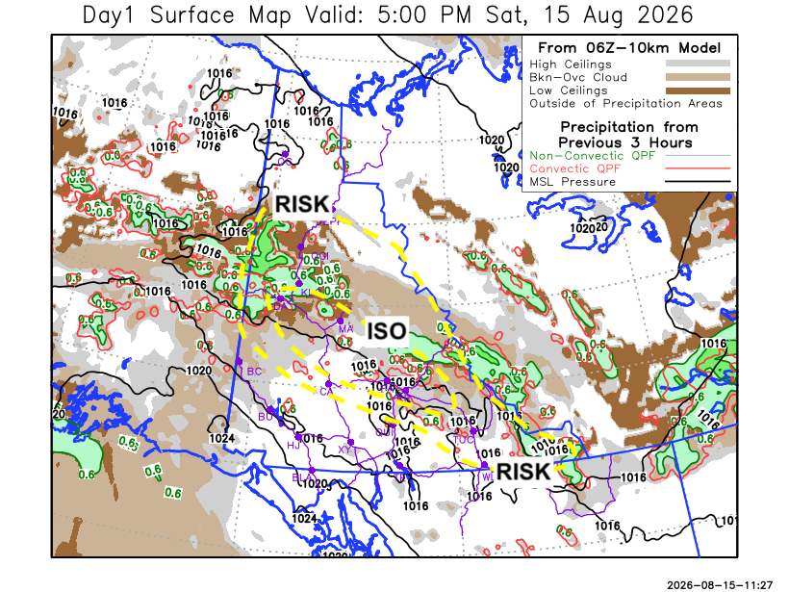
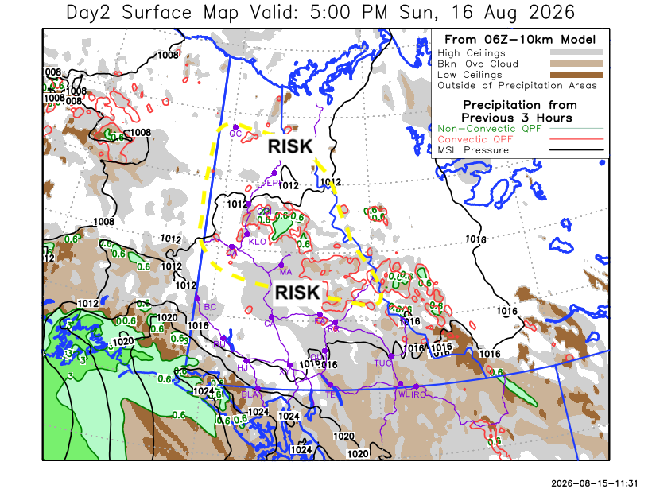

Forecast for | Sunday | (Peak burning period and overnight)
Community | Clouds | Pcpn | POP | POL | Max Temp | Min RH | Min Temp | Max  RH | Wind Dir | Wind Speed
Old Crow | SCT | RW-/TRW- | 30 | 10 | 26 | 30 | 11 | 95 | 180 | 15
Klondike Fc | SCT | RW-/TRW- | 30 | 10 | 28 | 25 | 12 | 95 | 180 | 10
Mayo A | SCT | RW-/TRW- | 30 | 10 | 27 | 25 | 10 | 90 | Var | 5-10
Carmacks | FEW |  | 0 | 0 | 30 | 20 | 12 | 85 | 160 | 10-15
Faro | FEW |  | 0 | 0 | 26 | 20 | 9 | 85 | Var | 5-10
Ross River | FEW |  | 0 | 0 | 27 | 20 | 8 | 85 | Var | 5-10
Beaver Creek Town | FEW |  | 0 | 0 | 27 | 20 | 9 | 85 | Var | 5-10
Burwash A | FEW |  | 0 | 0 | 24 | 35 | 9 | 80 | 140 | 10-15
Haines Junction | FEW |  | 0 | 0 | 25 | 25 | 8 | 90 | 270 | 15-20
Whitehorse Auto | FEW |  | 0 | 0 | 26 | 20 | 11 | 85 | 160 | 10-20
Teslin | FEW |  | 0 | 0 | 24 | 30 | 11 | 85 | 220 | 10-15
Watson Lake | FEW |  | 0 | 0 | 24 | 35 | 10 | 85 | 250 | 10

Forecast for |  |  | Monday |  |  | (Peak burning period and overnight)
Community |  |  | Clouds |  |  | Pcpn | POP |  | POL |  | Max Temp |  | Min RH | Min Temp | Max  RH | Wind Dir | Wind Speed
Old Crow |  |  | BKN |  |  | RW- | 60 |  | 0 |  | 21 |  | 50 | 11 | 95 | 250 | 25G35
Klondike Fc |  |  | BKN |  |  | RW- | 70 |  | 0 |  | 23 |  | 40 | 8 | 95 | 180 | 15
Mayo A |  |  | BKN |  |  | RW- | 60 |  | 0 |  | 22 |  | 45 | 10 | 95 | 180 | 15
Carmacks |  |  | SCT |  |  | RW- | 50 |  | 0 |  | 26 |  | 30 | 9 | 90 | 160 | 20
Faro |  |  | BKN |  |  | RW- | 60 |  | 0 |  | 20 |  | 45 | 7 | 90 | 220 | 15
Ross River |  |  | BKN |  |  | RW- | 60 |  | 0 |  | 21 |  | 45 | 6 | 90 | 200 | 15
Beaver Creek Town |  |  | SCT |  |  | RW- | 40 |  | 0 |  | 26 |  | 30 | 5 | 90 | 250 | 10-15
Burwash A |  |  | FEW |  |  |  | 0 |  | 0 |  | 23 |  | 30 | 6 | 90 | 140 | 25G40
Haines Junction |  |  | FEW |  |  |  | 0 |  | 0 |  | 21 |  | 35 | 5 | 95 | 270 | 20G30
Whitehorse Auto |  |  | SCT |  |  | RW- | 40 |  | 0 |  | 21 |  | 35 | 8 | 90 | 160 | 20G30
Teslin |  |  | BKN |  |  | RW- | 60 |  | 0 |  | 20 |  | 45 | 9 | 95 | 200 | 12
Watson Lake |  |  | BKN |  |  | RW- | 50 |  | 0 |  | 18 |  | 45 | 10 | 90 | 220 | 15
3-Day Forecast Precipitation Totals from 13:00 Yesterday
OC | 0.4 |  | FA | 2.2 |  | JAK | 3.5
EPF | 0.0 |  | RR | 1.7 |  | TE | 3.2
ANT | 4.1 |  | BC | 0.8 |  | QUI | 2.7
DA | 4.1 |  | BCT | 0.8 |  | SWI | 1.9
FMI | 5.6 |  | BU | 0.0 |  | FL | 1.0
HEN | 2.3 |  | HJF | 1.0 |  | TUC | 0.4
BAR | 3.1 |  | RAI | 1.0 |  | HAS | 0.4
MA | 1.8 |  | CH | 0.8 |  | TC | 0.2
STW | 1.6 |  | BR | 0.5 |  | WL | 0.2
WIL | 1.5 |  | NU | 1.4 |  | NA | NA
PE | 1.7 |  | XY | 2.1 |  | IRO | 0.0
CA | 1.2 |  | CC | 2.8 |  | NA | NA
DRU | 2.2 |  | ATL | 4.1 |  | NA | NA
Scott Kehler Meteorologist

Disclaimer : The information in these forecasts is collected and prepared for internal use by the Government of Yukon. The forecasts are specifically designed to meet the needs of the Wildland Fire Management and may not cover the requirements of other parties. Weather warnings or advisories are not included as part of the forecasts. Wildland Fire Management makes no representation and provides no warranty as to the accuracy of its weather forecasts. Any use the recipient chooses to make of the forecasts will be at its sole risk.

