YUKON WILDLAND FIRE MANAGEMENT WEATHER FORECAST - 9:00 AM ISSUE

16-Aug-2026
YESTERDAY'S VALUES
Community | Max  Temp  (°C) | Diff.  from  Normal | Min Temp  (°C) | Diff. from Normal | Pcpn  (mm) | Min RH | Max RH | L110 | L30
Old Crow | 24.5 | 7.6 | 8.1 | 2.6 | 0.0 | 33 | 90 | 0 | 0
Fort Mcpherson Airport | 22.2 |  | 10.1 |  | 0.0M | 54 | 98 | 0 | 0
Rock River Climate | 21.0 |  | 10.9 |  | 0.0 | 45 | 84 | 0 | 0
Eagle Plains Fire | 23.1 |  | 12.3 |  | 0.0 | 35 | 78 | 0 | 0
Antimony Creek | 23.8 |  | 8.6 |  | 0.0 | 47 | 98 | 1 | 0
Klondike Fc | 25.3 | 5.2 | 9.8 | 4.5 | 0.0 | 49 | 97 | 1 | 0
Forty Mile | 21.8 |  | 9.9 |  | 0.0 | 63 | 98 | 2 | 0
Henderson | 20.3 |  | 14.1 |  | 0.0 | 68 | 89 | 6 | 0
Barlow | 21.4 |  | 13.1 |  | 0.0 | 59 | 92 | 4 | 0
Mayo A | 21.0 | 1.0 | 11.1 | 4.4 | 1.1 | 58 | 96 | 29 | 0
Stewart Crossing | 22.7 |  | 12.8 |  | 2.1 | 51 | 93 | 111 | 0
Willow Creek | 24.1 |  | 11.5 |  | 1.3 | 43 | 98 | 134 | 0
Pelly Farm | 28.7 | 8.4 | 15.2 | 9.5 | 2.8 | 31 | 94 | 168 | 49
Carmacks | 32.1 |  | 13.4 |  | 0.0 | 24 | 79 | 141 | 1
Drury Creek | 28.0 |  | 13.6 |  | 0.0 | 28 | 87 | 113 | 0
Faro | 24.4 | 5.7 | 12.9 | 6.5 | 0.8 | 38 | 95 | 190 | 5
Ross River | 24.7 |  | 10.7 |  | 4.8 | 37 | 99 | 232 | 56
Macmillan Pass | 16.6 |  | 7.4 |  | 0.2 | 51 | 100 | 2 | 0
Beaver Creek A | 25.2 | 7.0 | 8.1 | 3.3 | 0.0 | 43 | 86 | 2 | 0
Beaver Creek Town | 26.8 |  | 7.9 |  | 0.0 | 33 | 86 | 1 | 0
Burwash A | 25.7 | 7.9 | 6.4 | 2.0 | 0.0M | 30 | 85 | 19 | 0
Haines Junction | 28.6 | 9.9 | 8.1 | 4.9 | 0.0 | 21 | 76 | 0 | 0
Rainbow | 28.3 |  | 15.2 |  | 0.0 | 19 | 41 | 0 | 0
Champagne | 28.8 |  | 16.0 |  | 0.0 | 15 | 41 | 0 | 0
Braeburn | 31.1 |  | 10.4 |  | 0.0 | 19 | 76 | 1 | 0
Nursery | 29.9 |  | 8.4 |  | 0.0 | 21 | 87 | 0 | 0
Whitehorse Auto | 28.3 | 9.4 | 13.0 | 6.4 | 0.0 | 22 | 59 | 0 | 0
Mount Sima | 26.5 |  | 13.4 |  | 0.0 | 21 | 47 | 0 | 0
Carcross | 28.4 |  | 14.2 |  | 0.0 | 23 | 67 | 0 | 0
Atlin | 28.2 |  | 11.4 |  | 0.0 | 19 | 60 | 0 | 0
Jakes Corner | 29.1 |  | 10.4 |  | 0.0 | 22 | 72 | 0 | 0
Teslin | 26.6 |  | 9.7 |  | 0.0 | 29 | 76 | 2 | 0
Quiet Lake | 27.9 |  | 10.8 |  | 0.0 | 28 | 88 | 147 | 0
Swift River | 27.1 |  | 6.7 |  | 0.0 | 24 | 93 | 26 | 0
Tuchitua | 25.5 |  | 10.0 |  | 5.3 | 35 | 99 | 168 | 1
Hasselburg | 25.3 |  | 11.9 |  | 7.6 | 31 | 100 | 159 | 11
Tom Creek | 26.6 |  | 11.3 |  | 11.1 | 31 | 99 | 145 | 66
Watson Lake | 26.5 | 7.0 | 13.7 | 6.7 | 7.0 | 28 | 99 | 137 | 27
Iron Creek | 28.1 |  | 10.2 |  | 10.3 | 27 | 99 | 168 | 49
Max Temp is the actual maximum temperature in °C from yesterday afternoon or evening.
Min Temp is the actual overnight minimum temperature in °C up until 6:00 AM this morning.
Diff. from Normal is the difference from the 30 year average max or min temperature.
Pcpn is the precipitation in mm since 13:00 yesterday.
Min RH is the minimum observed RH in % from yesterday afternoon or evening.
Max RH is the maximum observed overnight RH in % up until 6:00 AM this morning.
L110 is the actual number of lightning strikes within 110 km and in the Yukon for 24 hours ending at 06:00 AM this morning.
L30 is the actual number of lightning strikes within 30 km and in the Yukon for 24 hours ending at 06:00 AM this morning.
M is missing data. * denotes precipitation at stations that failed to report for at least part of the evening and overnight period.

SYNOPSIS:
Today: An upper-level ridge remains in place and will produce another day of warm-hot and dry conditions right across the territory, however a few afternoon showers and storms are expected for some. With the help of daytime heating, isolated afternoon convective showers with the risk of lightning will develop over Klondike, Northern Tutchone, and Tatchun region. Broad southerly flow will be generally light but occasional gusts of 20-35 km/h are possible. A period of breezy winds may overlap with dry air over Kluane, Tatchun and the Southern Lakes region.
Monday: A Pacific low moves ashore with a bit of rain, higher RH, a drop in temperature, and an uptick in winds. A brief band of rain will sweep east across the territory through the morning and clear the region by early afternoon however convective showers may develop with the help of daytime heating over central and northern Yukon. Daytime highs will be in the low to mid-twenties and RH will increase by a few points. The driest air will be found over the western half of the Yukon Plateau. Winds will be out of the southwest at 10-15 km/h gusting 30-40 km/h across most of the territory.
Tuesday: Widespread shower activity is expected on the back side of the surface low pressure over the northern half of the territory while conditions remain generally warm and marginally dry over the southern half. Moderate westerly winds are anticipated over the northern Yukon with gusts of 40-50 km/h while 20-30 km/h gusts are expected over the central/southern Yukon.
Wednesday: Troughing will be the min influence on the weather over the Yukon. Scattered shower activity is possible throughout the territory and daytime highs will be in the teens to low twenties. The potential for strong winds gusts over the southern Yukon needs to be monitored.
Thursday: Troughing will be the min influence on the weather over the Yukon. Scattered shower activity is possible throughout the territory and daytime highs will be in the teens to low twenties. The potential for strong winds gusts over the southern Yukon needs to be monitored.

Forecast for | Sunday | (Peak burning period and overnight)
Community | Clouds | Pcpn | POP | POL | Max Temp | Min RH | Min Temp | Max  RH | Wind Dir | Wind Speed
Old Crow | SCT | RW-/TRW- | 20 | RISK | 26 | 30 | 13 | 90 | 200 | 10G20
Klondike Fc | BKN | RW-/TRW- | 30 | RISK | 28 | 30 | 12 | 85 | 140 | 10G20
Mayo A | BKN | RW-/TRW- | 20 | RISK | 26 | 30 | 12 | 80 | 180 | 5
Carmacks | BKN |  | 0 | NIL | 29 | 20 | 12 | 75 | 160 | 10G30
Faro | BKN |  | 0 | NIL | 25 | 25 | 10 | 80 | 250 | 10G25
Ross River | BKN |  | 0 | NIL | 27 | 25 | 10 | 80 | 250 | 10G30
Beaver Creek Town | BKN |  | 10 | NIL | 26 | 25 | 13 | 85 | 180 | 15G35
Burwash A | BKN |  | 0 | NIL | 24 | 30 | 10 | 80 | 110 | 10
Haines Junction | BKN |  | 0 | NIL | 24 | 30 | 10 | 85 | 210 | 10G30
Whitehorse Auto | BKN |  | 0 | NIL | 25 | 20 | 10 | 80 | 200 | 15G35
Teslin | BKN |  | 0 | NIL | 24 | 30 | 12 | 85 | 250 | 15G35
Watson Lake | BKN |  | 0 | NIL | 24 | 30 | 10 | 75 | 250 | 10G20
POP is probability of precipitation in %.
POL is probability of lightning in %.

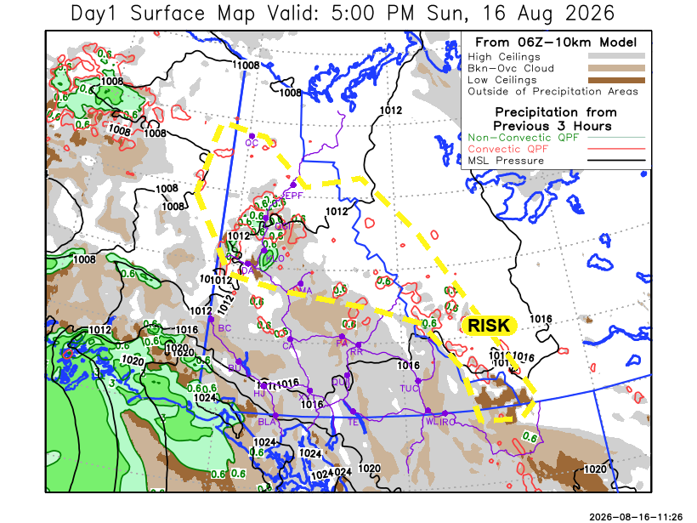
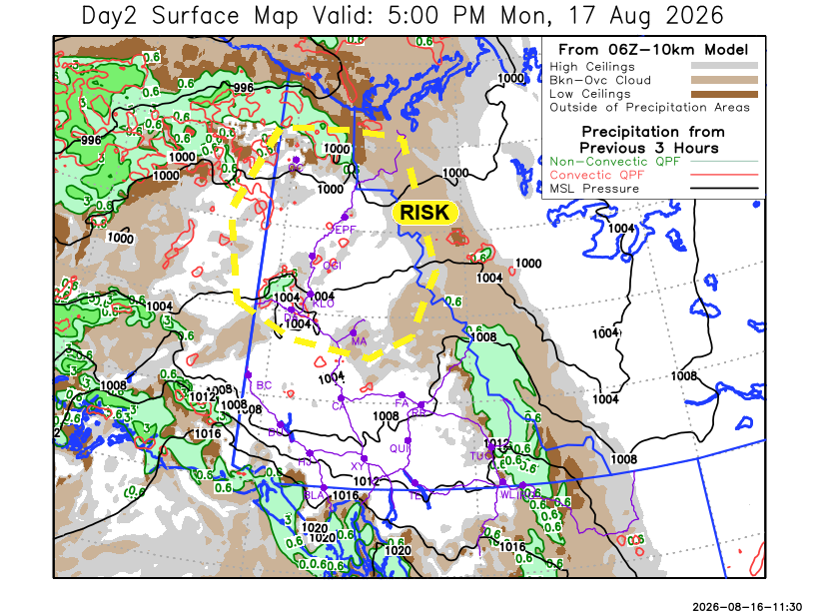

Forecast for | Monday | (Peak burning period and overnight)
Community | Clouds | Pcpn | POP | POL | Max Temp | Min RH | Min Temp | Max  RH | Wind Dir | Wind Speed
Old Crow | BKN | RW-/TRW- | 60 | RISK | 21 | 40 | 12 | 80 | 250 | 25G40
Klondike Fc | SCT | RW-/TRW- | 60 | RISK | 24 | 35 | 11 | 85 | 180 | 10G30
Mayo A | SCT | RW-/TRW- | 60 | RISK | 23 | 40 | 13 | 80 | 180 | 10G20
Carmacks | SCT | R- | 60 | NIL | 27 | 25 | 11 | 70 | 200 | 15G35
Faro | BKN | R- | 60 | NIL | 21 | 35 | 8 | 80 | 250 | 10G20
Ross River | BKN | R- | 60 | NIL | 22 | 45 | 7 | 75 | 250 | 10G20
Beaver Creek Town | FEW |  | 15 | NIL | 25 | 25 | 7 | 60 | 250 | 15G40
Burwash A | FEW |  | 15 | NIL | 23 | 30 | 8 | 70 | 160 | 10G20
Haines Junction | SCT |  | 15 | NIL | 21 | 50 | 7 | 85 | 200 | 15G40
Whitehorse Auto | SCT | R- | 20 | NIL | 22 | 35 | 10 | 75 | 230 | 15G40
Teslin | BKN | R- | 60 | NIL | 20 | 50 | 11 | 90 | 250 | 15G40
Watson Lake | BKN | R- | 80 | NIL | 18 | 55 | 11 | 80 | 250 | 10G30

Forecast for |  |  | Tuesday |  |  | (Peak burning period and overnight)
Community |  |  | Clouds |  |  | Pcpn | POP |  | POL |  | Max Temp |  | Min RH | Min Temp | Max  RH | Wind Dir | Wind Speed
Old Crow |  |  | OVC |  |  | RW- | 60 |  | NIL |  | 16 |  | 70 | 11 | 90 | 250 | 20G50
Klondike Fc |  |  | BKN |  |  | RW- | 40 |  | NIL |  | 20 |  | 40 | 9 | 80 | 250 | 15G40
Mayo A |  |  | SCT |  |  | RW- | 20 |  | NIL |  | 20 |  | 35 | 11 | 80 | 250 | 10G30
Carmacks |  |  | BKN |  |  | RW- | 20 |  | NIL |  | 23 |  | 30 | 10 | 80 | 200 | 5-10
Faro |  |  | SCT |  |  | RW- | 20 |  | NIL |  | 18 |  | 40 | 7 | 90 | 300 | 10G30
Ross River |  |  | SCT |  |  |  | 15 |  | NIL |  | 22 |  | 40 | 6 | 80 | 300 | 10G30
Beaver Creek Town |  |  | SCT |  |  |  | 0 |  | NIL |  | 23 |  | 30 | 5 | 75 | 270 | 10G30
Burwash A |  |  | SCT |  |  |  | 15 |  | NIL |  | 20 |  | 35 | 8 | 75 | 140 | 5
Haines Junction |  |  | SCT |  |  |  | 0 |  | NIL |  | 20 |  | 40 | 6 | 95 | 200 | 10G30
Whitehorse Auto |  |  | SCT |  |  |  | 0 |  | NIL |  | 20 |  | 35 | 9 | 80 | 270 | 10G25
Teslin |  |  | SCT |  |  |  | 0 |  | NIL |  | 19 |  | 35 | 8 | 80 | 270 | 15G35
Watson Lake |  |  | SCT |  |  |  | 0 |  | NIL |  | 20 |  | 40 | 10 | 70 | 300 | 15G30
3-Day Forecast Precipitation Totals from 13:00 Yesterday
OC | 2.3 |  | FA | 2.6 |  | JAK | 3.2
EPF | 0.8 |  | RR | 6.3 |  | TE | 3.6
ANT | 3.8 |  | BC | 0.5 |  | QUI | 2.1
DA | 3.4 |  | BCT | 0.5 |  | SWI | 3.1
FMI | 5.7 |  | BU | 0.5 |  | FL | 2.0
HEN | 2.2 |  | HJF | 0.8 |  | TUC | 7.9
BAR | 2.0 |  | RAI | 0.9 |  | HAS | 10.1
MA | 3.3 |  | CH | 0.6 |  | TC | 12.6
STW | 3.9 |  | BR | 0.8 |  | WL | 8.2
WIL | 2.7 |  | NU | 1.1 |  | NA | NA
PE | 3.9 |  | XY | 1.4 |  | IRO | 11.0
CA | 1.7 |  | CC | 1.8 |  | NA | NA
DRU | 2.3 |  | ATL | 3.7 |  | NA | NA
Dylan Kikuta Meteorologist

Disclaimer : The information in these forecasts is collected and prepared for internal use by the Government of Yukon. The forecasts are specifically designed to meet the needs of the Wildland Fire Management and may not cover the requirements of other parties. Weather warnings or advisories are not included as part of the forecasts. Wildland Fire Management makes no representation and provides no warranty as to the accuracy of its weather forecasts. Any use the recipient chooses to make of the forecasts will be at its sole risk.

