YUKON WILDLAND FIRE MANAGEMENT WEATHER FORECAST - 9:00 AM ISSUE

21-Aug-2026
YESTERDAY'S VALUES
Community | Max  Temp  (°C) | Diff.  from  Normal | Min Temp  (°C) | Diff. from Normal | Pcpn  (mm) | Min RH | Max RH | L110 | L30
Old Crow | 19.3 | 3.4 | 7.9 | 3.2 | 0.0 | 47 | 96 | 3 | 0
Fort Mcpherson Airport | 18.6 |  | 11.9 |  | 0.0M | 62 | 97 | 0 | 0
Rock River Climate | 18.1 |  | 10.9 |  | 0.0 | 52 | 87 | NA | NA
Eagle Plains Fire | 19.6 |  | 12.0 |  | 0.0 | 42 | 74 | 7 | 0
Antimony Creek | 19.7 |  | 9.3 |  | 0.0 | 41 | 87 | 0 | 0
Klondike Fc | 19.3 | 0.1 | 10.0 | 5.4 | 0.0 | 56 | 93 | 0 | 0
Forty Mile | 19.4 |  | 9.1 |  | 0.0 | 45 | 95 | 0 | 0
Henderson | 16.6 |  | 10.6 |  | 0.0 | 47 | 84 | 0 | 0
Barlow | 18.5 |  | 9.8 |  | 0.0 | 44 | 83 | 0 | 0
Mayo A | 19.5 | 0.4 | 8.3 | 2.4 | 0.0 | 43 | 89 | 0 | 0
Stewart Crossing | 20.0 |  | 10.0 |  | 0.0 | 38 | 88 | 0 | 0
Willow Creek | 18.7 |  | 6.6 |  | 0.0 | 44 | 96 | 0 | 0
Pelly Farm | 20.9 | 1.4 | 10.4 | 5.5 | 0.0 | 40 | 90 | 0 | 0
Carmacks | 19.8 |  | 9.3 |  | 0.0 | 48 | 92 | 0 | 0
Drury Creek | 20.6 |  | 11.6 |  | 1.1 | 37 | 97 | 0 | 0
Faro | 20.7 | 2.9 | 11.1 | 5.5 | 1.0 | 34 | 98 | 0 | 0
Ross River | 22.5 |  | 10.3 |  | 0.3 | 31 | 95 | 0 | 0
Macmillan Pass | 15.9 |  | 7.4 |  | 4.4 | 43 | 99 | 0 | 0
Beaver Creek A | 21.1 | 3.7 | 4.6 | 0.6 | 0.6 | 37 | 96 | 0 | 0
Beaver Creek Town | 22.8 |  | 3.3 |  | 0.3 | 31 | 95 | 0 | 0
Burwash A | 17.9 | 0.8 | 4.2 | 0.5 | 0.0M | 51 | 94 | 0 | 0
Haines Junction | 17.8 | -0.1 | 5.5 | 2.6 | 0.0 | 55 | 96 | 0 | 0
Rainbow | 16.4 |  | 11.1 |  | 0.3 | 59 | 83 | 0 | 0
Champagne | 14.9 |  | 9.8 |  | 4.6 | 58 | 88 | 0 | 0
Braeburn | 17.6 |  | 6.6 |  | 0.3 | 49 | 97 | 0 | 0
Nursery | 15.4 |  | 11.4 |  | 1.1 | 58 | 87 | 0 | 0
Whitehorse Auto | 14.4 | -3.7 | 11.1 | 5.1 | 1.4 | 65 | 87 | 0 | 0
Mount Sima | 11.7 |  | 8.5 |  | 1.2 | 69 | 94 | 0 | 0
Carcross | 15.6 |  | 9.3 |  | 1.5 | 57 | 96 | 0 | 0
Atlin | 15.4 |  | 12.1 |  | 0.8 | 57 | 85 | 0 | 0
Jakes Corner | 16.0 |  | 9.2 |  | 1.4 | 51 | 94 | 0 | 0
Teslin | 16.5 |  | 9.2 |  | 2.0 | 52 | 99 | 0 | 0
Quiet Lake | 19.1 |  | 11.5 |  | 0.8 | 47 | 96 | 0 | 0
Swift River | 20.7 |  | 9.2 |  | 0.0 | 32 | 95 | 0 | 0
Tuchitua | 22.2 |  | 9.7 |  | 0.0 | 34 | 98 | 0 | 0
Hasselburg | 20.8 |  | 6.6 |  | 0.0 | 39 | 98 | 0 | 0
Tom Creek | 21.3 |  | 9.3 |  | 0.0 | 36 | 95 | 0 | 0
Watson Lake | 21.7 | 3.0 | 9.8 | 3.4 | 0.0 | 35 | 94 | 0 | 0
Iron Creek | 23.4 |  | 7.1 |  | 0.0 | 32 | 98 | 0 | 0
Max Temp is the actual maximum temperature in °C from yesterday afternoon or evening.
Min Temp is the actual overnight minimum temperature in °C up until 6:00 AM this morning.
Diff. from Normal is the difference from the 30 year average max or min temperature.
Pcpn is the precipitation in mm since 13:00 yesterday.
Min RH is the minimum observed RH in % from yesterday afternoon or evening.
Max RH is the maximum observed overnight RH in % up until 6:00 AM this morning.
L110 is the actual number of lightning strikes within 110 km and in the Yukon for 24 hours ending at 06:00 AM this morning.
L30 is the actual number of lightning strikes within 30 km and in the Yukon for 24 hours ending at 06:00 AM this morning.
M is missing data. * denotes precipitation at stations that failed to report for at least part of the evening and overnight period.

SYNOPSIS:
Today: A low-pressure system will continue to influence much of Yukon, with an associated cold front extending into the southwest, a warm front across the southeast, and a TROWAL affecting northern and central portions of the Territory. Convective showers are expected to become widespread through the afternoon, accompanied by a risk of thunderstorms across much of Yukon, tied to the low-pressure system intensifying in the region. Temperatures will generally reach into the low-20s (isolated mid-20s possible in western Tatchun), while higher moisture will keep minimum RH values mostly above 40%. Winds are forecast to be light to moderate in intensity across the Yukon, generally out of the south or southwest. However, winds are forecast to shift to westerly or northwesterly through the northern half of the Territory as well as Beaver Creek district this afternoon/evening.
Saturday: The TROWAL will gradually shift eastward across Yukon. Isolated showers and a slight risk of thunderstorms will remain over northern and central areas (Klondike, Northern Tutchone, Tatchun), although activity is expected to be less widespread than Friday. Convective shower development is possible through the Tintina region. Kluane and Southern Lakes will see a gradual clearing trend throughout the day, with skies becoming a few clouds to scattered cloud cover by late afternoon/evening. A general cooling trend will begin across the Territory, with increasing RH values accompanying the cooler conditions. Winds light to moderate southwesterly or westerly, gustiest across the southern half of the Yukon where gusts of 25-35 km/h are possible.
Sunday: The trailing portion of the TROWAL will continue to affect central Yukon as it lingers, producing scattered showers. Meanwhile, an Arctic ridge building southward from the north will introduce cooler air into northern Yukon. Northerly flow will strengthen across the Klondike region, keeping temperatures near to below seasonal values. An area of cloud cover/shower activity may advance into Southern Lakes and Kluane late day/evening, tied to an upper trough advancing into the region from the Gulf of Alaska.
Monday: An area of weak high pressure will become established over eastern Yukon. Cloud cover is expected to gradually break through the burning period, with generally few clouds by peak burning and only isolated patches of showers remaining. Cooler conditions will continue, with temperatures generally ranging from the mid-teens to low-20s.
Tuesday: Southerly flow will strengthen across the Territory as the ridge shifts farther east. A relatively quiet day is expected with limited shower/thunderstorm activity and mainly sunny skies taking hold. Temperatures will generally reach the low-20s, with the driest conditions and lowest RH values expected across the southern half of Yukon.

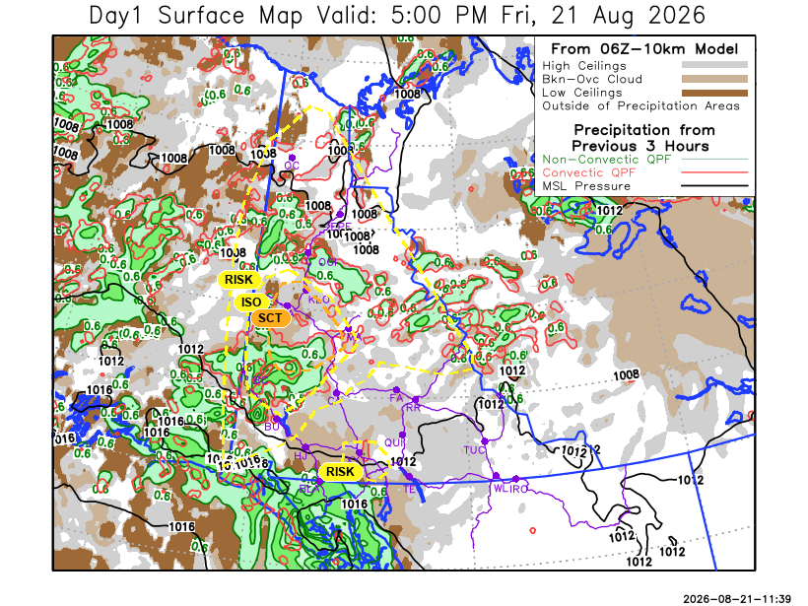

Forecast for | Friday | (Peak burning period and overnight)
Community | Clouds | Pcpn | POP | POL | Max Temp | Min RH | Min Temp | Max  RH | Wind Dir | Wind Speed
Old Crow | SCT | RW-/TRW- | 30 | RISK | 21 | 45 | 12 | 90 | 250 | 15 G 20
Klondike Fc | BKN | RW-/TRW- | 70 | SCT | 20 | 45 | 10 | 95 | 290 | 10
Mayo A | BKN | RW-/TRW- | 80 | ISO | 21 | 45 | 14 | 95 | 200 | 10
Carmacks | BKN | RW-/TRW- | 80 | RISK | 24 | 40 | 10 | 80 | 180 | 15 G 35
Faro | BKN | RW- | 60 | NIL | 20 | 40 | 9 | 95 | 220 | 10
Ross River | BKN | RW- | 60 | NIL | 22 | 40 | 8 | 90 | 200 | 10 G 25
Beaver Creek Town | BKN | RW-/TRW- | 80 | ISO | 21 | 55 | 6 | 90 | 250 | 10
Burwash A | BKN | RW-/TRW- | 50 | RISK | 19 | 40 | 7 | 90 | 160 | 15 G 30
Haines Junction | SCT | RW- | 30 | NIL | 21 | 50 | 7 | 90 | 180 | 15 G 30
Whitehorse Auto | BKN | RW-/TRW- | 60 | RISK | 20 | 40 | 10 | 90 | 180 | 20 G 40
Teslin | BKN | RW- | 60 | NIL | 20 | 50 | 11 | 85 | 200 | 10-15
Watson Lake | BKN |  | 20 | NIL | 22 | 40 | 13 | 90 | 220 | 10-15
POP is probability of precipitation in %.
POL is probability of lightning in %.

Forecast for | Saturday | (Peak burning period and overnight)
Community | Clouds | Pcpn | POP | POL | Max Temp | Min RH | Min Temp | Max  RH | Wind Dir | Wind Speed
Old Crow | BKN | RW-/TRW- | 30 | RISK | 21 | 55 | 11 | 85 | 250 | 10-15
Klondike Fc | BKN | R-/TRW- | 60 | RISK | 19 | 60 | 10 | 90 | 300 | 10-15
Mayo A | BKN | RW-/TRW- | 80 | RISK | 17 | 60 | 13 | 90 | 250 | 15 G 30
Carmacks | BKN | R-/TRW- | 70 | RISK | 20 | 45 | 8 | 85 | 270 | 15 G 30
Faro | BKN | RW-/TRW- | 60 | RISK | 15 | 65 | 6 | 90 | 250 | 15 G 35
Ross River | BKN | RW-/TRW- | 60 | RISK | 16 | 50 | 5 | 80 | 250 | 15 G 35
Beaver Creek Town | BKN | RW | 30 | NIL | 17 | 40 | 6 | 80 | 290 | 10
Burwash A | SCT | RW- | 30 | NIL | 17 | 40 | 7 | 85 | 140 | 15 G 25
Haines Junction | SCT | RW- | 30 | NIL | 18 | 45 | 6 | 90 | 200 | 15 G 30
Whitehorse Auto | SCT | RW- | 30 | NIL | 19 | 35 | 8 | 80 | 220 | 15 G 30
Teslin | SCT | RW- | 30 | NIL | 17 | 40 | 8 | 75 | 250 | 15 G 35
Watson Lake | SCT | RW- | 50 | NIL | 19 | 35 | 8 | 85 | 270 | 15 G 35

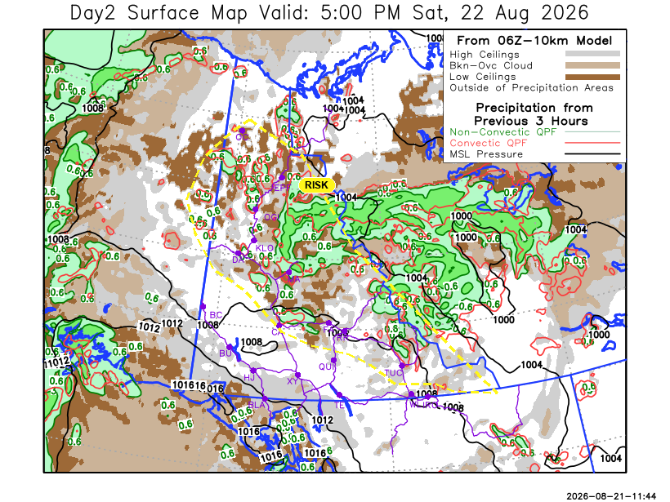
Forecast for |  |  | Sunday |  | (Peak burning period and overnight)
Community |  |  | Clouds |  | Pcpn |  | POP |  | POL |  | Max Temp |  | Min RH | Min Temp | Max  RH | Wind Dir | Wind Speed
Old Crow |  |  | BKN |  | R-/TRW- |  | 40 |  | RISK |  | 14 |  | 65 | 6 | 85 | 40 | 20 G 30
Klondike Fc |  |  | BKN |  | R-/TRW- |  | 60 |  | RISK |  | 16 |  | 70 | 9 | 90 | 320 | 10-15
Mayo A |  |  | BKN |  | RW-/TRW- |  | 70 |  | RISK |  | 17 |  | 70 | 12 | 90 | 270 | 10
Carmacks |  |  | BKN |  | RW- |  | 60 |  | NIL |  | 15 |  | 50 | 9 | 90 | 160 | 5-10
Faro |  |  | BKN |  | RW- |  | 40 |  | NIL |  | 16 |  | 60 | 7 | 90 | 250 | 5-10
Ross River |  |  | BKN |  | RW- |  | 30 |  | NIL |  | 15 |  | 50 | 5 | 90 | 270 | 10
Beaver Creek Town |  |  | BKN |  | RW-/TRW- |  | 30 |  | RISK |  | 15 |  | 60 | 6 | 85 | 290 | 15 G 30
Burwash A |  |  | OVC |  | RW- |  | 50 |  | NIL |  | 13 |  | 65 | 7 | 95 | 290 | 15
Haines Junction |  |  | OVC |  | RW- |  | 40 |  | NIL |  | 15 |  | 50 | 7 | 95 | 320 | 10
Whitehorse Auto |  |  | BKN |  | RW- |  | 30 |  | NIL |  | 15 |  | 50 | 9 | 90 | 180 | 10-15
Teslin |  |  | BKN |  | RW- |  | 40 |  | NIL |  | 16 |  | 45 | 9 | 90 | 160 | 10
Watson Lake |  |  | SCT |  |  |  | 20 |  | NIL |  | 19 |  | 35 | 10 | 80 | 270 | 15 G 25
3-Day Forecast Precipitation Totals from 13:00 Yesterday
OC | 0.3 |  | FA | 10.6 |  | JAK | 8.2
EPF | 8.9 |  | RR | 7.0 |  | TE | 6.9
ANT | 9.7 |  | BC | 7.3 |  | QUI | 9.7
DA | 9.4 |  | BCT | 7.0 |  | SWI | 6.6
FMI | 6.6 |  | BU | 13.3 |  | FL | 9.0
HEN | 18.6 |  | HJF | 0.9 |  | TUC | 6.9
BAR | 18.0 |  | RAI | 1.5 |  | HAS | 4.9
MA | 12.3 |  | CH | 5.6 |  | TC | 3.6
STW | 16.2 |  | BR | 3.4 |  | WL | 2.9
WIL | 10.1 |  | NU | 4.0 |  | POR3 | 14.1
PE | 9.0 |  | XY | 4.8 |  | IRO | 3.2
CA | 4.2 |  | CC | 6.0
DRU | 13.3 |  | ATL | 6.1
Pallawi Paudel Meteorologist

Disclaimer : The information in these forecasts is collected and prepared for internal use by the Government of Yukon. The forecasts are specifically designed to meet the needs of the Wildland Fire Management and may not cover the requirements of other parties. Weather warnings or advisories are not included as part of the forecasts. Wildland Fire Management makes no representation and provides no warranty as to the accuracy of its weather forecasts. Any use the recipient chooses to make of the forecasts will be at its sole risk.

