YUKON WILDLAND FIRE MANAGEMENT WEATHER FORECAST - 9:00 AM ISSUE

22-Aug-2026
YESTERDAY'S VALUES
Community | Max  Temp  (°C) | Diff.  from  Normal | Min Temp  (°C) | Diff. from Normal | Pcpn  (mm) | Min RH | Max RH | L110 | L30
Old Crow | 21.0 | 5.4 | 6.4 | 1.9 | 0.0 | 49 | 96 | 11 | 1
Fort Mcpherson Airport | 22.9 |  | 7.9 |  | 0.0M | 53 | 98 | 14 | 0
Rock River Climate | 18.9 |  | 10.4 |  | 0.6 | 45 | 86 | NA | NA
Eagle Plains Fire | 21.3 |  | 10.4 |  | 1.1 | 40 | 92 | 30 | 0
Antimony Creek | 19.2 |  | 8.8 |  | 27.8 | 57 | 99 | 737 | 16
Klondike Fc | 20.3 | 1.3 | 11.0 | 6.6 | 23.6 | 54 | 99 | 582 | 35
Forty Mile | 19.5 |  | 9.9 |  | 6.6 | 46 | 98 | 161 | 1
Henderson | 18.0 |  | 7.2 |  | 22.8 | 49 | 100 | 1029 | 76
Barlow | 21.5 |  | 7.7 |  | 23.0 | 44 | 99 | 791 | 87
Mayo A | 21.7 | 2.8 | 9.8 | 4.1 | 0.5 | 43 | 92 | 458 | 36
Stewart Crossing | 23.5 |  | 9.2 |  | 0.0 | 37 | 95 | 682 | 25
Willow Creek | 21.9 |  | 6.8 |  | 0.0 | 37 | 95 | 652 | 1
Pelly Farm | 23.8 | 4.5 | 8.1 | 3.4 | 0.3 | 34 | 96 | 773 | 5
Carmacks | 26.9 |  | 10.3 |  | 0.0 | 27 | 79 | 21 | 0
Drury Creek | 23.3 |  | 11.3 |  | 9.5 | 36 | 98 | 1 | 0
Faro | 21.3 | 3.6 | 11.2 | 5.7 | 12.4 | 39 | 97 | 2 | 0
Ross River | 23.0 |  | 11.1 |  | 4.1 | 35 | 98 | 0 | 0
Macmillan Pass | 12.2 |  | 6.1 |  | 2.2 | 77 | 99 | 0 | 0
Beaver Creek A | 16.8 | -0.5 | 8.0 | 4.2 | 4.0 | 59 | 97 | 358 | 0
Beaver Creek Town | 18.4 |  | 8.2 |  | 4.9 | 50 | 97 | 327 | 0
Burwash A | 21.2 | 4.3 | 7.5 | 4.0 | 2.6M | 41 | 96 | 94 | 1
Haines Junction | 24.5 | 7.1 | 9.6 | 6.7 | 0.0 | 24 | 90 | 1 | 0
Rainbow | 22.7 |  | 8.2 |  | 0.6 | 36 | 95 | 1 | 0
Champagne | 21.8 |  | 8.5 |  | 0.3 | 40 | 94 | 0 | 0
Braeburn | 23.2 |  | 9.6 |  | 1.3 | 31 | 96 | 0 | 0
Nursery | 23.0 |  | 9.9 |  | 3.1 | 42 | 97 | 0 | 0
Whitehorse Auto | 20.3 | 2.3 | 9.7 | 3.8 | 4.6 | 47 | 100 | 0 | 0
Mount Sima | 15.9 |  | 7.3 |  | 3.3 | 61 | 93 | 0 | 0
Carcross | 16.8 |  | 8.3 |  | 3.5 | 64 | 99 | 0 | 0
Atlin | 18.7 |  | 10.4 |  | 6.2 | 57 | 97 | 0 | 0
Jakes Corner | 20.0 |  | 9.3 |  | 11.5 | 48 | 97 | 0 | 0
Teslin | 19.5 |  | 10.3 |  | 6.2 | 56 | 99 | 0 | 0
Quiet Lake | 23.7 |  | 10.3 |  | 7.9 | 47 | 99 | 0 | 0
Swift River | 20.6 |  | 9.9 |  | 3.6 | 46 | 98 | 0 | 0
Tuchitua | 22.4 |  | 10.0 |  | 2.2 | 43 | 99 | 0 | 0
Hasselburg | 22.0 |  | 11.1 |  | 1.5 | 43 | 98 | 0 | 0
Tom Creek | 22.0 |  | 11.7 |  | 3.6 | 47 | 96 | 0 | 0
Watson Lake | 22.1 | 3.5 | 12.8 | 6.6 | 0.8 | 44 | 96 | 0 | 0
Iron Creek | 25.1 |  | 9.1 |  | 0.0 | 36 | 99 | 0 | 0
Max Temp is the actual maximum temperature in °C from yesterday afternoon or evening.
Min Temp is the actual overnight minimum temperature in °C up until 6:00 AM this morning.
Diff. from Normal is the difference from the 30 year average max or min temperature.
Pcpn is the precipitation in mm since 13:00 yesterday.
Min RH is the minimum observed RH in % from yesterday afternoon or evening.
Max RH is the maximum observed overnight RH in % up until 6:00 AM this morning.
L110 is the actual number of lightning strikes within 110 km and in the Yukon for 24 hours ending at 06:00 AM this morning.
L30 is the actual number of lightning strikes within 30 km and in the Yukon for 24 hours ending at 06:00 AM this morning.
M is missing data. * denotes precipitation at stations that failed to report for at least part of the evening and overnight period.

SYNOPSIS:
Today: The TROWAL will continue to shift eastward across Yukon, maintaining isolated showers and a slight thunderstorm risk across northern and central areas, including the Southern Klondike, Northern Tutchone, and Tatchun regions. Convective showers are also possible through Tintina. Kluane and Southern Lakes will gradually clear through the day, becoming few to scattered by late afternoon or evening. A cooling trend begins across the Territory, accompanied by increasing RH values. Winds will be light to moderate southwesterly to westerly, with gusts of 25-35 km/h across southern Yukon.
Sunday: The trailing TROWAL will linger over central Yukon, producing scattered showers and isolated thundershowers. An Arctic ridge building southward will bring cooler air into northern Yukon, with strengthening northerly flow across the Klondike and temperatures near to below seasonal values. An upper trough approaching from the Gulf of Alaska may spread increasing cloud and shower activity into Kluane and Southern Lakes late in the day or evening.
Monday: Weak high pressure will build over eastern Yukon. Cloud cover should gradually break through the burning period, with generally few to scattered clouds by peak burning and only isolated showers remaining. Cooler conditions persist, with highs mainly in the mid-teens to low 20s.
Tuesday: Southerly flow will strengthen as the ridge shifts eastward. A relatively quiet and mainly sunny day is expected, with limited shower or thunderstorm activity. Temperatures will generally reach the low 20s, with the driest conditions across southern Yukon where minimum RH values may fall into the 30% range.

Wednesday: A low-pressure system advancing eastward from Alaska will bring increasing cloud and widespread precipitation across western and central Yukon, particularly the Southern Klondike, Northern Tutchone, and Kluane regions. Southern Tutchone, Southern Lakes, and Tintina should remain comparatively drier, with temperatures in the low 20s and minimum RH values near 30%.

Forecast for | Saturday | (Peak burning period and overnight)
Community | Clouds | Pcpn | POP | POL | Max Temp | Min RH | Min Temp | Max  RH | Wind Dir | Wind Speed
Old Crow | SCT | RW-/TRW- | 30 | RISK | 21 | 50 | 8 | 85 | 10 | 10-15
Klondike Fc | OVC | R-/TRW- | 80 | RISK | 17 | 60 | 11 | 95 | 300 | 10-15
Mayo A | OVC | R-/TRW- | 90 | ISO | 15 | 70 | 14 | 95 | 250 | 15 G 30
Carmacks | BKN | R-/TRW- | 90 | RISK | 20 | 40 | 10 | 85 | 220 | 15 G 30
Faro | BKN | R-/TRW- | 90 | ISO | 14 | 55 | 7 | 90 | 250 | 15 G 35
Ross River | BKN | R-/TRW- | 90 | ISO | 17 | 50 | 5 | 80 | 250 | 15 G 35
Beaver Creek Town | SCT | RW- | 40 | NIL | 19 | 40 | 6 | 75 | 270 | 10-15
Burwash A | BKN | RW- | 60 | NIL | 19 | 35 | 7 | 85 | 290 | 10 G 25
Haines Junction | SCT | RW- | 30 | NIL | 20 | 35 | 6 | 90 | 200 | 15 G 30
Whitehorse Auto | SCT | RW- | 30 | NIL | 19 | 35 | 8 | 80 | 200 | 20 G 35
Teslin | SCT | RW- | 50 | NIL | 18 | 35 | 8 | 75 | 220 | 20 G 35
Watson Lake | SCT | RW- | 60 | NIL | 20 | 30 | 8 | 80 | 250 | 15 G 35
POP is probability of precipitation in %.
POL is probability of lightning in %.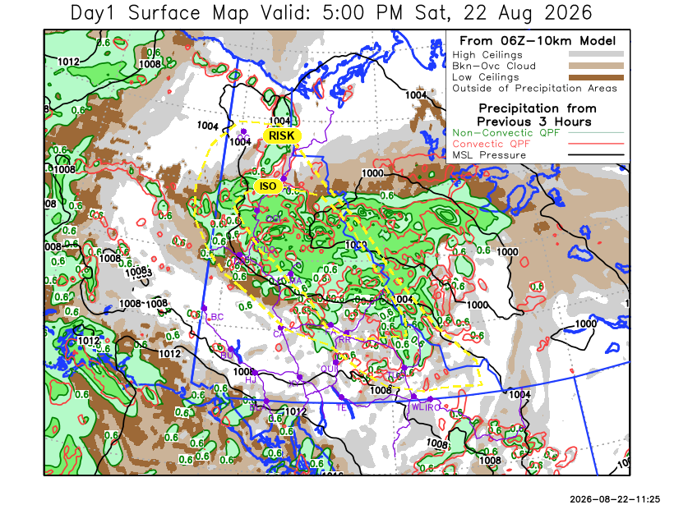

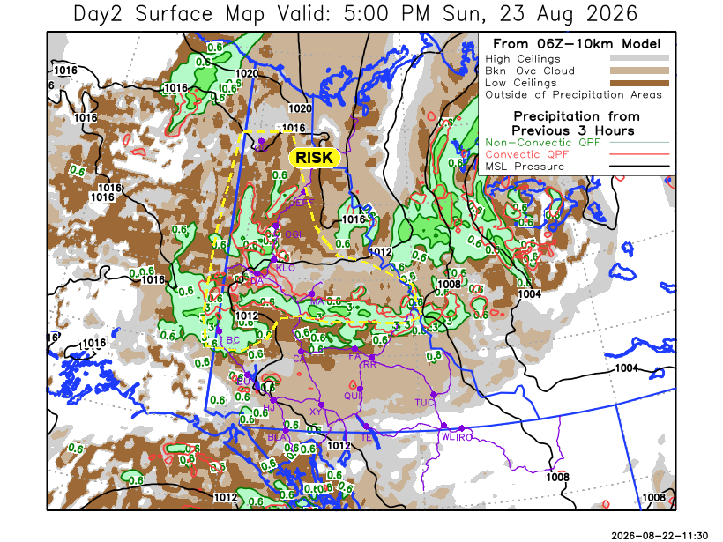
Forecast for | Sunday | (Peak burning period and overnight)
Community | Clouds | Pcpn | POP | POL | Max Temp | Min RH | Min Temp | Max  RH | Wind Dir | Wind Speed
Old Crow | BKN | RW-/TRW- | 30 | RISK | 12 | 55 | 5 | 85 | 20 | 20 G 40
Klondike Fc | BKN | R-/TRW- | 60 | RISK | 17 | 65 | 9 | 95 | 320 | 10-15
Mayo A | BKN | R-/TRW- | 70 | RISK | 17 | 60 | 11 | 90 | 20 | 10
Carmacks | BKN | RW- | 80 | NIL | 16 | 60 | 9 | 95 | 290 | 10
Faro | BKN | RW- | 70 | NIL | 14 | 65 | 7 | 95 | 270 | 10
Ross River | BKN | RW- | 40 | NIL | 15 | 55 | 6 | 90 | 290 | 10 G 20
Beaver Creek Town | BKN | RW-/TRW- | 80 | RISK | 14 | 70 | 7 | 90 | 290 | 15 G 35
Burwash A | OVC | R- | 90 | NIL | 14 | 50 | 8 | 95 | 290 | 15 G 25
Haines Junction | BKN | RW- | 40 | NIL | 18 | 40 | 8 | 95 | 220 | 10
Whitehorse Auto | BKN | RW- | 30 | NIL | 16 | 40 | 8 | 90 | 220 | 10-15
Teslin | BKN | RW- | 30 | NIL | 16 | 40 | 8 | 85 | 220 | 10
Watson Lake | SCT |  | 20 | NIL | 18 | 30 | 8 | 75 | 270 | 15 G 25

Forecast for |  |  | Monday |  |  | (Peak burning period and overnight)
Community |  |  | Clouds |  |  | Pcpn | POP |  |  | POL | Max Temp |  | Min RH | Min Temp | Max  RH | Wind Dir | Wind Speed
Old Crow |  |  | BKN |  |  |  | 0 |  |  | NIL | 16 |  | 50 | 7 | 80 | 220 | 15 G 25
Klondike Fc |  |  | BKN |  |  |  | 0 |  |  | NIL | 18 |  | 40 | 10 | 90 | 110 | 5-10
Mayo A |  |  | SCT |  |  | RW- | 30 |  |  | NIL | 19 |  | 50 | 11 | 85 | 140 | 5-10
Carmacks |  |  | SCT |  |  |  | 20 |  |  | NIL | 20 |  | 40 | 8 | 90 | 160 | 10
Faro |  |  | SCT |  |  | RW- | 30 |  |  | NIL | 18 |  | 40 | 7 | 90 | 140 | 5-10
Ross River |  |  | SCT |  |  |  | 0 |  |  | NIL | 19 |  | 40 | 5 | 90 | 110 | 5-10
Beaver Creek Town |  |  | SCT |  |  |  | 0 |  |  | NIL | 20 |  | 45 | 5 | 90 | 110 | 15 G 25
Burwash A |  |  | SCT |  |  | RW- | 30 |  |  | NIL | 17 |  | 50 | 6 | 90 | 160 | 15 G 30
Haines Junction |  |  | SCT |  |  |  | 20 |  |  | NIL | 21 |  | 50 | 6 | 90 | 180 | 5-10
Whitehorse Auto |  |  | SCT |  |  |  | 20 |  |  | NIL | 18 |  | 45 | 9 | 90 | 160 | 5-10
Teslin |  |  | BKN |  |  | RW- | 30 |  |  | NIL | 16 |  | 50 | 9 | 90 | 140 | 5-10
Watson Lake |  |  | BKN |  |  | RW- | 30 |  |  | NIL | 17 |  | 50 | 10 | 85 | 140 | 5-10
3-Day Forecast Precipitation Totals from 13:00 Yesterday
OC | 0.1 |  | FA | 19.2 |  | JAK | 12.6
EPF | 5.6 |  | RR | 7.2 |  | TE | 7.8
ANT | 30.4 |  | BC | 15.2 |  | QUI | 9.6
DA | 30.5 |  | BCT | 16.1 |  | SWI | 4.6
FMI | 15.6 |  | BU | 11.9 |  | FL | 3.7
HEN | 35.2 |  | HJF | 2.5 |  | TUC | 4.2
BAR | 39.5 |  | RAI | 2.9 |  | HAS | 2.2
MA | 17.1 |  | CH | 1.6 |  | TC | 4.8
STW | 17.6 |  | BR | 4.8 |  | WL | 1.8
WIL | 16.5 |  | NU | 3.6 |  | POR3 | 21.6
PE | 15.2 |  | XY | 4.9 |  | IRO | 2.3
CA | 7.0 |  | CC | 3.8
DRU | 24.0 |  | ATL | 8.3
Pallawi Paudel Meteorologist

Disclaimer : The information in these forecasts is collected and prepared for internal use by the Government of Yukon. The forecasts are specifically designed to meet the needs of the Wildland Fire Management and may not cover the requirements of other parties. Weather warnings or advisories are not included as part of the forecasts. Wildland Fire Management makes no representation and provides no warranty as to the accuracy of its weather forecasts. Any use the recipient chooses to make of the forecasts will be at its sole risk.

