YUKON WILDLAND FIRE MANAGEMENT WEATHER FORECAST - 9:00 AM ISSUE

23-Aug-2026
YESTERDAY'S VALUES
Community | Max  Temp  (°C) | Diff.  from  Normal | Min Temp  (°C) | Diff. from Normal | Pcpn  (mm) | Min RH | Max RH | L110 | L30
Old Crow | 21.0 | 5.6 | 9.4 | 5.1 | 0.2 | 38 | 85
Fort Mcpherson Airport | 23.7 |  | 9.7 |  | 0.0M | 47 | 92
Rock River Climate | 16.4 |  | 10.7 |  | 3.0 | 61 | 81
Eagle Plains Fire | 14.6 |  | 10.1 |  | 0.0 | 69 | 93
Antimony Creek | 15.0 |  | 10.6 |  | 4.8 | 76 | 100
Klondike Fc | 18.7 | -0.1 | 11.1 | 6.9 | 1.8 | 63 | 100
Forty Mile | 16.5 |  | 10.1 |  | 1.7 | 64 | 98
Henderson | 13.8 |  | 8.3 |  | 2.0 | 73 | 100
Barlow | 11.8 |  | 9.2 |  | 7.6 | 94 | 100
Mayo A | 12.8 | -5.9 | 10.1 | 4.6 | 3.1 | 82 | 99
Stewart Crossing | 15.4 |  | 11.0 |  | 4.5 | 62 | 98
Willow Creek | 14.9 |  | 8.5 |  | 3.2 | 57 | 98
Pelly Farm | 18.7 | -0.4 | 8.4 | 3.8 | 2.7 | 50 | 98
Carmacks | 23.0 |  | 8.2 |  | 0.0 | 29 | 86
Drury Creek | 17.2 |  | 7.9 |  | 11.3 | 57 | 98
Faro | 15.5 | -2.0 | 7.7 | 2.4 | 2.6 | 53 | 97
Ross River | 15.4 |  | 0.9 |  | 0.3 | 55 | 97
Macmillan Pass | 8.9 |  | 5.5 |  | 4.8 | 78 | 97
Beaver Creek A | 19.7 | 2.6 | 1.2 | -2.4 | 0.0 | 33 | 93
Beaver Creek Town | 20.1 |  | 2.2 |  | 0.0 | 31 | 92
Burwash A | 18.0 | 1.3 | 6.6 | 3.2 | 0.0M | 37 | 90
Haines Junction | 19.4 | 1.9 | 1.5 | -0.5 | 0.0 | 36 | 90
Rainbow | 18.0 |  | 6.4 |  | 0.0 | 37 | 82
Champagne | 18.9 |  | 3.0 |  | 0.0 | 35 | 87
Braeburn | 17.4 |  | 6.8 |  | 0.5 | 40 | 76
Nursery | 20.0 |  | -1.5 |  | 0.0 | 35 | 96
Whitehorse Auto | 17.6 | -0.2 | 2.6 | -3.2 | 0.0 | 35 | 97
Mount Sima | 14.2 |  | 5.7 |  | 0.0 | 39 | 69
Carcross | 17.9 |  | 4.7 |  | 0.0 | 42 | 95
Atlin | 16.6M |  | 6.8M |  | 0.0M | 43M | 81M
Jakes Corner | 17.8 |  | 3.4 |  | 0.0 | 37 | 94
Teslin | 16.7 |  | 4.0 |  | 0.4 | 47 | 95
Quiet Lake | 20.0 |  | 1.8 |  | 0.0 | 43 | 97
Swift River | 16.0 |  | 5.2 |  | 0.0 | 50 | 88
Tuchitua | 19.0 |  | 0.1 |  | 6.1 | 41 | 98
Hasselburg | 17.2 |  | 0.6 |  | 0.3 | 39 | 98
Tom Creek | 17.5 |  | 4.3 |  | 0.0 | 44 | 89
Watson Lake | 18.7 | 0.3 | 3.7 | -2.4 | 0.2 | 36 | 93
Iron Creek | 20.8 |  | 0.4 |  | 0.0 | 35 | 98
Max Temp is the actual maximum temperature in °C from yesterday afternoon or evening.
Min Temp is the actual overnight minimum temperature in °C up until 6:00 AM this morning.
Diff. from Normal is the difference from the 30 year average max or min temperature.
Pcpn is the precipitation in mm since 13:00 yesterday.
Min RH is the minimum observed RH in % from yesterday afternoon or evening.
Max RH is the maximum observed overnight RH in % up until 6:00 AM this morning.
L110 is the actual number of lightning strikes within 110 km and in the Yukon for 24 hours ending at 06:00 AM this morning.
L30 is the actual number of lightning strikes within 30 km and in the Yukon for 24 hours ending at 06:00 AM this morning.
M is missing data. * denotes precipitation at stations that failed to report for at least part of the evening and overnight period.

SYNOPSIS:
Today: The trailing TROWAL will linger over Yukon, bringing widespread cloud cover and scattered showers, with isolated thundershowers particularly around Dawson-Mayo corridor. Comparatively drier conditions and some breaks in cloud are possible through the Tintina region. Most areas are expected to receive 5 mm or less of precipitation, although localized amounts of 5-10 mm are possible, particularly in Kluane. An Arctic high building southward will bring cooler air into northern Yukon, with strengthening northerly flow across the Klondike. Temperatures will generally remain in the low to mid-teens, with a few warmer pockets reaching the upper teens. Winds will generally be moderate west to northwesterly across much of the Territory. An upper trough approaching from the Gulf of Alaska may spread increasing cloud and shower/light rain activity into Kluane and Southern Lakes late in the day or evening.
Monday: Weak high pressure will build over eastern Yukon. Cloud cover should gradually break through the burning period, with generally few to scattered clouds by peak burning and only isolated showers remaining. Cooler conditions will persist, with highs mainly in the mid-teens to low 20s. Winds will remain relatively light across the southern half of the Territory, while western regions will see a more established southerly flow.
Tuesday: Moderate southerly flow will strengthen as the ridge shifts eastward. A relatively quiet and mainly sunny day is expected, with limited shower or thunderstorm activity. Temperatures will generally reach the low-20s, with the driest conditions across southern half of Yukon where minimum RH values may fall into the thirties.

Wednesday: A low-pressure system advancing eastward from Alaska will bring increasing cloud cover and more widespread precipitation across much of Yukon. Precipitation will gradually spread from western regions eastward through the burning period, with the greatest coverage expected across Southern Klondike, Northern Tutchone, Southern Lakes, and Tatchun. Tintina should remain comparatively drier, with temperatures reaching the low 20s and minimum RH values near 30-40%. Moderate westerly to southwesterly winds are expected across much of the Territory.

Thursday: Scattered showers will continue across much of Yukon, keeping temperatures below seasonal values and RH values relatively elevated. Cloud cover and shower activity should gradually diminish as higher pressure builds in from Alaska. Moderate to strong westerly to northwesterly winds are expected, particularly across exposed areas, before gradually easing.

Forecast for | Sunday | (Peak burning period and overnight)
Community | Clouds | Pcpn | POP | POL | Max Temp | Min RH | Min Temp | Max  RH | Wind Dir | Wind Speed
Old Crow | SCT | RW-/TRW- | 30 | RISK | 12 | 50 | 5 | 75 | 40 | 20 G 40
Klondike Fc | BKN | R-/TRW- | 80 | ISO | 17 | 70 | 8 | 94 | 320 | 15 G 25
Mayo A | BKN | R-/TRW- | 90 | ISO | 17 | 65 | 10 | 92 | 20 | 10 G 20
Carmacks | BKN | R- | 90 | NIL | 15 | 60 | 10 | 94 | 320 | 5-10
Faro | BKN | RW- | 70 | NIL | 13 | 65 | 7 | 97 | 270 | 10 G 25
Ross River | BKN | RW- | 60 | NIL | 15 | 55 | 6 | 91 | 290 | 10 G 20
Beaver Creek Town | OVC | R-/TRW- | 90 | RISK | 13 | 55 | 7 | 93 | 290 | 15 G 35
Burwash A | OVC | R- | 90 | NIL | 13 | 45 | 8 | 93 | 310 | 15 G 25
Haines Junction | OVC | RW- | 70 | NIL | 16 | 40 | 9 | 92 | 340 | 10
Whitehorse Auto | BKN | RW- | 30 | NIL | 16 | 35 | 10 | 89 | 340 | 10-15
Teslin | BKN |  | 20 | NIL | 16 | 40 | 8 | 85 | 0 | 10
Watson Lake | SCT |  | 20 | NIL | 18 | 35 | 8 | 76 | 270 | 15 G 30
POP is probability of precipitation in %.
POL is probability of lightning in %.
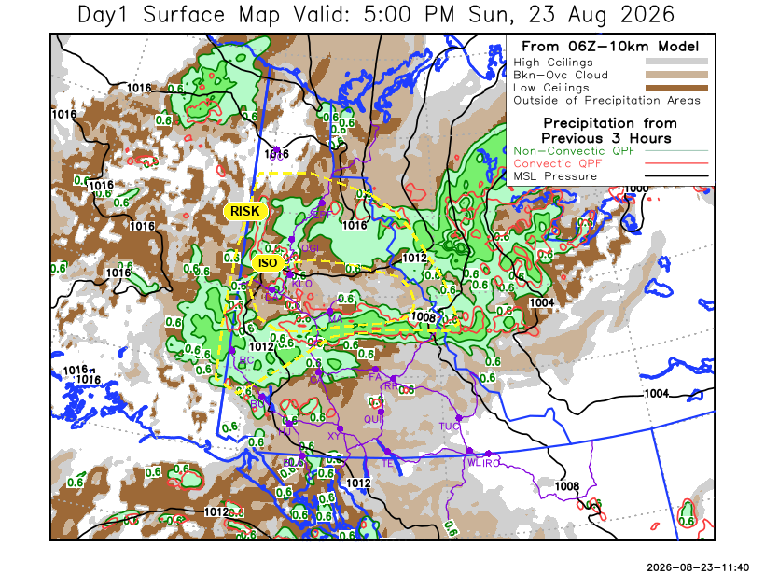
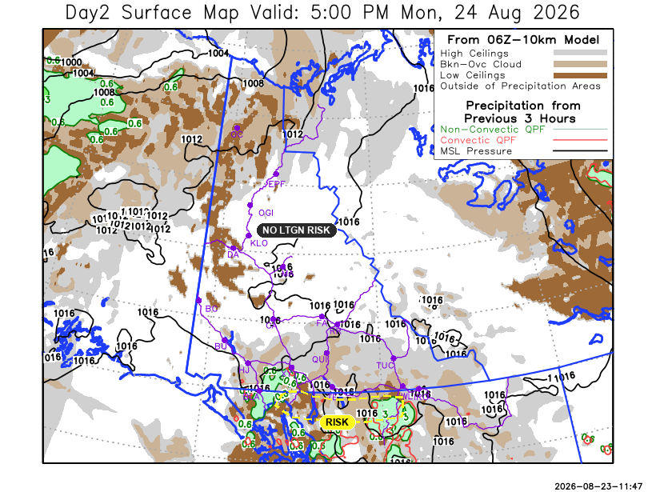
Forecast for | Monday | (Peak burning period and overnight)
Community | Clouds | Pcpn | POP | POL | Max Temp | Min RH | Min Temp | Max  RH | Wind Dir | Wind Speed
Old Crow | BKN |  | 0 | NIL | 18 | 50 | 8 | 79 | 220 | 20 G 35
Klondike Fc | SCT |  | 0 | NIL | 20 | 40 | 10 | 88 | 140 | 10 G 20
Mayo A | FEW |  | 0 | NIL | 20 | 45 | 11 | 85 | 140 | 5-10
Carmacks | FEW |  | 20 | NIL | 22 | 40 | 8 | 89 | 160 | 10
Faro | FEW |  | 20 | NIL | 18 | 45 | 7 | 89 | 140 | 10 G 25
Ross River | SCT | RW- | 40 | NIL | 19 | 40 | 5 | 88 | 140 | 5-10
Beaver Creek Town | SCT |  | 0 | NIL | 21 | 45 | 5 | 90 | 110 | 15 G 25
Burwash A | FEW |  | 20 | NIL | 17 | 50 | 6 | 89 | 160 | 15 G 30
Haines Junction | SCT | RW- | 30 | NIL | 21 | 50 | 5 | 94 | 180 | 5-10
Whitehorse Auto | SCT |  | 20 | NIL | 18 | 45 | 8 | 88 | 160 | 10-15
Teslin | BKN | RW- | 30 | NIL | 17 | 50 | 10 | 92 | 140 | 5-10
Watson Lake | BKN | RW- | 30 | NIL | 18 | 40 | 10 | 84 | 160 | 5-10

Forecast for |  |  | Tuesday |  | (Peak burning period and overnight)
Community |  |  | Clouds |  | Pcpn |  | POP |  | POL |  | Max Temp |  | Min RH | Min Temp | Max  RH | Wind Dir | Wind Speed
Old Crow |  |  | BKN |  | RW- |  | 40 |  | NIL |  | 18 |  | 50 | 11 | 89 | 220 | 15 G 30
Klondike Fc |  |  | BKN |  | RW- |  | 40 |  | NIL |  | 23 |  | 35 | 10 | 88 | 160 | 10-15
Mayo A |  |  | FEW |  |  |  | 0 |  | NIL |  | 22 |  | 30 | 12 | 85 | 180 | 15 G 30
Carmacks |  |  | FEW |  |  |  | 0 |  | NIL |  | 24 |  | 30 | 9 | 77 | 180 | 15 G 35
Faro |  |  | FEW |  |  |  | 0 |  | NIL |  | 21 |  | 35 | 8 | 86 | 160 | 10 G 25
Ross River |  |  | SCT |  |  |  | 0 |  | NIL |  | 23 |  | 35 | 6 | 88 | 180 | 15 G 30
Beaver Creek Town |  |  | BKN |  | RW- |  | 30 |  | NIL |  | 22 |  | 40 | 6 | 89 | 140 | 5-10
Burwash A |  |  | SCT |  |  |  | 0 |  | NIL |  | 19 |  | 40 | 7 | 80 | 140 | 15 G 30
Haines Junction |  |  | FEW |  |  |  | 0 |  | NIL |  | 20 |  | 30 | 6 | 92 | 200 | 15 G 35
Whitehorse Auto |  |  | FEW |  | RW- |  | 30 |  | NIL |  | 21 |  | 35 | 9 | 86 | 180 | 15 G 30
Teslin |  |  | SCT |  | RW- |  | 30 |  | NIL |  | 21 |  | 40 | 9 | 90 | 180 | 10 G 20
Watson Lake |  |  | SCT |  | RW-/TRW- |  | 30 |  | RISK |  | 22 |  | 45 | 12 | 83 | 160 | 10
3-Day Forecast Precipitation Totals from 13:00 Yesterday
OC | 0.2 |  | FA | 5.1 |  | JAK | 0.0
EPF | 1.3 |  | RR | 1.4 |  | TE | 0.4
ANT | 7.1 |  | BC | 6.7 |  | QUI | 0.4
DA | 4.3 |  | BCT | 6.7 |  | SWI | 0.9
FMI | 4.5 |  | BU | 4.7 |  | FL | 0.0
HEN | 5.9 |  | HJF | 5.9 |  | TUC | 6.1
BAR | 10.0 |  | RAI | 3.2 |  | HAS | 0.3
MA | 6.3 |  | CH | 0.9 |  | TC | 0.1
STW | 8.0 |  | BR | 2.3 |  | WL | 0.2
WIL | 11.3 |  | NU | 0.9 |  | POR3 | 5.1
PE | 10.4 |  | XY | 0.8 |  | IRO | 0.0
CA | 3.5 |  | CC | 0.3
DRU | 14.6 |  | ATL | 2.3
Pallawi Paudel Meteorologist

Disclaimer : The information in these forecasts is collected and prepared for internal use by the Government of Yukon. The forecasts are specifically designed to meet the needs of the Wildland Fire Management and may not cover the requirements of other parties. Weather warnings or advisories are not included as part of the forecasts. Wildland Fire Management makes no representation and provides no warranty as to the accuracy of its weather forecasts. Any use the recipient chooses to make of the forecasts will be at its sole risk.

