YUKON WILDLAND FIRE MANAGEMENT WEATHER FORECAST - 9:00 AM ISSUE

24-Aug-2026
YESTERDAY'S VALUES
Community | Max  Temp  (°C) | Diff.  from  Normal | Min Temp  (°C) | Diff. from Normal | Pcpn  (mm) | Min RH | Max RH | L110 | L30
Old Crow | 10.5 | -4.7 | 2.5 | -1.6 | 0.0 | 57 | 84 | 0 | 0
Fort Mcpherson Airport | 9.7 |  | 3.7 |  | 0.0 | 75 | 88 | 0 | 0
Rock River Climate | 11.4 |  | 5.2 |  | 0.0 | 68 | 100 | NA | NA
Eagle Plains Fire | 10.1 |  | 5.1 |  | 0.8 | 81 | 98 | 0 | 0
Antimony Creek | 17.9 |  | 0.8 |  | 2.1 | 65 | 99 | 3 | 0
Klondike Fc | 20.1 | 1.5 | 4.0 | -0.1 | 0.3 | 60 | 100 | 1 | 0
Forty Mile | 14.2 |  | 6.5 |  | 1.8 | 76 | 99 | 0 | 0
Henderson | 12.5 |  | 7.6 |  | 0.6 | 87 | 99 | 5 | 0
Barlow | 16.6 |  | 6.4 |  | 0.3 | 59 | 93 | 29 | 0
Mayo A | 17.9 | -0.5 | 4.4 | -1.0 | 0.1 | 64 | 99 | 29 | 2
Stewart Crossing | 16.9 |  | 5.4 |  | 2.8 | 67 | 98 | 30 | 20
Willow Creek | 16.4 |  | 4.2 |  | 9.3 | 63 | 98 | 30 | 21
Pelly Farm | 15.8 | -3.1 | 6.8 | 2.4 | 14.3 | 80 | 97 | 29 | 2
Carmacks | 13.0 |  | 10.0 |  | 9.5 | 68 | 99 | 2 | 0
Drury Creek | 12.8 |  | 9.1 |  | 2.5 | 77 | 98 | 0 | 0
Faro | 11.7 | -5.6 | 9.5 | 4.3 | 1.4 | 72 | 96 | 0 | 0
Ross River | 14.8 |  | 8.9 |  | 1.4 | 62 | 98 | 0 | 0
Macmillan Pass | 10.4 |  | 2.5 |  | 0.6 | 77 | 96 | 0 | 0
Beaver Creek A | 10.2 | -6.7 | 9.1 | 5.7 | 3.2M | 68 | 96 | 0 | 0
Beaver Creek Town | 11.0 |  | 9.2 |  | 4.7 | 72 | 97 | 0 | 0
Burwash A | 13.9 | -2.7 | 8.4 | 5.2 | 1.7M | 61 | 96 | 0 | 0
Haines Junction | 18.7 | 1.2 | 9.4 | 7.1 | 7.0 | 39 | 98 | 0 | 0
Rainbow | 16.6 |  | 8.6 |  | 5.9 | 47 | 99 | 0 | 0
Champagne | 16.0 |  | 7.9 |  | 1.2 | 45 | 97 | 0 | 0
Braeburn | 13.1 |  | 8.8 |  | 4.7 | 65 | 99 | 0 | 0
Nursery | 16.8 |  | 9.0 |  | 0.0 | 44 | 95 | 0 | 0
Whitehorse Auto | 15.1 | -2.5 | 8.3 | 2.7 | 0.0 | 46 | 97 | 0 | 0
Mount Sima | 12.2 |  | 5.5 |  | 0.6 | 57 | 98 | 0 | 0
Carcross | 16.2 |  | 4.2 |  | 0.0 | 45 | 96 | 0 | 0
Atlin | 16.0 |  | 6.5 |  | 0.0 | 43 | 82 | 0 | 0
Jakes Corner | 15.2 |  | 2.6 |  | 0.0 | 46 | 96 | 0 | 0
Teslin | 16.5 |  | 3.8 |  | 0.0 | 41 | 98 | 0 | 0
Quiet Lake | 15.0 |  | 4.2 |  | 0.3 | 50 | 98 | 0 | 0
Swift River | 16.5 |  | 3.1 |  | 0.0 | 39 | 92 | 0 | 0
Tuchitua | 18.9 |  | -1.1 |  | 0.0 | 37 | 97 | 0 | 0
Hasselburg | 17.1 |  | 3.6 |  | 0.0 | 36 | 94 | 0 | 0
Tom Creek | 18.1 |  | 5.9 |  | 0.0 | 38 | 88 | 0 | 0
Watson Lake | 18.6 | 0.4 | 5.1 | -0.8 | 0.0 | 35 | 89 | 0 | 0
Iron Creek | 20.2 |  | 1.2 |  | 0.0 | 34 | 98 | 0 | 0
Max Temp is the actual maximum temperature in °C from yesterday afternoon or evening.
Min Temp is the actual overnight minimum temperature in °C up until 6:00 AM this morning.
Diff. from Normal is the difference from the 30 year average max or min temperature.
Pcpn is the precipitation in mm since 13:00 yesterday.
Min RH is the minimum observed RH in % from yesterday afternoon or evening.
Max RH is the maximum observed overnight RH in % up until 6:00 AM this morning.
L110 is the actual number of lightning strikes within 110 km and in the Yukon for 24 hours ending at 06:00 AM this morning.
L30 is the actual number of lightning strikes within 30 km and in the Yukon for 24 hours ending at 06:00 AM this morning.
M is missing data. * denotes precipitation at stations that failed to report for at least part of the evening and overnight period.

SYNOPSIS:
Today: Weak high pressure will build over eastern Yukon today. Cloud cover should gradually break through the burning period, with generally few to scattered clouds by peak burning and only isolated showers remaining. Broken cloud cover may persist across the far north and far southeast, with the best chance of showers near the Southern Lakes and southeast Yukon. Cooler conditions will persist, with highs generally in the upper teens to low 20s and minimum RH values mainly 35-40%. Winds will remain relatively light across much of the southern and central Territory, while a more established southerly flow develops across western areas. Old Crow will see the strongest winds, with southwest winds around 20 km/h gusting to 40 km/h.
Tuesday: Moderate southerly flow will strengthen across much of Yukon as the ridge shifts eastward. A relatively quiet and mainly sunny day is expected across most of the Territory, with limited shower activity. The main exception will be portions of the Tintina and southeast Yukon, where isolated showers and a slight risk of thunderstorms are possible. Temperatures will generally reach the upper teens to low 20s. The driest conditions are expected across the southern and central Territory, where minimum RH values may fall into the low to mid-30s. Southerly winds will be moderate to locally strong, with gusts of 30-40 km/h possible in several areas, including Carmacks and Whitehorse.

Wednesday: A low-pressure system advancing eastward from Alaska will bring increasing cloud cover and more widespread precipitation across much of Yukon. Precipitation will gradually spread from western regions eastward through the burning period, with the greatest coverage expected across Southern Klondike, Northern Tutchone, Southern Lakes, and Tatchun. Tintina should remain comparatively drier, with temperatures reaching the mid-teens and minimum RH values near 35-45%. Moderate westerly to southwesterly winds are expected across much of the Territory.

Thursday: Scattered showers will continue across much of Yukon, keeping temperatures generally in the mid-teens and RH values relatively elevated. Somewhat drier conditions are expected across central portions of the Territory, particularly near Carmacks. No thunderstorm risk is currently expected. Cloud cover and shower activity should gradually diminish through the day as higher pressure builds in from Alaska. Moderate to strong westerly to northwesterly winds are expected, particularly across exposed areas, before gradually easing.

Friday: A broad trough will continue to bring cloud cover across northern and western portions of the Territory, with passing areas of showers expected. No thunderstorm risk is currently anticipated. Temperatures will generally range from the mid-teens to low 20s, with moderate southwesterly flow across much of Yukon. Drier conditions are expected through the Yukon Plateau, where minimum RH values may fall to around 35%, particularly across Northern Tutchone, Tatchun, Southern Lakes, and possibly the Southern Klondike.

Forecast for | Monday | (Peak burning period and overnight)
Community | Clouds | Pcpn | POP | POL | Max Temp | Min RH | Min Temp | Max  RH | Wind Dir | Wind Speed
Old Crow | BKN |  | 0 | NIL | 19 | 50 | 12 | 80 | 220 | 20 G 40
Klondike Fc | SCT |  | 0 | NIL | 22 | 40 | 10 | 85 | 110 | 10 G 20
Mayo A | FEW |  | 0 | NIL | 21 | 40 | 12 | 85 | 140 | 5-10
Carmacks | FEW |  | 0 | NIL | 22 | 40 | 9 | 90 | 160 | 10
Faro | SCT |  | 0 | NIL | 18 | 45 | 6 | 90 | 110 | 15 G 25
Ross River | SCT |  | 20 | NIL | 20 | 45 | 5 | 90 | 140 | 10
Beaver Creek Town | SCT |  | 0 | NIL | 21 | 50 | 5 | 85 | 110 | 15 G 30
Burwash A | FEW |  | 20 | NIL | 19 | 45 | 6 | 85 | 140 | 15 G 30
Haines Junction | SCT | RW- | 30 | NIL | 18 | 40 | 7 | 95 | 180 | 5-10
Whitehorse Auto | SCT | RW- | 30 | NIL | 18 | 40 | 8 | 90 | 160 | 15 G 25
Teslin | BKN | RW- | 60 | NIL | 15 | 45 | 9 | 95 | 110 | 5-10
Watson Lake | BKN | RW- | 40 | NIL | 18 | 40 | 11 | 85 | 140 | 10
POP is probability of precipitation in %.
POL is probability of lightning in %.
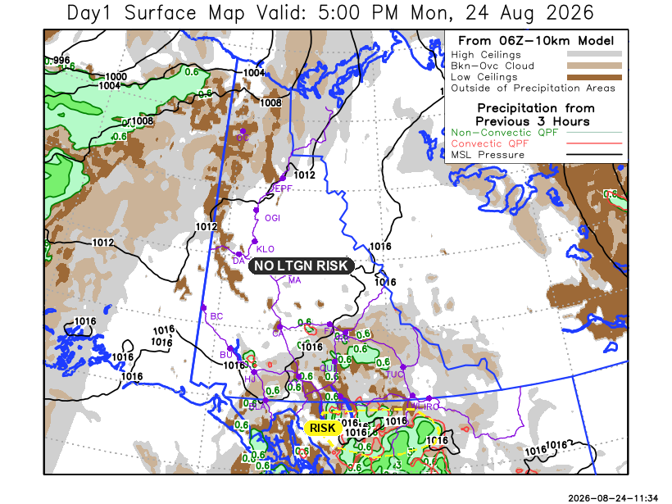
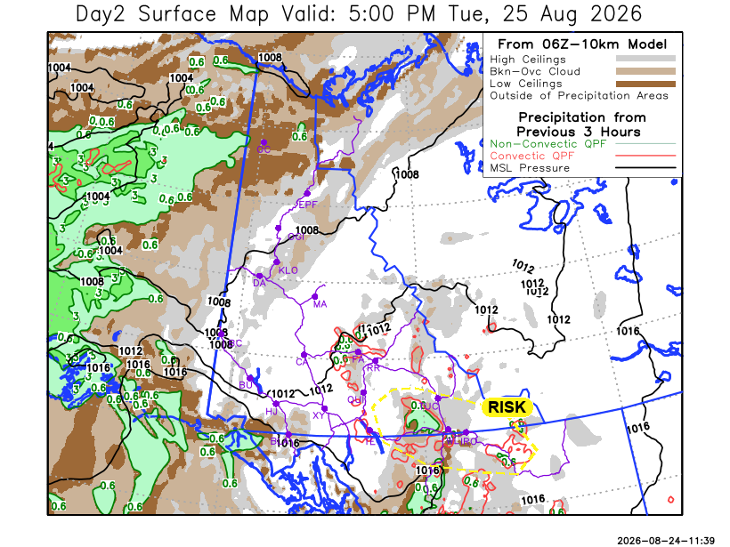
Forecast for | Tuesday | (Peak burning period and overnight)
Community | Clouds | Pcpn | POP | POL | Max Temp | Min RH | Min Temp | Max  RH | Wind Dir | Wind Speed
Old Crow | BKN | RW | 40 | NIL | 19 | 55 | 9 | 90 | 220 | 20 G 35
Klondike Fc | BKN | RW- | 30 | NIL | 20 | 35 | 10 | 90 | 160 | 15 G 30
Mayo A | SCT |  | 20 | NIL | 21 | 35 | 12 | 85 | 160 | 15 G 25
Carmacks | FEW |  | 20 | NIL | 22 | 30 | 8 | 80 | 180 | 20 G 40
Faro | FEW |  | 20 | NIL | 20 | 35 | 6 | 85 | 160 | 15 G 30
Ross River | FEW |  | 0 | NIL | 21 | 30 | 4 | 85 | 180 | 15 G 30
Beaver Creek Town | BKN |  | 20 | NIL | 22 | 30 | 6 | 90 | 180 | 5-10
Burwash A | SCT |  | 0 | NIL | 17 | 40 | 7 | 85 | 140 | 20 G 35
Haines Junction | SCT |  | 0 | NIL | 19 | 45 | 6 | 90 | 180 | 15 G 35
Whitehorse Auto | FEW |  | 0 | NIL | 20 | 30 | 7 | 85 | 180 | 20 G 40
Teslin | FEW | RW- | 40 | NIL | 19 | 35 | 8 | 90 | 200 | 15 G 25
Watson Lake | SCT | RW-/TRW- | 30 | RISK | 21 | 50 | 11 | 85 | 160 | 10 G 25

Forecast for |  |  | Wednesday |  |  | (Peak burning period and overnight)
Community |  |  | Clouds |  |  | Pcpn | POP |  | POL |  | Max Temp |  | Min RH | Min Temp | Max  RH | Wind Dir | Wind Speed
Old Crow |  |  | BKN |  |  | RW- | 40 |  | NIL |  | 10 |  | 70 | 3 | 90 | 250 | 20 G 40
Klondike Fc |  |  | SCT |  |  | RW- | 30 |  | NIL |  | 15 |  | 45 | 4 | 85 | 290 | 15 G 35
Mayo A |  |  | BKN |  |  | RW- | 60 |  | NIL |  | 15 |  | 45 | 8 | 85 | 320 | 15
Carmacks |  |  | OVC |  |  | RW- | 60 |  | NIL |  | 16 |  | 35 | 7 | 85 | 330 | 10-15
Faro |  |  | OVC |  |  | RW- | 50 |  | NIL |  | 14 |  | 40 | 6 | 90 | 290 | 10-15
Ross River |  |  | BKN |  |  | RW- | 40 |  | NIL |  | 18 |  | 50 | 5 | 90 | 290 | 10-15
Beaver Creek Town |  |  | BKN |  |  | RW- | 60 |  | NIL |  | 14 |  | 50 | 2 | 90 | 290 | 15 G 30
Burwash A |  |  | OVC |  |  | R- | 70 |  | NIL |  | 12 |  | 65 | 5 | 90 | 320 | 15 G 35
Haines Junction |  |  | OVC |  |  | R- | 70 |  | NIL |  | 14 |  | 70 | 7 | 90 | 320 | 5-10
Whitehorse Auto |  |  | OVC |  |  | RW- | 60 |  | NIL |  | 14 |  | 65 | 8 | 90 | 320 | 10
Teslin |  |  | BKN |  |  | RW- | 30 |  | NIL |  | 16 |  | 55 | 9 | 90 | 270 | 15
Watson Lake |  |  | SCT |  |  | RW- | 30 |  | NIL |  | 22 |  | 35 | 10 | 80 | 250 | 10 G 25
3-Day Forecast Precipitation Totals from 13:00 Yesterday
OC | 9.3 |  | FA | 1.7 |  | JAK | 1.7
EPF | 5.0 |  | RR | 1.6 |  | TE | 1.6
ANT | 6.2 |  | BC | 12.5 |  | QUI | 2.0
DA | 4.6 |  | BCT | 14.0 |  | SWI | 4.5
FMI | 10.8 |  | BU | 7.4 |  | FL | 1.4
HEN | 5.2 |  | HJF | 9.1 |  | TUC | 1.8
BAR | 6.0 |  | RAI | 8.0 |  | HAS | 2.6
MA | 3.7 |  | CH | 2.6 |  | TC | 0.9
STW | 6.9 |  | BR | 7.1 |  | WL | 0.9
WIL | 12.4 |  | NU | 0.9 |  | POR3 | 3.7
PE | 17.3 |  | XY | 0.9 |  | IRO | 1.7
CA | 12.0 |  | CC | 2.5
DRU | 4.6 |  | ATL | 3.2
Pallawi Paudel Meteorologist

Disclaimer : The information in these forecasts is collected and prepared for internal use by the Government of Yukon. The forecasts are specifically designed to meet the needs of the Wildland Fire Management and may not cover the requirements of other parties. Weather warnings or advisories are not included as part of the forecasts. Wildland Fire Management makes no representation and provides no warranty as to the accuracy of its weather forecasts. Any use the recipient chooses to make of the forecasts will be at its sole risk.

